# EEGpal: **Study design (full model)**

Version 1.0, 16.02.2025

The Full Model tool is used to specify a factorial design for your data, which will be used to perform statistics using the **Statistics module**. It will automatically fill in the *Subject*, *Condition* and *Factor_level* columns of the Data table on the main screen. This is a necessary step before entering the Statistics module.

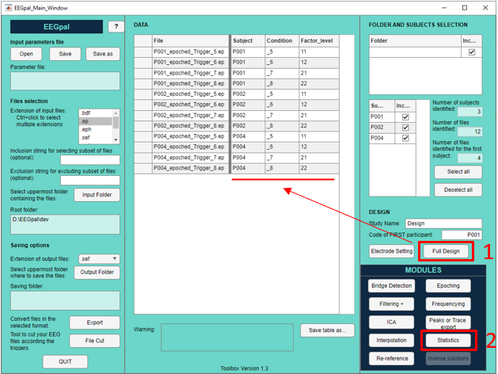

**How to use the Study design interface**

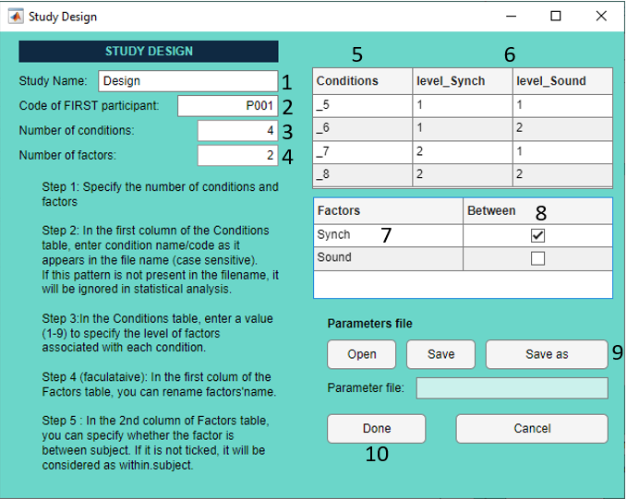

1. Specify a name for your Design.
2. To perform statistics correctly, EEGpal needs to know which participant is associated with each file. Please enter the code for the first participant. The EEG files must have this code in their name. This option is the same as the ‘Code of FIRST participant’ in the EEGpal main window.   
   WARNING: The participant code must have the same number of characters and the same position in the file name for every participant. Name your file according to this rule.
3. Specify the number of conditions in your design (for this example, we are running a 2x2 ANOVA which means that we have 4 different conditions).
4. Specify the number of factors in your design (for this example, we are running a 2x2 ANOVA which means that we have 2 different factors).
5. Enter the name of the condition. However, you should not enter an arbitrary name. It should be a substring present in the EEG file name so that EEGpal can associate the files with the corresponding factor (like the participant code in point 2). In this example, the condition identifier code is '_5' in the file 'P001_epoched_Trigger_5.ep'.
6. Specify the factor level associated with each condition. You must enter a number in each cell of the table. The combination of factor levels for each condition must be unique. In this example, the 'level_Synch' column is for 1=synchronous conditions, 2=asynchronous condition; the 'level Sound' column is for 1=sound play, 2=sound omission.
7. In the first column of the Factors table you can specify the name of your factors. This step is optional. Otherwise, the default names would be 'Factor1', 'Factor2', …
8. Now it is time to specify whether your factors are within subject (i.e. the same participant performed all the conditions associated with each level of that factor) or between subject (i.e. different participants performed the conditions associated with each level of that factor). In this example the Sound factor is unchecked, which means it is a within factor, and the Synch factor is checked, which means it is a between factor.
9. You can saved or load the parameters you entered in this tool for later reuse
10. Press on Done when you have finish.

FAQ

**What the output looks like?**

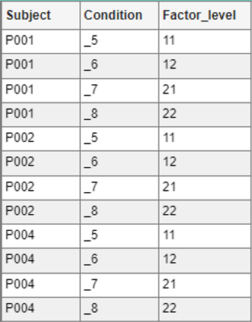

The module automatically fills these three columns of the Data table in the EEGpal Main_Window. This is necessary to use the **Statistics module**.