EEGpal: Re-referencing module
Version 2.16, 19.09.2026
Video tutorial: https://youtu.be/TwBe_8CH-i8

The Re-referencing module can be used to change the reference channel of the EEG signal. As you probably know, EEGs measure the difference in electrical potential between each channel and a reference channel. The reference channel exerts a significant influence, completely altering the signal. The usual convention is to use the average reference, i.e. the average signal from all electrodes. However, this module allows you to re-reference the signal to any scalp or auxiliary channel.
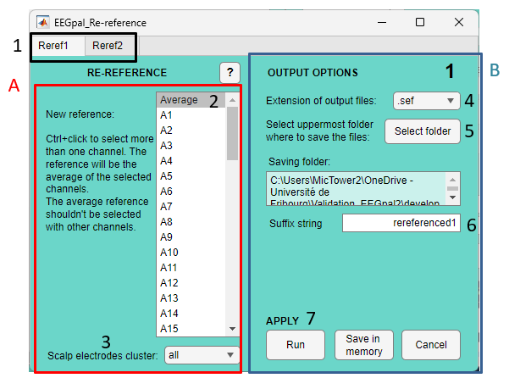
- There are two panels for saving two different sets of parameters. This is useful when you need to apply a re-referencing step twice in your EEG processing pipeline (as is the case with Biosemi data, which should first be re-referenced to Cz at the start, and then to Average at the end). This is particularly useful when programming a batch (see the manual for BATCH parameters).
Pannel A:
- The default option is to use the 'Average' reference. However, you can select any other scalp channel. You can even select multiple channels using Ctrl + mouse click to create a custom average reference. In this case, though, you cannot select the 'Average' option.
- In the majority, leave the default option ‘all’.

Pannel B:
- Select the format for the output files.
- Select the destination folder where the results files will be saved. Note that this reproduces the input structure. For example, if the input files were in subfolders, there would be a folder per participant.
- The suffix added to the input filename to obtain the output filename.
- There are three validation buttons:
  - The Run button will carry out the processing parameterized in the Re-referencing module.
  - The Save in memory button will store all the parameters in memory and close the Re-Referencing module without performing the processing.
  - The button Cancel closes the module without processing and without keeping the entered parameters in memory. The same effect will be achieved by closing the Re-Referencing module window.

FAQ
Can I use the mastoid as reference electrode?
Yes, in the 'Electrode Setting' window of EEGpal, you can specify the mastoid electrode as channel 65 for this example. You can then choose this channel as the reference.
