EEGpal: GEDAI module
Version 2.02, 03.01.2026
Video tutorial: Coming soon

The GEDAI toolbox (Generalized Eigenvalue De-Artifacting Instrument) offers a new approach to correcting EEG artefacts caused by muscles, eyes, electronic noise, etc with a fully automated strategy that does not require any human supervision or clean data samples.
Based on prior knowledge of the brain’s 'signal' subspace (i.e. its spatial covariance), the authors computed a matrix that corresponds to the theoretical EEG signal if all cortical sources were active simultaneously. This matrix is computed based solely on the spatial distribution of the electrodes (synthetic signal), and is therefore completely free from artefacts. The GEDAI toolbox then uses generalized eigenvalue decomposition (GEVD) to compare your real data with this theoretical perfect signal. This allows you to effectively separate source components belonging to the artefact subspace from those belonging to the brain subspace. The result is a new version of your EEG signal containing only the most probable brain signal (without artefact). This provides better results and faster processing than ICA or ASR strategies (which should not be applied in addition to GEDAI correction).
A complete theorical description and demonstration of its capacity can be found at the following website: https://cibm.ch/noise-cancelling-headphones-for-the-brain-how-a-new-algorithm-eliminates-noise-in-eeg-data/
The original paper which described the algorithm can be found at the following location:
Ros, T., Férat, V., Huang, Y., et al. (2025). Return of the GEDAI: Unsupervised EEG Denoising based on Leadfield Filtering. bioRxiv. https://doi.org/10.1101/2025.10.04.680449

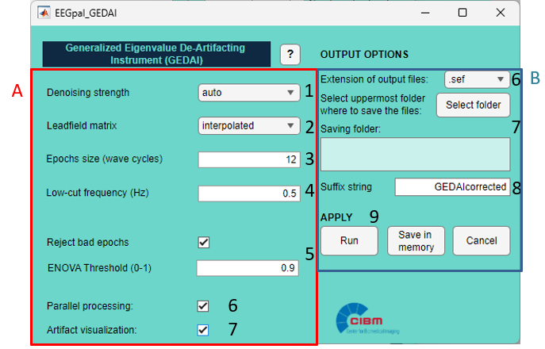

Pannel A:
- Determining deartifacting strength.
Stronger threshold type:
  - auto : Default option:
  - auto+ might remove more noise at the expense of signal, while milder threshold
  - auto- might retain more signal at the expense of noise.
- The leadfield matrix corresponds to the matrix of the theoretical clean EEG signal used as a reference. This matrix has been pre-computed based on a configuration of 343 electrodes (10-5 layout). The toolbox needs to interpolate it to match the electrode configuration of your data using a spherical algorithm. By default, leave the option interpolated. Use the option precomputed only if the electrode names load in Electrode Setting (main EEGpal window) respect the international convention (e.g. Fp1, Cz, …) with a standard electrode configuration.
- Epoch size in number of wave cycles for each wavelet band. Default is 12 which is a good compromise (see FAQ for more explanation of this parameter)
- Low-cut frequency in Hz. Wavelet bands below this frequency will be excluded. Default is 0.5 Hz to use if no filter has been applied to your data. If you have already applied a high-pass filter to your signal using the Filtering+ module, this is unnecessary. In this case, it is recommended that you use the same cut-off frequency as in the Filtering+ module. For example, if you applied a high-pass filter at 1 Hz, you should set the low-cut frequency threshold in GEDAI to 1 Hz.
- This option allows you to remove part of the signal rather than denoise it. Epochs are rejected based on Explained Noise Variance (ENOVA). Setting the threshold to 0.9 will result in the rejection of all epochs in which more than 90% of the signal is identified as noise. A smaller value will lead to more conservative processing. The toolbox automatically adjusts the position of EEG events recorded in MRK files.
This option is NOT RECOMMENDED for an ERP study! Indeed, the epochs used by GEDAI (typically 1 s) are independent of the events (triggers/markers) in the file. This means that epochs centred on events (triggers/markers) used for averaging could be truncated. This is why using this option for an ERP study is strongly not recommended, and the artefact rejection options in the Epoching module should be used instead. Keep this option for resting state recording.
- This option allows you to speed up processing by using multiple threads. This option is only available if you have the Parallel Computing Toolbox from MathWorks installed in your Matlab.
- Open an additional window overlaying the original and corrected signals for visualization.
Pannel B:
- Select the format for the output files.
- Select the destination folder where the results files will be saved. Note that this reproduces the input structure. For example, if the input files were in subfolders, there would be a folder per participant.
- The suffix added to the input filename to obtain the output filename.
- There are three validation buttons:
  - The Run button will carry out the processing.
  - The Save in memory button will store all the parameters in memory and close the GEDAI module without performing the processing. This is a useful option if you want to integrate GEDAI processing into a batch job.
  - The button Cancel closes the module without processing and without keeping the entered parameters in memory. The same effect will be achieved by closing the GEDAI module window.

FAQ
What is the impact of the parameter “Epochs size (wave cycles)”
In GEDAI, EEG data are not analyzed as one long continuous signal. Instead, the data are segmented into short epochs, and these epochs are used to compute frequency-specific covariance matrices that feed the GED (Generalized EigenDecomposition).
The parameter Epochs size (wave cycles) defines the length of each epoch in terms of the number of oscillatory cycles, not in seconds.
Key idea
The actual duration (in seconds) of an epoch depends on the frequency being analyzed:
$$\text{Epoch duration (s)}≈\frac{\text{Number of cycles}}{\text{Frequency (Hz)}}$$
With the default value:
- Epochs size (wave cycles) = 12
Examples:
- At 10 Hz → epoch ≈ 1.2 s
- At 5 Hz → epoch ≈ 2.4 s
- At 30 Hz → epoch ≈ 0.4 s
GEDAI relies on:
- Band-limited covariance matrices
- Wavelet-based spectral filtering
- Generalized eigenvalue decomposition to separate neural signal from noise/artifacts
The epoch length directly affects:
- Covariance estimation quality
  - Too short → ill-conditioned, noisy covariance matrices
  - Too long → smearing of nonstationary brain dynamics
- Time–frequency trade-off
  - More cycles = better frequency precision, worse temporal precision
  - Fewer cycles = better temporal precision, worse frequency precision
- Artifact detection sensitivity
  - Short epochs → better detection of brief EMG or movement artifacts
  - Long epochs → more robust detection of sustained noise sources
The default value (12 cycles) is a well-balanced compromise between statistical stability and temporal sensitivity across common EEG frequency bands.
Written by ChatGPT.

Is the GEDAI correction suitable for any types of EEG experiment, such ERP studies (visual, auditory, somatosensory) or resting state?
Yes. The GEDAI correction is independent of the task and relies on the biophysical spatial constraints of the cerebral EEG. This artefact rejection depends of :
- the geometry of the electrodes (this is why it is mandatory to load a file in the Electrode Setting)
- the conductive volume
- the fact that the sources are intracerebral and bipolar
It does not depend on:
- timing (ERP vs. ongoing)
- frequency
- phase locking
- inter-trial repeatability
Written with the help of ChatGPT

Are there any limitations to this artefact rejection method?
As the correction is based on the spatial distribution of the electrodes, it should be reasonable (medium head size, symmetric layout, more or less standard disposition). Efficiency depends on the number of electrodes, so this method is not suitable for single channels.
In terms of anatomy, the sources of deep brain structures such as the thalamus and the brainstem are not well estimated, and the signals from these regions are not well corrected.
Finally, the reference matrix has been computed for the entire brain. The GEDAI artefact correction will be less accurate for atypical brain anatomy, such as in patients with cerebral lesions. In addition, the presence of an active neurostimulator cannot be managed and will impair denoising.

Is it better to work with filtered or raw EEG signal when using GEDAI toolbox?
Very low-frequency noise, such as signal drift, would cause problems with GEDAI corrections. Therefore, it is recommended that you apply a high-pass filter to your signal and correct the line noise using either a 50 Hz notch filter or the CleanLine toolbox. If you are working with a raw signal, you will need to use the 'Low-cut frequency (Hz)' parameter from the GEDAI toolbox to apply a high-pass filter before artefact correction.
Applying a low-pass filter to the data (e.g. at 40 Hz) will not impair the GEDAI work.
In summary, it is advisable to apply filters using the Filtering+ module before proceeding to the GEDAI module.

Is GEDAI changing the references used in the data?
Yes, the output files generated by the GEDAI toolbox will be automatically re-referenced to the average. However, it is still necessary to re-reference the signal to the average using the Re-reference module after interpolation, in order to remove the impact of bad channels.

What is the recommended processing pipeline for an ERP study using the GEDAI toolbox?
I would recommend using a similar processing pipeline as usual but without ASR or ICA:
- Bridge Detection
- Filtering +: Apply a high-pass filter with a threshold of at least 0.5 Hz and deactivate the ASR bad burst correction and Additional removal of bad data periods options for CLEAN RAWDATA
- GEDAI: use the GEDAI toolbox with the same Low-cut frequency value as the high-pass threshold used in step 2. Do not activate the option Reject bad epochs.
- Interpolation: Make a visual inspection of your signal to check for bad electrodes. Interpolate them with the bridged channels detect in step 1
- Re-reference: Re-reference to average reference to correct the impact of bad channels on the signal
- Epoching: Use the Epoching module as usual to create your Evoked Related Potential (ERP) files.

