EEGpal: BATCH parameters tool
Version 2.16, 19.09.2026
Video tutorial: https://youtu.be/6AxTkXS2n9c

The 'Batch Parameter' tool allows you to program the order in which the processing steps must be applied to the data.
If you are a new user of EEGpal or if you need to optimize your processing pipeline, the authors strongly recommend to first process manually each step to become use of the interface/options
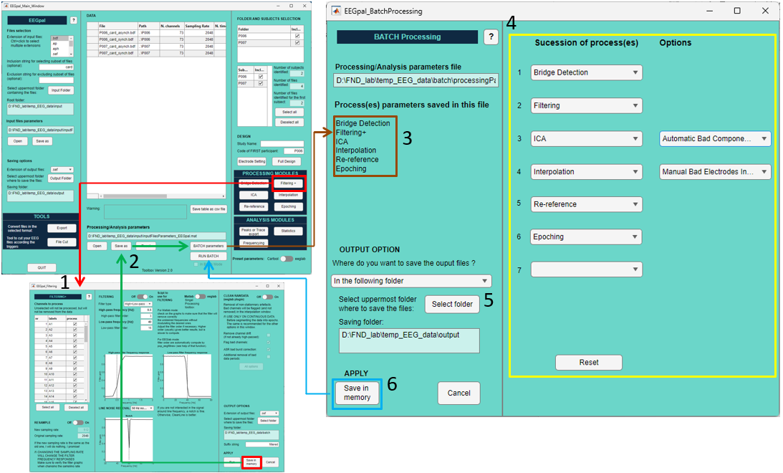
- First, you must open and specify the processing parameters for each module (except the Bridge detection) that you want to use in batch mode. After filling in all the parameters for each module, click Save in memory instead of Run. Note: You don’t need the specify the output folder if you use the option ‘In the following folder’ at step 5.
- Repeat step 1 for each processing module that you want to batch. Then, save the processing parameter file and click the Batch Parameters button.
- In the top left corner, you will see a list of all the available processing steps for the batch (depending on step 1). Note: the Bridge detection module is the only exception. There is no need to set processing parameters for this module, so it will always be available for the batch.
- In the column ‘Sucession of process(es)’, you will specify the order of the processing steps. You can only specify each processing step once. The next drop-down menu will be updated when you select an option in the previous step. An empty selection, such as position 7 in the illustrated example, will be ignored. You can reset the list by pushing the button Reset.
For ICA and Interpolation processing, you need to select a supplementary option from the 'Options' column.
  - For ICA: ICA processing usually requires a visual inspection to remove the noisy components of the signal. With the default option of 'Run only ICA decomposition', the batch will be interrupted after decomposition to allow the user to manually inspect the signal and decide which components to remove. When it is done, he has to click first on the Run button in the ICA module window and, after the recomposition is done, click on the RUN BATCH of the main EEGpal window to continue the batch.
The 'Automatic Bad Components Rejection' option will automatically select the bad components according to the threshold specified in the 'ICAlabel Assistance' section in the central part of the ICA window, using the ICAlabel plugin.
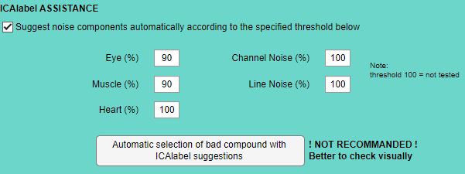
If you use this option, you should trust the ICAlabel suggestions. We recommend checking some participants visually to validate this automatic choice.
  - For Interpolation: Interpolation usually requires a visual inspection to remove the bad channel (see the interpolation manual for more details). With the default option of ‘Manual Bad Electrodes Inspection’, the batch will be interrupted to allow the user to manually inspect the signal and decide which components to remove (see the interpolation manual). When it is done, he has to click first on the Run button in the module window and, after the interpolation is done, click on the RUN BATCH of the main EEGpal window to continue the batch.
The ‘Automatic Bad Electrodes Rejection’ option automatically select which electrodes to interpolate based on Bridge Detection (all bridged channels will be interpolated) and on the ‘Flad bad channels’ from the Filtering+ (which is automatically computed in batch mode even if you have not selected the option). However, these modules must be placed at an earlier stage in the batch process (either separately or together).
NOTE: The author does not recommend using this fully automatic option, as the 'Flag Bad Channels' function in CleanRawData is unreliable without visual confirmation (see the Interpolation Manual for more details). It is up to you to decide.
- You have two options regarding the place where to save the files process by the Batch :
  - ‘In the following folder’: This option will save all processed files in the same specified folder. It will create a sub-folder for each processing step. This will override the output location that you specified in the modules' windows.
  - ‘In the folders specified inside of each module’: This option saves the output of each processing stage to the specified folder in the modules' windows. Make sure you have specified one for every module; otherwise, the batch will be interrupted.
- When you are done, click on the Save in memory button to transfer your selection to the processing parameter. Then, in the EEGpal main window, you will be able to press the RUN BATCH button to start the batch you have programmed.

FAQ
Why do I have to open and click 'Save in Memory' in every module before the batch?
This is the author's choice, allowing for flexibility in processing for the user, rather than having full automatic processing, where you have no control. The only exception is the Bridge Detection which does not require any processing parameters.

Is it possible to specify a bad electrode manually to be ignored in the ICA decomposition before running the batch?
In a standard batch succession involving first bridge detection, then filtering and finally ICA, this is not possible. Indeed, your saved choice will be overwritten by the Bridge Detection bad channel.
However, it is possible if you perform the batch in two steps. In the first step, only perform the bridge detection and filtering. Then open the ICA module and manually adjust the bad channel. Remember to click the 'Save in memory' button in the ICA module window. Finally, program a second batch which starts by ICA processing. In this case, the ICA will consider the manual changes specified in the previous step.
Is it possible to manually select the electrode to be interpolated before running the batch in automatic mode?
Yes, you can. Specify it manually in the interpolation table in the Interpolation module before running the batch. Don’t forget to press on the button Save in memory in the interpolation module to transfer your selection to the processing parameter file. However, be aware that it will systematically add the bad channel detected by the Bridge Detection and Filtering+ (flag bad channel) if these modules are processed before interpolation. Otherwise, it is recommended that you use the 'Manual Bad Electrodes Inspection' option to control what should be interpolated.
Why are there two references, and what do they correspond to?
In some cases, you will need to re-reference your data twice during processing. This is the case when processing Biosemi data, where you need to re-reference the data to Cz at the beginning and to the average at the end. The options 'Rereference_Reref1' and 'Rereference_Reref2' are designed for this purpose. These correspond to the ‘Reref1’ and ‘Reref2’ panels in the Re-reference module, where you can specify different parameters.

