EEGpal: ICA module
Version 2.16, 19.09.2026
Video tutorial: https://www.youtube.com/watch?v=PGzbCEqjD5w

The 'ICA' module performs an independent component analysis. The aim is to break down the EEG signal into its constituent parts. This strategy is used to isolate and remove unwanted signals (artefacts), such as eye blinks.
This module uses the function runica developed for eeglab using the infomax ICA algorithm of Bell & Sejnowski (1995) with the natural gradient feature of Amari, Cichocki & Yang, the extended-ICA algorithm of Lee, Girolami & Sejnowski, PCA dimension reduction, and/or specgram() preprocessing suggested by M. Zibulevsky.

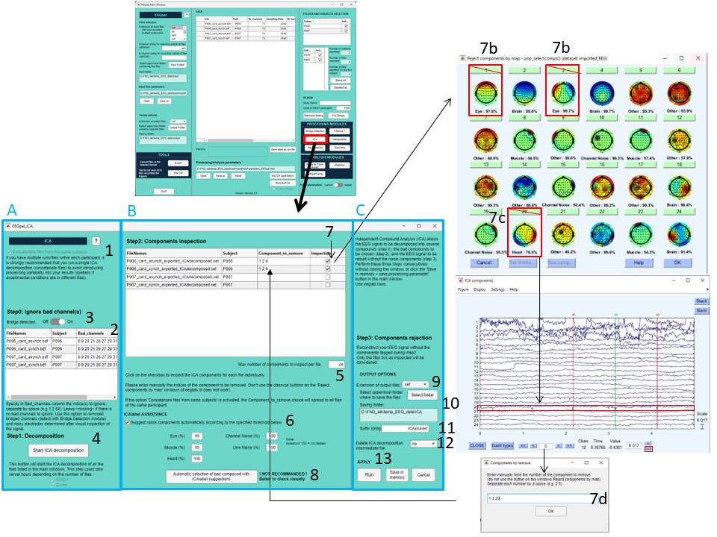
Independent Compound Analysis (ICA) enables the EEG signal to be broken down into different components (see panel A). You can then select the unwanted compounds, such as eye, muscle and heart activity (panel B). Finally, the EEG signal can be reconstructed without the unwanted compounds, without losing any data points or electrodes (panel C).
IMPORTANT NOTE: These three steps should be performed in sequence without closing this window. However, the decomposition (step 1) will record intermediate files in the ./temp_ICA folder in a .set format. If you have already performed the decomposition (step 1), you can load these intermediate files directly into the main EEGpal window. The ICA module will automatically detect that the decomposition has already been performed.
Pannel A: Decomposition
- Select the "concatenate files from the same subjects" option if you have multiple runs/files within each subject. To avoid introducing processing variability into your results, it is strongly recommended that you perform a single ICA decomposition (concatenate files). This option is activated by default if you have specified a subject code for each file in the input data table in the main EEGpal window.
For example, if you want to compare two conditions recorded in separate EEG files, you need to perform the same ICA decomposition on both files. If you perform two separate ICA decompositions, the components will differ, and after rejecting the incorrect components, you will introduce an additional difference to your statistics that will be impossible to distinguish from the difference of interest.
- Before running the decomposition, you can specify a list of channels that should be ignored during the ICA processing, such as bridged channels (see point 3) or channels identified as faulty through visual inspection of the signal. This will improve the quality of the decomposition.
Warning: Do not enter the name of the electrode (e.g. A11 B32), but rather the numerical indices of the channels separated by a space (e.g. 11 64). If there are no channels to ignore, you can leave the <missing> entry or clear the cell (result will be the same).
In batch mode, this table is automatically filled with bridged channels if ICA is preceded by Bridge Detection in the batch, and with flat channel used for Reref if ICA is preceded by Re-Reference module to another channel than the average.
- If you run the Bridge Detection module in EEGpal before ICA, the list of bridged channels will automatically be filled in the bad channel table in point 2. You can activate or deactivate this automatic filling using this slider.
Note: the processed signal must be independent before running an ICA decomposition, which is not the case for bridged electrodes. This is why they must be ignored during decomposition to achieve better results.
- Start the ICA decomposition of your EEG files. This process will take a long time.
The intermediate results of the ICA decomposition will be recorded at the following location: .\ICAtemp\decomposed\*_ICAdecomposed.set.

Pannel B: ICA Components inspection
- Select the number of components to be inspected in points 6–8. This value should be smaller than the number of decomposed electrodes minus one. For example, if you have an EEG file with 64 channels and you specified three bad channels in step 2, this means that 60 independent components are estimated (64-3-1). This value should be specified as a number between 1 and 60.
Note: We recommend inspecting only the first 24 components (the default value). The impact of additional components on the overall signal is usually negligible.
- EEGpal will automatically consult the ICLabel module included in eeglab (https://eeglab.org/plugins/ICLabel/). Ticking this box allows you to specify a threshold for classifying components for each type of noise. Panel 7d, used to specify the components to be removed, will automatically be filled with those that exceed the specified thresholds.
- Click on the checkbox to inspect the ICA components for each file individually.
  - The toolbox will display the topography of the first X components (X as specified in point 5) alongside the labels estimated by ICAlabel.
  - In the current example the compound 1 (blink = vertical movement) and the compound 3 (horizontal movement) are clearly associate with eye movement.
  - Look also to heat -beat activity. The best way to found is to found regular peak in the trace of ICA component. In this example, you see the compound 20 has this pattern.
  - Please enter manually the indices of the component to be removed, separated by a space (‘1 3 20’ in this example). The specified value will be added to the coloumn Components_to_remove of the central table. If the option 'Concatenare files from same subjects' is activated’ (point 1), the components to be removed and the inspection tick will be applied to all files belonging to the same participant.
BE AWARE: You must select each file, because only those will be taken into account in the following steps, even if you don't choose any components to remove.
- Full automatic selection of bad components. Clicking this button applies the ICLabel suggestion from point 6 without any visual inspection. The authors recommend performing a visual check instead of using this option. The decision is yours.
This option is used when running the ICA module in batch mode with the 'Automatic Bad Components Rejection' option selected (see the Batch manual for more details).

Pannel C: Signal recomposition without bad components and output save
- Select the format of the output files.
- Select the destination folder where the results files will be saved.
- The suffix that is added to the input filename in order to obtain the output filename.
- You can choose whether or not to remove the intermediate files stored in the 'ICAtemp\decomposed' folder to save disk space (the default setting is 'no').
- There are three validation buttons:
  - The Run button will carry out the recomposition processing of EEG signal without the compounds specified in Pannel B and save the result.
  - The Save in memory button will store the bad channels table, components inspection tables and options specified in ICA module.
  - The button Cancel closes the module without recompose the signal and without keeping the entered parameters in memory. The same effect will be achieved by closing the ICA module window.

FAQ
If I select “concatenate files from the same subjects” in option 1, why do I still get several files in the table instead of just one?
The eeglab algorithm concatenates the file in order to perform the ICA decomposition. However, it will record the decomposed components in each of the files independently. For this reason, step 2 of the ICA module automatically propagates the selection of removed components to all concatenated files.
What happens to bad channels specified in point 2?
Bad electrodes are simply ignored in the ICA decomposition process. In the file output, these electrodes are not removed, but they record the exact same signal as in the input files. This is why they should be interpolated in subsequent steps.

Can I perform ICA decomposition after the signal has been interpolated or re-referenced?
It is not recommended. When the raw data are first re-referenced or interpolated before ICA decomposition, it becomes rank deficient. ICA algorithms (and the Infomax ICA algorithm in particular) are not designed to handle rank-deficient data and will therefore fail.
For example, in the common average reference procedure, the sum of all channels is subtracted from each channel at each data sample. The sum of all channels at any given time is therefore 0. With three channels (A, B and C), for instance, A + B + C = 0 at each time point. This renders the data rank deficient, since each channel is equal to the sum of all the others minus one (A = –B – C, for example). Infomax ICA is not designed to process rank-deficient data.
Armaud Delmare (https://www.ncbi.nlm.nih.gov/pmc/articles/PMC10764542/)
There is one exception to this rule. If you are working with the Biosemi system, EEGLAB and FieldTrip community tend to start by referencing the signal to the Cz electrode before to do ICA. This is because the common mode correction is not perfect (see https://www.fieldtriptoolbox.org/faq/preproc/dataformat/biosemi_reference/ and https://www.biosemi.com/faq/cms&drl.htm). However, this has the consequence of removing one electrode, which must be ignored in ICA decomposition and put in the table ‘Ignore bad channel(s)’ (decreasing the rank).
Can I pre-fill the ‘Ignore bad channel(s)’ table with bad channels before executing my batch ?
Unfortunately not. You can pre-fill this table and save it in the processing parameters by clicking the 'Save in memory' button. However, the bad channel table will only be restored if the input files are the same. In batch mode, you will usually start by filtering the data, which changes the input file name compared to the raw data before the batch. In this particular case, it is recommended that you use the ICA module separately (i.e. not in batch mode) and add the bad channels spotted after visual inspection.
However, if you use batch mode, the module will automatically fill the 'bad channels' table with the bridged channels detected by preceding bridge detection, as well as the flat channels, if you re-ref your data before the ICA (as is the case with Biosemi data).

I have a problem of topography when I inspect my compounds. What I can do ?
This is an extremely irritating problem. Eeglab use different electrodes coordinates orientation. This could happen if you create your own electrode coordinate file based on coordinates extracted from EEGLAB. This should not happen if you use a coordinate file from the EEGpal Resource folder. The authors could not find an automated way to manage this, so the user must check it for one participant before running the pipeline processing for every participant.
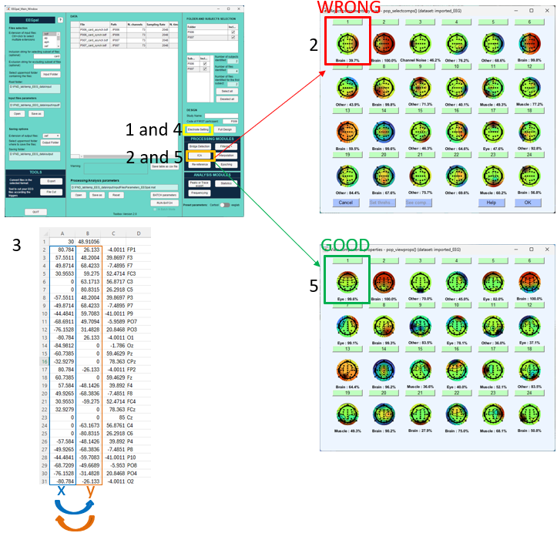
- Load your custom coordinate file in Electrode Setting in the main EEGpal window.
- Perform an ICA decomposition on a participant with several vertical eye blinks and inspect the topography of the compound (see points 1–7 of this manual). Pay special attention to the eye compound from the vertical eye blink. As can be seen in the first components of this example, the frontal positivity associated with the eye blink is shifted by 90°. This is a typical example of a problem with the electrode coordinate file. You can see that the ICALabel proposition is incorrect because it incorrectly attributes the component to the brain instead of the eye.
- In this example, we show the case of a *.xyz electrode coordinate file. Open the file with Excel and invert the position of the first column (position X) and the second column (position y) as shown in the figure. Save your file with .txt with Tab as delimiter. Then rename the file extension to be *.xyz instead of *.txt
- Load this new coordinate file in Electrode Setting in the main EEGpal window.
- Reperform the ICA decomposition on your original file and examine the topography of the components. Pay special attention to the eye compound from the vertical eye blink. As you can see here, the problem has been solved and the ICALabel proposition is correct.

