EEGpal: Statistics module
Version 2.16, 13.09.2026
Video tutorial: https://youtu.be/W8wzVinryh0

The purpose of the Statistics module is to compare statistical differences for each time frame (tf) and each electrode of interest. This is typically carried out when exploring the dataset to identify periods of interest, to study differences in EEG amplitude between conditions (trace analysis), or to perform statistics on the inverse solution map of results (.ris files).
The EEGpal produces outputs similar to those proposed by Cartool in its ‘Statistics on tracks’ option. In addition, it enables ANOVA with multiple factors, which is not possible in Cartool. It also replaces the STEN toolbox created by Jean-François Knebel (https://zenodo.org/records/1164038).
The parametric and ANOVA test required the MATLAB Statistics and Machine Learning Toolbox add-on package to work. It is not required for the non-parametric paired or unpaired T-test because it uses Fieldtrip functions.

Before to start
The use of the Statistics module depends on the Full Design tool of the EEGpal main windows. In order to use the Statistics module, you must first specify the factorial design you wish to study. It will automatically fill the columns Subject, Condition and Factor_level of the Data table on the main screen. Please refer to the Full Design tool manual to understand how it works.
It is also important to note that all EEG file must have the same length, number of electrodes and sampling frequency. This is usually the case after Epoching.

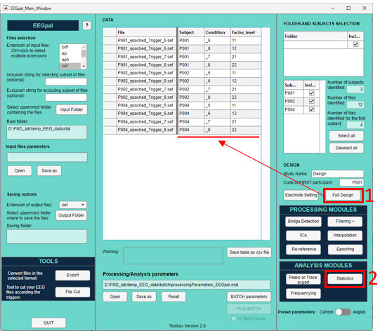

Statistics
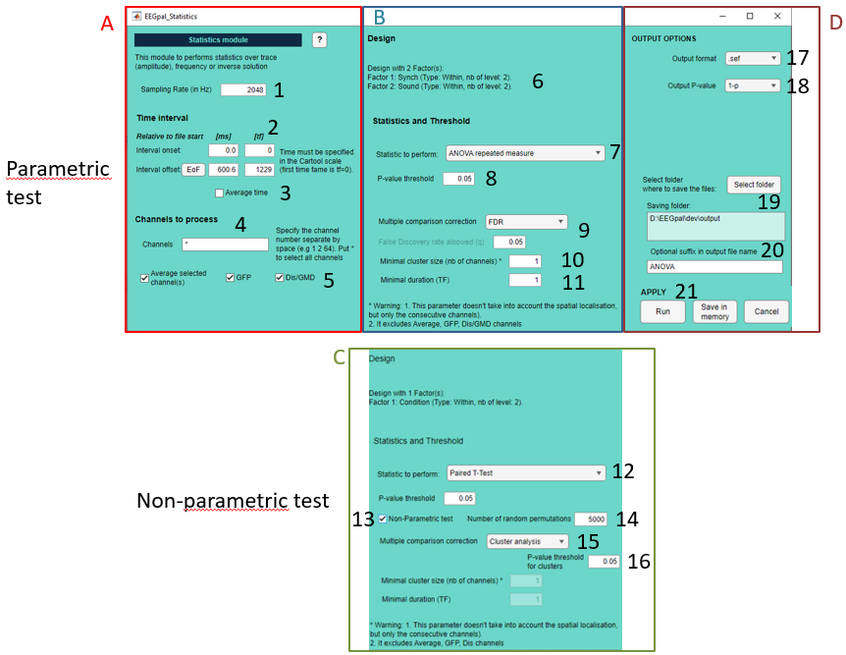
Pannel A (Data):
- Sampling rate of the data. This should normally be transferred automatically from the main window. You can adjust this if necessary.
- Specify the time interval. Warning: the value 0 marks the start of the file. This module does not take into account a possible .mrk file that could define a different origin.
EoF=End of File.
- Instead of looking at each time point individually, you can create an average by selecting this option.
- Specify the electrode to be studied and the indices of the electrodes (1, 2, 64), rather than the names specified by the coordinate file (A1, A2, B32). A ‘*’ means that all the electrodes will be study.
- You can study additional channels with the average of electrodes specified in 4, the global field power (GFP) or the global map dissimilarity (Dis).
Pannel B (Statistical test in parametric mode):
- This section summarizes the factorial design to be studied according to the elements specified in the Full Design tool. In this example we have a 2 within factors with 2 levels each (2x2 factorial design).
- Specify the statistical test which will be performed. This option will depend of the factorial design specified in the Full Design tool:
  - One sample T-Test with one factor and only one condition
  - ANOVA repeated measure or Paired T-Test with one within factor and two conditions
  - ANOVA between or Two Samples T-Test with one between factor and two conditions
  - ANOVA repeated measure with serval within factors
  - ANOVA between with several between factors
  - ANOVA mixed with a factorial design containing at least one within-factor and one between-factor
- Specify the P-value statistical threshold of test significance.
- Correct the statistical threshold specified in 8 for multiple comparison over the number of electrodes (independently of the number of TF, see FAQ for more details). EEGpal allows to use the False Discovery Rate (FDR) correction method proposed in the following paper : Benjamini, Y. & Yekutieli, D. (2001) The control of the false discovery rate in multiple testing under dependency. The Annals of Statistics. 29(4), 1165-1188.
You can specify the False Discovery rate (q) you want to apply. Usually, the value of 0.05 is quite standard. See the FAQ for more detail.
WARNING: Separate corrections are applied to the EEG and supplementary (Avg, GFP and Dis/GMD) channels. For example, if you have an EEG with 64 electrodes and activate the GFP option, EEGpal will first apply a correction to the EEG channels according to the number of electrodes (i.e. a separate correction for each time frame), and then apply a correction to the GFP channels according to the number of time frames.
- In addition to statistical significance, you can apply a criterion based on the minimum number of contiguous significant electrodes (clusters). It is NOT a true ‘cluster analysis’ as described in 14.
WARNING1: This parameter only considers consecutive channels, not spatial localization.
WARNING2: This is not applied to the Averaged, GFP, Dis channels (because they are unique separate channels).
- In addition to statistical significance, you can apply a criterion with a minimum significant period duration (this needs to be specified in the time frame, not in milliseconds).
Pannel C (Statistical test in non-parametric mode):
- The non-parametric test option is available only for
  - Paired T-Test with one within factor and two conditions
  - Two Samples T-Test with one between factor and two conditions
It used the functions of the toolbox Fieldtrip included in function folder of EEGpal. It does not require the Statistics and Machine Learning Toolbox to be used.
The test would be conducted using a two-tailed approach. It means positive results means condition 1 > condition2 and negative results condition2>condition1.
- Choose the number of permutations. It will use the Monte Carlo method.
- In non-parametric mode, you can use cluster analysis to address the issue of multiple comparisons. This is a very popular analysis in the EEG community. You will get as output the significant positive clusters (condtion1>condition2) and negative clusters (condition2>condition1) in separate files. More details can be found in the FAQ section. You can also choose the option of ‘FDR’ correction or ‘None’.
- If you have selected ‘Cluster analysis’ in 14, you can select the statistical threshold for clusters. The P-value threshold in 8, will be used on the uncorrected statistics to form the clusters. See FAQ for more information.
Pannel D (Output options):
- Select the destination folder where the results files will be saved.
- The p-value can be saved in 1-p (e.g. significant value are 0.95-1) or p (e.g. significant value are 0-0.05). The visualization in Cartool is easier in 1-p mode.
- Specify the output directory
- You can specify manually a suffix in the output file name.
- There are three validation buttons:
  - The Run button will carry out the processing parameterized in the module.
  - The Save in memory button will store all the parameters in memory and close the module without performing the processing.
  - The button Cancel closes the module without processing and without keeping the entered parameters in memory. The same effect will be achieved by closing the module window.

FAQ
What the output looks like?
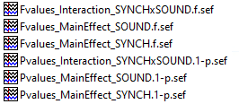
The Statistics module produce two files for each main effect and interaction in the case of a factorial model:
- Pvalues file contains these p-values but only for the SIGNIFICANT test according to the threshold specified in the points 8-11. According the option you have choose in 17, value are 1-p (significant values lie within the 0.95–1 interval) or p (rather than the usual 0–0.05 interval). Option 1-p is the default because it makes the visualization of the results easier in Cartool. However, you can change (for example if you export it in the .csv file).
All zero values indicate that the test was not significant according to the specified criteria.
You can use the Cartool software to visualise the results:
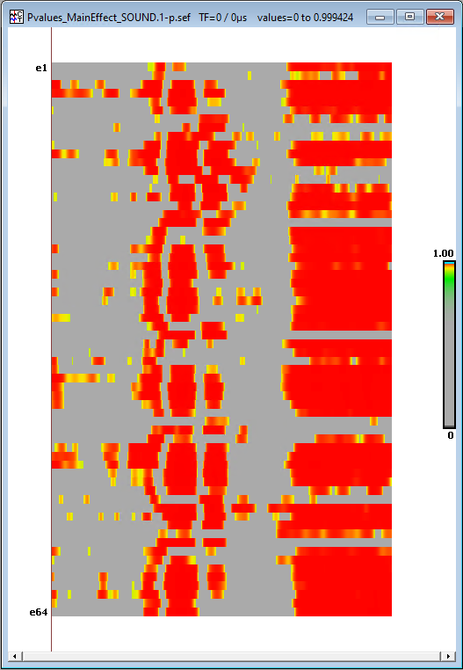 1-p figure Yellow and red are the significant results and grey are the non-significant results.
WARNING: If you have selected an FDR correction for multiple comparisons, the p-values in this file are the original values before correction (and not the q-adjusted values). The correction replaces any p-value with 0 if it does not survive the correction.

- Fvalues or Tvalues files contain the corresponding test values for each TF or channels tested, not just the significant ones. You can also use the Cartool software to visualise them in a colour-coded format by pressing the button 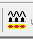 several times:
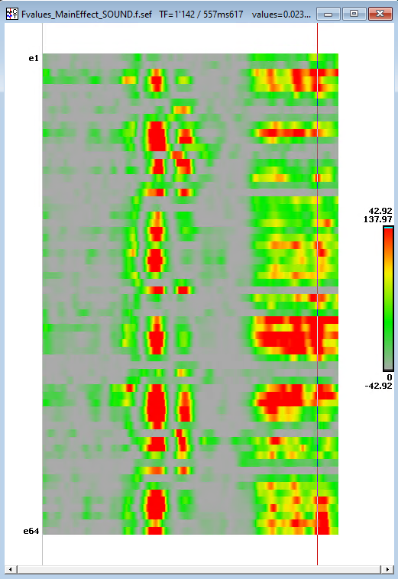

We usually use the le Pvalues file primarily to determine the period and group of electrodes showing a significant difference between the experimental conditions.
In the case of a cluster analysis, the output are different :
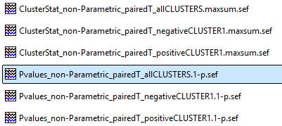
- Pvalues files contains the p-value for the current cluster. This is why the value is the same for all time points belonging to the cluster. All non-significant TF are set to 0. You have one separate file for each cluster positive (condition1>condition2) or negative (condition2>condition1) as well as ‘allCLUSTER’ file with all the significant cluster in the same file.
- Maxsum files contain the statistical value associated with the cluster. As explained below, the MaxSum is the sum of all the uncorrected T-values for TFs belonging to the cluster. Non-significant values are set to 0.
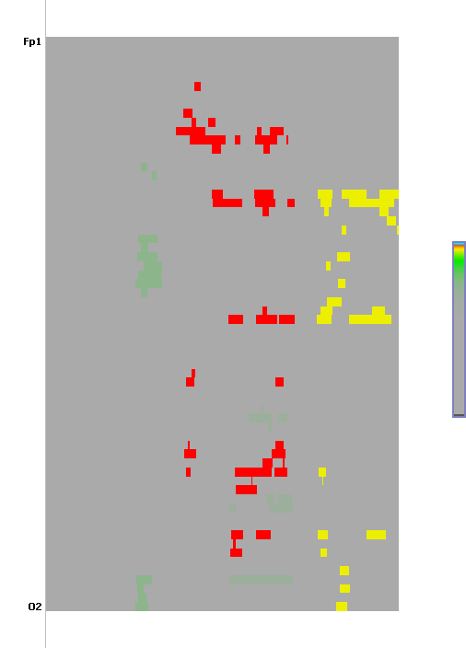
Which Maltab commands are used for statistical testing?
The commands use will depend on the statistical test performed as explained in point 7:
- For One sample T-Test and Paired T-Test, the module uses the function ttest
- For Two Samples T-Test, the module uses the function ttest2
- For ANOVA repeated measure and ANOVA mixed, the module uses fitrm then rmANOVA functions
- For ANOVA between, the module uses the function anovan
All of these functions are part of the MATLAB Statistics and Machine Learning Toolbox add-on package.
In the case of non-parametric statistics, the function ft_timelockstatistics of Fieldtrip are used for paired or unpaired T-test with the following argument:
cfg = [];
cfg.method = 'montecarlo';
cfg.tail = 0;
cfg.statistic = ‘ft_statfun_depsamplesT' or 'indepsamplesT';
For Cluster analysis
cfg.correctm = 'cluster';
cfg.clusterstatistic = 'maxsum';
cfg.clustertail = 0;
cfg.neighbours = neighbours;

Should I apply the false discovery rate (FDR) correction for multiple comparisons, and if so, how is it performed?
Yes, it is a good idea to apply corrections for multiple comparisons, since you are conducting many tests (the number of TFs multiplied by the number of channels), which increases the likelihood of false positives. Therefore, this correction is highly recommended.
To perform this correction, EEGpal use the script fdr_bh of David Groppe (Version 2.3.0.0) download on Matlab central at the following link: https://www.mathworks.com/matlabcentral/fileexchange/27418-fdr_bh
Complete ref:
David Groppe (2025). fdr_bh (https://www.mathworks.com/matlabcentral/fileexchange/27418-fdr_bh), MATLAB Central File Exchange. Retrieved February 16, 2025.
It is important to note that the correction is made over the number of channels and not the number of TF for the EEG. Indeed, the correction is computed separately for each TF. This is the strategy used in Cartool because correcting for the number of all tested point (nb electrode x nb of TF) is too conservative. In addition, the results between TF are not independent between them (value for the a TF is strongly correlated with the next one). It is why we decided to apply the correction separately by TF.
In the case of the additional computed channels (Avg, GFP and GMD), the correction is applied separately to each of them according to the number of time frames.

How cluster analysis is working ?
A cluster-based permutation test evaluates whether clusters of significant EEG activity are unlikely to have occurred by chance.
First, the statistical test is computed at every electrode × time point. Points exceeding the initial statistical threshold (parameter 8) are grouped into spatially and/or temporally adjacent clusters.
For example:
With clusterstatistic = 'maxsum', the cluster statistic is the sum of the test statistics across all points belonging to the cluster:
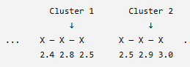
Cz
T-values
S1=2.4 + 2.8 + 2.5 = 7.7
S2= 2.5 + 2.9 + 3 = 8.4
The original data are then randomly permuted according to the experimental design. For each permutation, the statistical test, thresholding, and cluster formation are repeated:
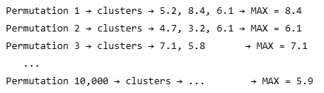
Only the largest cluster statistic from each permutation is retained. These values form the null distribution :
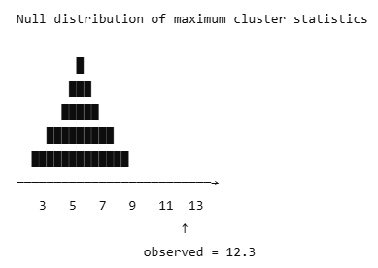
The observed clusters are then compared with this distribution. The permuted clusters do not need to occur at the same electrodes or time points as the observed clusters.
The procedure therefore asks:
What is the largest cluster that could occur by chance anywhere in the EEG data?
A cluster is considered significant when its statistic is sufficiently extreme compared with the distribution of maximum cluster statistics (parameter 15). This provides a correction for multiple comparisons across electrodes and time points while taking advantage of the spatial and temporal structure of EEG data.
An important point to note about the formation of clusters is that FieldTrip uses the location of electrodes to determine which ones are neighbors. It is not only indices as in option 10. It is why you need to specify the electrodes coordinates before to use this test.
Text generated by ChatGPT.

Why are two P-value thresholds (8 and 15) when I perform a cluster analysis?
As explained before, there are two successive tests. First, we perform an uncorrected statistical analysis of every time point and electrode in the dataset. The p-value parameter in 8 is the statistical threshold for this test. Fieldtrip then uses these significant points to create clusters, taking into account time and neighbouring space. The p-value parameter in 15 is the statistical threshold for considering a cluster significant in relation to the null distribution obtained by permuting the data. You can specify different thresholds for these two steps if you wish.

Why is non-parametric tests and cluster analysis only available for paired and unpaired t-tests?
It is a recommendation of the Fieldtrip team (https://www.fieldtriptoolbox.org/faq/stats/clusterstats_teststatistic/). The original function was developed for comparing two conditions. While it is possible to perform multifactorial analysis (F-test ANOVA), it is complex and not recommended. If you want to study a multi-factorial design, the authors recommend computing statistics as t-tests between differences (or in the case of interactions, differences of differences) instead of F-test from an Anova on the full experimental design.

How are the neighbouring electrodes determined for the cluster analysis?
In order to study clusters, Fieldtrip needs to know the neighbouring electrodes for each electrode. To do this, it uses the ft_prepare_neighbours function (https://github.com/fieldtrip/fieldtrip/blob/release/ft_prepare_neighbours.m). There are two main solutions for detecting neighbours:
- ‘distance’: This method defines neighbouring electrodes based on the physical distance between their sensor locations. Two electrodes are considered neighbours when the distance between their 3D positions is smaller than a predefined threshold (neighbourdist). This method therefore requires an appropriate distance threshold to be specified. The resulting neighbourhood structure depends on the spatial distribution of the electrodes and on the selected distance threshold. The default threshold used is 40mm which might be inappropriate according to the spatial montage.
- ’triangulation’: This method defines neighbours using a Delaunay triangulation of the electrode positions. Electrodes connected by the resulting triangles are considered spatial neighbours. This approach derives the neighbourhood structure from the geometry of the electrode montage and does not require the user to specify an absolute distance threshold. The resulting neighbourhood structure can therefore be more directly adapted to the spatial arrangement of the electrodes.
These methods influence the statistical results of spatial clusters and must be consistent across analyses. This is why we have decided to use the 'triangulation' method by default in EEGpal, which does not require the user to define an arbitrary distance threshold. This method produces more universal results for high-density electrode montages.
Text generated by ChatGPT.

