The University of Bristol
Faculty of Science and Engineering
School of Engineering Mathematics and Technology
SEMTM0031: Introduction to Financial Technology (INFT)
Name: Detai Dong Email: mz25325@bristol.ac.uk
Q1：
Q1.1 In this experiment, we evaluate the claim that “ZIP traders generate more profit than ZIC traders in a homogeneous, static, and symmetric CDA market” using the BSE simulator. The parameter configuration of the market is shown in Figure 1.

Q1.2 Figure 1: ZIP vs ZIC profits (95% CI)
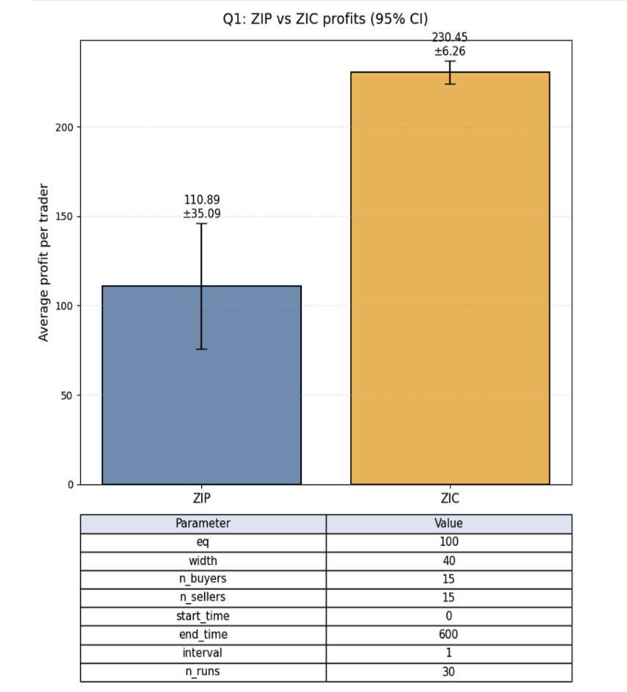
It’s clearly see in Figure 1 that ZIC achieves a much higher average profit than ZIP, and the confidence interval for ZIC is also much narrower. This means ZIC’s performance is not only better on average but also more stable across the 30 simulation runs.

Q1.3 Statistical Analysis
A two-sample t-test is appropriate here because each strategy was run independently under identical market conditions. A two-sample t-test was conducted to compare the per-trader profits between ZIP and ZIC across 30 independent runs.
- ZIP average profit: 110.89
- ZIC average profit: 230.45
- 95% CI shown in the figure
- The difference is statistically significant (p < 0.001)

Conclusion:
In this configuration, ZIC significantly outperforms ZIP, opposite to the usual claim in the lecture. The main reason is that with this market setup (width = 40, interval = 20), ZIP tends to push its bids and asks too aggressively while it’s “learning,” which often leads it to trade at prices that don’t actually give it a good profit.
Meanwhile, ZIC’s simple random pricing surprisingly avoids this problem — it doesn’t overreact or over-adjust, so it ends up catching a few very profitable trades in the wider price range. As a result, ZIC ends up making more money overall in this particular setup.

Q2 Replicating Vernon Smith (1962) Chart 5 Using BSE
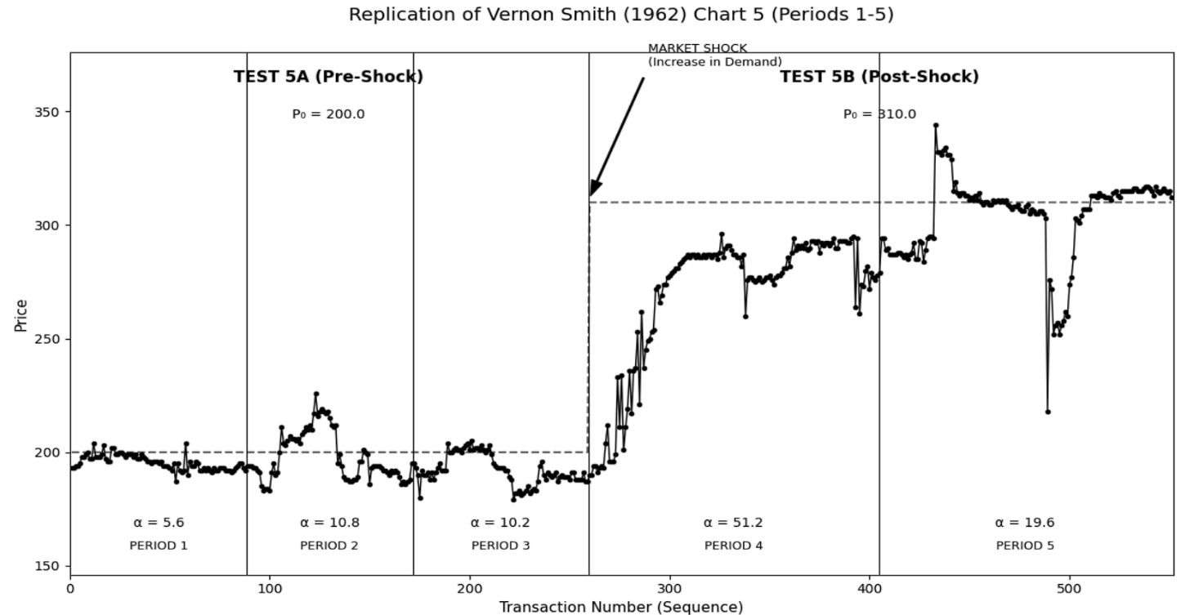
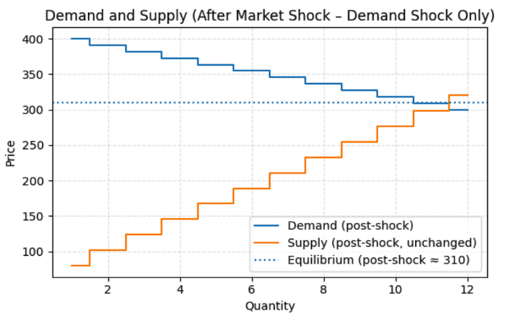
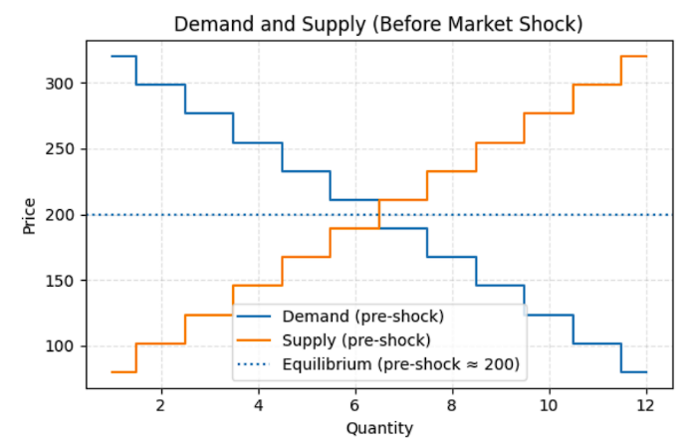
This experiment replicates Vernon Smith’s (1962) multi-period market experiment using the BSE simulator. The market is modeled as a continuous double auction containing heterogeneous traders: equal numbers of ZIP, ZIC, and SHVR agents on both buyer and seller sides. Each period begins with a new assignment of private values drawn from pre-defined symmetric supply and demand schedules.
Market Shock Design： A structural market shock is introduced at mid-simulation by shifting both supply and demand schedules upward, which raises the theoretical equilibrium price. This setup mirrors Smith’s Chart 5 framework, where Test 5A corresponds to pre-shock trading and Test 5B corresponds to post-shock behaviour. Only one representative run is shown as required.
Figure 2 & Figure3: Pre&Post - Shock and Supply and Demand Curves
Trading Results：Figure 4 presents all transaction prices in sequential order, annotated with equilibrium price lines, period boundaries, α-values (period-level convergence measures), and the shock point. Prices converge toward the equilibrium within each period during the pre-shock phase and re-converge quickly to the new equilibrium after the shock. This matches the qualitative patterns of Smith (1962).
Comparison to Smith (1962) ：The heterogeneous algorithmic market reproduces the core features of Smith’s Chart 5: rapid convergence toward equilibrium each period, stability around P₀ during the pre-shock phase, and a sharp but orderly adjustment after the shock. While algorithmic traders exhibit less behavioural dispersion than human subjects, the market-level convergence dynamics remain consistent with Smith’s findings.

Q3 Systematically explore the three parameters of MMM01
  - Introduction and Aim：
The aim of this task is to identify a robust and profitable parameter configuration for the Minimal Market Maker MMM01 in the BSE simulator. MMM01 has three key parameters – n_past_trades, bid_percent, and ask_delta.
I run a systematic parameter search across a grid of possible values, evaluate performance in two different markets, and select the configuration that performs consistently well. After selecting MMM01*, I run independent out-of-sample experiments and conduct hypothesis testing to check whether the expected profit is significantly greater than zero.
Following the CW requirements, I use two distinct market environments:
Synthetic Market ：a stable CDA market with static supply and demand curves.
Nasdaq Offset Market ：a dynamic market where equilibrium prices move according to real Nasdaq 1-minute price data.

Both markets include a set of competing traders (ZIC, ZIP, SHVR, SNPR, PRZI), plus one MMM01 market maker. This allows me to test MMM01 under both simple and more realistic trading conditions.

  - Market Design and Parameter Search
Synthetic Market：The synthetic market uses symmetric linear demand and supply curves around a fixed equilibrium price. Orders arrive through a periodic drip schedule so that trades occur throughout the session. This market is useful for observing MMM01’s behaviour in a clean and predictable environment. Buyers and sellers include several standard trader types, with equal numbers on each side. This creates a competitive environment where MMM01 must respond to a mixture of simple and adaptive strategies.
Nasdaq Offset Market：To introduce more realistic dynamics, I construct an offset function using real Nasdaq minute-level price data. After normalising the price series, the offset is added to both supply and demand curves. This keeps the market microstructure unchanged but produces a moving theoretical equilibrium price.
The trader composition is the same as in the synthetic market. This market mainly tests whether MMM01 can remain profitable when facing real-world price movements and stronger volatility.
I create a multi-dimensional grid of parameter combinations. For each combination, I run multiple IID sessions in each market and record MMM01’s end-of-session profit.
To compare parameter sets, I compute the profit mean and standard deviation in both markets. A simple robustness score favours combinations that achieve:
- positive and reasonably high mean profit in both markets,
- moderate variability across runs.
This approach allows me to identify a configuration that behaves well under different market conditions rather than over-fitting to a single environment.

  - Selection of MMM01*
The parameter search shows that all three parameters affect performance: A larger n_past_trades smooths noise but excessive values reduce responsiveness；Higher bid_percent makes MMM01 more selective when buying, reducing losses from unfavourable asks；A moderate ask_delta balances profit per trade and execution probability. Based on the robustness score, I select:
$$\text{MMM01*}: n_past_trades=8, bid_percent=0.96, ask_delta=12.$$This configuration performs well in both markets, with consistently positive profits and acceptable variance.

  - Hypothesis Testing and Visualisation：
After selecting MMM01*, I run 30 out-of-sample sessions in each market using a new set of random seeds. I then apply a one-sided one-sample t-test:
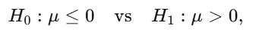
where $μ$is the expected profit of MMM01*.
Results:
- Synthetic Market:
mean ≈ 69.4, std ≈ 36.5, $t(29)≈10.43$, one-sided $p<0.001$.
→ reject $H_{0}$; expected profit is significantly positive.
- Nasdaq Market:
mean ≈ 226.4, std ≈ 80.8, $t(29)≈15.35$, one-sided $p<0.001$.
→ reject $H_{0}$; MMM01* remains strongly profitable even with real-price dynamics.
- To illustrate these results, Figure 5 presents the out-of-sample profit distributions using boxplots. Both boxes lie clearly above zero. The Nasdaq market shows higher profits but also greater variability, while the synthetic market produces lower but more stable returns.
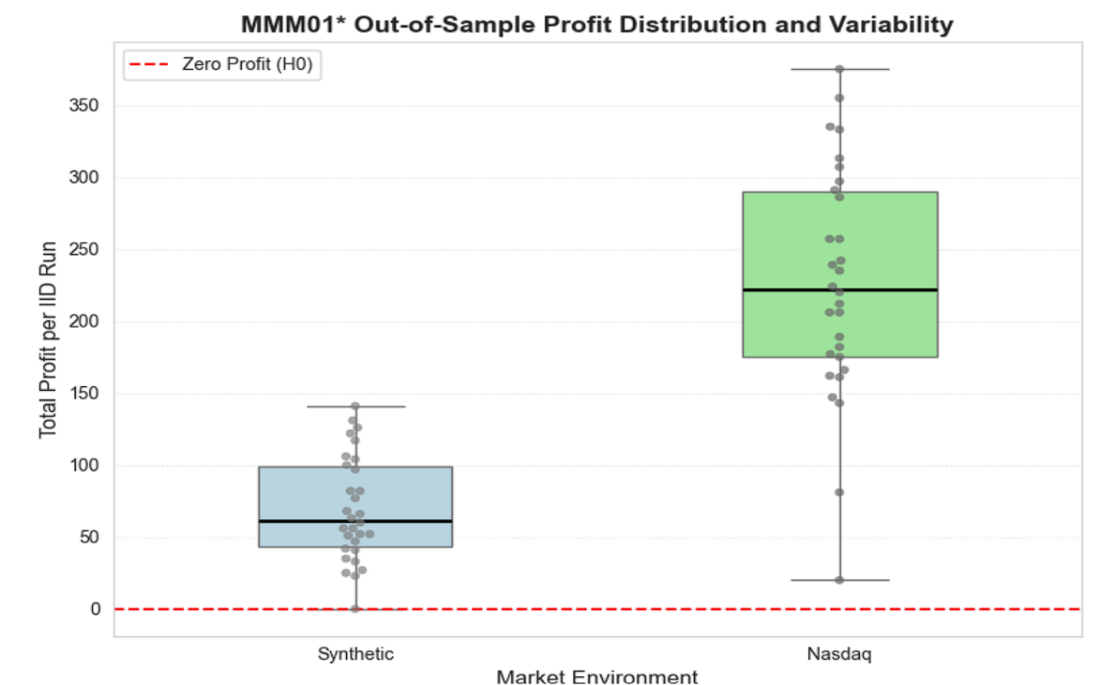
  - Conclusion
Through a structured parameter search in two different market environments, I identify a robust and profitable configuration for MMM01. The selected MMM01* achieves positive profits in both the synthetic and Nasdaq offset markets. Formal hypothesis testing confirms that the expected profit in each market is significantly greater than zero.
Overall, the results indicate that with well-chosen parameters, the Minimal Market Maker can operate as a stable liquidity provider and generate consistent earnings across market conditions. This provides a useful benchmark for the design and improvement of market-making strategies in later tasks.

Q4

Appendix

