DocVid — AI Document-to-Video Platform

Build Documentation

Tools Used

A. Frontend Technologies

1. Next.js 16 (App Router)
Full-stack React framework responsible for user interface rendering, routing, and API handling.

2. TypeScript
Provides type safety across application components, APIs, and state management layers.

3. Tailwind CSS + shadcn/ui
Utility-first styling framework combined with accessible and reusable UI components.

4. Framer Motion
Used for animations, transitions, and slide-in visual effects throughout the application.

5. Recharts
Charting library used for analytics visualisation, including bar charts, line charts, and pie charts.

6. Zustand
Lightweight client-side state management solution used for playback, documents, analytics, and session state.

B. AI and Generation Technologies

1. Google Gemini API (gemini-2.5-flash)
Used for script generation and document-grounded question answering functionality.

2. @google/generative-ai SDK
Official Google SDK used for communication with Gemini services.

3. Web Speech API
Browser-native text-to-speech engine used for narration playback without requiring external services.

4. Canvas API
Used to render animated presentation slides at 60 FPS.

5. MediaRecorder API
Captures canvas output and exports generated videos in .webm format.

C. Document Parsing Technologies

1. mammoth
Extracts raw text content from .docx and .doc files.

2. pdf-parse
Extracts text from PDF documents.

3. officeparser
Extracts text from PowerPoint .pptx and .ppt files.

D. Storage and Persistence

1. localStorage
Stores document history locally in the browser for up to 20 entries across sessions.

2. In-Memory Server Store
Stores analytics events temporarily during runtime. Data resets when the server restarts. A production deployment would replace this implementation with a persistent database.

Key Prompts

A. Script Generation Prompt
The Script Generation Prompt is sent to Gemini after a document upload is completed.
The model is instructed to behave as an expert professor preparing a comprehensive educational video lecture. The full document text, up to 30,000 characters, is provided as context.
The prompt instructs Gemini to:

1. Identify Important Content
- Detect all important topics, concepts, facts, arguments, and figures within the document.

2. Organise Educational Sections
- Divide the content into 4–12 logical teaching sections.

3. Generate Narration Scripts
- Produce a 150–250 word explanation for each section.
- Focus on explaining:
  - What the concept is
  - Why it matters
  - How it works

4. Select Appropriate Visual Layouts
The model selects the most suitable slide format for each section, including:
- Hero layout
- Bullet layout
- Step-by-step layout
- Two-column layout
- Statistics layout

5. Generate Slide Points
- Produce 3–5 concise slide points for each section.
- Each point includes:
  - A short bold heading
  - A supporting explanation grounded in the document content

6. Output Structure
- Return all generated content as structured JSON.
- If malformed JSON is returned, the system falls back to raw section content.

B. Question & Answer (Q&A) Prompt
The Q&A prompt injects the entire document text into Gemini’s system instruction before every user question.
The model is instructed to:

1. Restrict Responses to the Uploaded Document
- Answer only using the uploaded document content.
- Refuse unsupported or unrelated questions.

2. Explain Content Educationally
- Respond in a teacher-like manner using clear explanations.

3. Include Supporting Facts
- Reference factual details, numbers, and examples from the document.

4. Return Citations
Responses include:
- Inline citation markers such as [1] [2]
- A structured CITATIONS array containing:
  - Section index
  - Section title
  - Supporting quote excerpt

C. Prompt Iterations and Improvements

1. Initial Narration Limitation
The first implementation generated narration scripts between 60–90 words.
This caused several issues:
- Narration felt too brief
- Output resembled summaries rather than explanations
- Educational depth was insufficient
The system was improved by:
- Increasing narration length to 150–250 words
- Framing Gemini explicitly as a professor
- Adding instructional phrasing such as:
  - “What this means is…”
  - “The key thing to understand here is…”

2. Context Window Improvement
The first implementation generated each section independently.
This resulted in:
- Weak transitions between sections
- Shallow explanations
- Poor understanding of relationships across topics
The architecture was updated so the entire document is sent in a single prompt. This allows Gemini to understand broader context and generate more coherent educational flows.

Workflow and Architecture
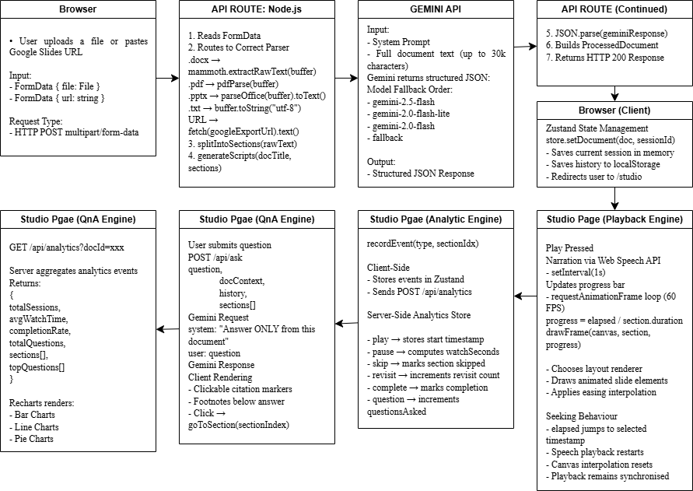

Data Sources and Accepted Document Formats
The platform does not use external data sources. All generated content originates exclusively from the uploaded document.

A. Accepted Formats
Format | Parser
PDF (.pdf) | pdf-parse
Word (.docx, .doc) | mammoth
PowerPoint (.pptx, .ppt) | officeparser
Plain Text (.txt) | UTF-8 direct read
Google Slides (Public URL) | Google Slides export endpoint

B. Section Processing Pipeline
After parsing, all document types pass through the same section-splitting pipeline.
The section splitter performs the following operations:

1. Heading Detection
Detects headings using:
- Capitalisation patterns
- Formatting structures
- Heading length analysis

2. Content Grouping
Groups paragraphs and text blocks under detected headings.

3. Section Merging
Sections shorter than 150 characters are merged into neighbouring sections to avoid shallow presentation scenes.

Separation of Extracted Facts, Generated Narration, and AI Answers
The system separates different content types into independent fields within the DocumentSection data model.

1. Extracted Facts
Stored in: section.content
- Raw text extracted directly from the source document
- No AI modification
- Represents the original document content exactly as parsed

2. Generated Narration
Stored in: section.script
- AI-generated explanation written by Gemini
- Based on section.content
- Intended to teach and explain the material
- May paraphrase the original text

3. Slide Points
Stored in: section.slidePoints
- AI-generated visual bullet points
- Designed for slide presentation
- Includes concise headings and factual summaries

4. AI Answers
Generated dynamically through the Q&A system.
Characteristics:
- Generated on-demand
- Uses only document text as context
- Does not use Gemini general knowledge
- Refuses unsupported questions outside the uploaded material

How Grounding Works for the Assistant
Grounding is implemented using prompt injection rather than Retrieval-Augmented Generation (RAG).
The full document text is inserted directly into Gemini’s system instruction before every Q&A request.
The instruction explicitly states that the model must:
- Answer only from the uploaded content
- Avoid unsupported assumptions
- Provide citations tied to document sections

A. Citation System
Each answer includes:
- Inline citation markers ([1] [2])
- Supporting verbatim quotes
- Section references linked to video timestamps
Users can click citations to jump directly to the referenced section in the generated video.

B. Limitations
This grounding approach has several limitations:
- Gemini may paraphrase instead of quoting exactly
- Subtle inaccuracies may still occur
- No exact fact verification is performed
- No embedding search or semantic retrieval is used
The system depends on Gemini following the grounding instructions correctly.

Analytics Events and Tracking
Analytics events are recorded client-side using Zustand and immediately sent to /api/analytics through POST requests.
The server stores analytics in an in-memory event log.

A. Event Definitions
Event | Trigger
play | User presses play or auto-advance begins
pause | User pauses playback
skip | User manually changes section
section_complete | Narration finishes
question_asked | User submits a Q&A request
revisit | User returns to a completed section
seek | Internal watch-time tracking event

B. Watch Time Calculation
When playback begins:
- The server records the start timestamp
When playback stops through:
- Pause
- Skip
- Section completion
The server calculates:
watchSeconds = stopTimestamp - startTimestamp
The result is stored per session and per section.

C. Dashboard Metrics
The analytics dashboard displays:
- Total sessions
- Average watch time
- Completion rate per section
- Questions asked per section
- Skipped sections
- Revisit counts

Limitations, Hallucination Risks, Privacy Risks, and Review Requirements

A. Hallucination Risks
Potential AI-related risks include:
- Narration scripts may slightly misrepresent source material
- Q&A responses may become inaccurate if the document itself is ambiguous
- Gemini may infer context not explicitly written
All generated educational content should be reviewed before official or high-stakes use.

B. Privacy Risks
Document content is transmitted to Google Gemini API servers for processing.
Users should not upload:
- Personal data
- Medical records
- Legal documents
- Confidential business information
- GDPR/HIPAA-regulated content
Additional privacy characteristics:
- Documents are not permanently stored server-side
- Browser history is stored locally using localStorage
- Uploaded content does not leave the client except during active AI processing

C. Technical Limitations

1. Google Slides Restrictions
Google Slides imports require the presentation to be publicly accessible.

2. Section Detection Limitations
Heavily formatted documents may reduce heading detection accuracy.

3. Voice Quality Variability
Web Speech API voice quality differs across browsers and operating systems. Google Chrome provides the best experience.

4. Analytics Persistence
Analytics reset when the server restarts because storage is in-memory.

5. Gemini Context Window
Maximum document size sent to Gemini is 30,000 characters. Longer documents are truncated before generation.

D. Review Requirements
Before distribution or deployment:
- Narration scripts should be reviewed for factual correctness
- Q&A citations should be spot-checked against the original document
- Analytics data should be interpreted carefully because sessions are not persisted if users close the browser abruptly

