Versions:

Date | Version | Author | Comment
20.01.2023 | 2 | Deac Melinda-Anca | Updated with the final use cases!

System requirements for “Cafeteria Meal Planner”

1 Introduction 2
2 General view of actors and use cases 2
3 Detailed description of actors and use cases 2
3.1 Actors 2
3.1.1 SimpleUser 2
3.1.2 CafeteriaUser 3
Type: ……….. 3
3.1.3 Provider 3
3.2 Use cases 3
3.2.1 Use Case Diagram for SimpleUser 3
3.2.2 Use Case Diagram for CafeteriaUser 3
4 Glossary – used terms 5

Introduction

The “Cafeteria Meal Planner” is an application dedicated to cafeteria places and to people who enjoy or are forced by the environment or by their lifestyle to eat at these places. A common unhappy event that takes place much too often is food waste. This affects not only the economy, but the environment also. And the objective of my application is to make it possible for people to be able to choose the cafeteria they want to eat at today, at best tomorrow, select the foods they find most appealing and so, let the cafeteria chef know how much food to make.
It will also be possible to leave reviews for the cafeterias and also, damaging users can be reported and eventually removed and banned from the application.
The cafeterias will have to present the list of meals they can prepare and the ingredients in each meal. They could also group the meals into courses and allow people to only select the course, not the component meals.
This way meal prepping for cafeterias will be a little bit easier, cheaper and maybe more environmentally friendly.
There will be an encrypted database for all types of users (not decided on how to do this yet, but I have ongoing research on this matter).
The app will group the cafeterias on Romanian cities, for starters.
Users will choose the city and receive a list of cafeterias that are part of the system.
Each cafeteria will have the menu for the next day showed. From the menu, the user can choose the most appealing meals/courses.
After making their choice, users can press the send button and the cafeteria will receive a short notice.
Another feature, for a frequent user, is to have favorite cafeterias, for which they can choose to receive a mail containing the tomorrow’s menu options.
When creating the system requirements file, I will be more precise about the specifications and the use-cases. But for a large picture, this description should be enough. I am available for solving any misunderstandings!
Formal Requirements Specification
- Users are of two types: Simple and Cafeteria
- A simple user can:
- Create an account
- Subscribe to cafeterias in order to receive a mail whenever the cafeteria posts something
- Select the meals they want to have at the cafeteria they plan to go to the next day
- Submit the meals selection. After submitting, another submission will not be available until the next day
- Add cafeteria to favorites, so the favorite cafeterias will appear at the top
- Delete cafeteria from favorites
- A cafeteria can:
- Create an account
- Publish menu options in order for customers to be available to select
- Add client to black list if the cafeteria considers it necessary
- See distribution of selections
- Update the menu table in the database
- Create a menu for the next day:
- Select standalone menu items
- Create a course containing more menu items
- Publish final menu for customers to analyze

General view of actors and use cases

Actor | Type | Description
Simple User | Human | A user which is not a cafeteria who is in search of a place to eat at.
Cafeteria User | Cafeteria (Managed by a human) | Updates its daily menu and prices.

Detailed description of actors and use cases

Actors

Simple User

Type: human
Detailed description:
This is the actor that the application is meant to help in choosing a place to eat. It has the possibility to choose its favorite cafeteria by means of the application. It has access to the visualization of the cafeteria menus and to its own profile.

Where is used:
This actor is used in the: “Create an account” use case
. “Change profile picture“ use case.
“User log-out” use case.
“User log-in” use case
“Send desired menu” use case
“Subscribe to cafeteria” use case
“Cancel subscription” use case

Cafeteria User

Type: cafeteria (managed by a human)
Detailed description:
This is the actor which represents a cafeteria. It is responsible with updating its daily menu and options. It receives the preferred dishes of the customers.
Where is used:
This actor is used in the: “Create an account” use case
“Change profile picture” use case
“User log-in” use case
“User log-out” use case
“See preferred dishes” use case
“Update menu items” use case
“Publish menu” use case

Use cases

Use Case Diagram for Simple User
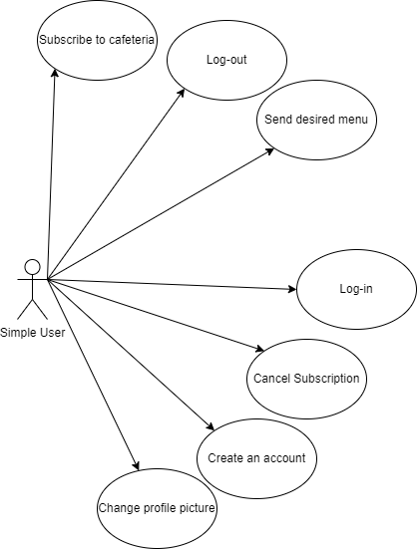
Description: Subscribe to cafeteria
Actor: Simple User
Precondition: user must be logged in and in View Cafeterias area
Postcondition: in the subscription list of the user, there will be one more cafeteria
Behavior: the user clicks on the little star from the corner of the cafeteria’s box and the subscription is done.

Description: Log out
Actor: Simple User
Precondition: user must be logged in
Postcondition: user is no longer logged in
Behavior: the user clicks on “Log out” button from the sidebar

Description: Send desired menu
Actor: Simple User
Precondition: user must be logged in and in View Tomorrow’s Options area
Postcondition: user’s choice has been sent and he cannot send another
Behavior: the user can scroll through cafeterias, choose the favorite one, select the menu items he desires and send them to the cafeteria

Description: Log in
Actor: Simple User
Precondition: user must be logged out
Postcondition: user is logged in
Behavior: the user enters the log in credentials and then clicks on “Log in” button

Description: Cancel subscription
Actor: Simple User
Precondition: user must be logged in and in View Cafeterias area and be subscribed to the cafeteria
Postcondition: user is no longer subscribed to the cafeteria
Behavior: the user clicks on the yellow star from the top right corner of the cafeteria’s box

Description: Create an account
Actor: Simple User
Precondition: there must not be an account with the desired username
Postcondition: user has an account in which he can enter if he writes the credentials in the log in window
Behavior: the user enters the necessary fields in the Register window and clicks on register, then then, if all fields are correct, the account is created.

Description: Change profile picture
Actor: Simple User
Precondition: user must be logged in
Postcondition: user’s profile picture is no longer the one before
Behavior: the user clicks on “Change profile picture” button from the sidebar and uploads a new picture

Use Case Diagram for Cafeteria User
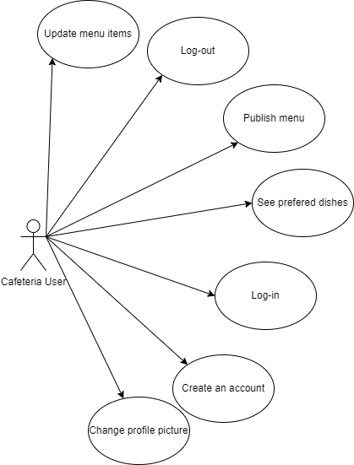

Description: Update menu items
Actor: Cafeteria User
Precondition: user must be logged in and in “Menu Items” area
Postcondition: the menu items database contains the changes applied by the user
Behavior: user clicks on “Add” button and completes the fields for adding a menu item or on “Edit” button after selecting a menu item and edits its fields or on “Delete” button after selecting the menu item to delete it

Description: Log out
Actor: Cafeteria User
Precondition: user must be logged in
Postcondition: user is no longer logged in
Behavior: the user clicks on “Log out” button from the sidebar

Description: Publish menu
Actor: Cafeteria User
Precondition: user must be logged in and in “Tomorrow’s Options” area
Postcondition: the options for tomorrow will be visible for the simple users
Behavior: user selects the menu items he is willing to prepare for tomorrow and publishes them by pressing “Publish” button

Description: See preferred dishes
Actor: Cafeteria User
Precondition: user must be logged in and in “Today’s Menu” area
Postcondition: -
Behavior: user can analyze the selections for the menu options in the chart area, either as a piechart or as a barchart

Description: Log in
Actor: Cafeteria User
Precondition: user must be logged out
Postcondition: user is logged in
Behavior: the user enters the log in credentials and then clicks on “Log in” button

Description: Create an account
Actor: Cafeteria User
Precondition: there must not be an account with the desired username
Postcondition: user has an account in which he can enter if he writes the credentials in the log in window
Behavior: the user enters the necessary fields in the Register window and clicks on register, then then, if all fields are correct, the account is created.

Description: Change profile picture
Actor: Cafeteria User
Precondition: user must be logged in
Postcondition: user’s profile picture is no longer the one before
Behavior: the user clicks on “Change profile picture” button from the sidebar and uploads a new picture

Glossary – used terms
Term | Use cases | Description
Cafeteria User | Cafeteria user use cases | Represents the account for a cafeteria, which can publish menus.
Profile Picture | Update profile picture | Optional picture representing the aspect of a person(in case of a simple user) or the building from outside(in case of a cafeteria).
Subscription | Subscribe, Cancel Subscription | Receive an email when the options for tomorrow from the subscribed cafeteria are posted.
Password | Log in, Register | Represents a secret set of characters that secure the user’s account.
Username | Log in, Register | Represents the set username of the user which is unique in the whole group of users.

Terms with related meanings and/or that are used in similar contexts can be grouped by term groups as depicted in the following table.

Term Groups | Included terms and term groups | Description
Log in | password, username, | Defines a general group of credentials used in the authentication process
Register | Username, email, password, | Defines a general group of credentials used in the registration process

