Tab 1
Name : Meghana Shivaprasad
Class : LY AIA 5 (Batch B)
Roll Number : 2223537

Assignment No. 1

Aim :
Introduction to Keras and Tensorflow (Optional – Pytorch). Configure and use google colab and kaggle GPU

Objectives :
1. To configure anaconda and google colab, kaggle environment
2. To Explore TF/Keras/Pytorch libraries
3. To learn to use GPU/TPU
4. To learn and understand Git

Theory :
Keras Configuration
1. Setup Environment
2. pip install keras
3. to check whether it has installed properly: python>>import keras
Python>> print keras.__version__
Tensorflow Configuration:
1. pip install tensorflow==2.2.0
2. To verify installation: python>> import tensorflow as tf
If no error then the installation has been completed
Colaboratory Configuration
1. Setup the environment
2. Connect to the Drive
3. Upload the files using: from google.colab import files
files.upload()
Kaggle Configuration:
1. Create a Kaggle Account
2. Create an Authorization token
3. Upload on Colab using the upload code
4. Make a folder and make the Json file executable
5. Get the dataset
6. Copy the API command and run on colab
GitHub Configuration
1. pip install git
2. Set up user profile by: global user.name “name”
Global user.email “mail”

Algorithm :
- Start
- Load Dataset
  - Import the dataset from a .csv or other file format.
- Preprocess the Data
  - Handle missing values (if any).
  - Encode categorical variables (e.g., convert "Yes"/"No" to 1/0).
  - Normalize or scale numeric features (optional but recommended).
- Split Dataset
  - Divide the dataset into training and testing sets (e.g., 80% train, 20% test).
- Build the Model
  - Choose a suitable model (e.g., neural network, decision tree, etc.).
  - Define input and output layers based on features and target variable.
- Compile the Model
  - Choose optimizer (e.g., Adam), loss function (e.g., binary crossentropy), and evaluation metric (e.g., accuracy).
- Train the Model
  - Fit the model using the training data.
  - Use validation data and/or early stopping to prevent overfitting.
- Evaluate the Model
  - Test the model on unseen data (test set).
  - Record metrics such as accuracy, precision, recall, or F1-score.
- Optimize the Model (Optional)
  - Tune hyperparameters (e.g., number of nodes, layers, epochs).
  - Check for overfitting/underfitting.
- Make Predictions
- Use the trained model to predict placements for new/unseen data.
- End

Dataset Attributes :
1. IQ
2. Prev_Sem_Result
3. CGPA
4. Academic_Performance
5. Internship_Experience
6. BMI
7. Extra_Curricular_Score
8. Communication_Skills
9. Projects_Completed
10. Placement (Outcome)

Code :

# Mount Google Drive
from google.colab import drive
drive.mount('/content/drive')

# Copy kaggle.json to correct location
!mkdir -p ~/.config/kaggle
!cp /content/drive/MyDrive/kaggle/kaggle.json ~/.config/kaggle/

# Set correct permissions
!chmod 600 ~/.config/kaggle/kaggle.json

#download dataset
!kaggle datasets list
!kaggle datasets download sahilislam007/college-student-placement-factors-dataset
!mkdir student_database

!unzip college-student-placement-factors-dataset.zip -d student_database

#import all libraries
import pandas as pd
import numpy as np
import tensorflow as tf
from tensorflow import keras
from keras import models, layers
from sklearn.preprocessing import StandardScaler
from sklearn.model_selection import train_test_split

data = pd.read_csv("student_database/college_student_placement_dataset.csv")
data.head(10)

# Show all columns with datatype 'object' (usually strings)
string_columns = data.select_dtypes(include='object').columns
print("Columns with string data:")
print(string_columns)

#replace with binary outputs
data['Placement'] = data['Placement'].map({'Yes':1, 'No':0})
data['Internship_Experience'] = data['Internship_Experience'].map({'Yes':1, 'No':0})
data.head(10)

#split the data
x = data.iloc[:,1:9]
y = data['Placement']

#standardized all numerical data of input features
obj = StandardScaler()
x_ = obj.fit_transform(x)

Xtrain, Xtest, Ytrain, Ytest = train_test_split(x_, y, test_size=0.1)

Results :

WITH 4 DENSE LAYERS

Training :
trainingModel = models.Sequential()
trainingModel.add(layers.Dense(75, activation='relu'))
trainingModel.add(layers.Dense(25, activation='relu'))
trainingModel.add(layers.Dense(8, activation='relu'))
trainingModel.add(layers.Dense(1, activation='sigmoid'))

trainingModel.compile(optimizer='adam', loss='binary_crossentropy', metrics=['accuracy'])

historychart1 = trainingModel.fit(Xtrain, Ytrain, epochs=50, validation_data=(Xtest, Ytest))

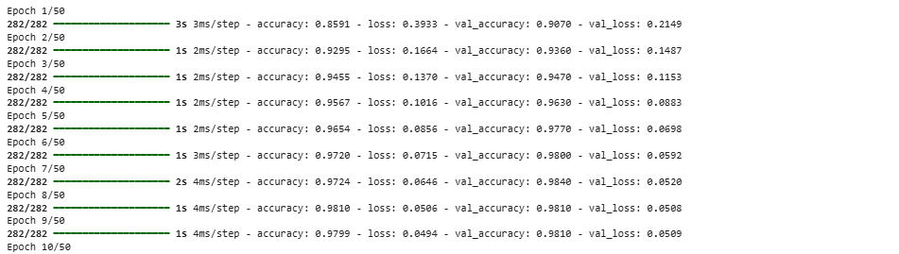
.
.
.
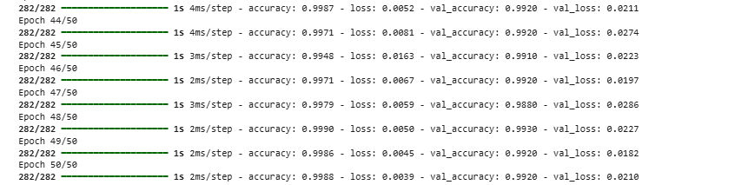

Evaluation :
result1 = trainingModel.evaluate(Xtest, Ytest)
print("Test Loss:", result1[0])
print("Test Accuracy:", result1[1])
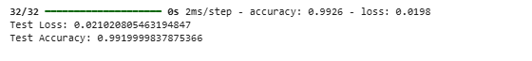

Loss function :
import matplotlib.pyplot as plt
plt.plot(historychart1.history['accuracy'])
plt.plot(historychart1.history['val_accuracy'])
plt.title('Model Accuracy')
plt.ylabel('Accuracy')
plt.xlabel('Epoch')
plt.legend(['Train', 'Validation'], loc='lower right')
plt.show()
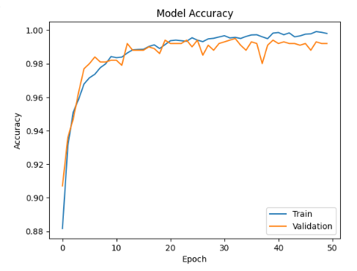

Accuracy :
plt.plot(historychart1.history['loss'])
plt.plot(historychart1.history['val_loss'])
plt.title('Model Loss')
plt.ylabel('Loss')
plt.xlabel('Epoch')
plt.legend(['Train', 'Validation'], loc='upper right')
plt.show()
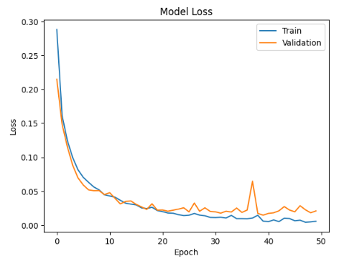

WITH 6 DENSE LAYERS AD LESSER NUMBER OF NODES

Training :
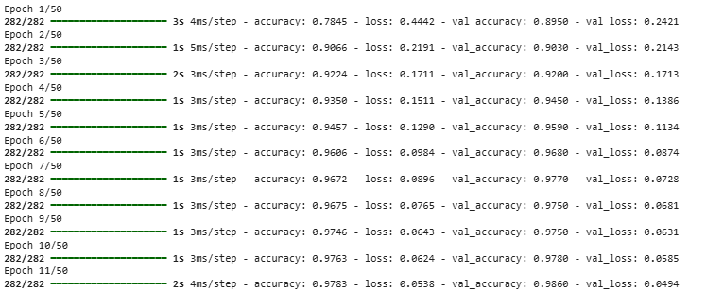
.
.
.
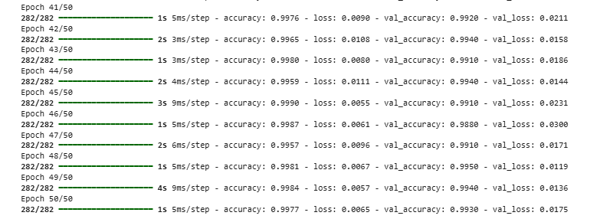

Evaluation :
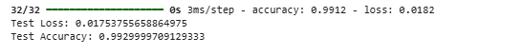

Loss function :
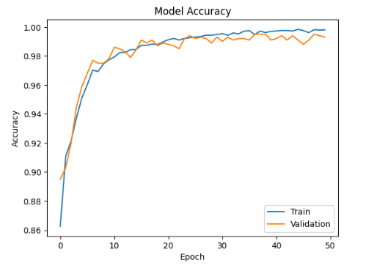

Accuracy :
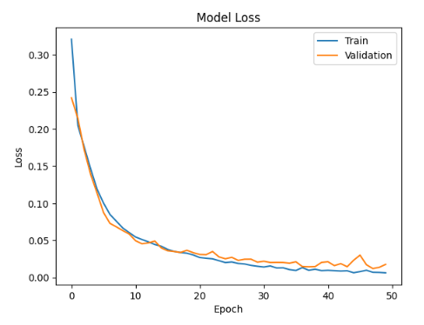

WITH 7 DENSE LAYERS

Training :
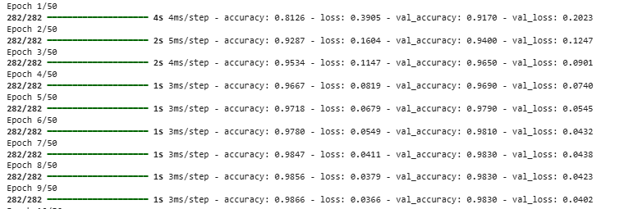
.
.
.
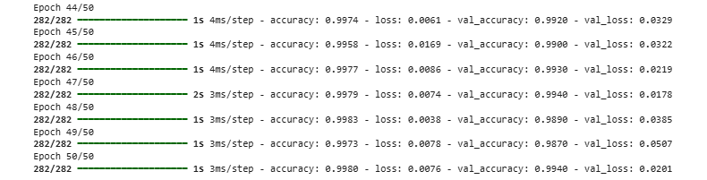

Evaluation :
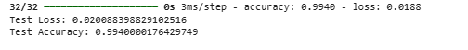

Loss function :
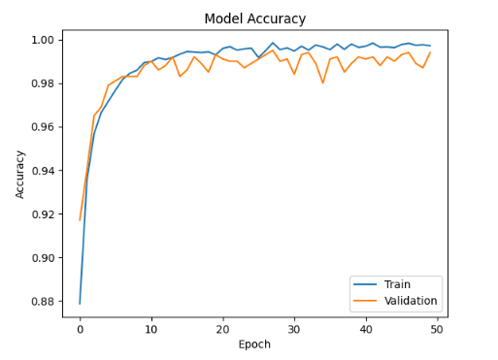

Accuracy :
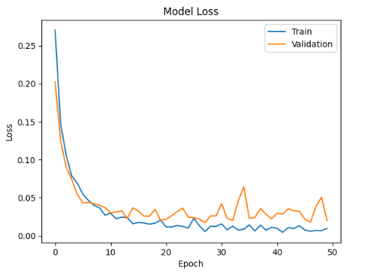

Conclusion :
Thus we have understood the configuration steps of Google Colab, tensorflow, etc and learned to use tensorflow and create a model to predict the chance of diabetes or not.

