Tab 1
Name : Meghana Shivaprasad
Class : LY AIA 5 (Batch B)
Roll Number : 2223537

Assignment No. 2

Aim :
Develop multi class classifier using deep multilayer perceptron (Keras/tensorflow/pytorch) for MNIST hand recognition dataset and CIFAR10. Fine the parameters for better accuracy.
- Develop an application with GUI to upload input to the system.
- Test the model

Objectives :
1. Learn Deep Neural Network modeling
2. Learn to develop and deploy models

Theory :

Standardisation
This is one of the most used types of scalar in data preprocessing . This is known as z-score . This re-distributes the data in such a way that mean (μ) = 0 and standard deviation (σ) =1 . Here is the below formula for calculation
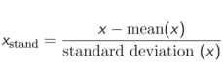

Normalization:
Normalization scales the feature between 0.0 & 1.0, retaining their proportional range to each other.
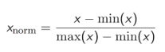
The range of normal distribution is [-1,1] with mean =0.

Data Splitting
Train Test Split is one of the important steps in Machine Learning. It is very important because your model needs to be evaluated before it has been deployed. And that evaluation needs to be done on unseen data because when it is deployed, all incoming data is unseen.
The main idea behind the train test split is to convert original data set into 2 parts
• train
• test
where train consists of training data and training labels and test consists of testing data and testing labels.
The easiest way to do it is by using scikit-learn, which has a built-in function train_test_split

Data Cleaning
Data cleaning is the process of preparing data for analysis by removing or modifying data that is incorrect, incomplete, irrelevant, duplicated, or improperly formatted.
This data is usually not necessary or helpful when it comes to analyzing data because it may hinder the process or provide inaccurate results. There are several methods for cleaning data depending on how it is stored along with the answers being sought.
Data cleaning is not simply about erasing information to make space for new data, but rather finding a way to maximize a data set’s accuracy without necessarily deleting information.
For one, data cleaning includes more actions than removing data, such as fixing spelling and syntax errors, standardizing data sets, and correcting mistakes such as empty fields, missing codes, and identifying duplicate data points. Data cleaning is considered a foundational element of the data science basics, as it plays an important role in the analytical process and uncovering reliable answers.

Algorithm :
- Import Required Libraries
  - Load Streamlit, TensorFlow, NumPy, PIL, etc.
- Load Pretrained Model
  - Use load_model('model.h5') to load the trained MNIST model.
- Define Image Preprocessing & Prediction Function
  - Resize image to 28x28.
  - Convert to grayscale.
  - Normalize pixel values.
  - Reshape to match model input: (1, 28, 28, 1).
  - Use model to predict the digit.
- Streamlit UI Components
  - Show a title and description.
  - Create a file uploader that accepts .jpg images.
- Handle Uploaded Image
  - If an image is uploaded:
    - Display a small thumbnail using st.image(width=150) or inside st.expander.
    - Call the prediction function.
    - Display the predicted digit using st.success().
- Handle Errors Gracefully
  - Wrap prediction logic in a try-except block.
  - Display an error message if anything goes wrong.

Code for MNIST :

import pandas as pd
import numpy as np
import tensorflow as tf
from tensorflow.keras import models,datasets,layers
import matplotlib.pyplot as plt
import matplotlib.image as mp

(train_images, train_labels),(test_images, test_labels) = datasets.mnist.load_data()
train_images = train_images/255
test_images = test_images/255

trainingModel = models.Sequential()
trainingModel.add(layers.Flatten(input_shape=(28, 28, 1)))
trainingModel.add(layers.Dense(32, activation="relu"))
trainingModel.add(layers.Dense(16, activation="relu"))
trainingModel.add(layers.Dense(10, activation="softmax"))

trainingModel.compile(optimizer='adam', loss='sparse_categorical_crossentropy', metrics=['accuracy'])

trainingModel.fit(train_images, train_labels, epochs=10, validation_data=(test_images, test_labels))

result1 = trainingModel.evaluate(test_images, test_labels)
print("Test Loss:", result1[0])
print("Test Accuracy:", result1[1])

{GUI PART}

#!/usr/bin/env python
# coding: utf-8

from PIL import Image
import streamlit as st
import tensorflow as tf
import numpy as np
from tensorflow.keras.models import load_model

# Load the trained model once
model = load_model('model.h5')

# Function to preprocess and predict
def predict_image(img):
# Convert to grayscale (MNIST is grayscale)
img = img.convert('L') # 'L' mode = 8-bit pixels, black and white

# Resize to 28x28 (same as MNIST input size)
img = img.resize((28, 28))

# Convert to NumPy array and normalize
img_array = np.array(img).astype(np.float32) / 255.0

# Reshape to match model input: (1, 28, 28, 1)
img_array = img_array.reshape(1, 28, 28, 1)

# Predict
prediction = model.predict(img_array)
predicted_class = np.argmax(prediction, axis=1)[0]

return predicted_class

# Streamlit UI
st.title("MNIST Digit Classifier")
st.write("Upload an image of a handwritten digit (will be converted to 28x28 grayscale).")

uploaded_file = st.file_uploader("Choose an Image...", type=["jpg", "jpeg", "png"])

if uploaded_file is not None:
try:
image = Image.open(uploaded_file)
st.image(image, caption='Uploaded Image', use_column_width=150)

st.write("Classifying...")
label = predict_image(image)
st.success(f"The digit is predicted to be: **{label}**")
except Exception as e:
st.error(f"Something went wrong: {e}")

Results for MNIST :

[ MNIST Training ]
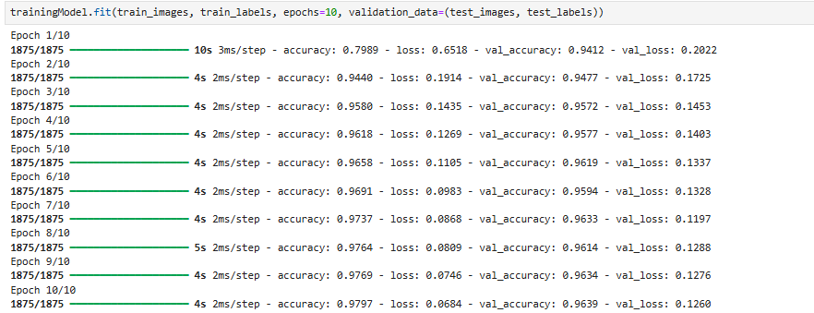

[ MNIST GUI]
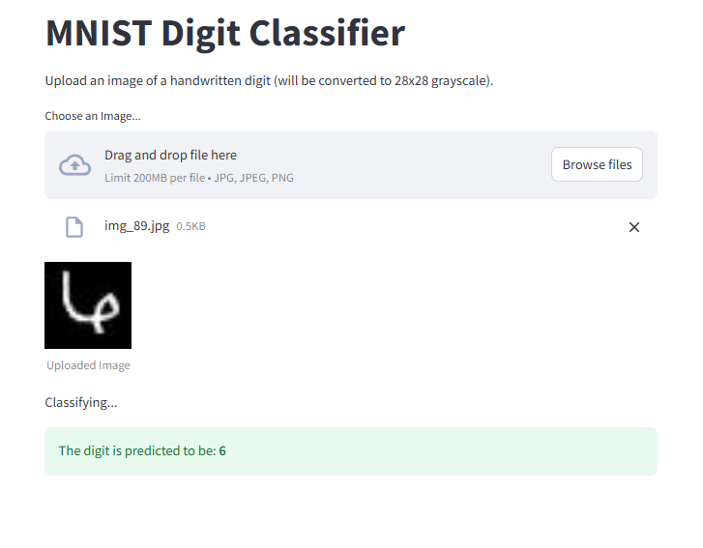

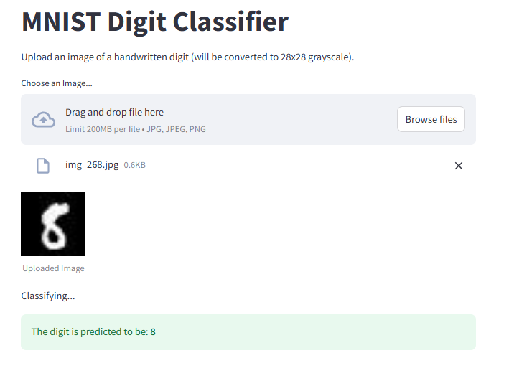

Code for CIFAR 10 :
import pandas as pd
import numpy as np
import tensorflow as tf
from tensorflow.keras import models,layers,datasets

(train_images, train_labels),(test_images,test_labels)=datasets.cifar10.load_data()
train_images=train_images/255
test_images=test_images/255

model=models.Sequential()
model.add(layers.Flatten(input_shape=(32, 32, 3)))
model.add(layers.Dense(512,activation="relu"))
model.add(layers.Dense(256,activation="relu"))
model.add(layers.Dense(128,activation="relu"))
model.add(layers.Dense(64,activation="relu"))
model.add(layers.Dense(32,activation="relu"))
model.add(layers.Dense(16,activation="relu"))
model.add(layers.Dense(10,activation="softmax"))

model.compile(optimizer="adam",loss="sparse_categorical_crossentropy",metrics=
["accuracy"])

result1=model.fit(train_images,train_labels,epochs=10,validation_data=(test_images,test_labels))

result2 = model.evaluate(test_images, test_labels)
print("Test Loss:", result2[0])
print("Test Accuracy:", result2[1])

model.save("cifar_model.h5")

Results for CIFAR 10 :

[ CIFAR 10 Training ]
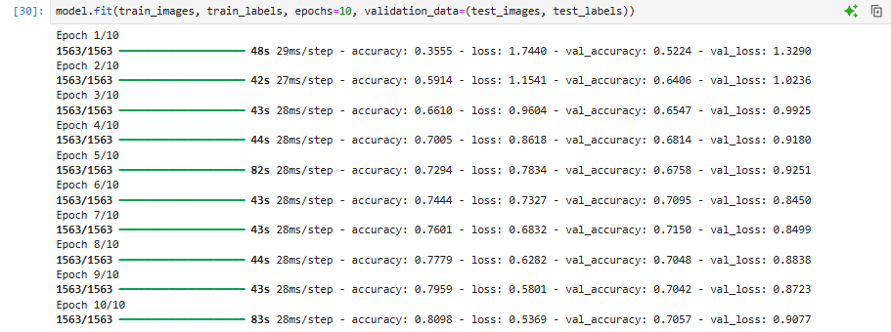

[ CIFAR 10 GUI ]

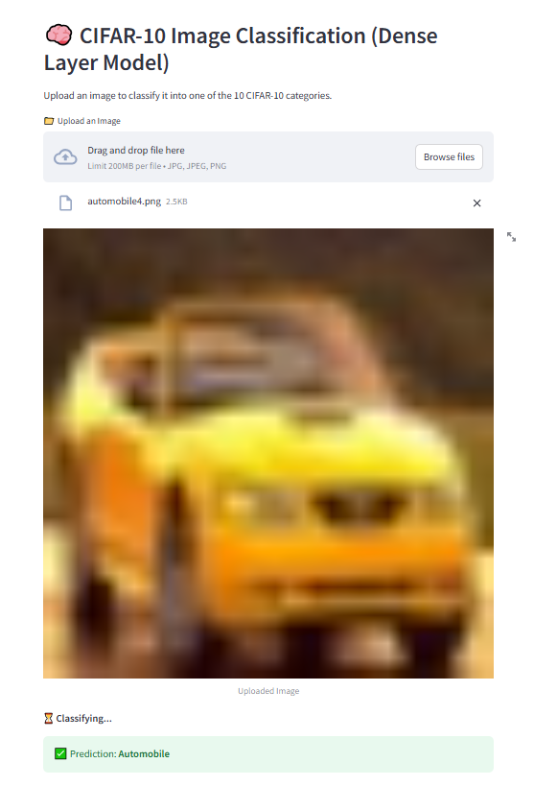
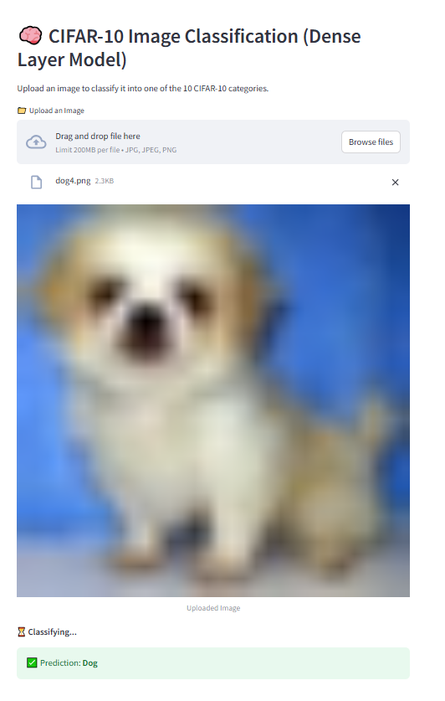

Conclusion :
Thus, we have understood the syntax and basic model creation in TensorFlow for 2 different tasks. We have also learned how to create a GUI using services to do so.

