Tab 1
Name : Meghana Shivaprasad
Class : LY AIA 5 (Batch B)
Roll Number : 2223537

Assignment No. 3.1

Aim :

Develop classification model for cat-dogs dataset using CNN model. Analyze the model accuracy and generate classification report.
- Develop an application and test the user given inputs.
- Analyze the result with and without regularization/dropout

Objectives :
- To learn about classification
- To learn CNN
- To demonstrate and analyse the results

Theory :
A convolutional neural network (CNN, or ConvNet) is a class of deep neural networks, most commonly applied to analysing visual imagery. They are also known as shift invariant or space invariant artificial neural networks (SIANN), based on their shared-weights architecture and translation invariance characteristics. They have applications in image and video recognition, recommender systems, image classification, medical image analysis, natural language processing, brain-computer interfaces, and financial time series.
CNNs are regularized versions of multilayer perceptron. Multilayer perceptron usually mean fully connected networks, that is, each neuron in one layer is connected to all neurons in the next layer. The "fully-connectedness" of these networks makes them prone to overfitting data. Typical ways of regularization include adding some form of magnitude measurement of weights to the loss function. CNNs take a different approach towards regularization: they take advantage of the hierarchical pattern in data and assemble more complex patterns using smaller and simpler patterns. Therefore, on the scale of connectedness and complexity, CNNs are on the lower extreme.
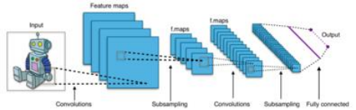

Mathematics -
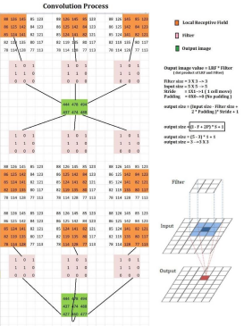
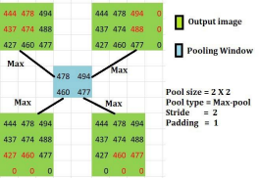

Batch Normalization -
Batch normalization is a technique for training very deep neural networks that standardizes the inputs to a layer for each mini-batch. This has the effect of stabilizing the learning process and dramatically reducing the number of training epochs required to train deep networks.

Regularisation -
This technique discourages learning a more complex or flexible model, so as to avoid the risk of
overfitting. A simple relation for linear regression looks like this. Here Y represents the learned relation and β represents the coefficient estimates for different variables or predictors(X).
Y ≈ β0 + β1X1 + β2X2 + …+ βpXp
The fitting procedure involves a loss function, known as residual sum of squares or RSS. The coefficients are chosen, such that they minimize this loss function.
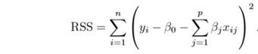Now, this will adjust the coefficients based on your training data. If there is noise in the training data, then the estimated coefficients won’t generalize well to the future data. This is where regularization comes in and shrinks or regularizes these learned estimates towards zero.

Padding -
Padding is a term relevant to convolutional neural networks as it refers to the amount of pixels added to an image when it is being processed by the kernel of a CNN. For example, if the padding in a CNN is set to zero, then every pixel value that is added will be of value zero.
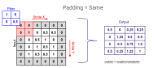

Strides -
Stride is the number of pixels shifts over the input matrix. When the stride is 1 then we move the filters to 1 pixel at a time. When the stride is 2 then we move the filters to 2 pixels at a time and so on. The below figure shows convolution would work with a stride of 2.
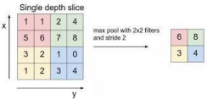

Algorithm -
- Import Libraries
  - TensorFlow, Keras, NumPy, Matplotlib, etc.
- Load and Clean Dataset
  - Extract images from .zip.
  - Remove or skip corrupted images.
  - Organize into Cat/ and Dog/ folders.
- Create Datasets
  - Use flow_from_directory() to load training and validation sets.
  - Resize images and normalize pixel values.
- Build CNN Model
  - Use Sequential() with Conv2D, MaxPooling2D, Flatten, Dense.
  - Use sigmoid activation for binary output.
- Compile the Model
  - Optimizer: Adam
  - Loss: binary_crossentropy
  - Metric: accuracy
- Train the Model
  - Use .fit() with training and validation data.
  - Train for multiple epochs.
- Evaluate and Save
  - Use .evaluate() or metrics to assess performance.
  - Save the model using model.save('model.h5').
- Deploy
  - Load the model in tkinter or streamlit GUI.
  - Let the user select an image.
  - Preprocess, predict, and display the label.

Code (with 10 epochs, no regularization and no dropout rate) :
import pandas as pd
import numpy as np
import tensorflow as tf
from tensorflow import keras
from keras import models, layers, regularizers
from sklearn.preprocessing import StandardScaler
from sklearn.model_selection import train_test_split
from tensorflow.keras.preprocessing.image import ImageDataGenerator
from tensorflow.keras.preprocessing import image_dataset_from_directory
from sklearn.metrics import classification_report, confusion_matrix
import zipfile
import os

# Replace this with your actual .zip file name
zip_path = 'cnd_dataset.zip'

# Optional: create a folder to extract into
extract_to = 'cnd_dataase'
os.makedirs(extract_to, exist_ok=True)

# Extract the ZIP file
with zipfile.ZipFile(zip_path, 'r') as zip_ref:
zip_ref.extractall(extract_to)

print(f"Extracted all files to '{extract_to}'")
from tensorflow.keras.preprocessing import image_dataset_from_directory
from tensorflow.keras.preprocessing.image import ImageDataGenerator

datagen = ImageDataGenerator(
rescale=1. / 255,
validation_split=0.2
)

train_ds = datagen.flow_from_directory(
'cnd_dataase/PetImages',
subset="training",
seed=123,
target_size=(128, 128),
batch_size=32,
class_mode='binary'
)

val_ds = datagen.flow_from_directory(
'cnd_dataase/PetImages',
subset="validation",
seed=123,
target_size=(128, 128),
batch_size=32,
class_mode='binary'
)

def create_model(dropout_rate=0.0, regularization=None):
model = keras.Sequential([

layers.Conv2D(32, (3, 3), activation='relu', input_shape=(128, 128, 3)),
layers.MaxPooling2D((2, 2)),

layers.Conv2D(64, (3, 3), activation='relu'),
layers.MaxPooling2D((2, 2)),

layers.Conv2D(128, (3, 3), activation='relu'),
layers.MaxPooling2D((2, 2)),

layers.Flatten(),
layers.Dense(128, activation='relu',kernel_regularizer=regularization),
layers.Dropout(dropout_rate),
layers.Dense(1, activation='sigmoid') # binary classification
])
model.compile(
optimizer='adam',
loss='binary_crossentropy',
metrics=['accuracy']
)
return model
model1 = create_model(dropout_rate=0.0, regularization=None)
history1 = model1.fit(train_ds, validation_data=val_ds, epochs=10)

Results on Model WITHOUT dropout/regularization :

[ Training ]
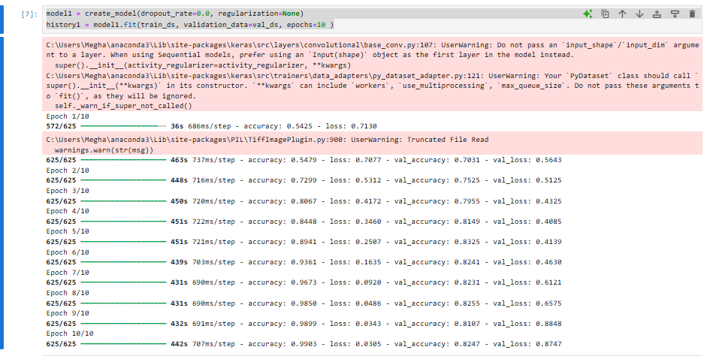

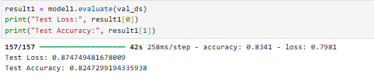
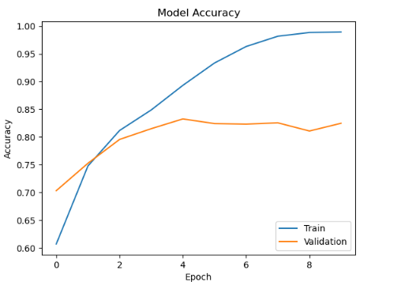
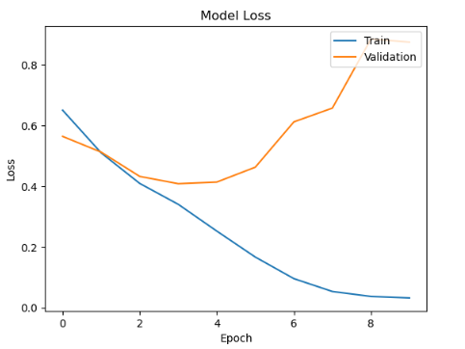

[ GUI ]

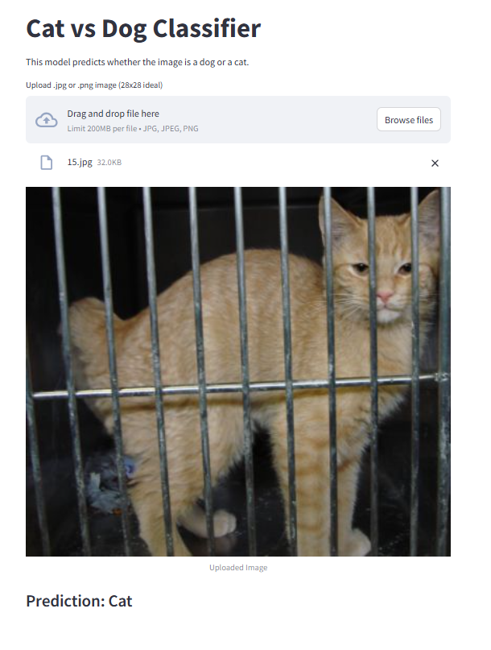
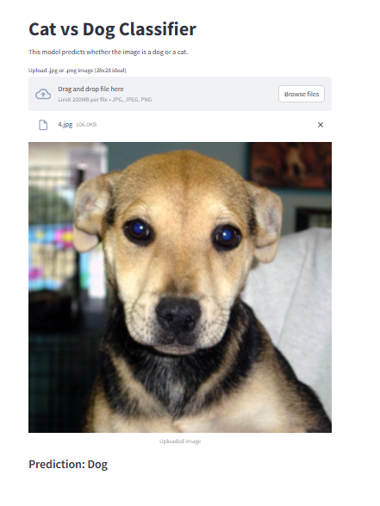
( But sometimes predicts dog as cat )

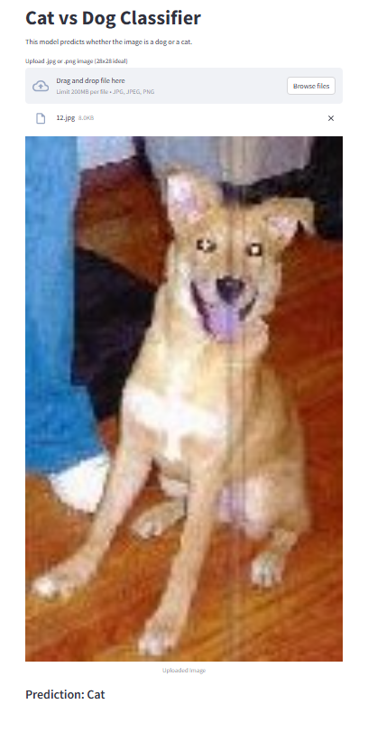

Results on Model WITH dropout = 0.5, regularization = 12(0.01) and 6 layers :

[ Training ]
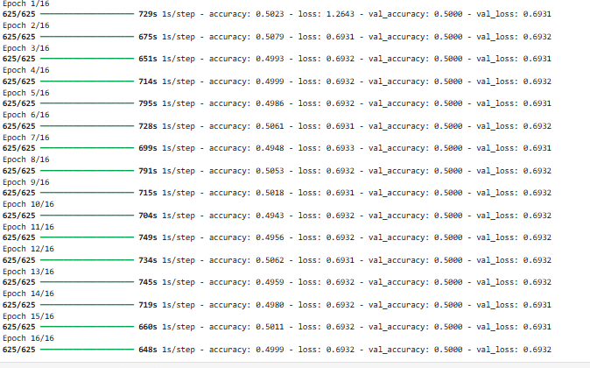
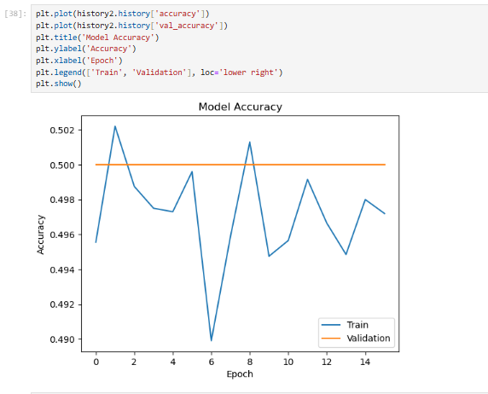
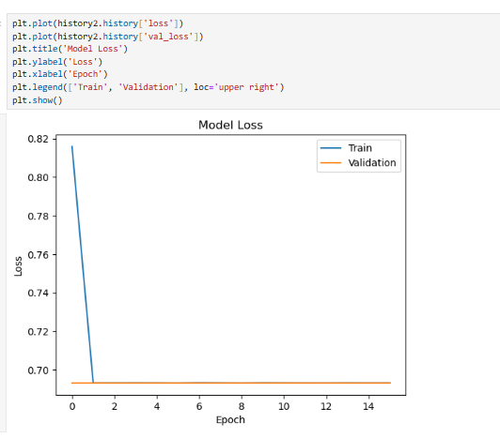

Results on Model WITH dropout = 0.2, regularization = 12(0.0001), 6 layers and batch normalization + early stopping :

[ Training ]
Code -

def create_deep_model(dropout_rate, regularization):
reg = regularizers.l2(regularization)

model = models.Sequential([

layers.Conv2D(32, (3, 3), activation='relu', padding='same', kernel_regularizer=reg, input_shape=(128, 128, 3)),
layers.BatchNormalization(),
layers.MaxPooling2D((2, 2)),

layers.Conv2D(64, (3, 3), activation='relu', padding='same', kernel_regularizer=reg),
layers.BatchNormalization(),
layers.MaxPooling2D((2, 2)),

layers.Conv2D(128, (3, 3), activation='relu', padding='same', kernel_regularizer=reg),
layers.BatchNormalization(),
layers.MaxPooling2D((2, 2)),

layers.Conv2D(256, (3, 3), activation='relu', padding='same', kernel_regularizer=reg),
layers.BatchNormalization(),
layers.MaxPooling2D((2, 2)),

layers.Flatten(),
layers.Dense(256, activation='relu', kernel_regularizer=reg),
layers.Dropout(dropout_rate),
layers.Dense(1, activation='sigmoid')
])

model.compile(optimizer='adam',
loss='binary_crossentropy',
metrics=['accuracy'])
return model
from tensorflow.keras.callbacks import EarlyStopping, ModelCheckpoint

callbacks = [
EarlyStopping(patience=4, restore_best_weights=True),
ModelCheckpoint("model_best.h5", save_best_only=True)
]
from tensorflow.keras.regularizers import l2
model3 = create_deep_model(0.2, 0.0001)
history3 = model2.fit(train_ds, validation_data=val_ds, epochs=20, callbacks=callbacks)

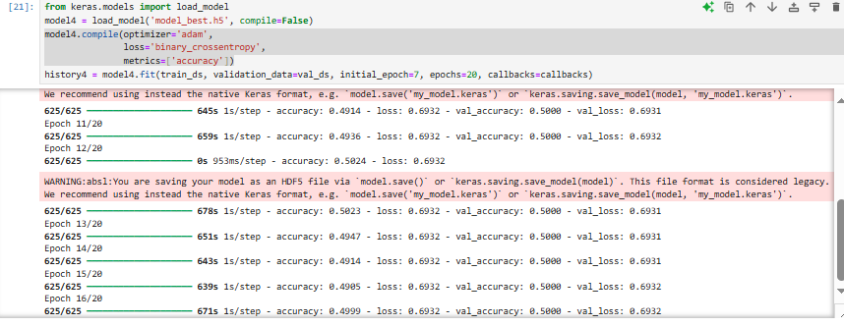
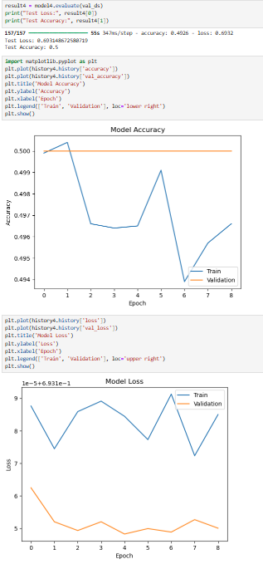

FINAL Results on Model WITH dropout = 0.2, regularization = 12( 1e-4 ) only in last layer and 6 layers :

[ Training ]

def create_deep_model(dropout_rate, regularization):
reg = regularizers.l2(regularization)

model = models.Sequential([

layers.Conv2D(32, (3, 3), activation='relu', padding='same', input_shape=(128, 128, 3)),
layers.BatchNormalization(),
layers.MaxPooling2D((2, 2)),

layers.Conv2D(64, (3, 3), activation='relu', padding='same'),
layers.BatchNormalization(),
layers.MaxPooling2D((2, 2)),

layers.Conv2D(128, (3, 3), activation='relu', padding='same'),
layers.BatchNormalization(),
layers.MaxPooling2D((2, 2)),

layers.Conv2D(256, (3, 3), activation='relu', padding='same'),
layers.BatchNormalization(),
layers.MaxPooling2D((2, 2)),

layers.Flatten(),
layers.Dense(256, activation='relu', kernel_regularizer=reg),
layers.Dropout(dropout_rate),

layers.Dense(1, activation='sigmoid')
])

model.compile(optimizer='adam',
loss='binary_crossentropy',
metrics=['accuracy'])
return model
from tensorflow.keras.callbacks import EarlyStopping, ModelCheckpoint

callbacks = [
EarlyStopping(patience=4, restore_best_weights=True, monitor='val_loss'),
ModelCheckpoint("model_best.h5", save_best_only=True)
]
from tensorflow.keras.regularizers import l2
model5.compile(optimizer='adam',
loss='binary_crossentropy',
metrics=['accuracy'])
model5 = create_deep_model(0.2, 1e-4)
history5 = model5.fit(train_ds, validation_data=val_ds, epochs=15, callbacks=callbacks)

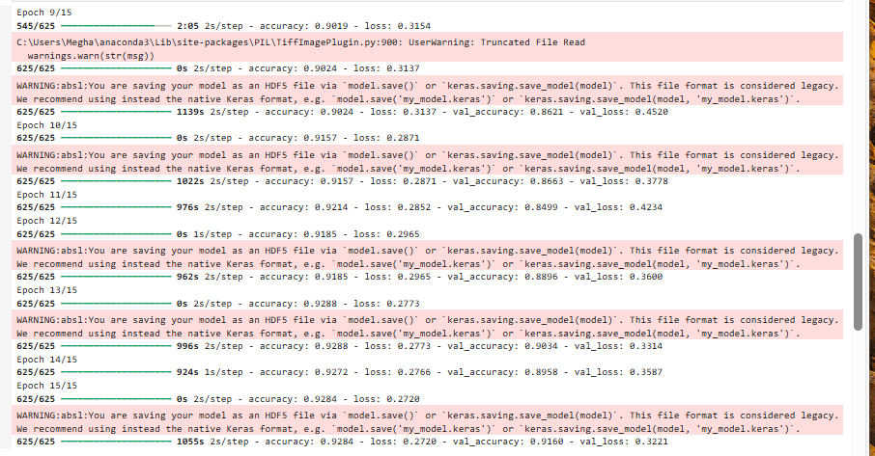
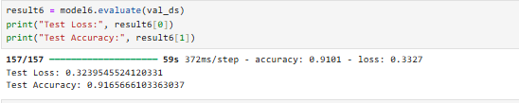
Finally showing good accuracy and loss results
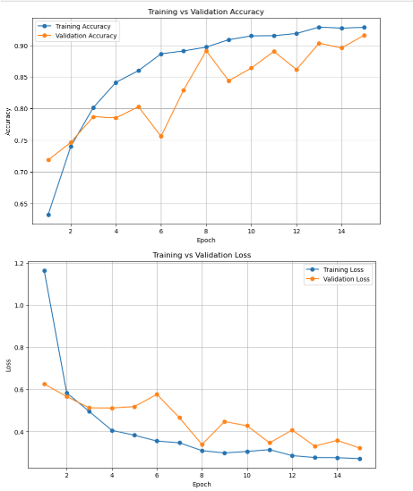

[ GUI ]
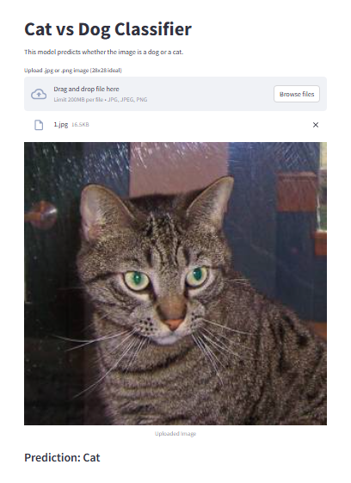
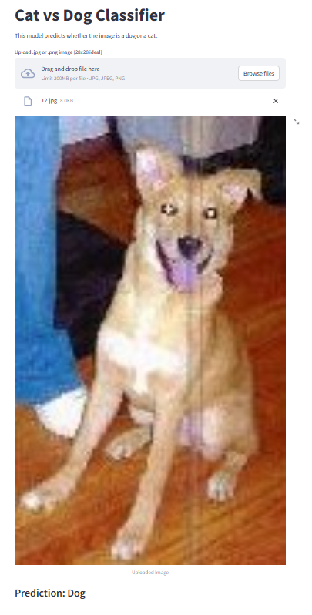
Previously classified as “Cat” is now classified as “Dog”.

Conclusion :
Thus, we have understood how and where CNN is used and how it is programmed in TensorFlow. We have also been able to polish GUI creation skills even further.

