Tab 1
Name : Meghana Shivaprasad
Class : LY AIA 5 (Batch B)
Roll Number : 2223537

Assignment No. 4

Aim :
Develop a face recognition system using CNN. Create a dataset of minimum 20 students from your class. Check and validate the accuracy of the model. Apply dimensionality reduction on input image and plot the change in accuracy of the system.

Objectives :
1. To learn Data set creation
2. To learn data normalization

Theory :

1. Dataset creation steps
1. Articulate the problem early.
2. Establish data collection mechanisms.
3. Format data to make it consistent.
4. Reduce data.
5. Complete data cleaning.
6. Decompose data.
7. Rescale data.
8. Discretize data.

2. Image Augmentation
Image data augmentation is a technique that can be used to artificially expand the size of a training dataset by creating modified versions of images in the dataset. Image data augmentation is used to expand the training dataset in order to improve the performance and ability of the model to generalize.
The intent is to expand the training dataset with new, plausible examples. This means, variations of the training set image that are likely to be seen by the model. For example, a horizontal flip of a picture of a cat may make sense, because the photo could have been taken from the left or right. A vertical flip of the photo of a cat does not make sense and would probably not be appropriate given that the model is very unlikely to see a photo of an upside-down cat.
Libraries for image augmentation
There are a lot of image augmentations packages
● skimage
● Opencv
● imgaug
● Albumentations Augmentor
● Keras(ImageDataGenerator class)

3. Concept of Fit_generator, validate_generator, predict_generator
fit_generator
fit_generator(
generator, steps_per_epoch=None, epochs=1, verbose=1, callbacks=None, validation_data=None, validation_steps=None, validation_freq=1, class_weight=None, max_queue_size=10, workers=1, use_multiprocessing=False, shuffle=True, initial_epoch=0
)
predict_generator
predict_generator(
generator, steps=None, callbacks=None, max_queue_size=10, workers=1, use_multiprocessing=False, verbose=0
)
evaluate_generator
evaluate_generator(
generator, steps=None, callbacks=None, max_queue_size=10, workers=1, use_multiprocessing=False, verbose=0
)
Evaluates the model on a data generator.
Fits the model on data yielded batch-by-batch by a Python generator.
Generates predictions for the input samples from a data generator.
Dataset Organisation- Get atleast face image dataset of 5 students and if you can manage for 10 students that will be good. Make a dataset using google teachable machine. 150-200 images per person
Organize the dataset as below:
dataset/
student_1/
img1.jpg
img2.jpg
...
student_2/
img1.jpg
img2.jpg

Algorithm :

Input:
- Face image dataset (organized by person)
- Parameters: image size, model architecture, PCA components

Output:
- Trained CNN model
- Trained PCA + ANN model
- Accuracy comparison (graphs & values)

Pseudocode
Input: dataset_dir, IMG_SIZE
Output: CNN model, PCA+ANN model, accuracy plots

1. Load dataset
For each image in dataset_dir:
Read -> Resize -> Normalize -> Assign label
Split into train/validation

2. CNN:
Define CNN architecture
Compile + Train CNN
Save training history

3. PCA+ANN:
Flatten train/val images
Apply PCA
Train ANN on reduced features
Predict labels
Compute accuracy

4. Compare:
Extract CNN final acc
Extract PCA+ANN acc
Plot CNN acc vs epochs
Plot CNN vs PCA+ANN acc (bar)

5. Face Detection:
Capture/Load test image
Detect faces with HaarCascade
Preprocess face
Predict with CNN / PCA+ANN
Display predicted label

Code for CNN:
import os
import numpy as np
from tensorflow.keras import layers, models
from sklearn.decomposition import PCA
from sklearn.neural_network import MLPClassifier
from sklearn.metrics import classification_report, accuracy_score
print(os.getcwd())
print(os.listdir("dataset"))

# USING CNN Model
import tensorflow as tf

data_dir = "dataset"

train_ds = tf.keras.utils.image_dataset_from_directory(
data_dir,
validation_split=0.2,
subset="training",
seed=123,
image_size=(128,128),
batch_size=32
)
val_ds = tf.keras.utils.image_dataset_from_directory(
data_dir,
validation_split=0.2,
subset="validation",
seed=123,
image_size=(128,128),
batch_size=32
)

class_names = train_ds.class_names
print("Classes:", class_names)
print("Train batches:", len(train_ds))
print("Validation batches:", len(val_ds))

model = tf.keras.Sequential(
[
tf.keras.layers.Rescaling(1./255, input_shape=(128,128,3)),

tf.keras.layers.Conv2D(32, (3,3), activation="relu"),
tf.keras.layers.MaxPooling2D(),

tf.keras.layers.Conv2D(64, (3,3), activation="relu"),
tf.keras.layers.MaxPooling2D(),

tf.keras.layers.Conv2D(128, (3,3), activation="relu"),
tf.keras.layers.MaxPooling2D(),

tf.keras.layers.Flatten(),
tf.keras.layers.Dense(128, activation="relu"),
tf.keras.layers.Dropout(0.5),
tf.keras.layers.Dense(len(class_names), activation="softmax")

]
)

model.compile(optimizer="adam",
loss="sparse_categorical_crossentropy",
metrics=['accuracy'])

model.summary()

history = model.fit(train_ds,
validation_data=val_ds,
epochs=10)

import numpy as np
import matplotlib.pyplot as plt

# Take one batch from validation
for images, labels in val_ds.take(1):
predictions = model.predict(images)
predicted_classes = np.argmax(predictions, axis=1)

plt.figure(figsize=(12, 12))
for i in range(9):
ax = plt.subplot(3, 3, i+1)
plt.imshow(images[i].numpy().astype("uint8"))
plt.title(f"Pred: {class_names[predicted_classes[i]]}\nTrue: {class_names[labels[i]]}")
plt.axis("off")
break

Results for CNN:

[ Training ]
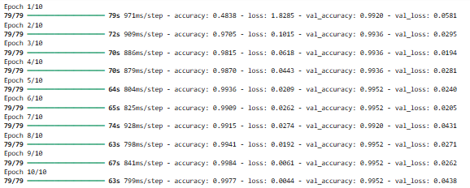

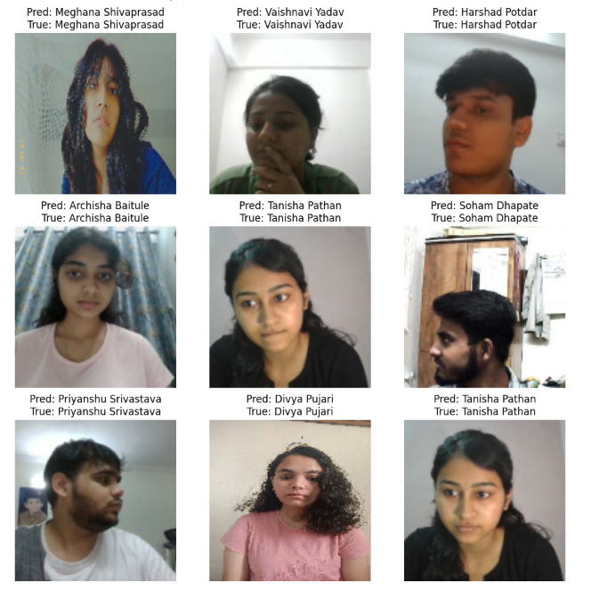

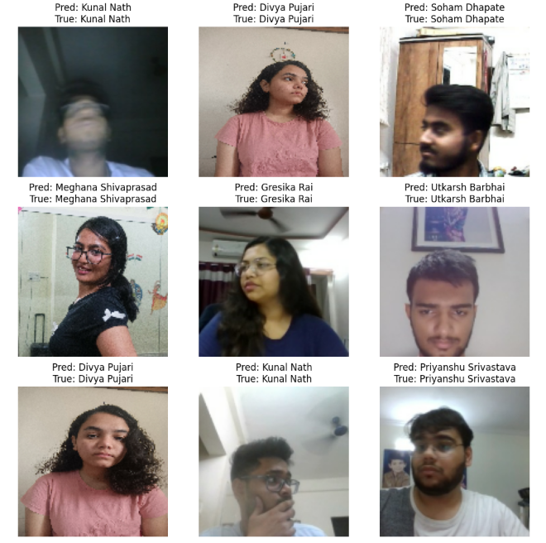

Code for PCA + CNN:

Results for PCA:

[Training ]
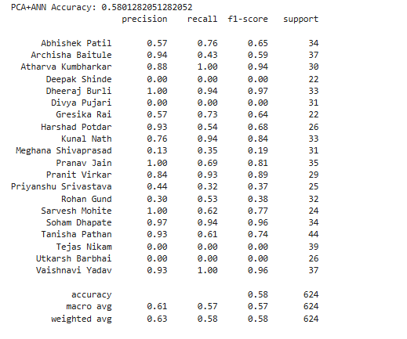

[ Comparision ]
# ---------------- CNN + PCA+ANN Comparison ----------------
# Get CNN accuracy history
cnn_train_acc = history.history["accuracy"]
cnn_val_acc = history.history["val_accuracy"]

# Get CNN final accuracy
cnn_final_train_acc = cnn_train_acc[-1]
cnn_final_val_acc = cnn_val_acc[-1]

# Plot side-by-side
fig, axs = plt.subplots(1, 2, figsize=(14, 5))

# CNN Accuracy over epochs
axs[0].plot(cnn_train_acc, label="Train Accuracy")
axs[0].plot(cnn_val_acc, label="Val Accuracy")
axs[0].set_title("CNN Accuracy History")
axs[0].set_xlabel("Epochs")
axs[0].set_ylabel("Accuracy")
axs[0].legend()
axs[0].grid(True, linestyle="--", alpha=0.6)

# Bar chart comparison
models = ["CNN", "PCA+ANN"]
train_accs = [cnn_final_train_acc, train_acc_pca]
val_accs = [cnn_final_val_acc, val_acc_pca]

x = np.arange(len(models))
width = 0.35

axs[1].bar(x - width/2, train_accs, width, label="Train")
axs[1].bar(x + width/2, val_accs, width, label="Validation")
axs[1].set_title("CNN vs PCA+ANN Accuracy")
axs[1].set_xticks(x)
axs[1].set_xticklabels(models)
axs[1].set_ylabel("Accuracy")
axs[1].legend()
axs[1].grid(True, linestyle="--", alpha=0.6)

plt.tight_layout()
plt.show()

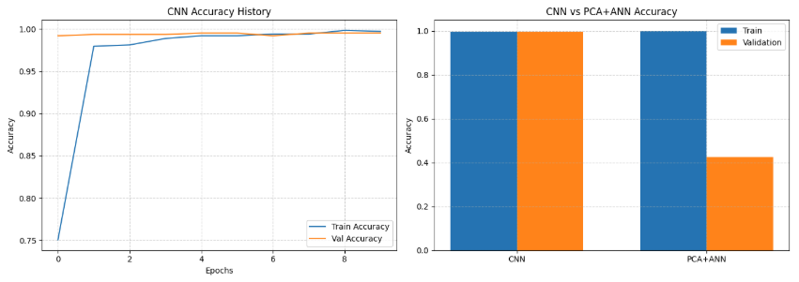
import random

# ---------------------------
# Visual Prediction Demo
# ---------------------------

# Pick 5 random test indices
num_samples = 5
random_indices = random.sample(range(len(x_val_pca)), num_samples)

plt.figure(figsize=(12, 6))
for i, idx in enumerate(random_indices):
# Original flat image
original_img = x_val[idx].reshape(IMG_HEIGHT, IMG_WIDTH)

# PCA reconstruction
reconstruction = pca.inverse_transform(x_val_pca[idx])
reconstruction_img = reconstruction.reshape(IMG_HEIGHT, IMG_WIDTH)

# ANN prediction
pred_label = mlp.predict(x_val_pca[idx].reshape(1, -1))[0]
true_label = y_val[idx]

# Show side-by-side
plt.subplot(num_samples, 2, 2*i + 1)
plt.imshow(original_img, cmap='gray')
plt.title(f"Original - True: {true_label}")
plt.axis('off')

plt.subplot(num_samples, 2, 2*i + 2)
plt.imshow(reconstruction_img, cmap='gray')
plt.title(f"Reconstructed - Pred: {pred_label}")
plt.axis('off')

plt.suptitle("Original vs PCA Reconstructed Faces with ANN Prediction", fontsize=14)
plt.tight_layout()
plt.show()
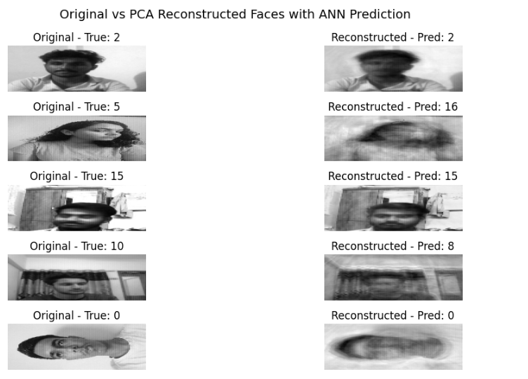

Conclusion :
Thus, we have understood how to create the Face recognition system and how it is programmed in TensorFlow.
We have also learned to use various face detection algorithms.

