**Task Description and Execution**

### **Assignment:**

Execute three versions of code using Apache Spark and analyze the results in the Spark UI. For each version, the following steps are required:

1. **Run the provided code.**
2. **Take screenshots of all Jobs from the Spark UI.**
3. **Briefly describe the task execution and explain the number of Jobs in each case.**

### **Execution:**

#### **Part 1:**

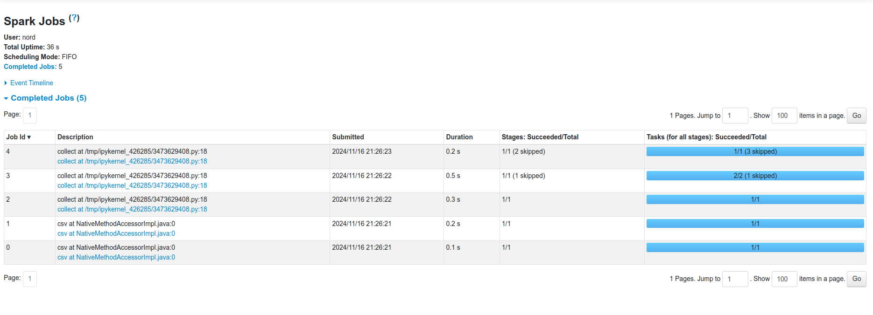

* **Description:**
  + Ran the original code without additional actions.
  + The code reads data from a CSV file, applies several transformations, and performs a single collect() action.
* **Result:**
  + **5 Jobs** appeared in the Spark UI.
* **Explanation:**
  + Each collect() action in Spark triggers the execution of all preceding transformations.
  + The transformations include filtering, selecting columns, grouping, and aggregation.
  + The number of Jobs is related to the need for shuffles during data grouping.

#### **Part 2:**

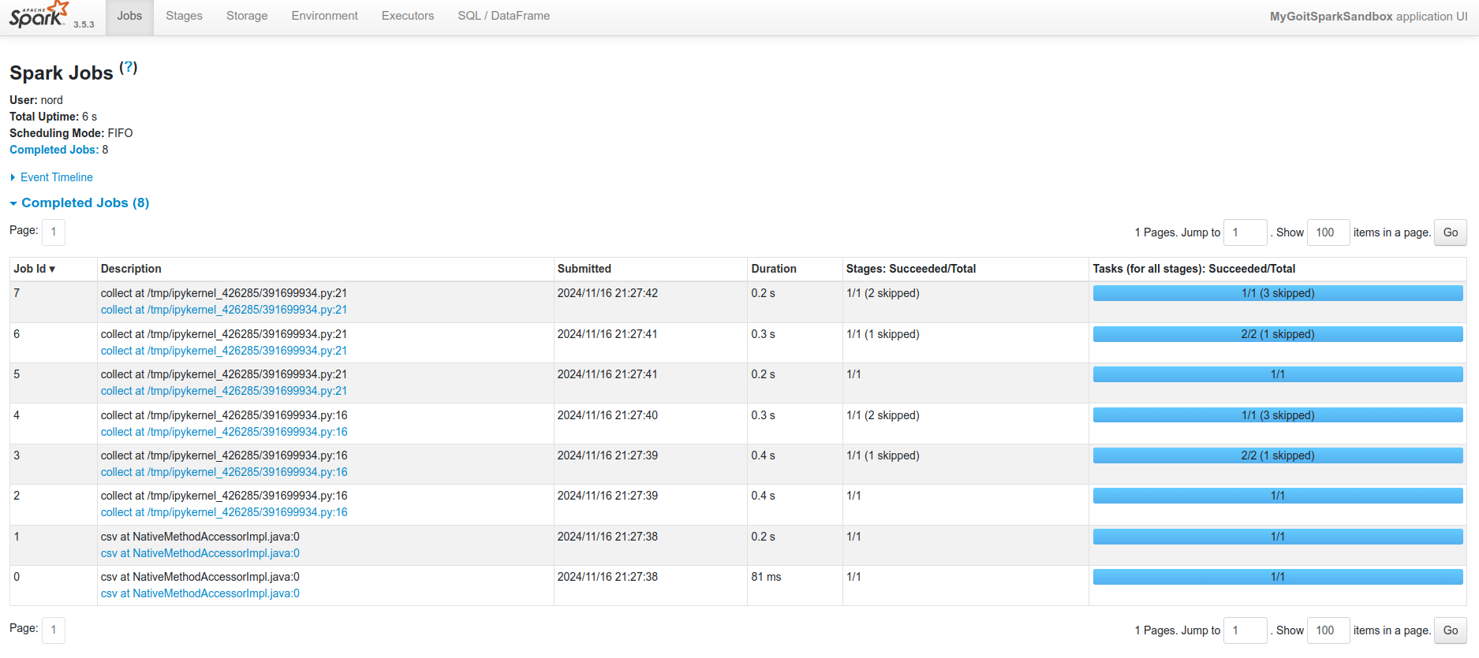

* **Description:**
  + Added an intermediate collect() action after the first series of transformations.
* **Result:**
  + **8 Jobs** appeared in the Spark UI.
* **Explanation:**
  + The additional collect() action causes Spark to execute computations twice.
  + Since the data is not cached, Spark re-executes all transformations for each action.
  + This increases the total number of Jobs because each action requires its own set of computations.

#### **Part 3:**

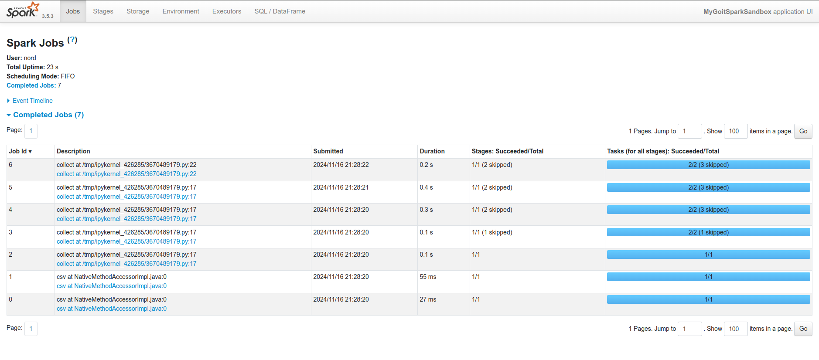

* **Description:**
  + Added the cache() function after the first series of transformations and before the first collect().
* **Result:**
  + **7 Jobs** appeared in the Spark UI.
* **Explanation:**
  + Using cache() allows intermediate computation results to be stored in memory.
  + Upon subsequent data access, Spark uses the cached data, reducing the number of computations needed.
  + This decreases the total number of Jobs compared to Part 2 because redundant computations are avoided.