# Referring things

In this document we show how to refer to various things contained in it through internal links, where the text of the link will be substituted in the final RASH document.

In particular, we can refer to sections (Formula), tables (Tabella 1), formulas (Equazione 1), figures (Figura 1), listings (Text 1), and references (2).

## Tables

Here’s a table.

|  |  |  |  |
| --- | --- | --- | --- |
| Table heading 1 | Table heading 2 | Table heading 3 | Table heading 4 |
| Cell 1 row 1 | Cell 2 row 1 | Cell 3 row 1 | Cell 4 row 1 |
| Cell 1 row 2 | Cell 2 row 2 | Cell 3 row 2 | Cell 4 row 2 |
| Cell 1 row 3 | Cell 2 row 3 | Cell 3 row 3 | Cell 4 row 3 |

Tabella 1My current table

## Formula

Here’s a formula.

$$a-b=¬c$$

Equazione

## Figure

Here’s a figure.

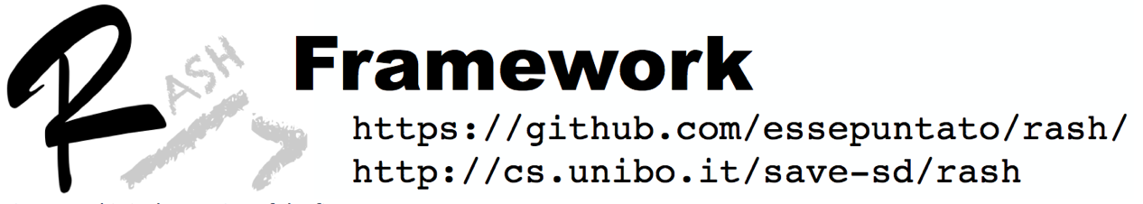

Figura This is the caption of the figure

## Listing

Here’s a listing.

This is a piece of code

Text 1This is the caption of the listing.

## References

1. Ciancarini, P., Di Iorio, A., Nuzzolese, A. G., Peroni, S., Vitali, F. (2014). Evaluating citation functions in CiTO: cognitive issues. In Presutti, V., d'Amato, C., Gandon, F., d'Aquin, M., Staab, S., Tordai, A. (Eds.), Proceedings of the 11th Extended Semantic Web Conference (ESWC 2014), Lecture Notes in Computer Science 8465: 580-594. Berlin, Germany: Springer. <http://dx.doi.org/10.1007/978-3-319-07443-6_39>
2. Peroni, S. (2014). Research Articles in Simplified HTML (RASH). <http://cs.unibo.it/save-sd/rush/rush.rng>
3. Prud'hommeaux, E., Carothers, G. (2014). RDF 1.1 Turtle: Terse RDF Triple Language. W3C Recommendation, 25 February 2014. World Wide Web Consortium. Retrieved from http://www.w3.org/TR/turtle/