**AI/ML EXP-1**

|  |  |
| --- | --- |
| **NAME AND UID** | **Srikanth Iyengar (2020400062)**  **Amal Thundiyil (2020400066)**  **Bhuvanesh Trivedi (2020400067)** |
| **BRANCH** | **INFORMATION TECHNOLOGY - D** |
| **TITLE** | **To implement an intelligent agent.** |

**AIM:**

a. To write down the PEAS System for the chosen Case Study: Automated Car Drive

b. To implement Missionaries Cannibal problem using if-else

**Problem Statement**

**PROBLEM STATEMENT:**

1. Autonomous Chess-Playing Robot takes input from the potentiometers, initializes the bit-board and plays the best possible move for that position. For the given intelligent system, mention the PEAS parameters.
2. In the missionaries and cannibals’ problem, three missionaries and three cannibals must cross a river using a boat which can carry at most two people, under the constraint that, for both banks, if there are missionaries present on the bank, they cannot be outnumbered by cannibals (if they were, the cannibals would eat the missionaries).

**OBSERVATIONS AND RESULTS:**

**• Performance:** Evaluation function bar, 2 points/win, 1 points/draw, 0 for loss

**• Environment:** Chess board, pieces, rules, move history.

**• Actuators:** 5 BLDC motorswhich control the motion of the robotic arm.

**• Sensors:** Potentiometers to detect the position of all the pieces on the board.

**Code:**

import **java.util.\***;

import **java.io.\***;

**public** **class** Main {

**static** **int** N;

**static** **StringBuilder** sb = **new** StringBuilder();

**public** **static** **void** main(**String** args[]) {

        N = Integer.parseInt(args[**0**]);

        vis = **new** **boolean**[N+**1**][N+**1**][N+**1**][N+**1**][**2**];

        go(N, N, **0**, **0**, **true**);

        System.out.println(sb);

    }

**static** **boolean** go(**int** lc, **int** lm, **int** rc, **int** rm, **boolean** boatIsLeft) {

**if**(lc + lm == **0**) {

**return** **true**;

        }

**if**((lc > lm && lm != **0**)|| (rc > rm && rm != **0**)) {

**return** **false**;

        }

**boolean** ans = **false**;

**if**(boatIsLeft) {

**if**(lc >= **2**) {

                ans |= go(lc-**2**, lm, rc+**2**, rm, !boatIsLeft);

            }

**if**(lm >= **2**) {

                ans |= go(lc, lm-**2**, rc, rm+**2**, !boatIsLeft);

            }

**if**(lm >= **1** && lc >= **2**) {

                ans |= go(lc-**1**, lm-**1**, rc+**1**, rm+**1**, !boatIsLeft);

            }

        }

**else** {

**if**(rc >= **1**) {

                ans |= go(lc+**1**, lm, rc-**1**, rm, !boatIsLeft);

            }

**if**(rm >= **1**) {

                ans |= go(lc, lm+**1**, rc, rm-**1**, !boatIsLeft);

            }

**if**(rm >= **2**) {

                ans |= go(lc, lm+**2**, rc, rm-**2**, !boatIsLeft);

            }

**if**(rc >= **2**) {

                ans |= go(lc+**2**, lm, rc-**2**, rm, !boatIsLeft);

            }

**if**(rc >= **1** && rm >= **1**) {

                ans |= go(lc+**1**, lm+**1**, rc-**1**, rm-**1**, !boatIsLeft);

            }

        }

**if**(ans) {

            sb.append("M".repeat(rm)+"_".repeat(N-rm) + " " + "C".repeat(rc)+"_".repeat(N-rc) + " ================== " + "M".repeat(lm)+"_".repeat(N-lm) + " " + "C".repeat(lc)+"_".repeat(N-lc) + "**\n**");

        }

**return** ans;

    }

}

**Output:**

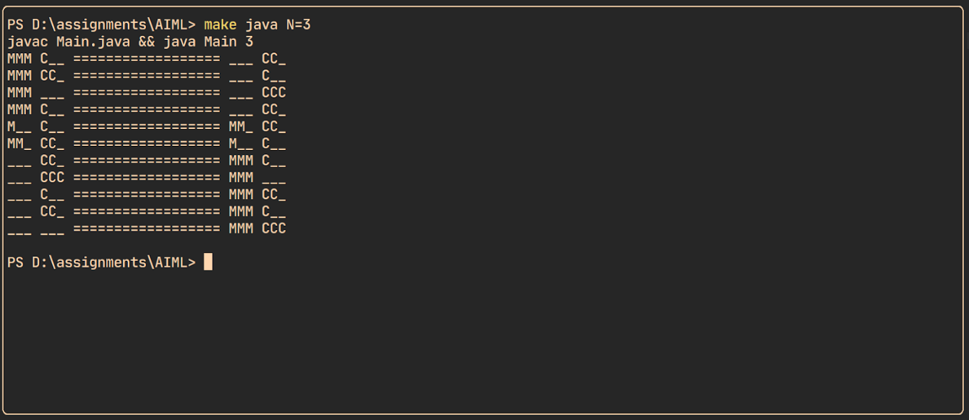

**Conclusion:**

From the given experiment I understood the PEAS parameters defined for an agent (Autonomous Chess Playing Robot) as well as the implementation of the Missionary Cannibals Problem using simple if-else statements.