

SCHOOL OF INFORMATICS & IT

Diploma in Information Technology

Part 1: Implementation of DevOps Practices

Student Name (Matric Number) : Aaron Sim

Tutorial Group : PC02
Jenny LING (TP)
Tutor : Mr Allen Tan

Submission Date : 24/11/2025

Declaration of Originality

I am the originator of this work and I have appropriately acknowledged all other original sources used as my references for this work.

I understand that Plagiarism is the act of taking and using the whole or any part of another person’s work, including work generated by AI, and presenting it as my own.

I understand that Plagiarism is an academic offence
and if I am found to have committed or abetted the offence of plagiarism in relation to this submitted work, disciplinary action will be enforced.

Note to Tutor: This page is only to be used if your subject specifically allows AI-generated content to be used. Please delete this page if it is not required.

Declaration on the use of Generative AI tools for assignments

Describe how you have used Generative AI tools such as ChatGPT or Dall.E- in your assignment.

Share the link to the conversations you had with the AI tool (i.e., the prompts you used and the responses you get from the AI tool).

Please refer to this PDF on “How to share the conversations made with ChatGPT?”

How do you indicate the reference?
The content generated by AI tools are not retrievable except by the user who generated them, so they are considered non-recoverable sources. Although non-recoverable data or quotations in APA Style papers are usually cited as personal communications, with ChatGPT-generated text there is no person communicating. Quoting text from ChatGPT chat is therefore more like sharing the output of an algorithm, with a reference list entry and the corresponding in-text citation.
According to the official APA Style site, ChatGPT references should be cited as:
E.g. OpenAI. (2024). ChatGPT (Feb 13 version) [Large language model].
https://chat.openai.com/chat

Note: The information in parentheses refers to the update or revision date of the model used. Refer to the release notes in the ChatGPT application.

Important Note:

- Do not copy answers produced by the AI tool in totality as it is considered as plagiarism.

- Do not rely on any information produced by the AI tool blindly. You should always verify the answer with other sources. Do not assume that these answers provided by the AI tool are correct.

- To achieve quality outputs from the AI tool, you should provide good prompt that is clear and specific. Be precise and provide context. Avoid asking open-ended questions.

Table of Contents
Declaration of Originality 1
Project Overview 1
Individual Contribution 2
Version Control 3
Additional Features 4

You are NOT allowed to modify the page margins, font sizes and line and paragraph spacings.
Screenshots should be readable.
Please REMOVE all prompting questions and guidelines in each section before submitting.
Report should NOT exceed 8 pages.

Project Overview
Describe the team project and show application of DevOps principles.
Application Name | To Do Manager
Application features | The application allows users to create, view, update, and delete tasks that they want to complete by a certain deadline along with supporting images. In this project, Xavier will work on the create task function, Isaac will work on the update tasks function and Aaron will work on the delete tasks function.  Xavier — Create Task (adds a new task).  Isaac — Update Task (modifies an existing task).  Aaron — Delete Task (removes a task by its ID). ← (my feature)

Wireframe:
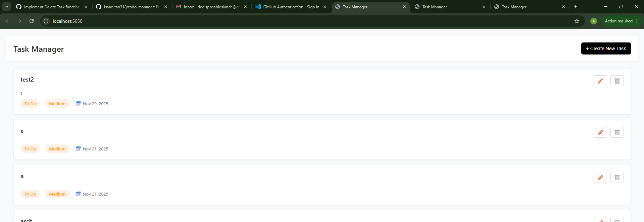
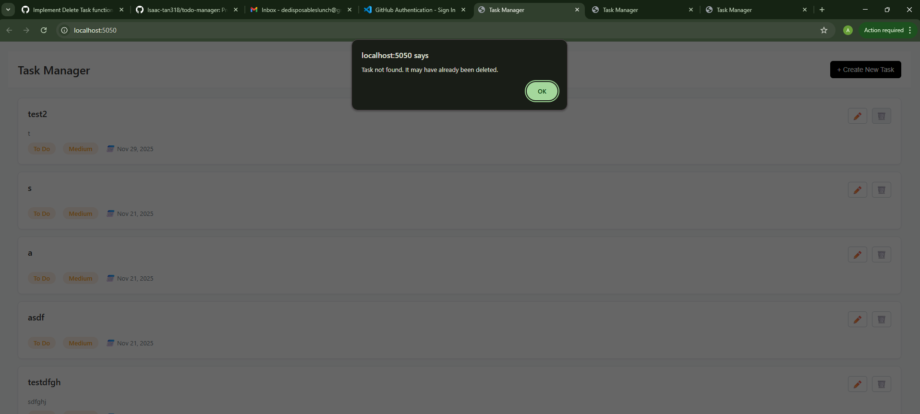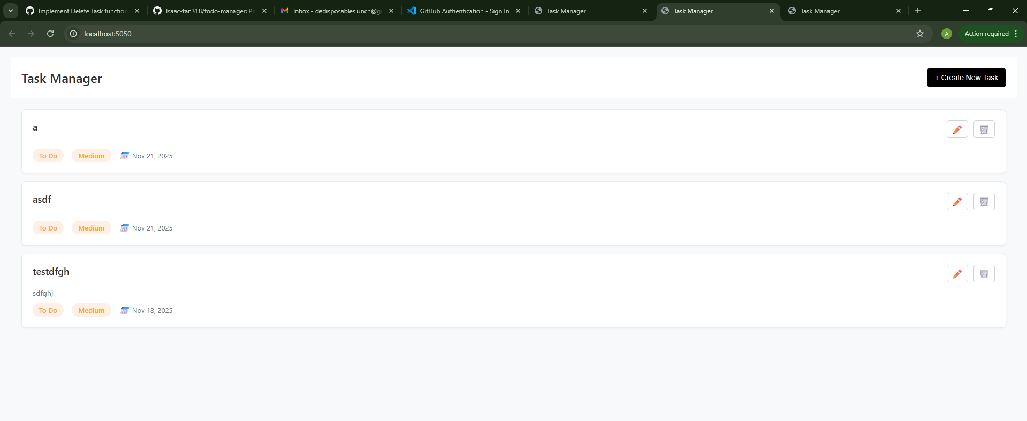

Individual Contribution
Elaborate on the feature that you proposed and have contributed to the project, with emphasis on the following:
- User's interaction with your function, including input, actions, and expected outputs.
- Comprehensive account of how your function interacts with the database.

Feature Name | Delete Task
User Interaction | The user clicks the 🗑️ delete icon on a task card.  A confirmation flow triggers (modal/confirm).  On confirm, the frontend calls the backend route to delete the task by ID.  The page gives a clear result: success message on deletion, or an error explaining what went wrong.
Database Interaction | Data resides in utils/tasks.json as an array of task objects.  The delete flow: read file → parse JSON → locate task by id → remove it → write file back.  All file operations are async and return explicit success/error payloads so the UI can display accurate messages.
Inputs | Route parameter: id (the task’s identifier), taken from the clicked card.  Preconditions: id must be present and in the expected format (numeric string in my implementation).
Actions | Starting Flow  User clicks 🗑️ on a task → frontend sends DELETE /tasks/:id (or POST if your routing uses POST) with the id.  Primary Flow (Success)  Backend validates id, reads tasks.json, finds matching task, removes it, writes the updated array back, and responds with:  HTTP 200 and a payload like:  { message: "Task deleted successfully.", deletedTask: {…}, remainingTasksCount: N }.  Alternative/Error Flows (mapped to your server responses)  1 Missing ID – HTTP 400  Example: { message: "Task ID is required for deletion.", error: "MISSING_TASK_ID" }.  2 Invalid ID format (non-numeric) – HTTP 400  Example: { message: "Invalid task ID format. Task ID must be numeric.", error: "INVALID_TASK_ID_FORMAT" }.  3 Task not found – HTTP 404  Example: { message: "Task with ID 17 not found.", error: "TASK_NOT_FOUND" }.  4 Database file missing or unreadable – HTTP 404/500 depending on cause  Missing file: { error: "DATABASE_NOT_FOUND" }  Permission denied / generic read error: { error: "FILE_READ_ERROR" }.  5 Corrupted JSON – HTTP 500  Example: { message: "Database file is corrupted. Unable to parse tasks data.", error: "INVALID_JSON" }.  6 Write failure after deletion – HTTP 500  Permission denied / no disk space / generic write error with a specific error code.
Expected Outputs | Success: visible confirmation, the deleted task card disappears after list refresh/reload.  Error: a clear message explaining the exact reason (missing/invalid ID, not found, file/JSON errors) so users understand what to do next.  (Optional) Sequence/Decision Diagram (describe for your figure)  Decision: ID present? → valid format? → file readable? → JSON parsable? → task exists? → splice & write → write OK? → success; else emit the specific error above.  (Insert your own diagram screenshot.)

Consider incorporating visual aids such as diagrams or screenshots to enhance clarity in your explanation. Suggested visual aids:
- Sequence Diagram
  - Reference: https://creately.com/guides/sequence-diagram-tutorial/
- Flowchart
- Decision Tree

Version Control
Repository Layout (high-level)
- /utils — backend utility files (one per member): XavierLeeUtil.js, IsaacTanUtil.js, AaronSimUtil.js
- /public/js — per-member frontend files (e.g., xavier-lee.js, isaac-tan.js, aaron-sim.js) + any shared view scripts
- /public/css — styling
- /uploads — user images (tracked as a folder via .gitkeep)
- Root files: index.js, package.json, and shared HTML (public/index.html)
Branching Strategy
- Feature branches per member: feature/create-task-xavier, feature/update-task-isaac, feature/delete-task-aaron.
- Integration via a dev branch to test combined behaviour before merging to main.
- Small, descriptive commits; PRs require screenshots/tests before merge.
Sample Commit Messages
- feat(delete): add route + util for safe deletion by id
- refactor(delete): normalize id validation & error payloads
- fix(delete): handle corrupted JSON with 500 + details
- chore(repo): add .gitattributes and .gitkeep
Conflicts & Lessons
- We hit naming collisions during integration (e.g., generic names like modal/closeModal).
- Fix: adopt clearer, feature-scoped names (openDeleteConfirm, renderDeleteResult).
- Prevention going forward:
  - Stricter naming conventions (e.g., BEM-like patterns or feature prefixes).
  - Pull dev into your feature branch and test locally before opening a PR to catch integration issues early.

Additional Features
GitHub Issues — Each feature/bug tracked as an issue (e.g., “Implement Delete Task end-to-end”, “Harden JSON parse errors”). Helps accountability and scope control.

Labels & Milestones — Labels (bug, enhancement, good-first-issue) and a milestone “Finish CRUD” to group and time-box issues/PRs.

GitLens (VS Code) — Used to inspect line-level authorship and history during integration, which sped up conflict diagnosis.

.gitkeep for /uploads — Ensures empty folders critical to runtime exist in fresh clones.
.gitattributes — Enforces consistent line endings for .js/.json and excludes non-essential files on export, reducing cross-OS surprises.

Appendix – Backend Behaviour Summary (for your Q&A)

- Route: deletes by req.params.id
- Validations: missing ID → 400, non-numeric ID → 400
- Read phase errors: file missing → 404, permission denied/other → 500
- Parse errors: invalid JSON → 500
- Domain errors: ID not found → 404
- Write phase errors: permission denied / no space / generic write → 500
- Success: 200 with { message, deletedTask, remainingTasksCount }
This matches what you demoed: one tab deletes → other tab still shows old state until it refreshes; the second delete attempt correctly returns “not found” because the backend state is already updated.

Git milestones: GitHub docs. Creating and editing milestones for issues and pull requests

Git issues and labels: GitHub Docs. Quickstart for GitHub Issues

.gitattributes: W3Schools. https://www.w3schools.com/git/git_gitattributes.asp

GitLens: GitKraken. https://www.gitkraken.com/blog/gitlens-tips

