## ORTHOTIC DEVICE NEED ASSESSMENT

EXAM DATE: 24

**CHIEF COMPLAINT**

The patient complains of 13 pain at the time of this assessment.

## VITALS

Height: 4

Weight: 5 lbs. Shoe Size : 11

Waist Size: 12

DOB: 7

# 26

# NPI: 27

# DEA: 28

**29**

**Phone: 30**

**Fax: 31**

## SUBJECTIVE

The patient describes their 13 pain to be at a level of 23 on a 0 to 10 scale. The patient describes the duration of the pain as 19. The etiology of the patient's 13 pain is described by patient as 14 . Conditions that cause or aggravate the 13 pain include 16. Previously, the patient has tried 17, with limited success. When asked whether it eﬀects activities of daily living, the patient stated 21.

## RELATED SURGERY

The patient states, they had 22 surgeries in the area of 13

## OBJECTIVE/ASSESSMENT

Patient name, 1, a 8, currently 6 years old and weighs 5 lbs. The patient claims their pain was initially caused by 14 . Treatments previously tried for 13 pain include 17. When asked about previous surgery, the patients response was 22. Conditions that cause or aggravate the patients 13 pain include 16. The condition necessitating the 43 is expected to be permanent or of 6 months or more duration and there is a need to control the 13 pain in more than one plane. Adjustments and assistance with ﬁtting and sizing will not be required for the 43 . The 43 is prescribed for the following indication(s); the patient is ambulatory and has weakness of the 13 pain that requires stabilization and has the potential to beneﬁt the patient functionally.

## DIAGNOSIS:

46 .

## PLAN AND TREATMENT GOALS

Based on my clinical impression with 1 and evaluation of their condition, I am ordering the following for the 13: 43 - 44 42, the patient has been advised to use the device for support of their 13 pain as needed for comfort; or daily if necessary, to provide support to the area and aid potentially weak musculature and to improve activities of daily living.

## THE INDICATIONS OF NEED:

13: The patient is ambulatory and has pain, discomfort and weakness in the region that requires stabilization and has the potential to beneﬁt functionally, by aiding and supporting the musculoskeletal unstable or weak area.

## TREATMENT GOALS:

13 pain: Improvement in patient’s function. Improvement in patient’s pain. Increase performance in activities of daily living. Reduce medications. Slow musculoskeletal degeneration. Reduce inﬂammation.

Custom ﬁtting of the orthosis is not required and the patient or an assisting caregiver can apply the prescribed orthotic device with minimal self-

Our telephone number has been provided to 1 in case there are follow up questions for his use and/or adjustment directions from our oﬃces. I have also recommended for the patient to speak with their primary care Physician in the near future as part of their ongoing plan of care.

I, 26, verify and conﬁrm this order for the above-named patient, and certify that I have personally performed the assessment of the patient for the prescribed treatment and device and verify that it is reasonably and medically necessary, according to accepted standards of medical practice within the community, for this patient’s medical condition.

Electronically Signed and Dated:



*24*

34. 32, NPI: 27

From IP Address:

33

32

Colleen Bro

**Patient Information** Patient: 1

Address: 2

Phone: 3

Weight: 5 lbs.

Height: 4

Shoe Size: 11

Age: 6 Years

DOB: 7

Gender: 8

# ------Detailed Written Order------

**Date of Service: 24**

**26**

**NPI: 27**

**DEA: 28**

**29**

**Phone: 30**

**Fax:31**

**DIAGNOSIS**

13 pain 46.

# STATEMENT OF MEDICAL NECESSITY

The orthotic device or devices ordered as of the result of this examination is being prescribed as adjunctive therapy to assist in reducing the level of pain and symptoms associated with the patient’s identiﬁed diagnosis, and for overall improvement in the patient’s quality of life.

# PREVIOUSLY TRIED TREATMENTS

17

# PAIN LEVEL DESCRIBED BY PATIENT

23 on a 0-10 scale

I, 26, verify and conﬁrm this order for the above-named patient, and certify that I have personally performed the assessment of the patient for the prescribed treatment and device and verify that it is reasonably and medically necessary, according to accepted standards of medical practice within the community, for this patient’s medical condition. I hereby aﬃrm this documentation as part of this patient’s medical record.

# Insurance Information

Member ID: 37

Insurance Type: 25

# ORTHOSIS DEVICE(S) PRESCRIBED

Based on my examination of this patient, I am ordering the following orthosis for the 13:

44 42

Patient should begin using the orthosis as needed. Length of need:

# 45.

First date patient is authorized to begin using 43 : 24

# My treatment goal(s) for the use of the prescribed orthosis are:

* Support weak musculature
* Improvement in Patient’s function
* Decrease in Patient’s pain
* To assist the patient or improve activities of daily living
* To aid in the stabilization of the 13
* To aid in controlling unwanted movements in the area of pain
* Slow degenerative changes
* Reduce potential inﬂammation

# Additional Doctor Notes:

Thoroughly reviewed all available medical information on record and listened to survey recording. Contacted patient today, 24, today for further evaluation and remote examination. Patient advised to f/u with PCP regarding this and other ongoing medical issues. Consultant's n/n provided for future reference, as needed. Patient with understanding of and agreement with plan of care. cdb. 24.

Electronically Signed and Dated:



*24*

34. 32, NPI: 27

From IP Address:

33

32

26

NPI:27

DEA:28

29

Phone:30

Fax:31

Patient Information

Patient:1

Address: 2

Phone: 3

Height: 4

Weight: 5

Age: 6

Date of Birth: 7

Gender: 8

Medicare Insurance Information

Patient Group:35

PCN:36

Member ID:37

Medicare Subscriber #:38

Secondary/Supplement Insurance Carrier:39

Subscriber #:40

Patient Allergies

Allergies: 9

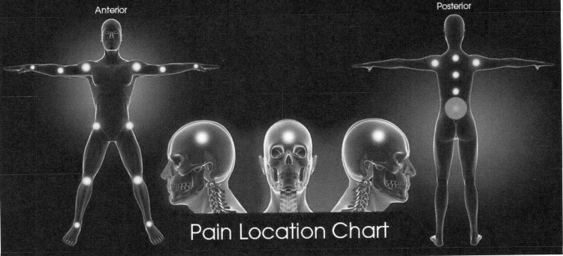

* 13

General Intake Notes 41