Pickle Rick — TryHackMe Writeup
A walkthrough for the Pickle Rick room on TryHackMe — a beginner-friendly Rick and Morty themed CTF that covers web enumeration, a PHP login panel, a web shell, and privilege escalation via sudo.
Goal: find all three of Rick's secret ingredients hidden across the file system.

Recon
Started with an nmap scan against the target to see what's open.
nmap -sCV -p- 10.48.177.128 --min-rate=3000 -o picklerick
- 22/tcp — OpenSSH 8.2p1 (Ubuntu)
- 80/tcp — Apache httpd 2.4.41, page title "Rick is sup4r cool"
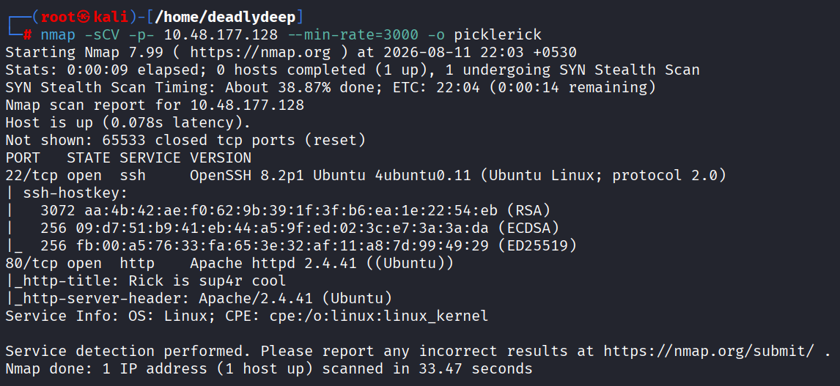
nmap scan results

Web Enumeration
Checked the page source of the website and found a username hidden there.
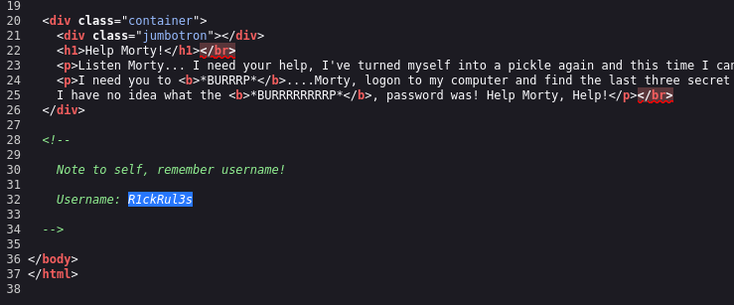
Username found in page source
Ran feroxbuster, which came up empty. Followed up with gobuster using common.txt, which turned up robots.txt.
robots.txt contained a password.
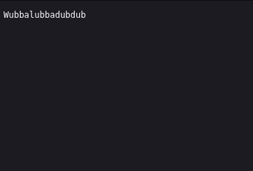
Password found via robots.txt
Tried the credentials against SSH first — no luck. Continued manual directory fuzzing and found login.php.
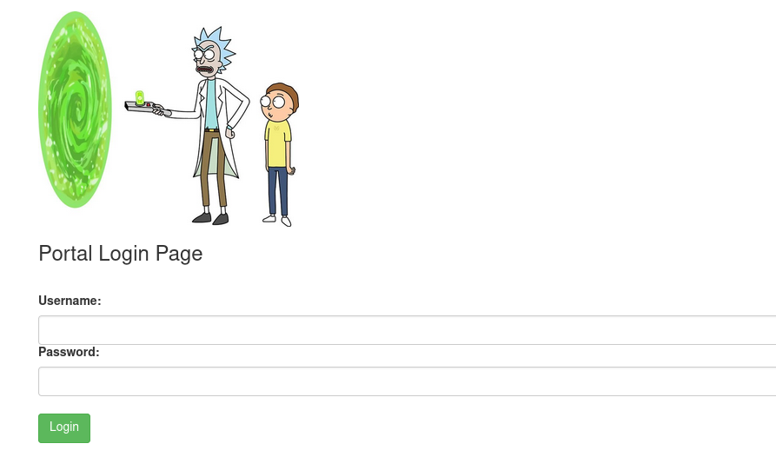
Discovering login.php

Gaining a Foothold
The credentials worked on login.php, logging into a panel that exposed a web shell.
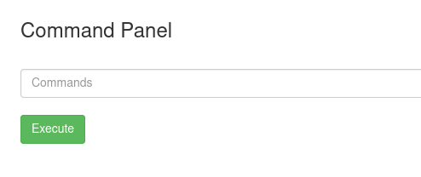
Logged into the web shell
Checked the page source of the shell panel and found a base64-encoded string. Tried decoding it (including nested decoding), but this turned out to be a rabbit hole — no useful data.
Ran whoami through the web shell — running as www-data.
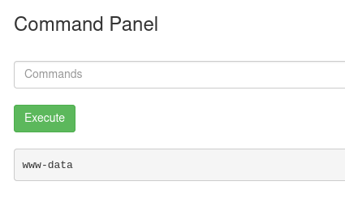
whoami returns www-data
Ran pwd — landed in /var/www/html.
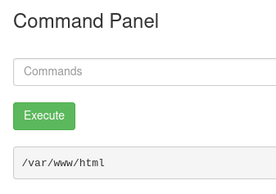
pwd shows /var/www/html
Listed the directory and found several files, including clue.txt and Sup3rS3cretPickl3Ingred.txt.
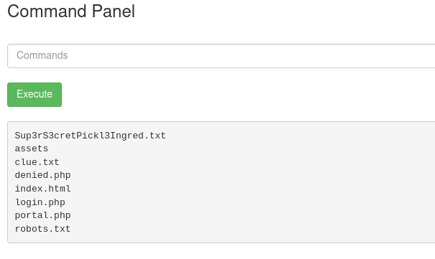
Directory listing showing ingredient files
The web shell's ls command didn't return output properly, so I used less to read files instead:
- clue.txt — hinted to look elsewhere on the file system for the next ingredient.
- Sup3rS3cretPickl3Ingred.txt — contained Ingredient #1.

Upgrading to a Reverse Shell
Checked whether Python3 was available on the target with which python3 — it was.
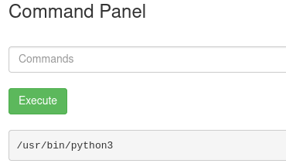
Confirming python3 is available
Set up a netcat listener on my machine to catch the reverse shell.
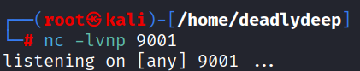
Netcat listener ready
Tried the classic pentestmonkey PHP reverse shell first — it failed to connect. Switched to the shortest Python3 reverse shell from revshells.com, which worked.
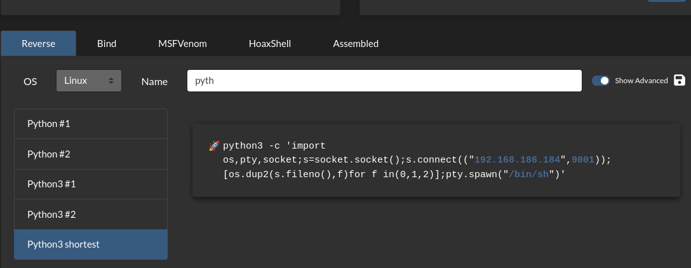
Sending the python3 reverse shell payload
Caught the shell on the listener.
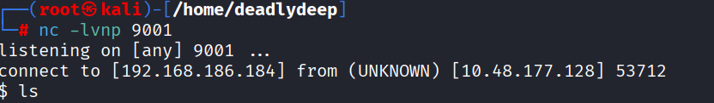
Reverse shell caught on listener

Privilege Escalation
From the shell, navigated to /home and found two users: rick and ubuntu. Moved into rick's home directory and found a file named “second ingredients”. Used cat to read it and obtained Ingredient #2.
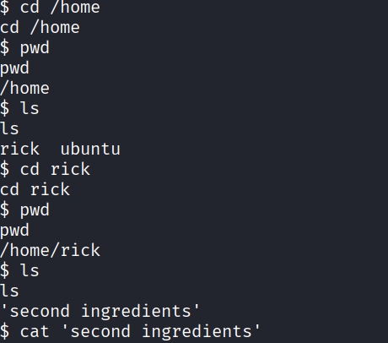
Reading the second ingredient
Checked sudo privileges with sudo -l — the rick user could run all commands with sudo, with no password required.
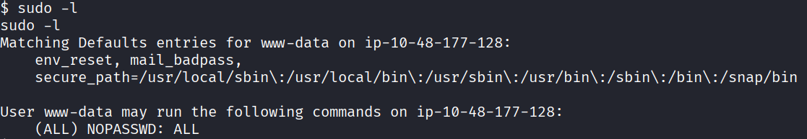
sudo -l showing NOPASSWD ALL
Moved to /, and tried cd /root directly — permission denied. Also tried running cd through sudo, but cd isn't a standalone binary so that failed too. Stabilized the shell to make further interaction easier.
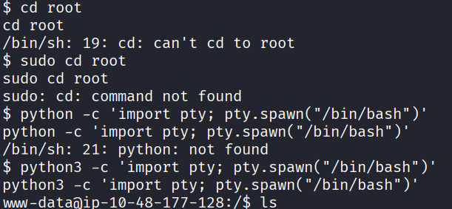
Shell stabilization
Instead of cd-ing into /root, used sudo ls /root to list its contents directly, which revealed 3rd.txt. Read it with:
sudo cat /root/3rd.txt
This returned Ingredient #3 — the final piece.
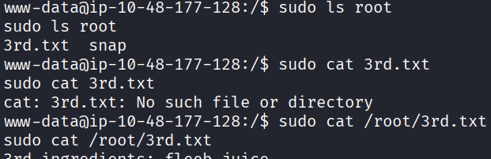
Reading the final ingredient as root

Summary
Stage | Technique
Recon | nmap full port scan
Enumeration | Page source review, gobuster/feroxbuster, robots.txt
Foothold | Credential reuse on login.php → built-in web shell
Shell upgrade | Python3 reverse shell via revshells.com
Privilege escalation | sudo -l → passwordless sudo for all commands
All three of Rick's secret ingredients recovered.
Thanks for reading!

