# DLD Assignment #1

By Rushan khan Bscs-3

Submitted to Sir Rafay Shaikh

Q:1 which gates are categorized as universal gates and how are they used?

Ans: There are 2 universal type of gates

* Nand Gate
* Nor Gate
* From there universal gate we can make other login gates for example or, and, not, Xnor gates by using the combination of Nand or Nor gates.

Q:1 Verify the Truth Table for AND Gate and OR Gate.

And Gate:

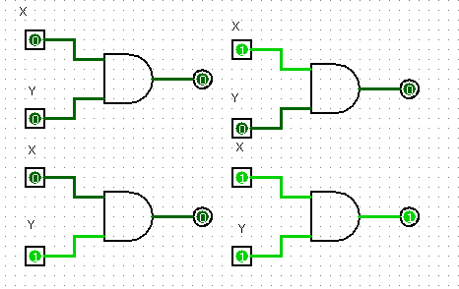

|  |  |  |
| --- | --- | --- |
| X | Y | Z |
| 0 | 0 | 0 |
| 0 | 1 | 0 |
| 1 | 0 | 0 |
| 1 | 1 | 1 |

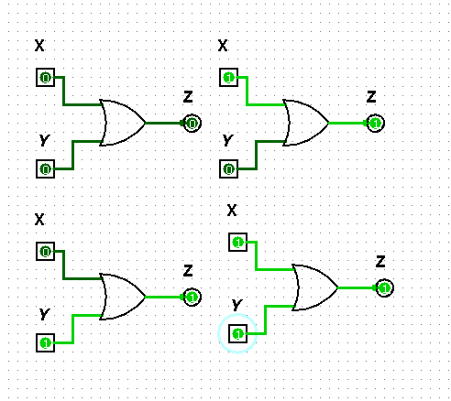OR Gate:

|  |  |  |
| --- | --- | --- |
| X | Y | Z |
| 0 | 0 | 0 |
| 0 | 1 | 1 |
| 1 | 0 | 1 |
| 1 | 1 | 1 |

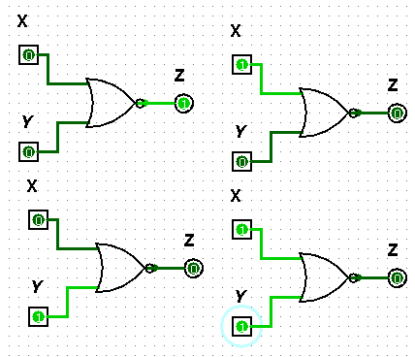

NOR Gate:

|  |  |  |
| --- | --- | --- |
| X | Y | Z |
| 0 | 0 | 1 |
| 0 | 1 | 0 |
| 1 | 0 | 0 |
| 1 | 1 | 0 |

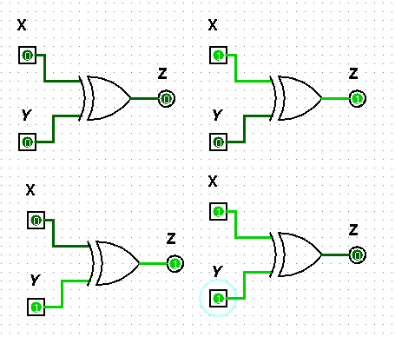

XOR Gate:

|  |  |  |
| --- | --- | --- |
| X | Y | Z |
| 0 | 0 | 0 |
| 0 | 1 | 1 |
| 1 | 0 | 1 |
| 1 | 1 | 0 |

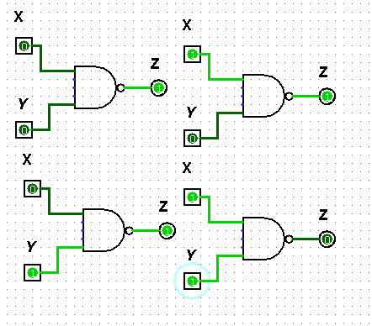NAND Gate:

|  |  |  |
| --- | --- | --- |
| X | Y | Z |
| 0 | 0 | 1 |
| 0 | 1 | 1 |
| 1 | 0 | 1 |
| 1 | 1 | 0 |

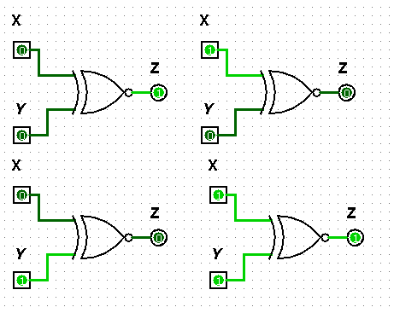XNOR Gate:

|  |  |  |
| --- | --- | --- |
| X | Y | Z |
| 0 | 0 | 1 |
| 0 | 1 | 0 |
| 1 | 0 | 0 |
| 1 | 1 | 1 |

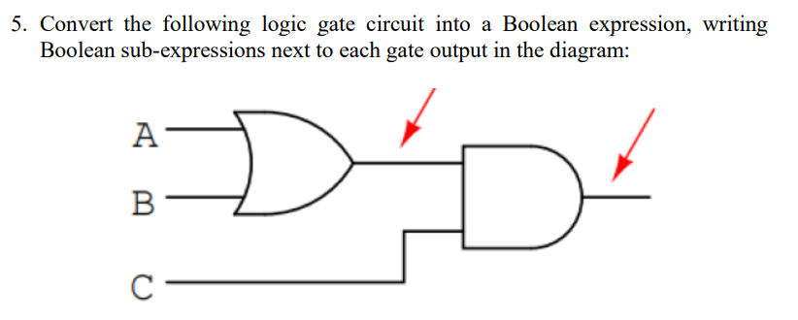

Ans: (A+B)*C

6. Draw the following function in Circuit maker.

1. F = 𝑿’YZ + 𝑿’Y𝒁’ + XZ
2. F=𝑿’Z + X𝒀’Z +Y **Z’**

**1:**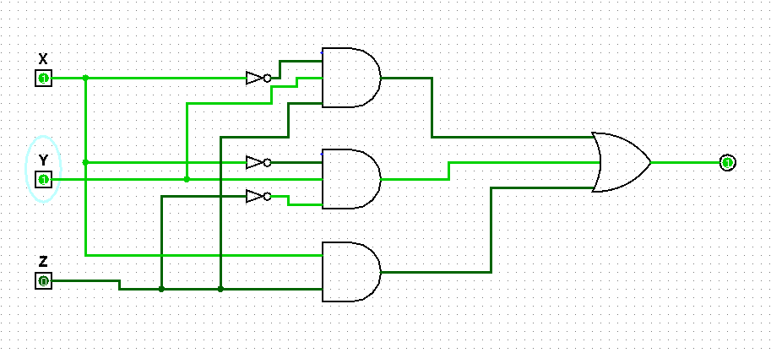

2: 