SMARTROAD
Traffic Accident Risk, Severity & Hotspot Analytics
Computational Analytics - Assignment 2
BCA Semester 7 | Academic Year 2026-2027
Group members: ______________________________

Abstract
SmartRoad is an end-to-end computational analytics solution for understanding traffic collision patterns, identifying geographic hotspots, and predicting whether a reported collision is high severity. The system combines data preprocessing, exploratory data analysis, engineered temporal indicators, supervised classification, cross-validation, model evaluation, and K-Means geographic clustering. A Streamlit dashboard provides interactive exploration and prediction. The project is designed around the official Great Britain STATS19 collision dataset published by the UK Department for Transport. A synthetic demonstration dataset is bundled only to validate the software locally; official results must be regenerated with the downloaded DfT dataset before academic submission.

1. Problem Statement
Traffic collisions are influenced by interacting temporal, road, environmental, and geographic factors. A descriptive table of accident counts is not sufficient for decision support. SmartRoad aims to transform collision records into actionable analytics: when collisions are concentrated, which conditions correlate with higher severity, where spatial hotspots are concentrated, and whether a new record resembles the high-severity class.

2. Objectives
- Acquire a structured road-collision dataset and document its provenance.
- Clean duplicates, parse dates/times, validate numeric ranges, and build a modeling-ready feature set.
- Perform statistical summaries and exploratory analysis of temporal, environmental, road and severity patterns.
- Create at least five distinct visualizations using Matplotlib/Seaborn.
- Engineer interpretable features such as hour, month, weekend, night and rush-hour indicators.
- Train and compare classification models for high-severity prediction.
- Evaluate performance using accuracy, precision, recall, F1-score, confusion matrix and 5-fold cross-validation.
- Cluster accident coordinates to identify geographic hotspot groups.
- Deliver an interactive Streamlit dashboard for exploration and prediction.

3. Dataset Description
The primary source selected for the project is the UK Department for Transport road safety open data. The source provides record-level personal-injury road collision data reported through the STATS19 collision system. The currently published final full-year data are available for 2025. The 2025 collisions file is approximately 19.3 MB and is suitable for a student-scale analytics workflow. Source: GOV.UK Road Safety Open Data.
Feature group | Examples | Purpose
Temporal | Date, Time, Day of Week | Trend and peak-period analysis
Road | Road Type, Speed Limit, Junction Detail | Road-context risk signals
Environment | Weather, Light, Road Surface | Environmental conditions
Location | Latitude, Longitude, Urban/Rural | Spatial hotspot analysis
Outcome | Accident Severity | Prediction target

Data provenance and licensing
The official DfT page states that the data consist of record-level files covering personal-injury collisions on public roads reported to police and recorded using STATS19. The page also states that the open data are made available under the Open Government Licence v3.0. The project keeps source attribution in the README and report.

4. Methodology
The pipeline follows the analytics lifecycle specified by the assignment: acquisition -> cleaning -> exploratory analysis -> feature engineering -> model training/testing -> cross-validation -> evaluation -> visualization -> dashboard. The implementation is deliberately modular so that the same transformations support both the notebook and Streamlit application.

4.1 Data cleaning
- Duplicate records are removed before feature creation.
- Date and time strings are parsed into standardized datetime-derived variables.
- Numeric columns are converted safely; impossible speed/coordinate values are treated as missing.
- The model pipeline imputes numeric values with the median and categorical values with the most frequent category.
- Categorical coded variables are one-hot encoded and unknown categories are ignored at inference time.

4.2 Feature engineering
The project derives hour, month, day name, weekend, night-time, rush-hour and multi-vehicle indicators. The target `high_severity` is 1 for Fatal or Serious collisions and 0 for Slight collisions. Outcome-derived fields such as casualty count are not used as predictors to reduce target leakage.

4.3 Predictive modeling
Three classifiers are implemented: a class-weighted Random Forest, a class-weighted Logistic Regression baseline, and Gradient Boosting. All use the same preprocessing pipeline, an 80/20 stratified train-test split, and five-fold Stratified Cross-Validation. The final model artifact is the model with the highest mean cross-validated F1 score. F1 is used as the primary validation score because the high-severity class is less common than the slight-severity class.

4.4 Hotspot clustering
Valid latitude/longitude records are grouped with K-Means. The dashboard summarizes each cluster by accident count and high-severity rate and calculates a simple risk score combining severity rate and cluster size. These clusters are exploratory rather than official police hotspot designations.

5. Exploratory Data Analysis
The final run generates six EDA chart types and two model-evaluation charts. They are saved in the outputs folder and can be refreshed automatically when the official dataset is used.
Line chart: Accidents by hour. Shows concentration by time of day.
Bar chart: Severity distribution. Shows the balance across Fatal/Serious/Slight.
Histogram: Speed-limit distribution. Shows the distribution of recorded speed limits.
Heatmap: Weekday vs hour. Highlights temporal concentration patterns.
Boxplot: Speed limit by severity. Compares speed-limit distributions across severity classes.
Geographic scatter: Accident locations. Shows the spatial spread of records.

6. Model Implementation
The model implementation is contained in src/analytics.py. A scikit-learn Pipeline joins preprocessing and the estimator so that the exact same feature transformations are applied to training, cross-validation and inference. Three classifiers are compared: Random Forest, Logistic Regression, and Gradient Boosting. This reduces accidental train/test leakage and makes the deployed model reproducible.

7. Performance Evaluation
The final academic run was performed on the official 2025 DfT collision CSV. The dataset contains 101,525 records before preprocessing and 101,525 records after duplicate removal. The pipeline compares Random Forest, Logistic Regression, and Gradient Boosting using an 80/20 stratified split and 5-fold Stratified Cross-Validation. Gradient Boosting was selected because it achieved the highest mean cross-validated F1 score (0.4209).
Validation metric | Final 2025 value
ACCURACY | 0.6058
PRECISION | 0.3412
RECALL | 0.5395
F1 | 0.4180
CV_F1_MEAN | 0.4209
CV_F1_STD | 0.0024
POSITIVE_RATE | 0.2624
Final 2025-data performance is summarized below. The confusion matrix is stored as 07_confusion_matrix.png and the model comparison as 08_model_comparison.png. Feature importance is estimated with repeated permutation importance on the held-out test set.

8. Dashboard Design
The Streamlit dashboard contains KPI cards, severity and hourly charts, an interactive geographic plot, hotspot cluster analysis, and an input form for high-severity prediction. The application automatically uses the official dataset when data/road_collisions_2025.csv exists and otherwise uses the demo dataset for software testing.

9. Results and Analytical Interpretation
The final 2025 run contains 101,525 recorded collisions. The binary high-severity target (Fatal or Serious versus Slight) has a positive rate of 26.24%. Among the engineered predictors, number_of_vehicles, urban_or_rural_area, speed_limit, road_type, and hour have the highest mean permutation importance in the final run. The selected Gradient Boosting model achieved 60.58% test accuracy and a 41.80% test F1, with a mean 5-fold CV F1 of 42.09%. The project intentionally avoids presenting correlation as causation; these values describe statistical patterns in recorded collision data.

10. Limitations
- Police-reported collision data capture recorded personal-injury collisions and may not represent every road incident.
- Coded STATS19 variables can change over time; the data guide should be checked for the selected year.
- Hotspot clustering is exploratory and depends on the chosen number of clusters.
- The classifier predicts a binary high-severity label, not exact injury outcomes or causal risk.
- The embedded appendix chart images in this packaged report are illustrative validation figures from the bundled demo dataset; the real 2025 PNG outputs are generated locally by the student and should replace these figures before the final PDF is submitted.
Final 2025 results summary: The model-selection process favored Gradient Boosting by cross-validated F1 (0.4209). The test-set F1 was 0.4180, recall was 0.5395, and accuracy was 0.6058. These metrics should be interpreted together with the confusion matrix and the target prevalence of 26.24%.

11. Conclusion
SmartRoad demonstrates the complete computational analytics lifecycle expected by the assignment. It integrates official-data acquisition, preprocessing, EDA, six visualization types, feature engineering, supervised classification, cross-validation, performance metrics, geographic clustering and an interactive dashboard. The modular design also makes it easy to rerun the analysis with updated collision data.

12. Future Scope
- Add live weather/traffic APIs for near-real-time contextual features.
- Integrate road network or traffic-volume data to estimate exposure-adjusted risk.
- Evaluate additional approved boosting models and probability calibration.
- Add explainable AI plots such as SHAP for individual predictions.
- Deploy the Streamlit application to a cloud service and schedule dataset refreshes.

13. References
- UK Department for Transport. Road Safety Open Data. https://www.gov.uk/government/statistical-data-sets/road-safety-open-data
- scikit-learn documentation. https://scikit-learn.org/
- Pandas documentation. https://pandas.pydata.org/docs/
- Matplotlib documentation. https://matplotlib.org/stable/
- Seaborn documentation. https://seaborn.pydata.org/
- Streamlit documentation. https://docs.streamlit.io/

Appendix A - Submission Checklist
- Use the official 2025 collision CSV and retain the source citation.
- Run unit tests.
- Run run_analysis.py on the official CSV.
- Confirm the final 2025 metrics in outputs/run_summary.json and keep them synchronized with the report.
- Run the notebook from top to bottom and save the official charts.
- Run streamlit run app.py and capture dashboard screenshots.
- Prepare 8-10 slide presentation and rehearse within 10 minutes.
- Keep source, dataset, report PDF, PPT and requirements file in the submission folder.

Appendix B - Temporal Analysis
Figure B1 below is the official 2025 DfT collision output generated by the SmartRoad analysis pipeline.
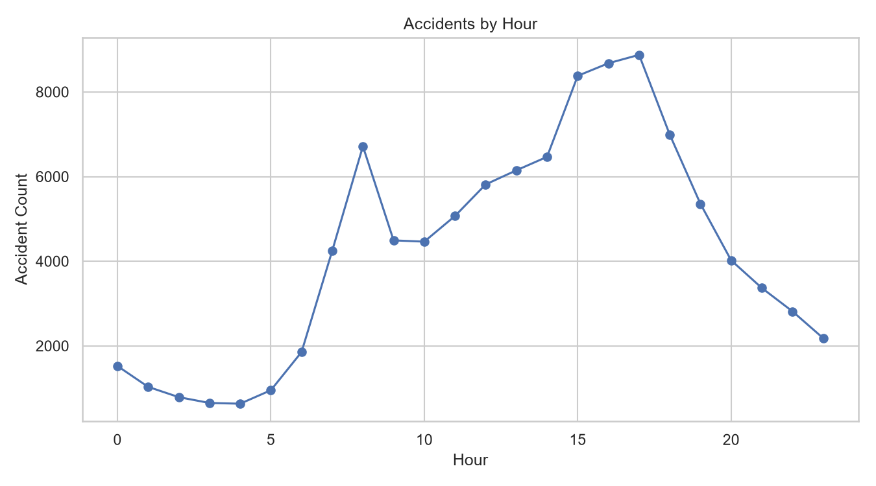
Figure B1. Accident count by hour.

Appendix C - Severity Distribution
Figure C1 below is the official 2025 DfT collision output generated by the SmartRoad analysis pipeline.
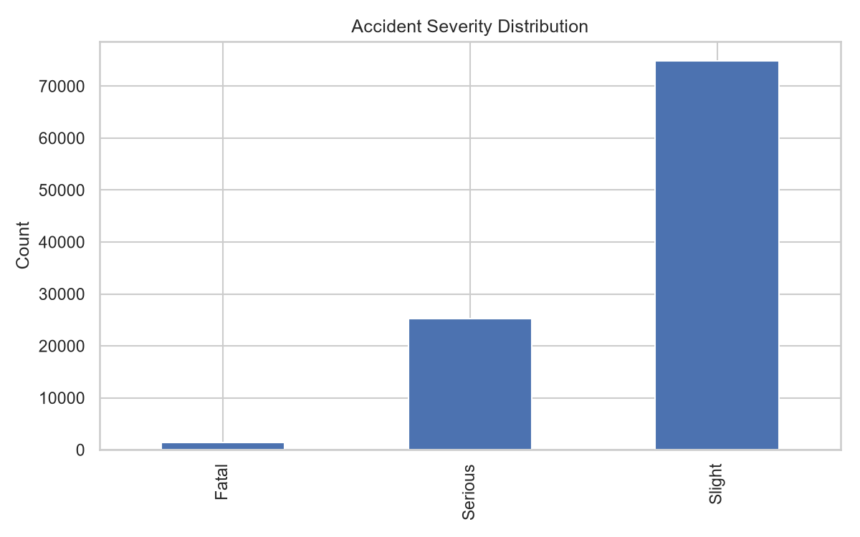
Figure C1. Distribution of reported collision severity.

Appendix D - Speed Limit Analysis
Figure D1 below is the official 2025 DfT collision output generated by the SmartRoad analysis pipeline.
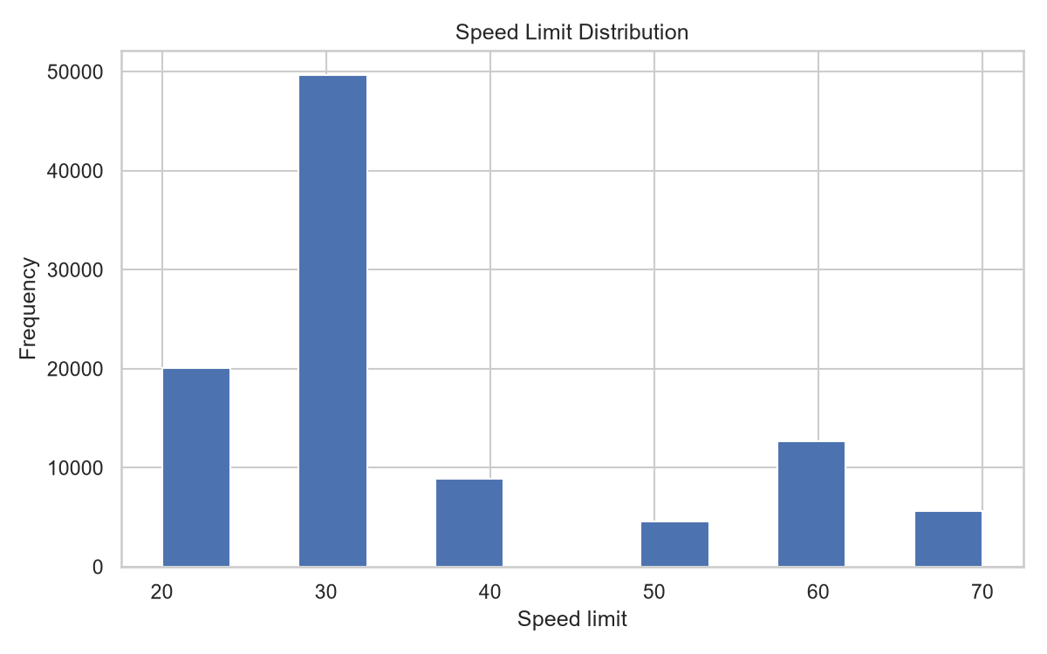
Figure D1. Distribution of recorded speed limits.

Appendix E - Weekday and Hour Heatmap
Figure E1 below is the official 2025 DfT collision output generated by the SmartRoad analysis pipeline.
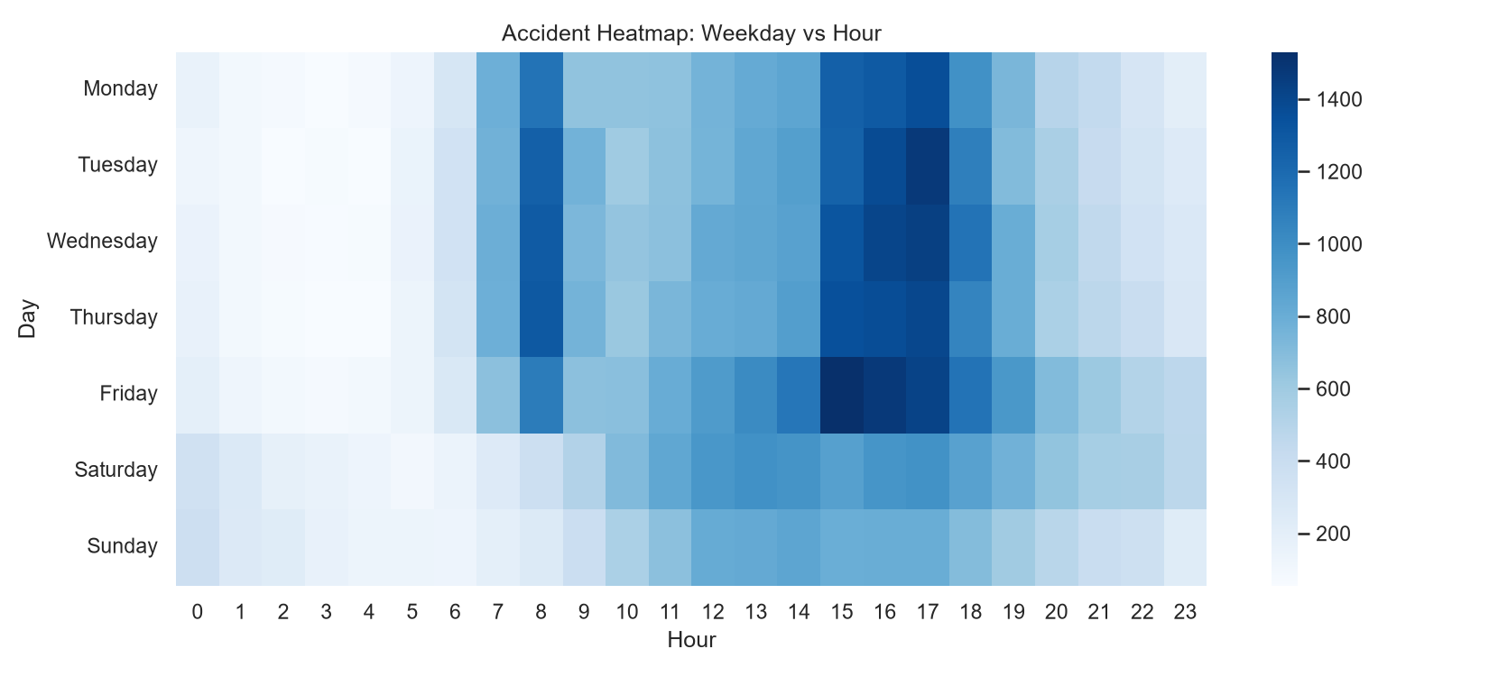
Figure E1. Accident concentration by weekday and hour.

Appendix F - Speed by Severity
Figure F1 below is the official 2025 DfT collision output generated by the SmartRoad analysis pipeline.
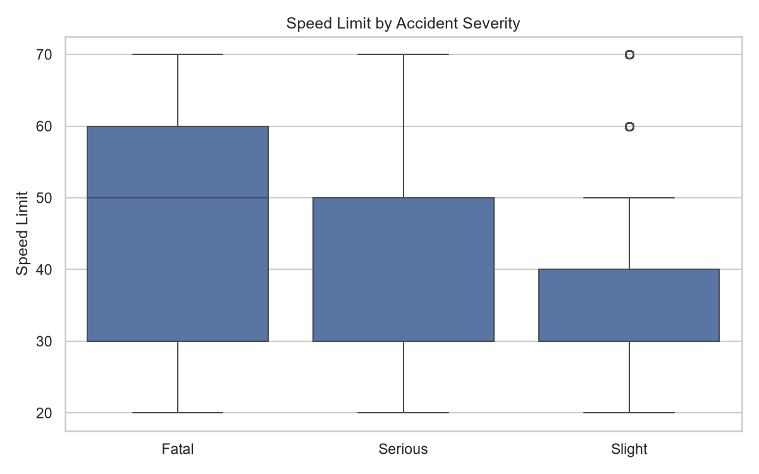
Figure F1. Speed-limit distribution by severity class.

Appendix G - Geographic Distribution
Figure G1 below is the official 2025 DfT collision output generated by the SmartRoad analysis pipeline.
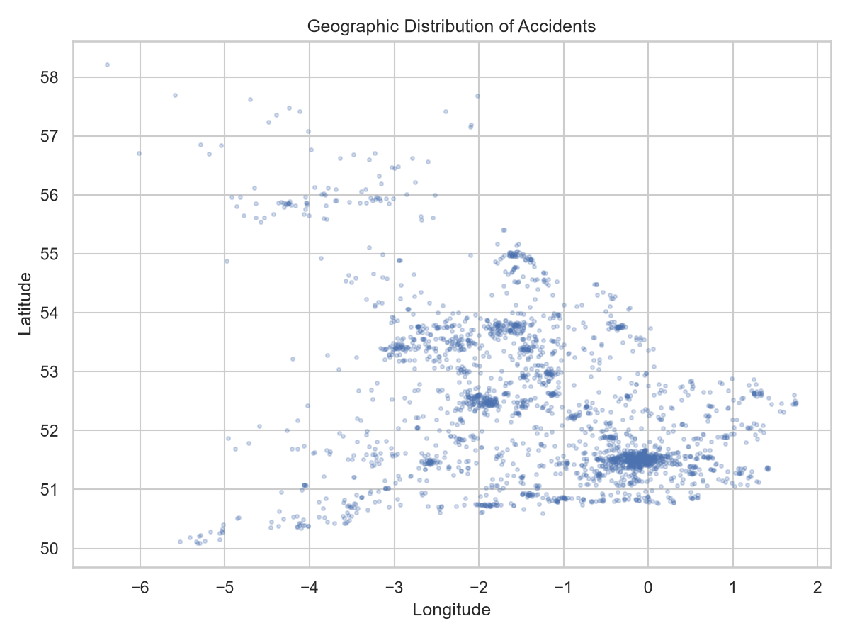
Figure G1. Geographic distribution of collision records.

Appendix H - Model Comparison and Feature Importance
Three classification models are trained with the same feature-engineering and preprocessing framework. Model selection is based on the mean F1 score from five-fold Stratified Cross-Validation. The figures and values below are from the official 2025 DfT run.
Model | Accuracy | Precision | Recall | F1 | CV F1
Random Forest | 0.6501 | 0.3385 | 0.3492 | 0.3438 | 0.3459
Logistic Regression | 0.5733 | 0.3260 | 0.5866 | 0.4191 | 0.4185
Gradient Boosting | 0.6058 | 0.3412 | 0.5395 | 0.4180 | 0.4209
Selected model in the final 2025 run: Gradient Boosting.
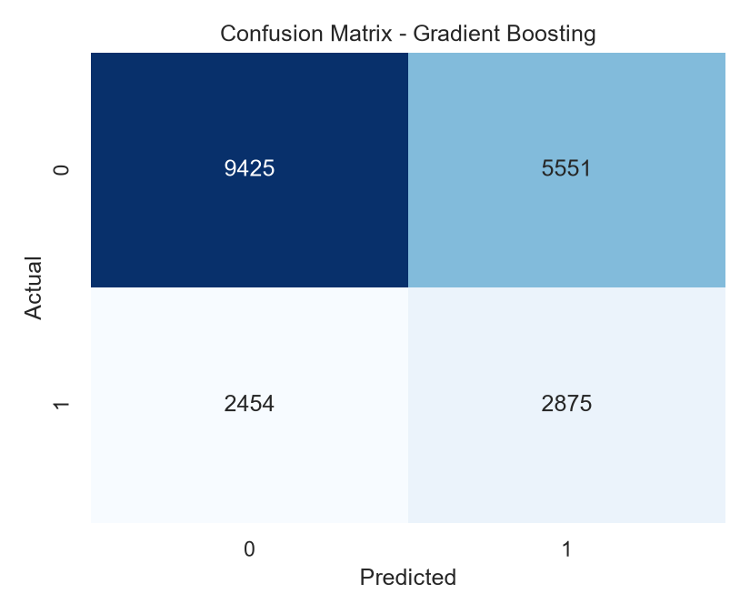 | 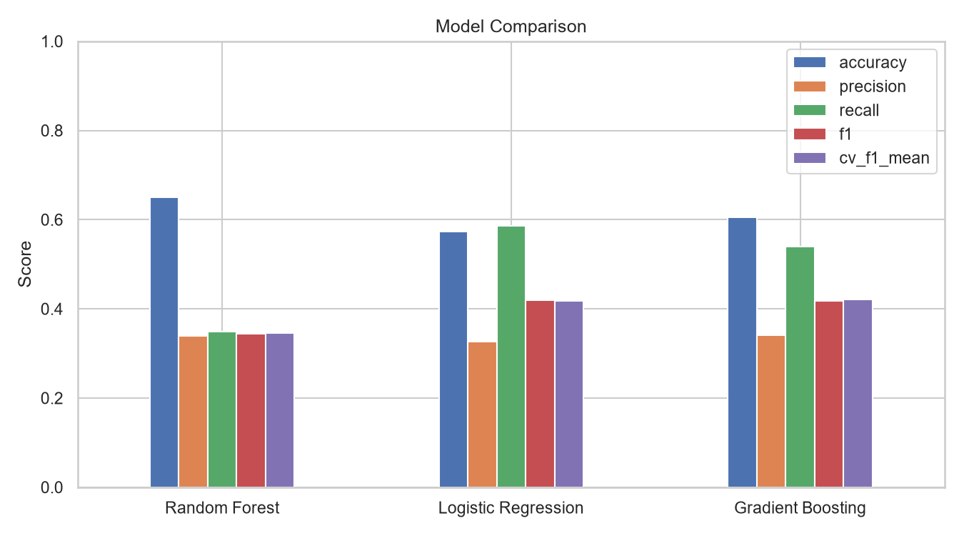
Figure H1. Confusion matrix (left) and three-model performance comparison (right), official 2025 run.

Top permutation-importance features
Feature | Mean importance | Std. dev.
number_of_vehicles | 0.04165 | 0.00301
urban_or_rural_area | 0.01993 | 0.00151
speed_limit | 0.01917 | 0.00197
road_type | 0.01271 | 0.00138
hour | 0.00727 | 0.00189
weather_conditions | 0.00539 | 0.00136
first_road_class | 0.00371 | 0.00084
junction_detail | 0.00338 | 0.00058
month | 0.00261 | 0.00082
night | 0.00187 | 0.00052

Appendix I - Viva Technical Notes

Why binary severity?
Fatal/Serious is grouped as high severity so the dashboard can provide a direct risk flag and use binary classification metrics.

Why exclude casualty count?
Casualty count is an outcome closely related to severity, so it would create target leakage if used as a predictor.

Why use stratified splitting?
It preserves the class balance when the high-severity class is smaller.

Why use F1?
F1 balances precision and recall and is more informative than accuracy alone when classes are imbalanced.

Why one-hot encode coded categories?
Road, light, weather and surface codes are labels, not measurements. One-hot encoding avoids false numeric ordering.

What is K-Means doing?
K-Means groups valid coordinates into exploratory geographic clusters that are ranked by collision volume and severity rate.

What is the key limitation?
The model identifies statistical associations in recorded data; it does not prove causal relationships. Performance is reported from the official 2025 dataset, but future years may produce different results.

