DIP Project 1

**Topic:** Image Enhancement and Morphology (10 points)

**Project Details**

1. Spatial filtering

Each person is assigned 3 images to be processed. Everyone should first analyze the noise types in the images and utilize the appropriate Denoising methods **without using the already built libraries**. **Todo: Please proceed on xxx.jpeg (xxx is the number of the assigned image, size: 224*224) and save your output picture as output_xxx. jpeg.**

1. Morphology

In some applications, we need to find the boundary of a shape in a binary image. Morphological algorithm can solve this problem very conveniently and you are required to realize it **without using the already built morphology libraries**. Given a binary image, please design a morphological algorithm to find its boundary, and the process is shown in Figure 2.1. **Todo: Please proceed on Figure 2.2(size: 1024*1024) and save your output picture as output_2.png.** Tips: you may have to binarize the original image first.

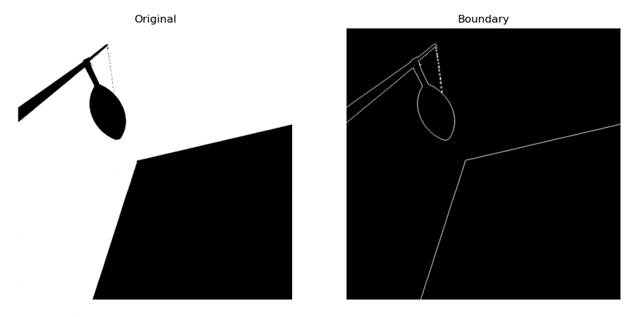

Figure 2.1 Binary image and it’s boundary



Figure 2.2 Original image

**Scoring criteria of the project:**

(1) The content of the report;

(2) The method used;

(3) The effect.

(The three rankings are in no particular order, with the same proportion)

**Attention**

1. The programing language is not limited.
2. You cannot call any third party library for key processing steps, but functions use to I/O images, visualization or do mathematics are allowed. Take python as an example, you cannot call any function from cv2 except I/O functions in cv2 or visualization functions in cv2 and you can use numpy to do mathematics.
3. You need to submit the source code and a brief report in English (Report template is given).
4. Submission format: ‘Pro1_student ID_name.zip/rar’, and please send to: 1042683219@qq.com.
5. Deadline: 31, March.
6. Take it easy and Have fun! Most important: Do it by yourself!