# 边缘识别算子快速入门手册

目录

边缘识别算子快速入门手册 1

1．引言 3

1.1编写目的 3

1.2其它说明 3

2. 算子说明 3

2.1 边缘识别算子 3

2.1.1类型定义及说明 3

2.1.2相关数据结构 3

2.1.3 调用流程 4

2.1.4 使用案例 5

2.1.5 注意事项 12

2.1.6 算子配置 12

2.1.7 函数说明： 13

3. 附录 14

# 1．引言

## 1.1编写目的

此文档是为了说明边缘识别算子的功能，以及调用算子的具体流程，方便其他人使用开发算子。

## 1.2其它说明

算子实例的通用构造、执行接口、算法配置文件等说明可见附录《X_vision SDK快速入门手册》。

# 2. 算子说明

## 2.1 边缘识别算子

### 2.1.1类型定义及说明

算子类型为：algType::MV_ALG_COMPONENT_DET1/ algType::MV_ALG_COMPONENT_DET2，主要功能是进行边缘的识别以及检测。

### 2.1.2相关数据结构

相关数据结构定义如下：

/* alg sub_type */

#define MV_ALG_COMPONENT_DET1 20

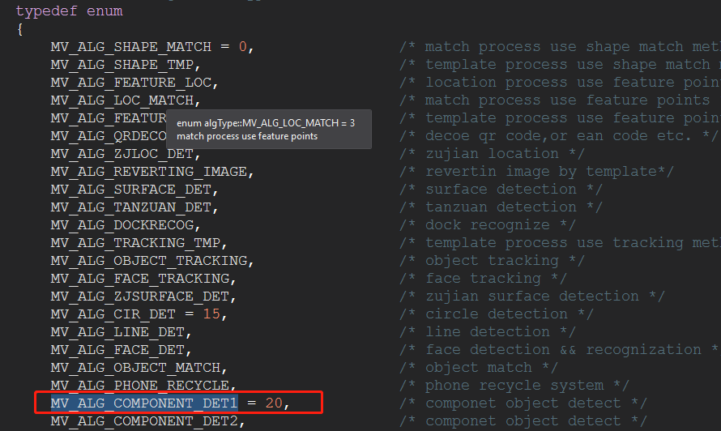

### 2.1.3 调用流程

边缘识别算子调用流程如下：

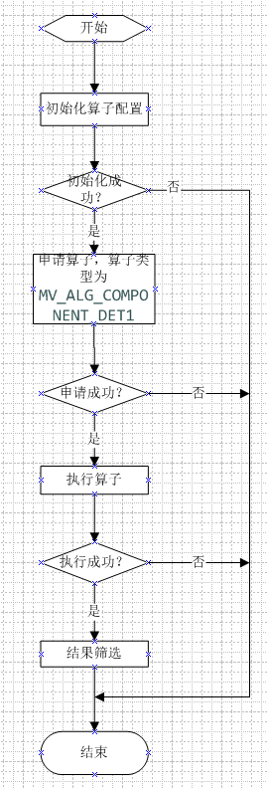

边缘识别流程图

### 2.1.4 使用案例

#include <stdio.h>

#include <stdlib.h>

#include <opencv2/opencv.hpp>

#include "DllmvInterface.h"

#include <windows.h>

#include "mvSDK_interface.h"

#include <iostream>

#include <vector>

#include<opencv2/ml/ml.hpp>

using namespace cv;

using namespace std;

algDllHandle *pAlg = NULL;

RNG rng(12345);

//alg算法配置

//算法缩放系数

#define MV_ALG_SCL 1

//算法配件路径

#define MV_CONFIG_PATH "D:/VS/TestComponent/x64/Release/imvcfg/"

#define TEST_SAMPLE_PATH "D:/VS/TestComponent/x64/Release/pic/"

//输入图像缩放系数

#define MV_INTPUT_IMAGE_SCAL 1

//算法类型

#define MV_ALG_TYPE (MV_ALG_COMPONENT_DET1)

#define INPUT_WIDTH 1024

#define INPUT_HEIGHT 750

#define TEST_PATH "imageList.txt"

void load_images(const string & prefix, const string & filename, vector< Mat > & img_lst, int flag, Size ct)

{

string line;

ifstream file;

Mat img1, img2;

int width = ct.width;

int height = ct.height;

file.open((prefix + filename).c_str());

if (!file.is_open())

{

cerr << "Unable to open the list of images from " << filename << " filename." << endl;

exit(-1);

}

bool end_of_parsing = false;

while (!end_of_parsing)

{

getline(file, line);

if (line.empty()) // no more file to read

{

end_of_parsing = true;

break;

}

Mat img = imread((prefix + line).c_str()); // load the image

if (img.empty()) // invalid image, just skip it.

continue;

#ifndef _DEBUGX

//imshow("image", img);

//waitKey(10);

#endif

if (flag)

{

//resize

resize(img, img2, Size(width, height));

#ifdef _DEBUG

//imshow("image", img2);

//waitKey(10);

#endif

img_lst.push_back(img2.clone());

}

else

img_lst.push_back(img.clone());

}

}

void cclTtemsDraw(mvCCLItems *pComps, cv::Mat img)

{

int i;

mvCCLItem *pComp;

mvRect rc;

mvPoint pt;

int x, xx, y, yy;

cv::Point pp1, pp2;

vector<mvFPoint> subpixels;

for (i = pComps->num_comp - 1; i >= 0; i--)

{

cv::Scalar color = Scalar(rng.uniform(0, 255), rng.uniform(0, 255), rng.uniform(0, 255));

pComp = &pComps->ccomps[i];

if (!pComp->vflag)

continue;

x = pComp->rec_bound.up_left.x;

y = pComp->rec_bound.up_left.y;

xx = pComp->rec_bound.dw_right.x;

yy = pComp->rec_bound.dw_right.y;

rc = pComp->rec_bound;

pt = pComp->pnt_mass;

cv::rectangle(img, cv::Rect(x, y, xx - x, yy - y), Scalar(0, 0, 255));

for (int k = 0; k < pComp->pnt_countour.nump; k++)

{

pp1.x = pComp->pnt_countour.pnts[k].x;

pp1.y = pComp->pnt_countour.pnts[k].y;

cv::circle(img, pp1, 0.1, color, 1, 8, 0);

}

//draw "+"

int len = 10;

pp1.x = pComp->pnt_center.x;

pp1.y = pComp->pnt_center.y - len;

pp2.x = pComp->pnt_center.x;

pp2.y = pComp->pnt_center.y + len;

rectangle(img, pp1, pp2, CV_RGB(0, 255, 0));

pp1.x = pComp->pnt_center.x - len;

pp1.y = pComp->pnt_center.y;

pp2.x = pComp->pnt_center.x + len;

pp2.y = pComp->pnt_center.y;

rectangle(img, pp1, pp2, CV_RGB(0, 255, 0));

/*object centor */

pp1.x = pComp->pnt_center.x, pp1.y = pComp->pnt_center.y;

line(img, pp1, pp1, cvScalar(0, 0, 255), 2);

}

return;

}

void* algLocationProcessWrap(algType type)

{

int ret;

mvInputImage orgImage;

initParam param;

mvResult *pRes;

int keyval = 0;

int key;

mvImage clone;

vector< Mat > pos_lst;

vector< Mat > test_lst;

vector< Mat > full_neg_lst;

vector< Mat > neg_lst;

vector< Mat > gradient_lst;

vector< int > labels;

//string neg = NEG_PATH;

string test_dir = TEST_SAMPLE_PATH;

string test_sample = TEST_PATH;

int frameNum;

//设置alg param初始化参数

strcpy_s(param.cfg_path, MV_CONFIG_PATH);

//param.tmp_offset = offset;

//param.tmp_roi = loc;

param.online_temp = 0; //not used

param.tmp_img.pframe = NULL;

param.tmp_img.width = 0; //temp->width;

param.tmp_img.height = 0; //temp->height;

param.tmp_img.channels = 0; //temp->nChannels;

param.tmp_img.depth = 0; //temp->depth;

param.tmp_img.wstep = 0; //temp->wstep;

param.tmp_img.type = MV_CV_IPL; //MV_CV_IPL;

IplImage *org = NULL;

pAlg = (algDllHandle*)mvInstanceAlloc(INPUT_WIDTH, INPUT_HEIGHT, type, &param);

if (!pAlg)

return NULL;

pAlg->sub_type = 2; //sub_type of this algorithm

pRes = (mvResult*)&pAlg->result;

//读取本地图像

load_images(test_dir, test_sample, test_lst, 1, Size(INPUT_WIDTH, INPUT_HEIGHT));

vector< Mat >::const_iterator img = test_lst.begin();

vector< Mat >::const_iterator end = test_lst.end();

frameNum = 0;

mvDetRoi det;

for (int i = 0; img != end; img++)

{

static int flag = 0;

//cv::Mat frame = cv::imread(TEST_IMAGE, -1);

cv::Mat frame = img->clone();

if (flag == 0)

{

org = cvCreateImage(cvSize(frame.cols, frame.rows), IPL_DEPTH_8U, 3);

flag = 1;

det.num_poly = 3;

int startxy = 120;

int rww, rhh;

rww = 200; rhh = 200;

det.polys[0].ppnts[0].x = 40;

det.polys[0].ppnts[0].y = 40;

det.polys[0].ppnts[1].x = rww - det.polys[0].ppnts[0].x;

det.polys[0].ppnts[1].y = det.polys[0].ppnts[0].y;

det.polys[0].ppnts[2].x = rww - det.polys[0].ppnts[0].x;

det.polys[0].ppnts[2].y = rhh - det.polys[0].ppnts[0].y;

det.polys[0].ppnts[3].x = det.polys[0].ppnts[0].x;

det.polys[0].ppnts[3].y = rhh - det.polys[0].ppnts[0].y;

det.polys[0].ppnts[4] = det.polys[0].ppnts[0];

det.polys[0].num = 5;

det.polys[0].index = 0;

det.polys[0].uc = 80;

det.polys[0].valid = 1;

det.polys[0].uflag = 0;

det.polys[0].seed.x = det.polys[0].ppnts[0].x + 2;

det.polys[0].seed.y = det.polys[0].ppnts[0].y + 2;

cv::Mat frame2 = img->clone();

clone.channels = 1;

clone.width = frame2.cols;

clone.height = frame.rows;

det.roi_map = NULL; //important

}

Mat input2;

frame.copyTo(input2);

orgImage.index = frameNum++;

orgImage.pframe = (void*)frame.data; /* 图像数据地址 */

orgImage.width = frame.cols; /* 图像宽度 */

orgImage.height = frame.rows; /* 图像高度 */

orgImage.channels = frame.channels(); /* 图像通道*/

orgImage.wstep = frame.cols * frame.channels(); /* 图像 wstep = 宽度* 通道数 */

orgImage.depth = frame.depth(); /* 图像深度 */

orgImage.type = MV_BGR24; /*帧的格式*/

int64 nTick = ::GetTickCount();

double ptime;

nTick = getTickCount();

/* 算法处理 */

imshow("org", frame);

ret = mvAlgProcess(pAlg, (mvInputImage*)&orgImage);

ptime = ((double)getTickCount() - nTick)*1000. / getTickFrequency();

printf("processed time = %.2f ms\n", ptime);

cout << pAlg->result.cc_items->ccomps->com_label;

if (ret > 0)

{

//绘制结果

//mvMatchObjsDrawAndDisplay(pAlg, pRes);

cclTtemsDraw(pRes->cc_items, input2);

imshow("ccls", input2);

//strcpy(strsss, TEST_SAMPLE_PATH);

//sprintf(nnn, "result-%02d.png", frameNum);

//strcat(strsss, nnn);

//

//imwrite(strsss, input2);

Mat bin, edge, com;

bin = Mat(cvSize(pAlg->bin_img.width, pAlg->bin_img.height), CV_8UC1, (void*)pAlg->bin_img.pdata);

imshow("bin-image", bin);

edge = Mat(cvSize(pAlg->edge_img.width, pAlg->edge_img.height), CV_8UC1, (void*)pAlg->edge_img.pdata);

imshow("edge-image", edge);

mvImage imm;

mvImageCreate(&imm, pAlg->com_img.width, pAlg->com_img.height, 1);

mvSetComponentRoiArea(imm, det);

mvImageShow("mvImage", imm);

mvImageDestroy(&imm);

int cnt = mvDetRoiMapFilter(det, pAlg->com_img.width, pAlg->com_img.height, pAlg->com_img.pdata);

cout << "cnt=" << cnt << endl;

com = Mat(cvSize(pAlg->com_img.width, pAlg->com_img.height), CV_8UC1, (void*)pAlg->com_img.pdata);

///* 将ccl 的lable 二值化 */

/*for (i = 0; i < pAlg->com_img.nsize; i++)

{

if (pAlg->com_img.pdata[i] > 0)

pAlg->com_img.pdata[i] = 255;

}*/

imshow("com-image", com);

key = cvWaitKey();

}

}

while (1);

key = cvWaitKey();

printf("stop.\n");

cvWaitKey();

if (1)

{

mvInstanceDelete(pAlg);

}

return (void*)pAlg;

}

int main(int argc, char* argv[])

{

int key;

////process

algLocationProcessWrap(MV_ALG_TYPE);

key = cvWaitKey(0);

while (key != 'q' && key != 'Q')

{

cvWaitKey(0);

}

return 0;

}

### 2.1.5 注意事项

①初始化算子时，配置文件的文件夹路径要以“/”结束，例如：”D:/imvcfg/”

②存放图片的文件夹必须有图片的列表文件imagelist.txt,并将图片名字写在该文件中，每行一个，不能有空格。

### 2.1.6 算子配置

###################

algType=MV_ALG_COMPONENT_DET1

#edge threshold

edge_thres=80

conf_thres=0.1

use_tracker=0

#alg parameters#

#use filter

use_filter=0

#minimal object pixels

min_pixels=0

#maxmal object pixels，if = -1,not use

max_pixels=50000

#diff val, default: 50

diff_val=50

#minimal area of object

min_area=32

#maxmal area, if = -1,not use

max_area=-1

#minimal gray value

min_gray=-1

#maxmal gray value

max_gray=-1

#min_wh_rate: min(w,h)/max(w,h)

min_wh_rate=0

#max_wh_rate

max_wh_rate=0

#ppa edge-pixels/area

ppa=0

gr_thres=0

co_thres=0

conLikeness=0

#remove edge flag

edge_flag=0

#use classifier

use_clasfier=0

#use mapper

use_mapper=0

#smooth factor

use_deepl=0

#binary

useOtsu=1

#use smooth=1

useSmooth=1

#use binary,bin metho: 1,2,3,4

useBin=4

#disp_level=3281073

### 2.1.7 函数说明：

mvSetComponentRoiArea，设置ROI区域

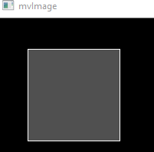

mvDetRoiMapFilter，检测结果筛选：

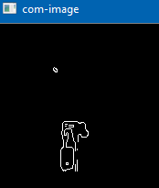

# 3. 附录

[1] 《X_vision SDK快速入门手册》