Chapter 4: DeceptiTech - Unveiling Dark Patterns with AI-Driven Detection & Analysis

*S. Anwarul (SoCS, UPES, Dehradun, shahinaanwarul@gmail.com)

P. A. Thomas (SoCS, UPES, Dehradun, pranit.100820@stu.upes.ac.in)

D. Sharma (SoCS, UPES, Dehradun, yashwant.108505@stu.upes.ac.in)

Y. Yadav (SoCS, UPES, Dehradun, deepansh.110134@stu.upes.ac.in)

G. Baranwal (SoCS, UPES, Dehradun, gaurang.108618@stu.upes.ac.in)

4.1 Introduction, Problem & Motivation

The modern digital environment has profoundly transformed the parameters of online service consumption, such as e-commerce, subscription services, social media, and mobile apps. At the same time, an increasing amount of empirical evidence supports the existence of dark patterns, i.e. intentional interface designs that are designed to influence user behaviour. Systematic inspection of more than 11,000 online shopping sites demonstrated that 1,818 different cases of these patterns are used as a strategy to influence users without informed consent in online services, which means that about 11% of online services use deceptive design elements to direct users to make their choices [1]. Moreover, even in mainstream mobile ecosystems, one of the latest Indian reports found that 52 out of 53 most often downloaded apps use at least one dark pattern, which underlines the prevalence of the specified phenomenon. These manipulative practices are also changing as the digital space grows, hence making it harder to detect.

Dark patterns pose dire negative consequences to users by tempting them to make unintended purchases, subscribe, enable privacy-invading data transfers, and making opt-out processes complex. Scarcity cues, confirm shaming, obstruction, misdirection, and sneaking are techniques that exploit cognitive biases and direct users to actions that are advantageous to the providers to the detriment of independence [2]. Such practices undermine user trust, reduce transparency, and bring serious ethical and legal implications to the issue of consumer rights, fairness, and digital well-being [3].

In spite of the use of advanced detection algorithms, such as transformer-based natural language processing systems and multi-modal analytical frameworks, the systems usually work in the controlled laboratory environment, need curated datasets, or can be characterized by high computational costs [4-5]. The work of automated tools is also barely able to serve dynamic interfaces, layouts of visual complexity, and real-time manipulations, which creates a significant disparity between theoretical knowledge and feasible and accessible solutions [6-7].

To address this threat, the concept of DeceptiTech has been developed as an AI-powered, user-friendly platform that recognises, classifies, and describes dark patterns in real-time web pages. Using a combination of real-time Document Object Model (DOM) monitoring and rule-based heuristic detection and transformer-based NLP classification, the system provides users with clear understanding of manipulative UI components. Users can use the browser extension to scan any web page where fraudulent elements are identified and highlighted instantly and simple straightforward explanations that are human decipherable are provided to define the qualifying criterion of each dark pattern.

The target users of DeceptiTech cover regular internet users, software developers, teachers, novice cybersecurity professionals, and consumer-protecting agencies, who all are in need of quality yet affordable solutions to navigate the modern online environment in a morally and legally sound manner. By simplifying the detection procedure and offering clear cut explanations, DeceptiTech will enhance digital literacy, reduce the susceptibility to manipulation, and educate people to make knowledgeable online choices.

In addition to personal empowerment, DeceptiTech supports a wider mission in society, which is the need to create digital justice and responsibility. With the growing global conversation about privacy, transparency, and ethical design, tools that can determine cheating digital activities are becoming quite critical. Through its naturalistic design, real time analytical ability, and low technical requirements, DeceptiTech is a sensible move towards a more sincere, user oriented digital world.

The spread of digital platforms and other interactive web services has intensified fears about dark patterns, which can be defined as a deliberate design strategy that undermines the independence of the user and causes a lack of privacy. These trends, including misleading scarcity communications, confirm shaming, hidden opt-outs, and pre-selected options block trust in online ecosystems. Empirical articles support the prevalence of dark patterns in e-commerce, subscription and social apps, often directing users to accidental purchases, forced sharing of information and cancelation barriers [8-9]. However, such manipulation will go unnoticed by most consumers, and moreover, there is a lack of transparent and real-time tools to help people detect and comprehend such manipulation.

In spite of the fact that more sophisticated detection mechanisms of machine learning and multi-modal analysis have been reported in the research setting, their applicability is limited almost exclusively to fixed web pages under controlled settings. As a result, a significant gap still exists, which denies people and small organisations a proper way to inspect webpages to identify deceitful design. The Dark Pattern Detection System by DeceptiTech attempts to narrow this gap by providing a low-cost, easy-to-use browser extension that can identify and provide a clear explanation on dark patterns on-the-fly. By producing the capabilities of monitoring of the DOM through synthesis, detection of the heuristic rules, and transformer-based NLP classification, the system provides the user with the ability to detect manipulation, therefore, supporting ethical web practices and creating safer and more transparent digital communication.

The widespread use of dark patterns i.e. deceptive interface designs that intentionally manipulate user behavior poses a growing threat to digital fairness, user autonomy and ethical web practices. Although research and industrial tools exist for detecting such manipulative patterns, these systems are:

• Static-based: Current tools only analyse static HTML snapshots.

• Technologically Demanding: Existing solutions often rely on complex AI pipelines, specialized datasets or multi-modal analysis frameworks, making them difficult for non-technical users to deploy or understand.

• Lacking in Public Awareness: Most internet users are unaware of dark patterns and their impact, resulting in accidental subscriptions, data misuse, forced consent and reduced transparency while browsing.

To address these challenges, we propose a simple, transparent and user-friendly platform that uses a combination of DOM analysis, heuristics and NLP-driven classification to detect dark patterns and promote responsible, informed and safe digital interactions.
4.2 Literature Review
The rise of digital platforms has also brought about a rise in the occurrences of dark patterns. These are manipulative design techniques that are intentionally crafted to try and influence user decisions without the user being aware. As more services move online, practices such as hidden opt-outs, preselected checkboxes, scarcity cues, confirm shaming and obstruction have become widespread across e-commerce, subscription services, applications and social media platforms. The existing detection methods work either by manual inspection or static rule-based tools, both of which are neither scalable nor sufficient for analysing the large volume and dynamic nature of modern web interfaces [10-11]. In response to these challenges, researchers have increasingly implemented machine learning, NLP and automated UI analysis to detect dark patterns more effectively. This literature review explores the research work in automated dark pattern detection, focusing on the key studies that have contributed to creating a classification system using large-scale detection methods, NLP-driven classification and multi-modal analysis. The insights from these studies form the foundation for developing DeceptiTech.
Mathur et al. [1] conducted the first large-scale observational study on dark patterns by crawling over 11,000 different shopping websites and identifying almost 1,818 instances consisting of 15 types and 7 categories. This study introduced a structured classification of dark patterns and demonstrated how online platforms frequently employ manipulative design strategies such as false urgency, hidden costs and misdirection. This study highlights the widespread nature of dark patterns and provides the foundational categories that DeceptiTech relies on for accurate classification.
Yada et al. (2022) [9] developed a text-based dataset to identify dark patterns within online interfaces and also tested it with multiple machine learning models including transformer-based architectures to detect manipulative language like urgency or confirm shaming. This study shows the efficiency of NLP models in identifying linguistic dark patterns which validates DeceptiTech’s use of transformer-based classification for text snippets from webpages.
Li et al. [3] introduced the Dark Pattern Analysis Framework (DPAF) and compiled a unified dataset of 5,561 instances from multiple sources. The work focused on evaluating the coverage of existing detection tools and revealed major gaps in their scope and accuracy. This study shows that existing tools provide limited coverage which further highlights the need for a dynamic and multi-layered system like DeceptiTech.
Chen et al. [8] proposed UIGuard, a multi-modal detection system for mobile interfaces that integrates computer vision, NLP and UI structural analysis to detect over 1,660 mobile dark pattern instances. The proposed system achieved an F1-score of 0.79. This work demonstrates the advantage of combining DOM analysis with NLP which is a central part of DeceptiTech’s architecture.
Vedhapriyavadhana et al. [12] built a browser extension that uses BERT-based NLP models to detect dark patterns on e-commerce websites. BERT achieved an accuracy of 97% which outperformed SVM and Random Forest. The study validates the feasibility of a browser-based detection method, core to DeceptiTech’s practical implementation.
Kocyigit et al. [4] studied the use of measurable HCI features such as button placement, color contrast, element size and visibility to detect manipulative UI layouts. They introduced structural features to detect visual manipulation. This study emphasizes the importance of combining DOM structural analysis with another layer which reinforces DeceptiTech’s hybrid approach.
This literature review forms the foundation for DeceptiTech, demonstrating both the feasibility and the importance of an accessible, real-time and hybrid system that detects and explains dark patterns in modern web interfaces.
4.3 Proposed Methodology
The proposed system, DeceptiTech, is an AI-driven, browser-based dark pattern detection platform that aims to make access to ethical digital practices and user protection accessible to everyone. It provides real-time detection, classification and explanation of deceptive user interface patterns through a combination of DOM monitoring, heuristic rules and transformer-based NLP analysis. The flow diagram of the DeceptiTech is shown in Figure 4.1 and the key components of the system include:
4.3.1 Hybrid DOM Monitoring Engine: A client-side DOM Layer integrated into the browser extension that captures webpage structure, continuously monitors DOM mutations and flags suspicious UI changes such as hidden controls, preselected inputs, countdown timers or sudden text manipulations.
4.3.2 Heuristic & Rule-Based Detector: A curated library of keyword heuristics (e.g. “only 2 left,” “auto-renew,” “skip savings”) and DOM rules for structural detection (e.g. pre-checked checkboxes, hidden active elements), enabling instant identification of known dark pattern types as illustrated in Table 4.1.
DeceptiTech uses a set of heuristic rules in the DOM Layer to detect certain suspicious UI manipulations even before any text is passed on to the NLP layer for further analysis. These rules run directly in the browser using the built-in JavaScript API MutationObserver, providing an early warning system before sending text to NLP.
4.3.3 NLP Classification Layer: A transformer-based text classification pipeline in which multiple pre-trained models, including DistilBERT [13], ALBERT [14], ELECTRA [15] and DeBERTa [16] were evaluated and the best-performing model was selected for detecting linguistic dark patterns such as urgency, confirm shaming and misdirection.
DistilBERT: DistilBERT is a compressed, lightweight version of BERT, retaining ~95% of its performance at nearly half the size. The strengths of the model are: fast inference, lower memory consumption and good baseline for lightweight systems. The weaknesses are: it misses subtle manipulative cues like confirmshaming and weaker at multi-sentence contextual reasoning. In DeceptiTech, it is used as an early baseline to evaluate feasibility of real-time NLP classification.
ALBERT (A Lite BERT): ALBERT reduces parameters significantly using factorized embeddings and cross-layer parameter sharing. The strengths are: efficient memory footprint and good for edge devices. The weaknesses are: flattened parameter sharing reduces depth representation, performs poorly on manipulative, psychologically framed phrases. In DeceptiTech, ALBERT struggled with nuanced patterns such as emotional pressure or deceptive scarcity.
ELECTRA: ELECTRA replaces the masked-language-training objective with “replaced token detection,” making it highly sample-efficient. The strengths are: fastest among all models, excellent at short manipulative phrases (“Only 2 left,” “Offer ends soon”) and high recall for urgency/scarcity. The weaknesses are: Slightly lower contextual understanding than DeBERTa, sometimes misclassifies borderline promotional language. In DeceptiTech, it is Great for real-time detection but not ideal for deep reasoning.
DeBERTa: Decoding-enhanced BERT with Disentangled Attention separates content and positional embeddings while using enhanced mask decoding.
Why it performs best for dark patterns?
- Understands subtle linguistic manipulation
- Strong in multi-clause reasoning (e.g., confirmshaming sentences)
- High generalization to unseen wording
- Balanced speed and accuracy
- Best performance on longer UI texts (policy text, checkout pages, pop-ups)
DeBERTa was selected as the final NLP model for DeceptiTech because it achieved the highest accuracy, highest F1-score and best linguistic contextual understanding, making it ideal for detecting complex deceptive patterns across modern dynamic websites.
4.3.4 Interactive Browser Extension UI: A lightweight React-based frontend in the form of a browser extension that helps identify manipulative elements, displays explanations of the same and provides category-based filters and summary charts.
4.3.5 Explanation Generator: A reasoning module powered by an open-source LLM (Qwen2.5-1.5B-Instruct) to produce natural-language explanations to help the user understand why an element qualifies as a dark pattern.
4.3.6 Continuous Logging System: A built-in mechanism enabling continuous expansion of the available dataset to regularly improve the model.
4.3.7 Accessibility-Driven Design: The system requires no technical expertise at all, making it suitable for everyday users, educators, small organizations and researchers that are concerned with digital fairness.
Through these components, DeceptiTech aims to bridge the gap between users and ethical design practices by offering an affordable, real-time and transparent approach to identifying any deceptive UI patterns across modern digital platforms.
4.4 Experimental Results and Discussion
4.4.1 Experimental Setup: To evaluate the effectiveness of DeceptiTech, experiments were conducted using a curated dataset of linguistic and structural dark pattern instances collected from:
- Publicly available dark pattern datasets
- Manually annotated samples from live e-commerce websites
- Synthetic testbed HTML pages designed to simulate deceptive patterns
The final dataset consisted of:
- 5 major linguistic categories: Urgency, Confirm Shaming, Misdirection, Sneaking, Obstruction
- Balanced class distribution
- Stratified 5-Fold Cross Validation

Hardware Configuration: Intel i7 Processor, 16GB RAM, NVIDIA GPU (for transformer fine-tuning), Chrome (Manifest V3 Extension Environment)
4.4.2 Transformer Model Comparison: Four transformer models, DistilBERT, ALBERT, ELECTRA, and DeBERTa were evaluated and the comparative performance of these models is illustrated in Table 4.2. From Table 4.2, it is observed that:
- DeBERTa achieved the highest F1-score (96.8%), indicating strong balance between precision and recall.
- ELECTRA showed excellent performance for short urgency phrases.
- ALBERT struggled with nuanced confirm-shaming phrases.
- DistilBERT provided fast inference but lower contextual understanding.
Thus, DeBERTa was selected for deployment due to superior contextual reasoning and generalization on unseen manipulative phrasing.
4.4.3 Real-Time Detection Performance: The system was tested on:
- Synthetic HTML test pages
- Live e-commerce websites
- Subscription-based platforms

Detection Latency
- DOM heuristic detection: < 40 ms
- NLP classification (DeBERTa API call): 220–350 ms
- Explanation generation: 300–500 ms
- Total average response time per detection: ~650 ms
This confirms that DeceptiTech operates within acceptable real-time usability thresholds. The screenshots of the output results are illustrated from Figure 4.2 to Figure 4.5.
4.4.4. Hybrid Architecture Impact
To evaluate the importance of hybrid detection, three configurations were compared as illustrated in Table 4.3.

Key Insights:
- Heuristics alone miss contextual manipulation.
- NLP alone cannot detect structural tricks like hidden checkboxes.
- The hybrid architecture improved detection accuracy by ~15% over heuristics-only systems.
This validates the design choice of combining DOM structural inspection with transformer-based classification.
4.4.5 Discussion
The experimental results demonstrate that DeceptiTech:
- Achieves high classification accuracy (97.2%).
- Maintains real-time usability.
- Significantly outperforms single-layer detection approaches.
- Provides interpretable AI outputs.
Compared to prior static-detection research tools, DeceptiTech introduces:
- Live DOM mutation tracking
- Hybrid structural + linguistic detection
- Human-readable explanation generation
- Browser-native real-time deployment
The findings strongly suggest that hybrid AI-driven detection systems represent a practical and scalable solution for combating deceptive digital interface practices.
4.5 Conclusion
DeceptiTech, Dark Pattern Detection System provides a smart, accessible and scalable system to the growing need to identify manipulative and deceptive interface practices in digital platforms. The system provides a solution to the gap between the quotidian user and transparent, ethical online interaction by providing a multi-layer system that consists of a DOM layer and an NLP layer. By enabling people to identify deceptive design decisions, deceptiTech will improve digital literacy and create a less dangerous internet space.
The proposed work has made the following key successes:
• Automated Dark Pattern Detection:
It combines DOM-based heuristics with a trained DeBERTa model to automatically recognize and categorize dark patterns (urgency, confirm shaming, sneaking, misdirection, and preselected options) with high precision.
• Human-Readable Explanations:
A lightweight reasoning layer based on LLM uses raw detections to provide clear and contextual explanations that help users understand why an element is manipulative and how it affects their decision-making process.
• Browser-Based Interface with Real-Time Insights:
DeceptiTech operates as an add-on to the browser, which immediately gives the user detection capabilities. The interface also provides a categorized results and summary report, which provide a smooth experience on up to date browsers.
• Streamlined and User-Centric Design:
The UI is focused on simplicity and utilises the use of uniform labelling, colour palette and the ability to distinguish interaction elements.
• Efficient Hybrid Architecture:
The mix of the ability to monitor the DOM, heuristic rules, NLP classification, and explanation generation is the strong pipeline which can process dynamic web-content in an efficient manner at a cost of providing quick and trustworthy insights.
• Modular and Scalable System Design:
The architecture of DeceptiTech allows innovative additions to it in the future, including multi-language detection, incorporation with other data sets, sophisticated visualisation tools, and even partnership with digital rights organisations. All in all, DeceptiTech is a sensible and effective move towards ethical interface design and security of users against manipulative web protocols. The modular nature of its architecture, the hybridized approach of detection, and the attention towards accessibility assure further evolution with the new digital threats and demands of the users.
4.6. Limitations and Future Enhancements
4.6.1 Limitations
• Dependence on Text Availability
The system is mostly based on heuristic triggers and DOM extracted text. The interface visual elements (e.g. the use of misleading colors, flawed layout hierarchy, distracting graphics, etc.) are not completely examined, because the existing implementation does not encompass a full computer-vision component.
• No Multi-Language Support (Current Version)
DeceptiTech is still limited to the English language. Other language webpages might have very lower detection accuracy since there are no multilingual transformers and datasets.
• Non-Automated Model Retraining
New patterns are recorded, however, the system does not automatically retrain the classifier. The updates of the model require manual data summations and periodical retraining.
4.6.2 Future Enhancements
• Multi-Language Dark Pattern Detection
Implement multilingual transformer models like mBERT and XLM-Roberta to serve regional websites and users across the world and consequently make the system more inclusive.
• Visual UI Manipulation Detection
Extend computer-vision-based analysis on non-textual dark patterns such as button misdirection, fraudulent colour schemes, visual hierarchy abuse, optical illusory effects, and misleading layouts with models such as DETR or ViT.
• Automated Continuous Model Retraining
Setting up a pipeline that automatically adds new patterns logged into a specific training cycle by month’s end would allow DeceptiTech to adjust to new manipulative schemes and UX tactics.
• Browser-Agnostic Deployment
Support more browsers, Firefox, Edge, Brave, and Safari Web Extensions to make sure it is available to a wider range of user settings.
• Integration with Digital Rights Organizations
Work with consumer protection agencies and digital ethics organizations to legitimize detections, keep up to date taxonomies and publish reports on prevalence of dark patterns.
• Interactive Educational Mode
Bring an educational module on the topic of different dark patterns and demonstrate different examples, as well as brief quizzes to raise awareness.
• Shadow DOM & SPA Deep Integration
Even though a relatively small proportion of modern websites utilize more sophisticated front-end architecture, the extension can be improved to handle frameworks like Shadow DOM and SPA elements. This would include the inclusion of deep-inspection mechanisms or framework-knowledgeable event listeners to enhance suitability to dynamic SPA environments.
References

[1] Mathur, A., Acar, G., Friedman, M. J., Lucherini, E., Mayer, J., Chetty, M., & Narayanan, A. (2019). Dark patterns at scale: Findings from a crawl of 11K shopping websites. Proceedings of the ACM on Human-Computer Interaction, 3(CSCW), 1–32.
[2] Gray, C. M., Santos, C. T., Tong, N., Mildner, T., Rossi, A., Gunawan, J. T., & Sinders, C. (2023, April). Dark patterns and the emerging threats of deceptive design practices. In Extended Abstracts of the 2023 CHI Conference on Human Factors in Computing Systems.
[3] Li, M., Wang, X., Nie, L., Li, C., Liu, Y., Zhao, Y., ... & Said, K. S. (2024). A Comprehensive Study on Dark Patterns. arXiv preprint arXiv:2412.09147.
[4] Kocyigit, E., Rossi, A., & Lenzini, G. (2024, September). A systematic approach for a reliable detection of deceptive design patterns through measurable HCI features. In Proceedings of the 2024 European Symposium on Usable Security.
[5] Leiser, M., & Santos, C. (2023). Dark patterns, enforcement and the emerging digital design acquis: Manipulation beneath the interface.
[6] Khanna, S. T., Johri, A., & Tangri, V. (2024). Detecting deception: An AI-driven approach to identify dark patterns. International Journal of Intelligent Systems and Applications in Engineering, 12(4), 1658–1669.
[7] Anwarul, S., & Agarwal, S. (2017, February). Image enciphering using modified AES with secure key transmission. In Proc. of the Int. Conf. on Communication and Computing Systems (ICCCS) (p. 137).
[8] Chen, J., Sun, J., Feng,S., Xing, Z., Lu, Q., Xu, X., & Chen, C. (2023, October). Unveiling the tricks: Automated detection of dark patterns in mobile applications. In Proceedings of the 36th Annual ACM Symposium on User Interface Software and Technology.
[9] Yada, Y., Feng, J., Matsumoto, T., Fukushima, N., Kido, F., & Yamana, H. (2022, December). Dark patterns in e-commerce: a dataset and its baseline evaluations. In 2022 IEEE International Conference on Big Data (Big Data) (pp. 3015–3022). IEEE.
[10] McGarrigle, J., Smith, J., Griffiths, J., Torrance, J., Quigley, M., & Dymond, S. (2026). Dark patterns in online gambling: A scoping review and classification of deceptive design practices. Journal of Behavioral Addictions, 2006-2025.
[11] Jahan, T., Saurav, S., Devi, M. A., & Singh, H. (2026). Unravelling Digital Ethics: Dark Patterns and Algorithm Bias. In Championing Civil Rights in the Digital Era (pp. 427-444). IGI Global Scientific Publishing.
[12] Vedhapriyavadhana, R., Bharti, P., & Chidambaranathan, S. (2025). Detecting dark patterns in shopping websites – a multi-faceted approach using Bidirectional Encoder Representations From Transformers (BERT). Enterprise Information Systems, 2457961.
[13] Sanh, V., Debut, L., Chaumond, J., & Wolf, T. (2019). DistilBERT, a distilled version of BERT: smaller, faster, cheaper and lighter. arXiv preprint arXiv:1910.01108.
[14] Chiang, C. H., Huang, S. F., & Lee, H. Y. (2020, November). Pretrained language model embryology: The birth of ALBERT. In Proceedings of the 2020 conference on empirical methods in natural language processing (EMNLP) (pp. 6813-6828).
[15] Clark, K., Luong, M. T., Le, Q. V., & Manning, C. D. (2020). Electra: Pre-training text encoders as discriminators rather than generators. arXiv preprint arXiv:2003.10555.
[16] He, P., Liu, X., Gao, J., & Chen, W. (2020). Deberta: Decoding-enhanced bert with disentangled attention. arXiv preprint arXiv:2006.03654.
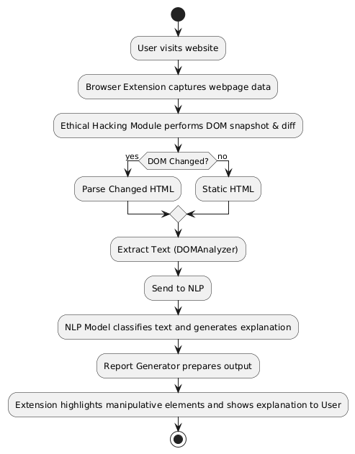
Figure 4.1: The flow diagram of DeceptiTech.
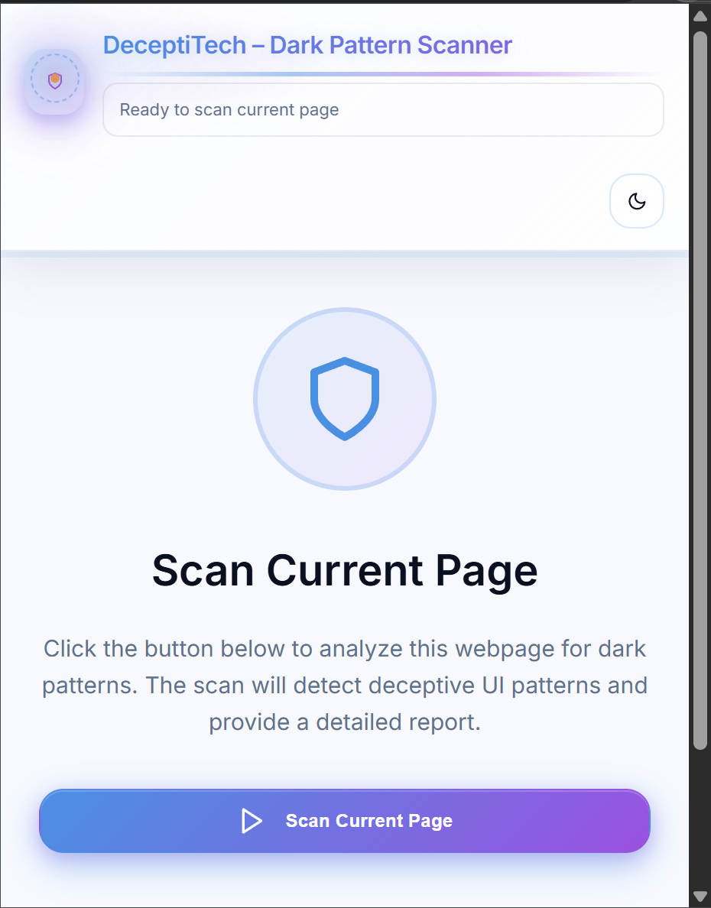
Figure 4.2: DeceptiTech extension popup.
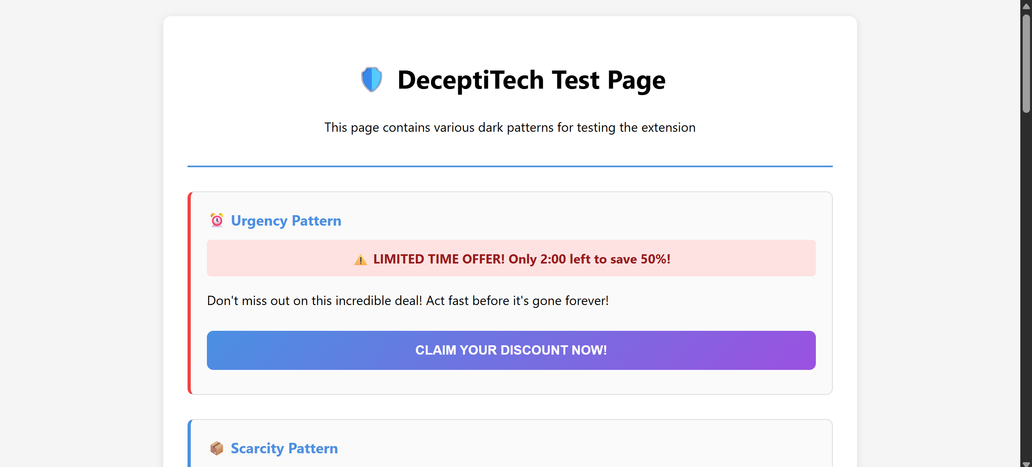
Figure 4.3: DeceptiTech HTML-based test page designed for initial testing.
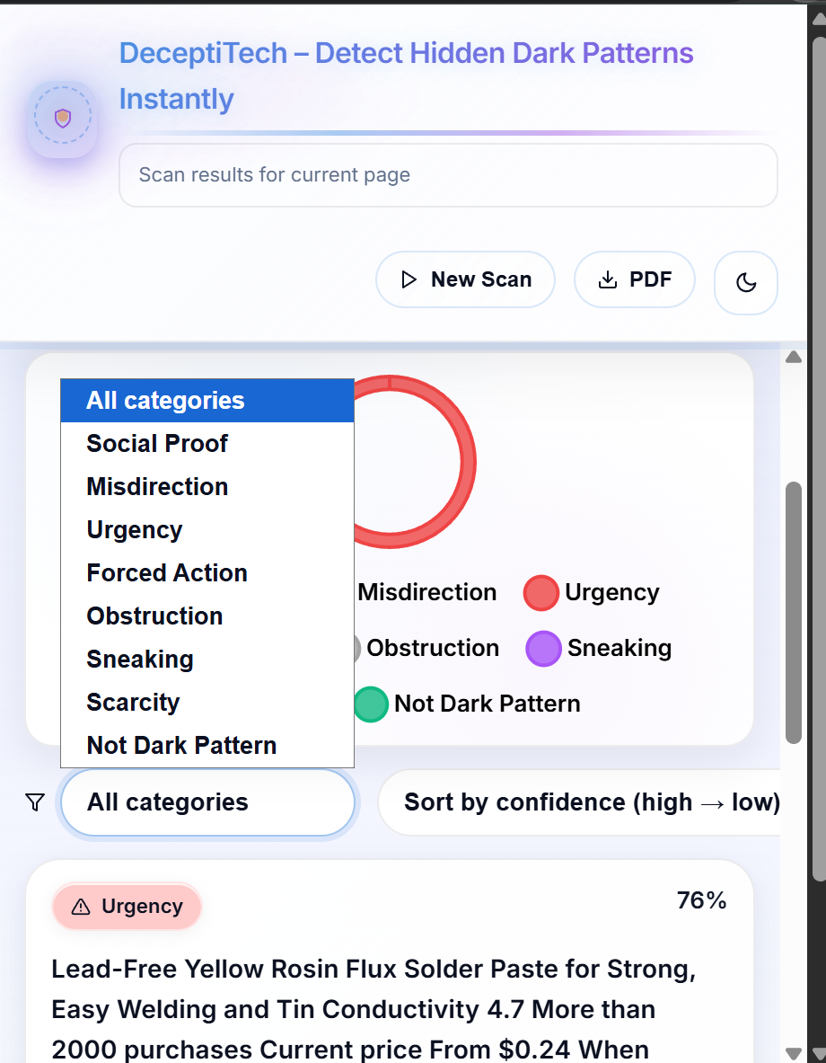
Figure 4.4: DeceptiTech results interface.
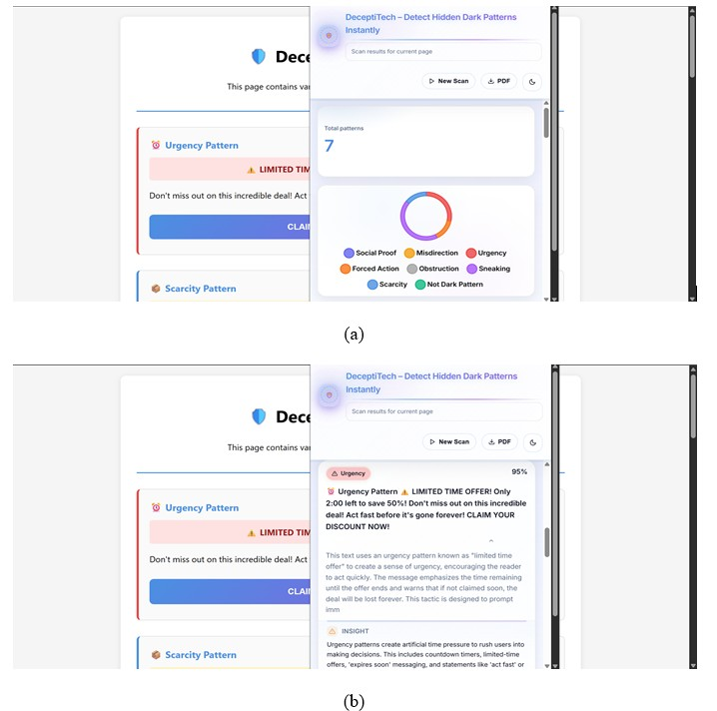
Figure 4.5: DeceptiTech results on the test page.
Table 4.1: DOM priority & heuristic rules.
Category | DOM Rules / Triggers | Examples / Keywords
Scarcity / Urgency | Detect countdown timers, urgency text | “Only 2 left”, “Ends soon”, \d{1,2}:\d{2}
Subscription Traps | Hidden auto-renew terms | “Free trial”, “Auto-renew”, “You will be charged”
Deceptive Opt-Outs | Emotionally manipulative decline buttons | “No, I don’t want savings”, “Reject offer”
Hidden Costs | Extra fees shown late in checkout | “Service fee”, “Added at checkout”
Exclusive/Pressure Language | Manipulative social pressure | “Selected for you”, “Act fast”, “Don’t miss out”
Preselected Inputs | Checkboxes/radio buttons preset without consent | <input checked>, <option selected>
Hidden Active Controls | Elements hidden via CSS but active | opacity:0, display:none
New/Removed DOM Nodes | Suspicious pop-ups, modals, overlays | Sudden pop-up urging decisions
Attribute Manipulation | Suspicious changes in style, disabled, or visibility attributes | Buttons disabled until forced actions

Table 4.2: The performance comparison of different models
Model | Accuracy | Precision | Recall | F1-Score
DeBERTa | 97.2% | 96.2% | 97% | 96.8%
ELECTRA | 96.9% | 96% | 96.5% | 96.4%
DistilBERT | 96.3% | 95.7% | 95% | 96.1%
ALBERT | 95.9% | 96.1% | 95.7% | 96%

Table 4.3: Performance comparison of different configurations for dark pattern classification.
Configuration | Accuracy
Heuristic Only | 81.40%
NLP Only | 93.60%
Hybrid (DOM + NLP) | 97.20%

Appendix A. Acronyms and Abbreviations
AI : Artificial Intelligence
ML : Machine Learning
NLP : Natural Language Processing
LLM : Large Language Model
DOM : Document Object Model
UI : User Interface
UX : User Experience
API : Application Programming Interface
JSON : JavaScript Object Notation
BERT : Bidirectional Encoder Representations from Transformers
DFD : Data Flow Diagram
PERT : Program Evaluation Review Technique
HTML : HyperText Markup Language
CSS : Cascading Style Sheets
SPA : Single Page Application
URL : Uniform Resource Locator

Appendix B. Technology Stack
Programming Languages:
JavaScript (Browser Extension Frontend + DOM Layer)
Python (Backend API, NLP Inference, Heuristics, Explanation Engine)
Frontend Technologies:
React JS (Detection Dashboard & Result Rendering)
Chrome Extension APIs (Manifest V3)
CSS / Material UI (Theme, Styling, Visualization)
Backend Framework:
FastAPI / Flask (NLP Model Serving & Reasoning Layer)
Model Architecture:
Transformer Models - DistilBERT, ELECTRA, ALBERT, DeBERTa (Selected Model)
LLM for Explanation - Qwen2.5-1.5B-Instruct
DOM Monitoring - MutationObserver-based Heuristic Engine
Storage / Data Files:
JSON (Heuristic Rules, Dark Pattern Categories, Explanation Templates)
CSV / Excel (Feedback Logging, Training Dataset Storage)
APIs Used:
Internal FastAPI endpoints for:
• Classification
• Explanation Generation
• Feedback Submission
Tools Used:
VS Code, Jupyter Notebook, Postman, GitHub, Chrome Developer Tools, Hugging Face Transformers
Version Control:
Git & GitHub

