GeoLabel: Community Label Correction System for Geospatial ML
Teja Kattenborn1, Janusch Vajna-Jehle1, Clemens Mosig2
1 Chair of Sensor-based Geoinformatics (GeoSense), University of Freiburg, Germany
2 Institute for Earth System Science and Remote Sensing, Leipzig University, Germany
Date of submission: 2026-02-16
Pilot title | GeoLabel: Community Label Correction System
Project duration | 01-2025 to 12-2025
Contributors | Teja Kattenborn (Conceptualization; Project Administration; Supervision; Writing - Review & Editing), Janusch Vajna-Jehle (Software; Writing - Original Draft), Clemens Mosig (Conceptualization; Writing - Review & Editing)
DOI | To be reserved on Zenodo
Corresponding author | Janusch Vajna-Jehle, janusch.jehle@geosense.uni-freiburg.de
This work has been funded by the German Research Foundation via NFDI4Earth (DFG project no. 460036893, https://www.nfdi4earth.de/).
Abstract
High-quality geospatial labels are a central prerequisite for training and validating machine learning models in Earth System Science. However, current labeling workflows face critical bottlenecks: limited support for large geospatial datasets, insufficient integration of geospatial context, lack of scalable web-based collaboration, and missing audit mechanisms for quality control. Existing tools are often not designed for georeferenced data, do not scale to large prediction layers, and provide limited support for distributed community contributions or AI-assisted editing. GeoLabel addresses these challenges through the development of a scalable, browser-based, and community-driven correction and labeling system for geospatial machine learning outputs. The system enables users to directly review and edit model predictions in a web-based GIS environment, combining interactive polygon editing with optional AI-assisted boundary suggestions. A structured audit workflow ensures that community contributions remain transparent, reversible, and scientifically reliable. The tool architecture integrates database-native vector tile generation, role-based editing and review workflows, and conflict-aware data handling to enable fast rendering and safe collaborative editing of large datasets. By combining high-performance geospatial visualization with AI-assisted labeling and built-in auditability, GeoLabel provides an operational solution to one of the major bottlenecks in geospatial ML: scalable, high-quality, and community-based label refinement. The developed tools are showcased on the deadtrees.earth platform using high-resolution orthomosaics as a real-world application case. In this context, GeoLabel enables the correction and refinement of model predictions for deadwood detection and forest cover mapping. This deployment demonstrates how large-scale orthomosaic-based segmentation outputs can be collaboratively reviewed and improved in a fully web-based environment, providing a transferable template for similar Earth observation workflows across domains.
- Introduction
Machine learning (ML) methods have become a cornerstone of Earth System Science (ESS), enabling large-scale mapping, monitoring, and modeling of complex environmental processes from remote sensing data. Applications range from vegetation structure and species mapping to disturbance detection, land cover classification, and ecosystem monitoring across spatial scales. However, the performance, transferability, and interpretability of these models critically depend on the availability of high-quality, geospatially explicit labels.
Despite rapid advances in model architectures and computational infrastructure, the generation and curation of reliable training and validation data remain major bottlenecks. In many ESS domains, labels are sparse, inconsistently formatted, spatially biased, or not preserved with sufficient metadata. Moreover, labeling workflows are often fragmented across tools that were not designed for large, georeferenced datasets. Conventional annotation software typically operates on small, non-geocoded image subsets, limiting spatial context, reducing interoperability, and complicating downstream reuse. As a result, researchers frequently resort to ad hoc workflows that combine GIS software, local scripts, and manual data handling—processes that are time-consuming, difficult to reproduce, and hard to scale.
Several core challenges can be identified:
- Scalability: Large orthomosaics, satellite time series, and dense prediction layers exceed the capacity of many conventional labeling tools. Efficient visualization and editing of millions of geometries require database-native and tile-based solutions.
- Geospatial context: Labels must remain spatially explicit, interoperable, and compatible with standard geospatial formats to enable reuse across tasks and resolutions. Currently, most labeled datasets are created on tiles with fixed size (e.g. 512x512 pixels) without geocoordinates, making reuse with different settings difficult.
- Collaboration: Distributed community contributions are increasingly important, yet most tools lack robust role management, conflict handling, and web-based accessibility.
- Auditability and quality control: Open contribution models require structured review, versioning, and revert mechanisms to ensure scientific reliability.
- AI-assisted workflows: While automated segmentation models exist, few systems tightly integrate AI-assisted boundary refinement into interactive, browser-based editing environments. AI-assisted labeling could substantially reduce manual labeling effort.
GeoLabel addresses these bottlenecks by developing a scalable, web-based, and community-driven correction and labeling system for geospatial ML outputs. Rather than treating labeling as an isolated preprocessing step, GeoLabel integrates prediction review, correction, and audit mechanisms directly into a browser-accessible GIS workflow. The system is designed to handle large prediction layers derived from high-resolution Earth observation data, while preserving full geospatial context and metadata.
Technically, GeoLabel combines efficient browser-based visualization with role-based editing and review workflows. Corrections are stored separately from the original predictions, enabling reversible edits, structured approval processes, and full audit trails. AI-assisted segmentation can be optionally activated to support boundary delineation, improving efficiency without sacrificing transparency.
The pilot demonstrates this workflow in a real-world Earth observation context using high-resolution orthomosaics, where deadwood and forest cover predictions are collaboratively reviewed and refined in high-resolution drone imagery. By embedding correction tools directly within an operational platform, GeoLabel moves beyond conceptual tool design and provides a functional example of scalable, community-based geospatial label refinement.
- Results
  - Implemented Solution
GeoLabel is implemented as a public correction workflow integrated into deadtrees.earth. Users review model predictions on high-resolution orthomosaics and propose edits directly on the map. The correction workflow is designed around two complementary roles: contributors propose edits through an interactive browser-based editor, while auditors review pending changes, approve or revert them, and maintain a clear audit trail.
In practical terms, the workflow connects several steps that are often separated across different tools: map-based visualization of model outputs, interactive geometry editing, structured submission of proposed changes, and moderator-style review. Contributors work directly against the prediction layer rather than exporting data into desktop GIS software, which lowers the technical barrier for participation and reduces format conversions. Auditors, in turn, can focus on validating changes in a dedicated review interface that preserves context about the original geometry, the proposed modification, and the current review status.
The implemented solution also supports the needs of an operational platform rather than a one-off annotation task. The same workflow can be applied repeatedly as new prediction layers are generated, corrections accumulate over time, and multiple contributors work on the same region or layer type. This makes GeoLabel suitable not only for producing improved labels, but also for maintaining living, quality-controlled correction layers that can feed back into future model development and evaluation.
Another practical advantage of this implementation is that it supports incremental improvement rather than requiring a fully curated dataset from the outset. Existing model outputs can be published quickly, community corrections can begin immediately, and review can proceed continuously as activity grows. This creates a realistic pathway for scaling geospatial label refinement in research settings where data volumes are large, expert time is limited, and platform usage evolves over months rather than days.
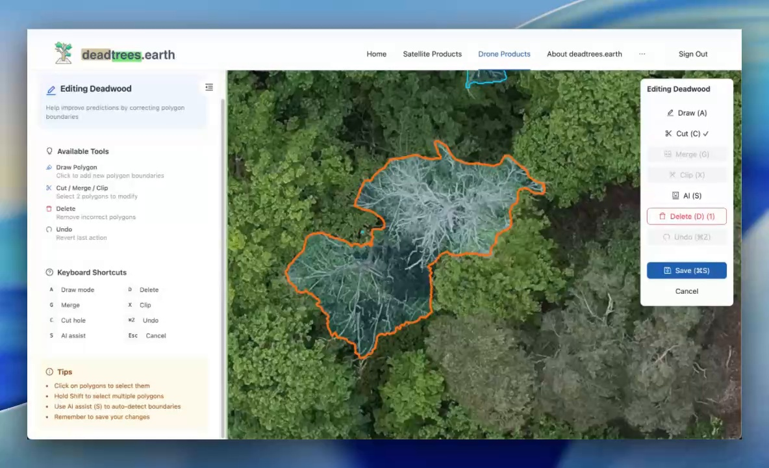
GeoLabel editing interface on deadtrees.earth
The GeoLabel editing interface on deadtrees.earth, showing the polygon editor with available tools, keyboard shortcuts, and an active correction on a high-resolution orthomosaic.
At the interface level, the implementation emphasizes spatial context and action clarity. Contributors can inspect the orthomosaic, the currently selected polygon, and the available editing operations in one view without switching modes or opening separate dialogs. This is particularly useful for correction tasks in forest scenes, where subtle edge decisions often depend on surrounding canopy structure, shadows, neighboring crowns, or deadwood fragments that would be difficult to judge in a cropped tile-only workflow.
  - Editing Tools
The editor provides a comprehensive set of polygon editing tools for correcting model predictions. All edits are stored as corrections linked to the original predictions, preserving the source data while tracking every change with full audit metadata.
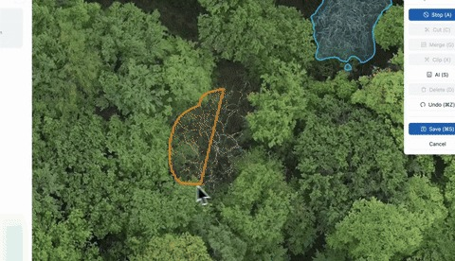  Freehand draw. | 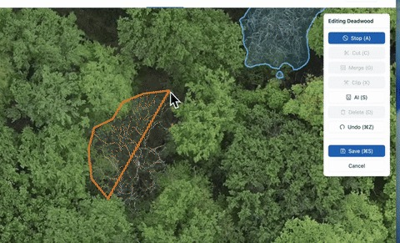  Click draw. | 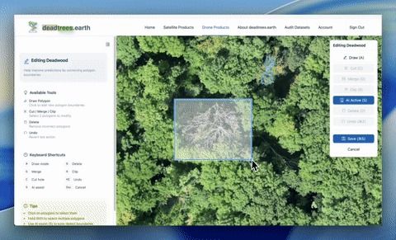  AI boundary assist. | 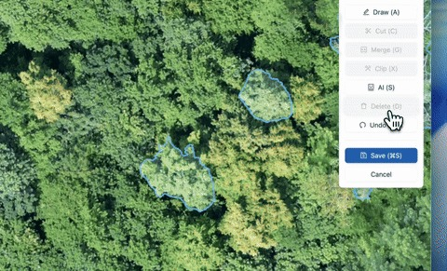  Delete polygon.
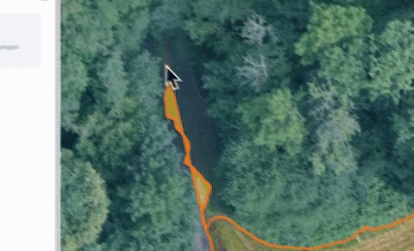  Cut hole. | 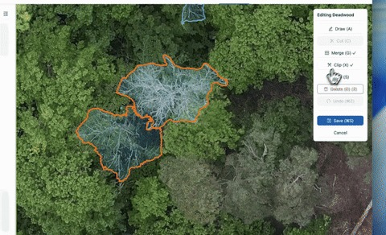  Merge polygons. | 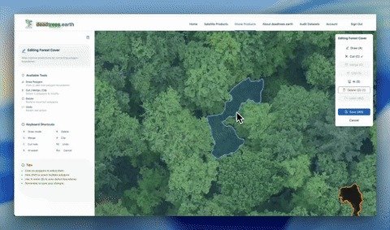  Clip polygons. | 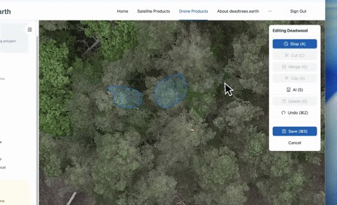  Undo action.
Keyboard shortcuts support fast, friction-free editing:
Key | Action | Key | Action
A | Draw mode | S | Toggle AI assist
D | Delete selection | Ctrl/Cmd+Z | Undo
G | Merge polygons | Ctrl/Cmd+S | Save
X | Clip polygons | Esc | Cancel editing
C | Cut hole
  - Correction Lifecycle
The correction lifecycle is designed to make community contributions auditable and reversible. Contributors submit corrections in pending status; auditors then approve or revert them as part of a structured review process.
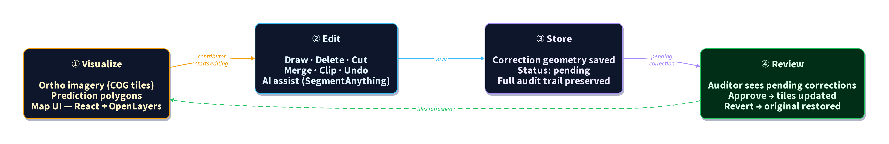
GeoLabel correction lifecycle: pending → approve / revert
Conceptual correction lifecycle: corrections are stored with review status and applied in a reversible manner (e.g., inserts and soft-deletes), enabling safe community editing with formal review.
  - Audit and Approval Workflow
Auditors review pending corrections in an audit UI and can approve or revert changes to preserve data quality.
This review step is central to the quality-control concept of the pilot. Rather than immediately overwriting the visible prediction layer, proposed edits remain pending until they are checked by an auditor. This creates a lightweight moderation workflow suitable for community contributions: contributors can work independently at scale, while domain experts or project coordinators retain a clear mechanism for curation. The result is a balanced design in which openness and participation are encouraged, but the scientific reliability of the resulting labels is still protected through explicit review decisions.
In operational terms, this also improves maintainability. Reviewers can process changes in batches, focus attention on ambiguous areas, and preserve a shared standard for how deadwood and forest cover objects should be interpreted. Over time, the audit trail therefore becomes not only a record of edits, but also a record of how annotation conventions were applied and stabilized within the project.
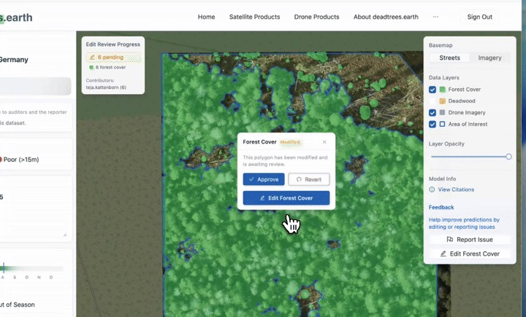
Approving pending corrections in the audit UI
Representative frame from the audit workflow, showing approval of pending corrections.
  - Architecture
The system architecture combines database-native vector tile generation with a structured correction workflow, enabling fast rendering of large prediction layers and safe collaborative editing.
At a technical level, the architecture links a React/OpenLayers frontend, a FastAPI backend, and a PostgreSQL/PostGIS database into a single correction pipeline. The frontend is responsible for responsive interaction and geometry editing, the API layer exposes save/approve/revert logic, and the database serves both as the source of truth for geometries and as the tile-generation engine for map display. This distribution of responsibilities keeps the interface responsive while ensuring that edits, permissions, and review states are handled consistently on the server side.
An important implementation choice was to avoid a detached export-import workflow and instead keep visualization and persistence tightly coupled. The same corrected geometries that are edited through the browser are immediately available to tile generation, status-aware rendering, and downstream analysis. This reduces synchronization errors, minimizes duplicated storage, and makes the system easier to operate as part of a continuously updated public platform.
This architectural choice is especially relevant for large orthomosaic-based datasets, where copied annotation files quickly become difficult to synchronize with the authoritative data source. By centering the workflow on one database-backed representation of predictions and corrections, GeoLabel reduces the risk of divergence between what users see on the map, what is stored in the system, and what is exported for later analysis. The design therefore improves both technical robustness and traceability.
At the same time, the architecture remains lightweight enough to be transferable. It does not depend on a specialized standalone labeling backend, but instead builds on widely used web and geospatial components that can be combined in a reproducible way. This makes the pilot easier to understand, extend, and potentially adapt in other Earth observation settings where similar review workflows are needed.
From a systems perspective, this also means that performance and governance are handled together rather than as separate concerns. Fast rendering alone is not sufficient for a public correction platform if review status, provenance, and reversibility are not represented in the same data flow. GeoLabel therefore treats visualization, editing, and audit metadata as parts of a shared operational architecture instead of independent modules stitched together after the fact.
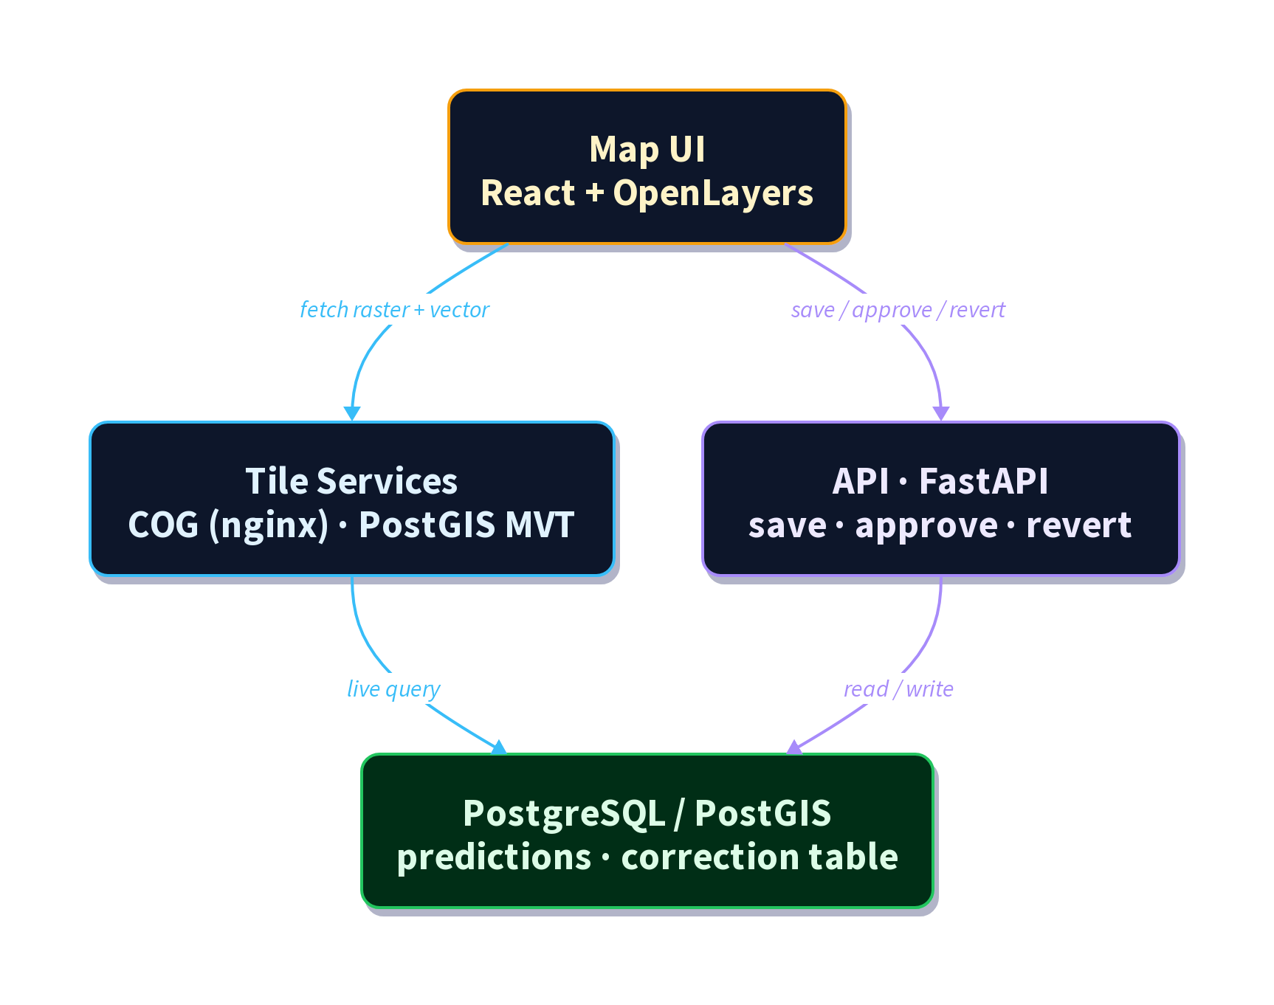
GeoLabel architecture: visualize, edit, store, review workflow
GeoLabel correction workflow architecture (visualize → edit → store → review) with correction status feeding back into database-native vector tiles.
Key architectural decisions:
- Database-native vector tiles: Prediction geometries are rendered as vector tiles generated directly in PostGIS using ST_AsMVT, avoiding the need for a separate tile server. Tiles include correction status metadata, enabling visual distinction between pending and approved edits.
- Correction-based editing: Edits are stored in a dedicated correction table rather than modifying predictions directly. Original geometries are soft-deleted (flagged, not removed), making every change fully reversible.
- Audit workflow: Corrections start with pending status. Auditors can approve (making changes permanent) or revert (restoring original geometries and removing additions). The full edit history, including contributor, timestamp, and session, is preserved.
- AI-assisted segmentation: Users can optionally activate SegmentAnything to propose polygon boundaries. The ortho raster is cropped client-side, sent to an external SAM API, and returned polygons are added to the editor as regular edits.
- Multi-layer support: The same correction workflow applies to both deadwood and forest cover prediction layers, with layer-specific vector tile endpoints and shared correction infrastructure.
  - Data and Software availability
- Platform: https://deadtrees.earth
- Backend repository (public, MIT): https://github.com/Deadwood-ai/deadtrees-backend
- Frontend repository: https://github.com/Deadwood-ai/deadtrees-frontend
- Pilot documentation: docs/projects/geolabel/
The platform provides open access to datasets, prediction layers, and the GeoLabel correction workflows. Documentation includes user guidance, technical overviews, and detailed descriptions of the correction workflow.
From a reuse perspective, the pilot combines openly accessible platform components with public code repositories that document the technical implementation. The web platform exposes the practical user-facing workflow, while the repositories provide the underlying application logic and architectural design choices. This combination is important because reproducibility in this context depends not only on downloadable code, but also on being able to understand how editing, approval, and data serving are integrated in an operational geospatial application.
The availability of both a live demonstrator and public repositories also lowers the threshold for different audiences. End users can evaluate the workflow through direct interaction with the platform, while technically oriented users can inspect the implementation details and reuse specific components. In this sense, the pilot offers not only software availability, but also workflow transparency, which is essential for broader adoption within the community.
Core data and software assets include:
- PostGIS-backed vector tile generation for large-scale prediction layers.
- Correction history stored in a dedicated table with review metadata and session tracking.
- Supabase RPC functions that expose database logic as API endpoints for save, approve, and revert operations.
  - Innovation and FAIRness
The key innovation is a community-first, audit-ready correction system applied directly to model outputs, rather than isolated labeling tasks. This approach supports:
- Findability and accessibility: open access to datasets and corrections via a public platform.
- Interoperability: PostGIS-based geospatial standards and APIs; use of common geospatial data formats for labelled data (geopackage and GeoTIFF format).
- Reusability: corrections are tracked, reviewed, and preserved with history, supporting downstream model training and validation.
GeoLabel also demonstrates a scalable approach to collaborative labeling that can be adapted to other domains in Earth System Science. Its modular architecture allows the integration of different data types, prediction layers, and labeling tasks without fundamental changes to the core system. By combining database-native geospatial processing, browser-based editing, and structured audit workflows, the approach can be transferred to applications such as land cover mapping, habitat delineation, cryosphere monitoring, or coastal change detection. This flexibility makes GeoLabel not only a domain-specific solution, but a generalizable framework for community-driven, AI-assisted geospatial data curation
Compared with conventional annotation pipelines, the main novelty is that FAIR-oriented data handling is embedded directly into the correction workflow rather than added afterwards. Provenance is retained through explicit correction records, reversibility is preserved through soft-delete and review states, and interoperability is maintained because the workflow remains grounded in geospatial database objects and standard spatial formats. In this sense, the system does not simply produce labels; it produces traceable, reviewable, and reusable correction knowledge that can be shared across researchers, projects, and future model iterations.
- Challenges and Gaps
The main technical challenge was balancing high-performance visualization with direct, editable data access. Several iterations were required:
- Copy-based editing (used in the reference data editor). This approach is reliable but slow for large datasets and leads to heavy data duplication.
- Database-native vector tiles and edit workflows. The final solution generates vector tiles directly in the database and exposes PostGIS functions as API endpoints. This allows fast rendering and direct editing without full dataset copies.
Additional challenges included:
- Designing a robust audit workflow for community contributions.
- Ensuring edits remain reversible and auditable to preserve data quality.
- Optimizing caching and tile refresh to avoid stale visuals after edits.
The final system resolves these issues by combining PostGIS MVT generation with Supabase RPC functions for save/approve/revert workflows and a review queue for auditors.
- Relevance for the community and NFDI4Earth
The GeoLabel team has been highly active in presenting and discussing the pilot at international conferences, workshops, and community meetings, with a strong focus on research data management (RDM), FAIR principles, and scalable geospatial infrastructures. The underlying concepts, system architecture, and demonstrator use case were continuously communicated to both the Earth System Science and NFDI communities, fostering dialogue on collaborative labeling and AI-ready data workflows. In addition, the conceptual and methodological foundations and application context have been formalized in peer-reviewed publications, strengthening the scientific visibility and long-term impact of the initiative.
Community uptake indicators (last 12 months):
- 7,472 datasets submitted
- 166 unique submitters
- 18,155 unique users (based on distinct pageview users)
Outreach and visibility include:
- Joint NFDI4Earth & NFDI4Biodiversity Plenary 2025 (Bremen) on the GeoLabel pilot
- SmartForest 2025: deadtrees.earth: Crowd-Sourced Imagery and AI for Global Insights into Tree Mortality Dynamics
- Dreilaendertagung 2025: From Local Drones to Global Insights: AI-Driven Tree Mortality Mapping with Remote Sensing
- EGU 2025 & EGU 2026 talks on the deadtrees.earth platform and related RDM activities
- Living Planet Symposium 2025 and BioSpace 2025 presentations
- International Tree Mortality Network seminar (2024)
Publications:
Mosig, C., Vajna-Jehle, J., Mahecha, M. D., Cheng, Y., Hartmann, H., Montero, D., Junttila, S., Horion, S., Schwenke, M. B., ... & Kattenborn, T. (2026). deadtrees.earth – An open-access and interactive database for centimeter-scale aerial imagery to uncover global tree mortality dynamics. Remote Sensing of Environment, 332, 115027. https://doi.org/10.1016/j.rse.2025.115027
Möhring, J., Kattenborn, T., Mahecha, M. D., Cheng, Y., Beloiu Schwenke, M., Cloutier, M., Denter, M., Frey, J., Gassilloud, M., Göritz, A., Hempel, J., Horion, S., Jucker, T., Junttila, S., Khatri-Chhetri, P., Korznikov, K., Kruse, S., Laliberté, E., Maroschek, M., Neumeier, P., Pérez-Priego, O., Potts, A., Schiefer, F., Seidl, R., Vajna-Jehle, J., Zielewska-Büttner, K., & Mosig, C. (2025). Global, multi-scale standing deadwood segmentation in centimeter-scale aerial images. ISPRS Open Journal of Photogrammetry and Remote Sensing. https://doi.org/10.1016/j.ophoto.2025.100104
These activities demonstrate active engagement with the Earth System Science community and provide multiple entry points for collaboration and adoption.
- Future Directions
GeoLabel establishes a robust public correction workflow, but there is still substantial opportunity for growth. The pilot shows that community labeling at scale is feasible when performance, auditability, and usability are addressed together. The next steps focus on strengthening adoption, expanding feature coverage, and ensuring long-term sustainability:
- Expand correction workflows to additional label types and domains.
- Improve analytical tooling around correction impact and reviewer throughput.
- Provide enriched dataset metadata and tighter linkage to publications.
- Support broader integration into external workflows and third-party systems.
- Continue outreach to grow the contributor base and diversify geographic coverage.
- Integrate crowd-sourced labels into active supervised AI training workflows.

