Home Page

Logo

Button
Password Input
Button
Button
Password Input
Button

Login Page

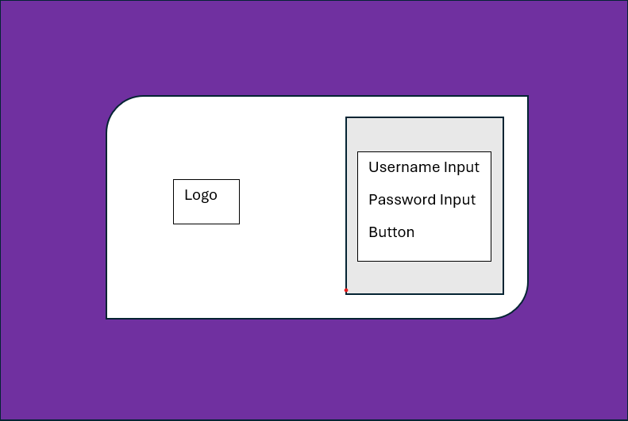

Register Page



Button
Input Box
Chatbot Page

