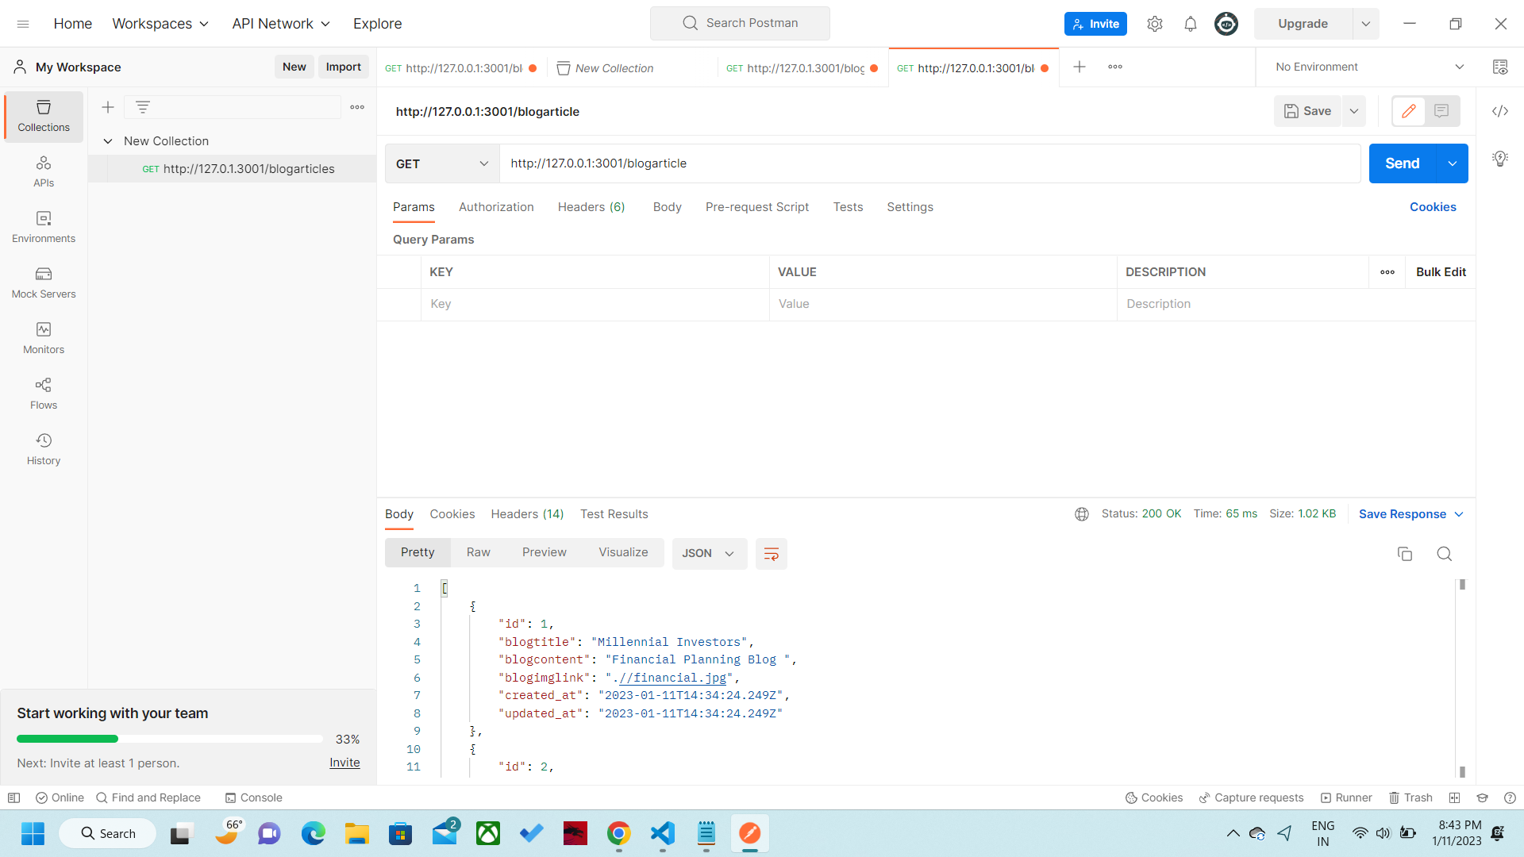
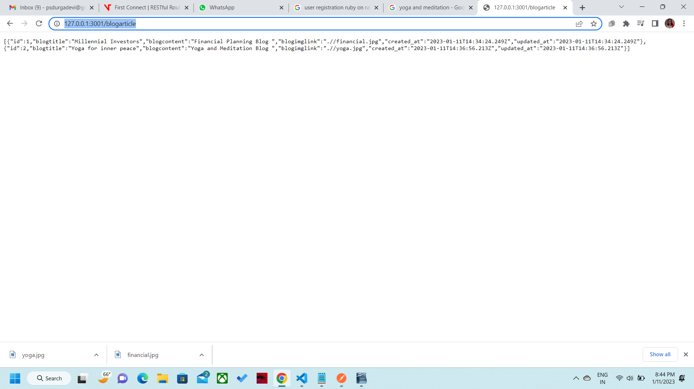
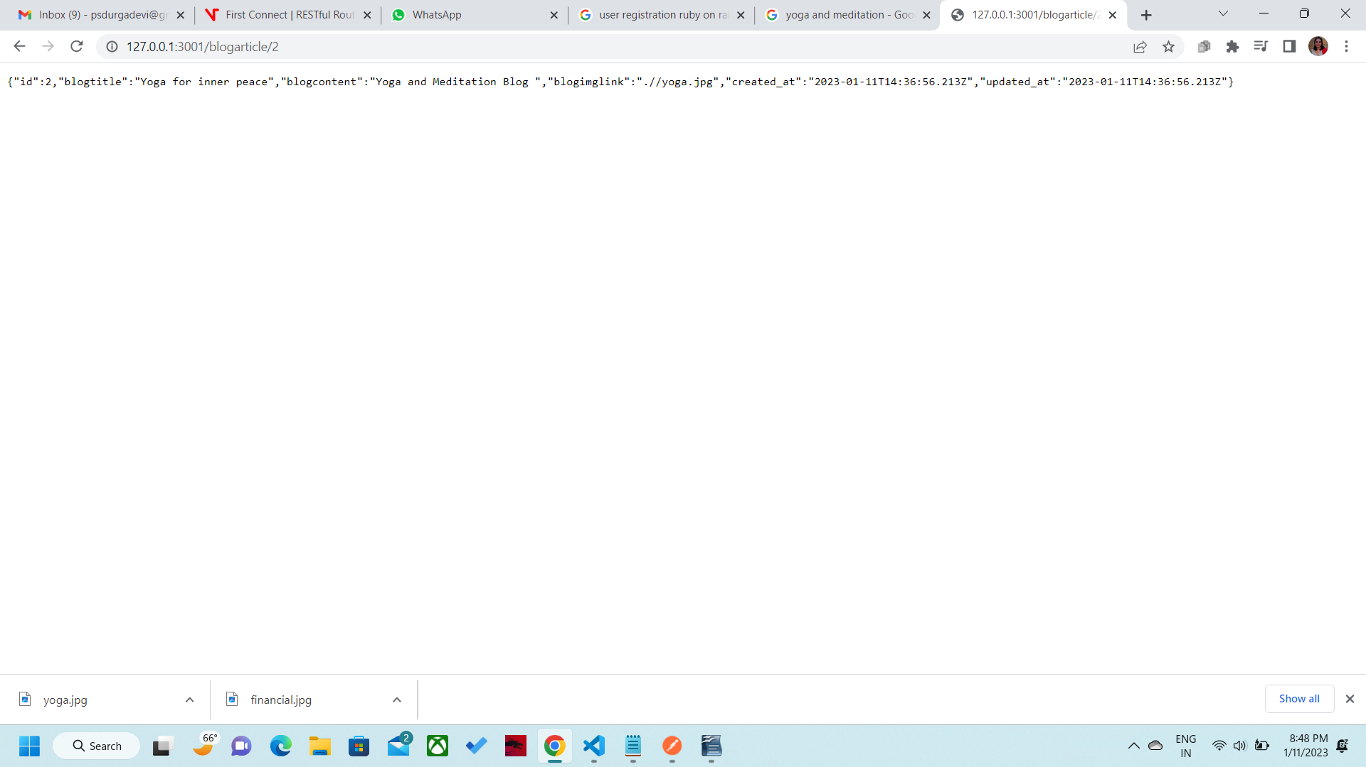
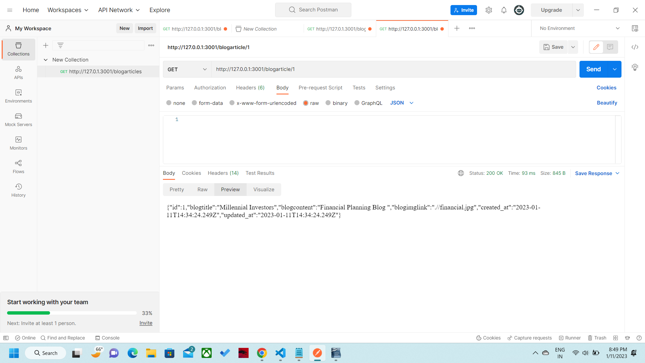
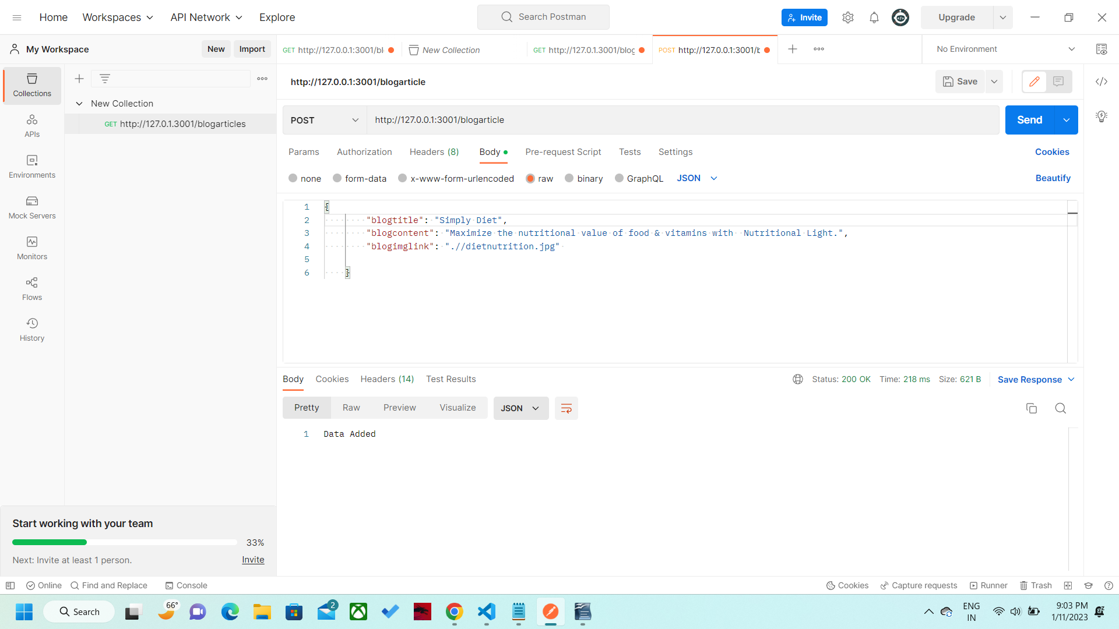
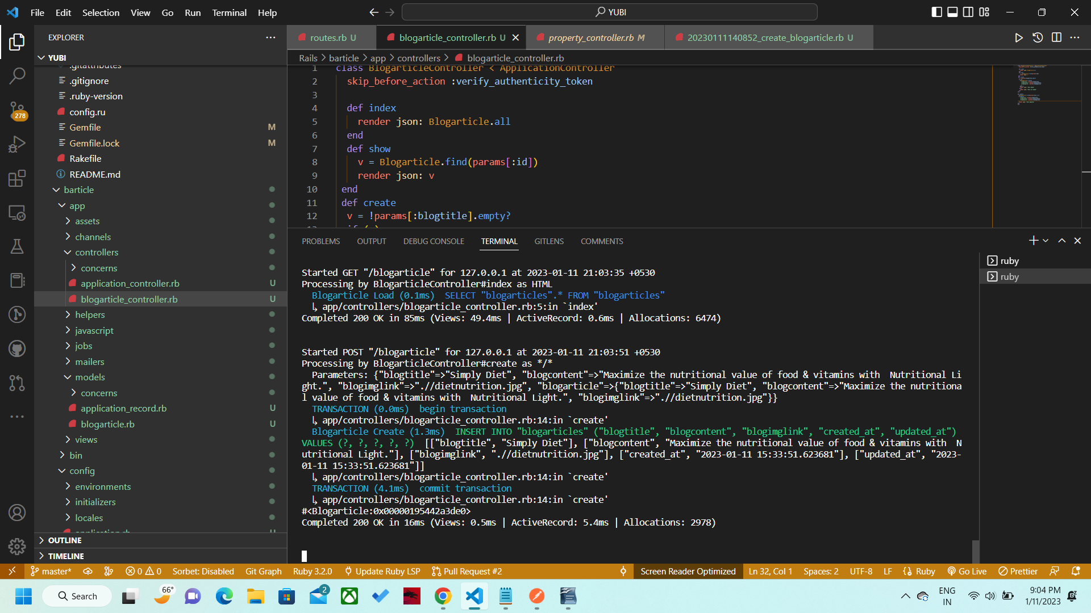
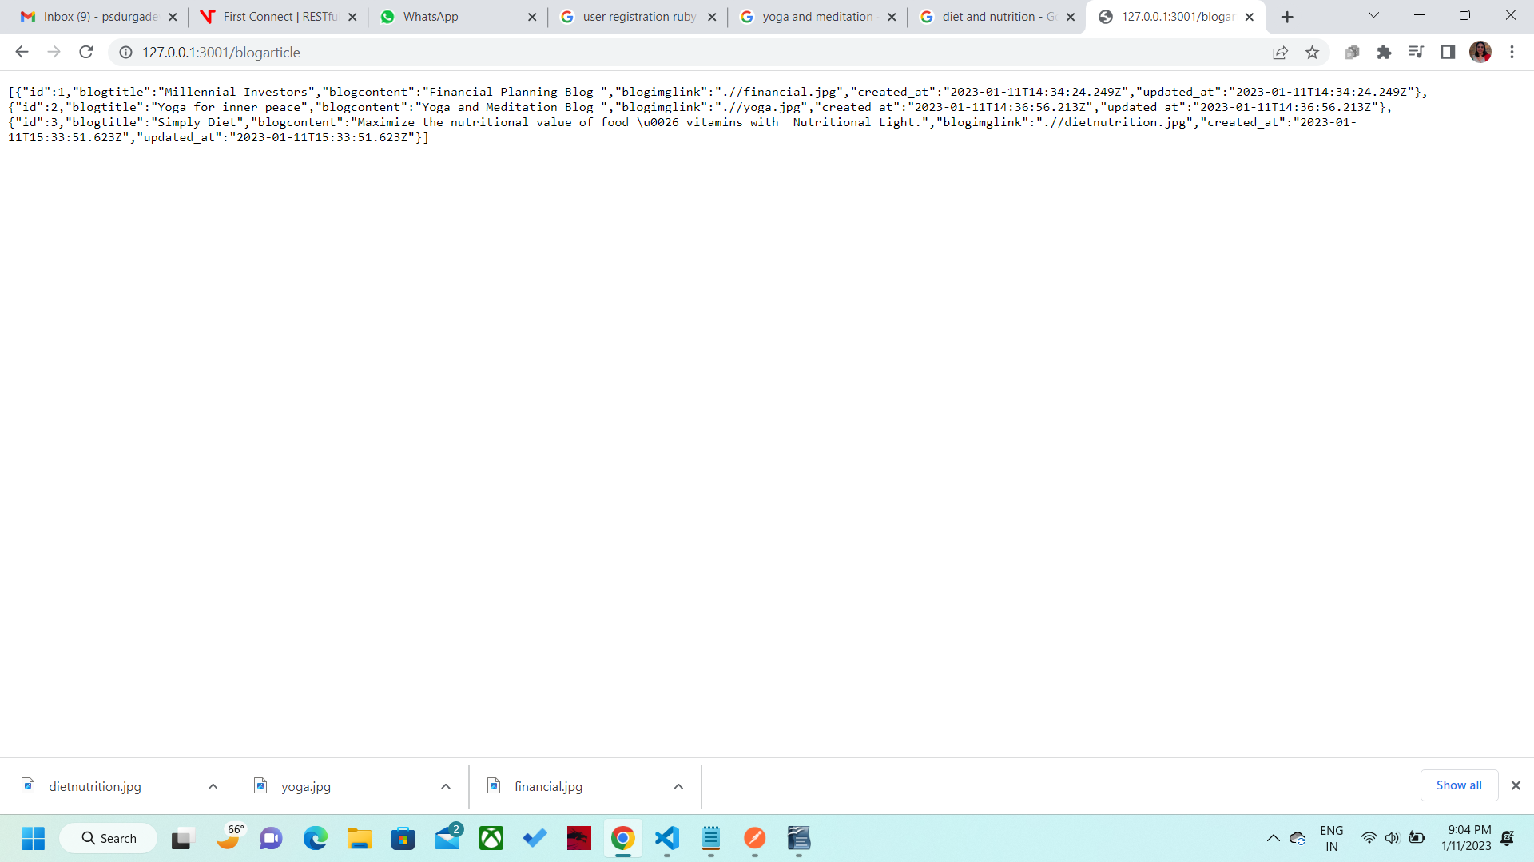
Second record edited with same values 3rd record. Now again editing with new values.
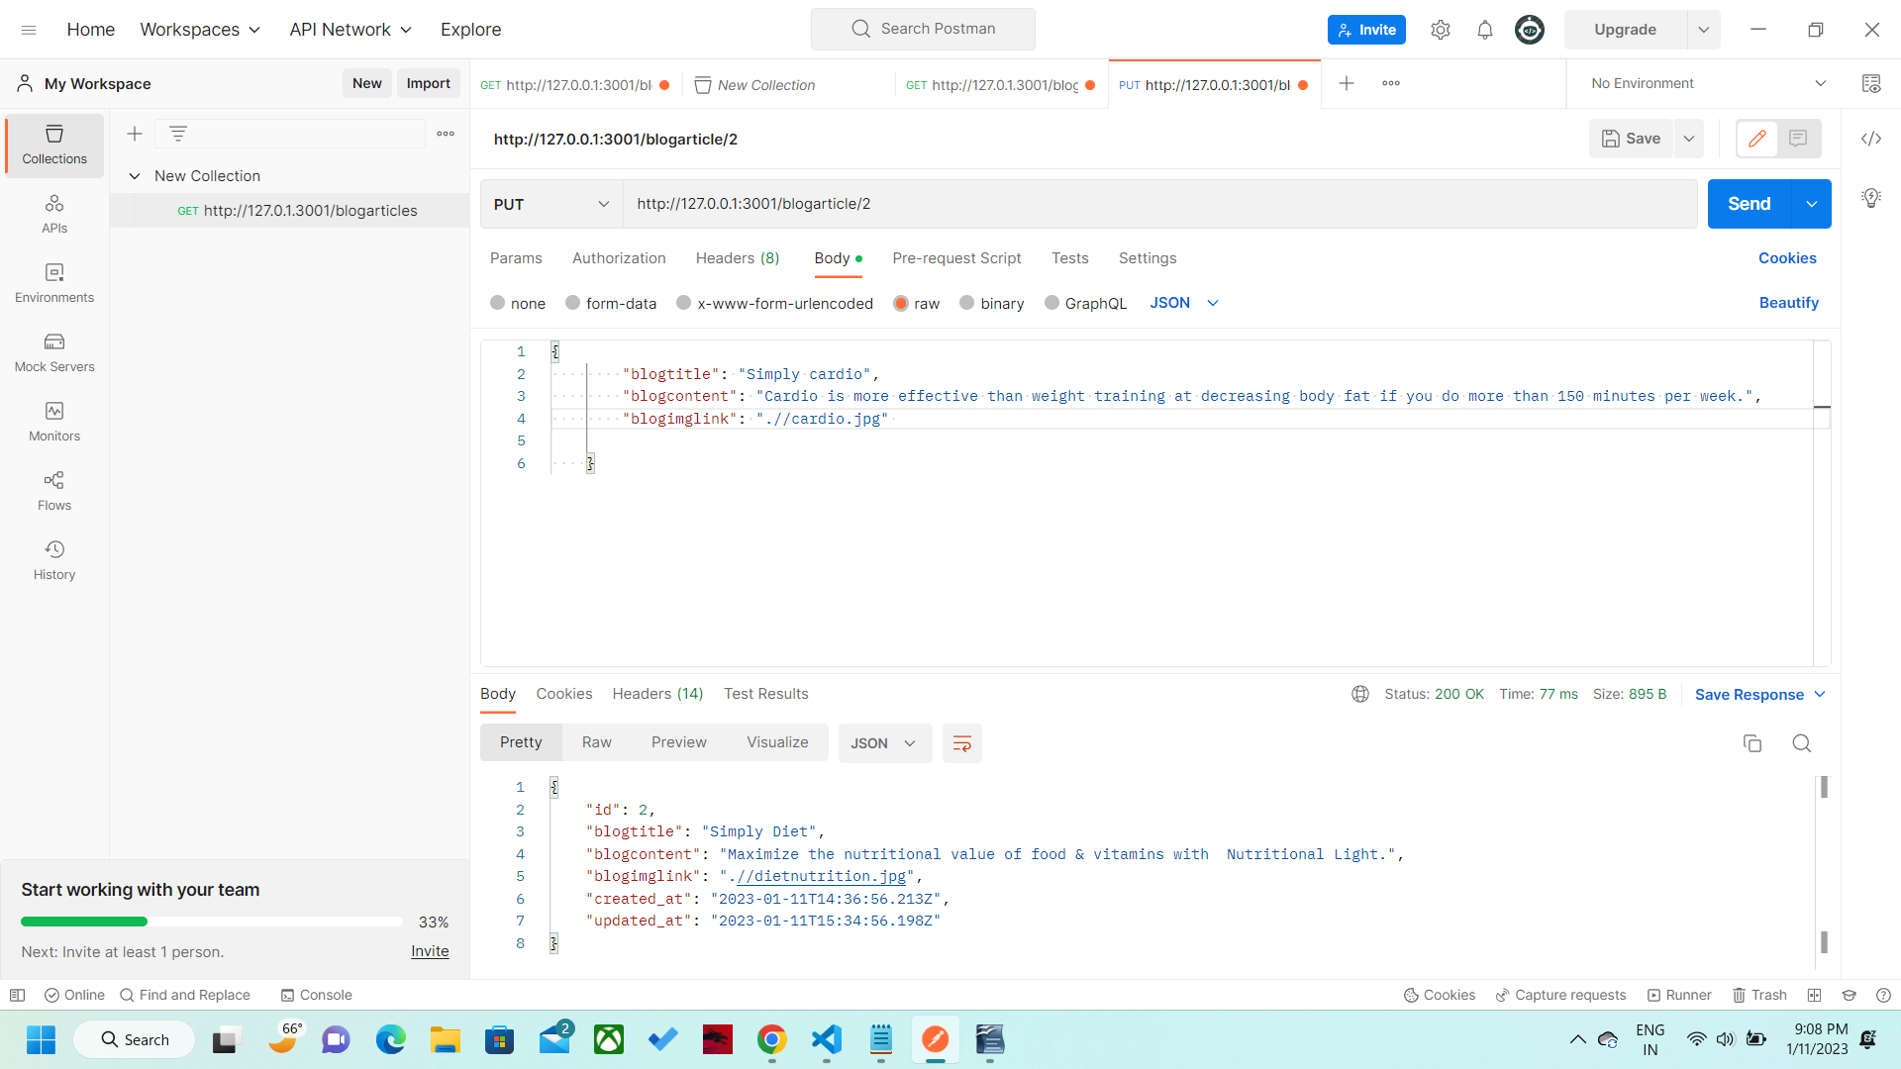
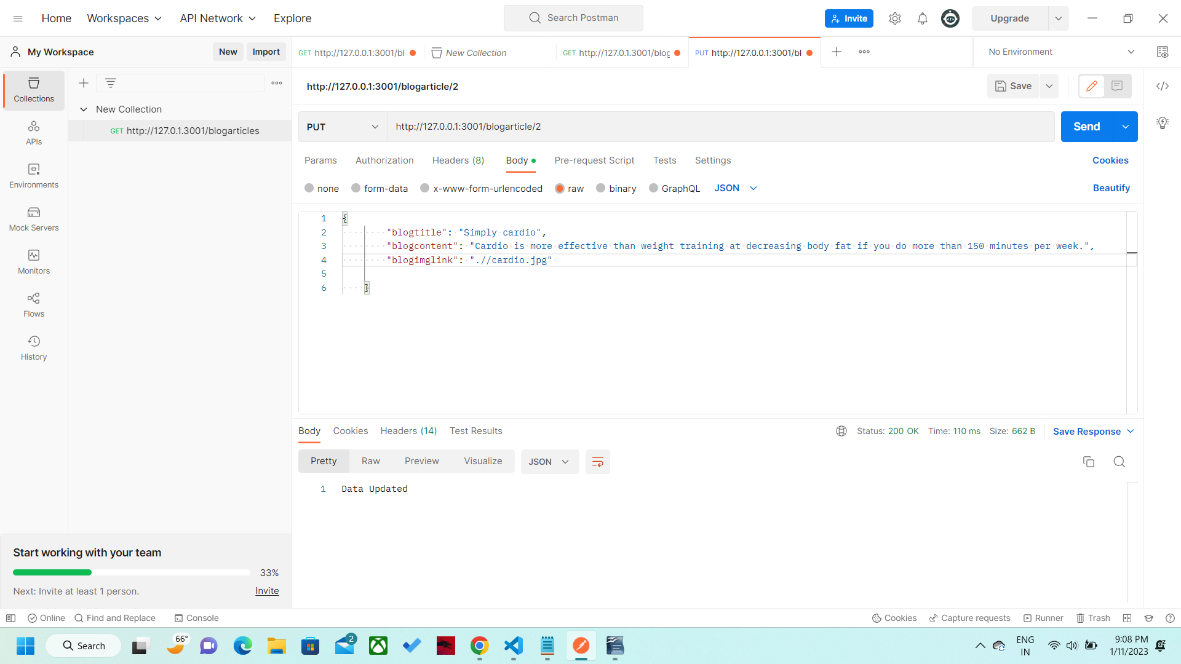
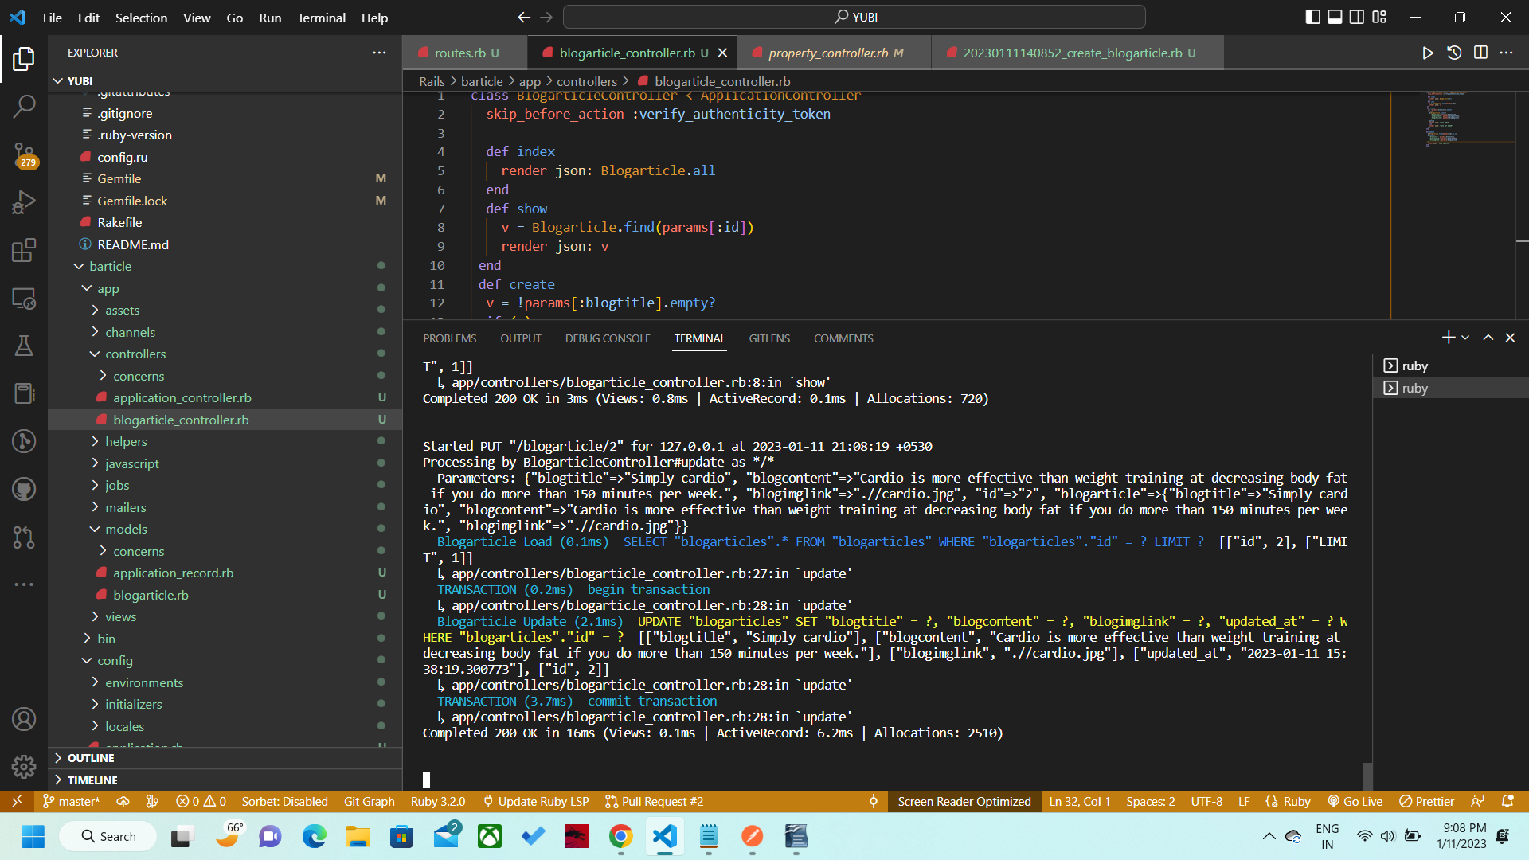
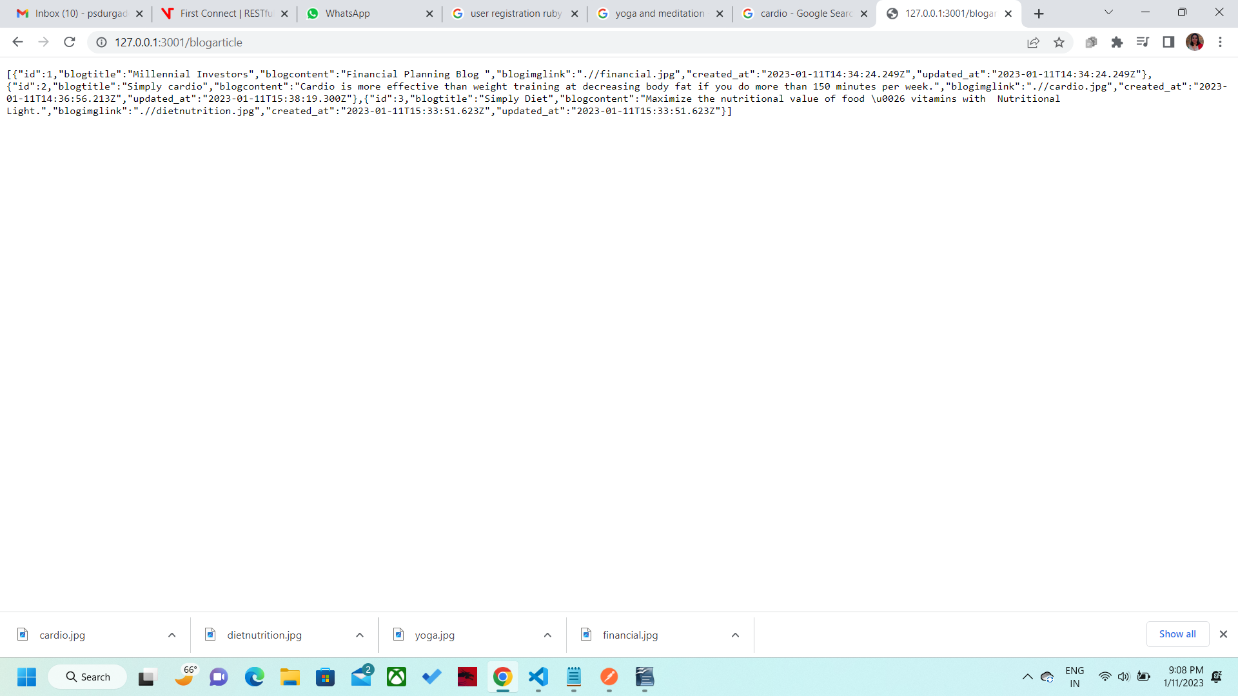
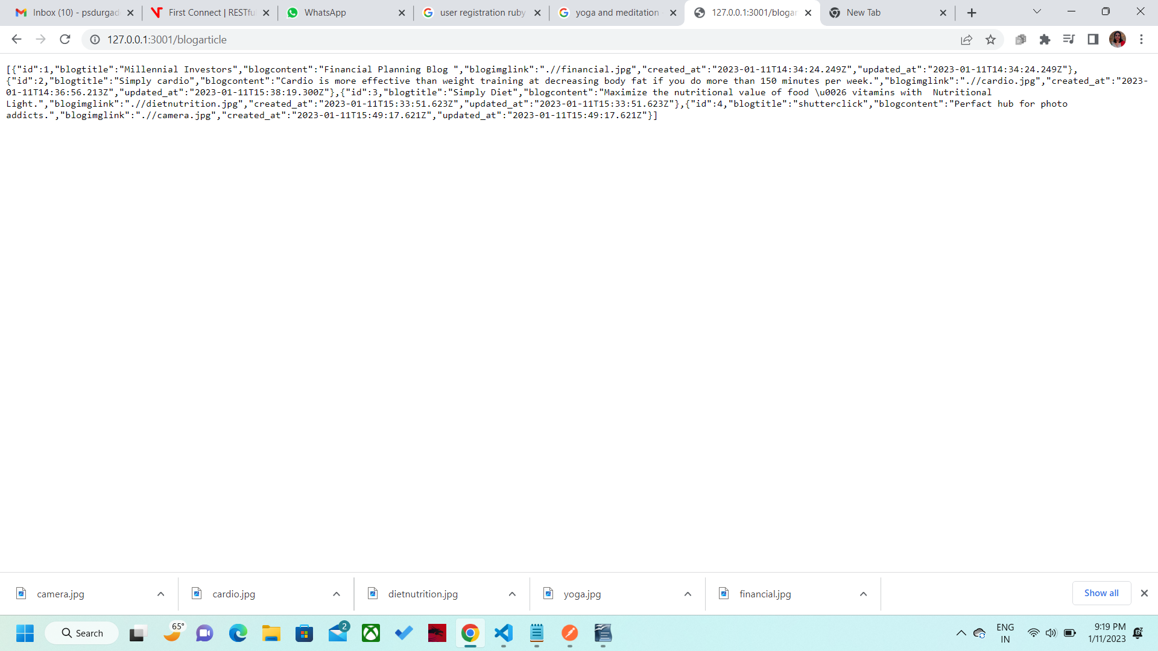
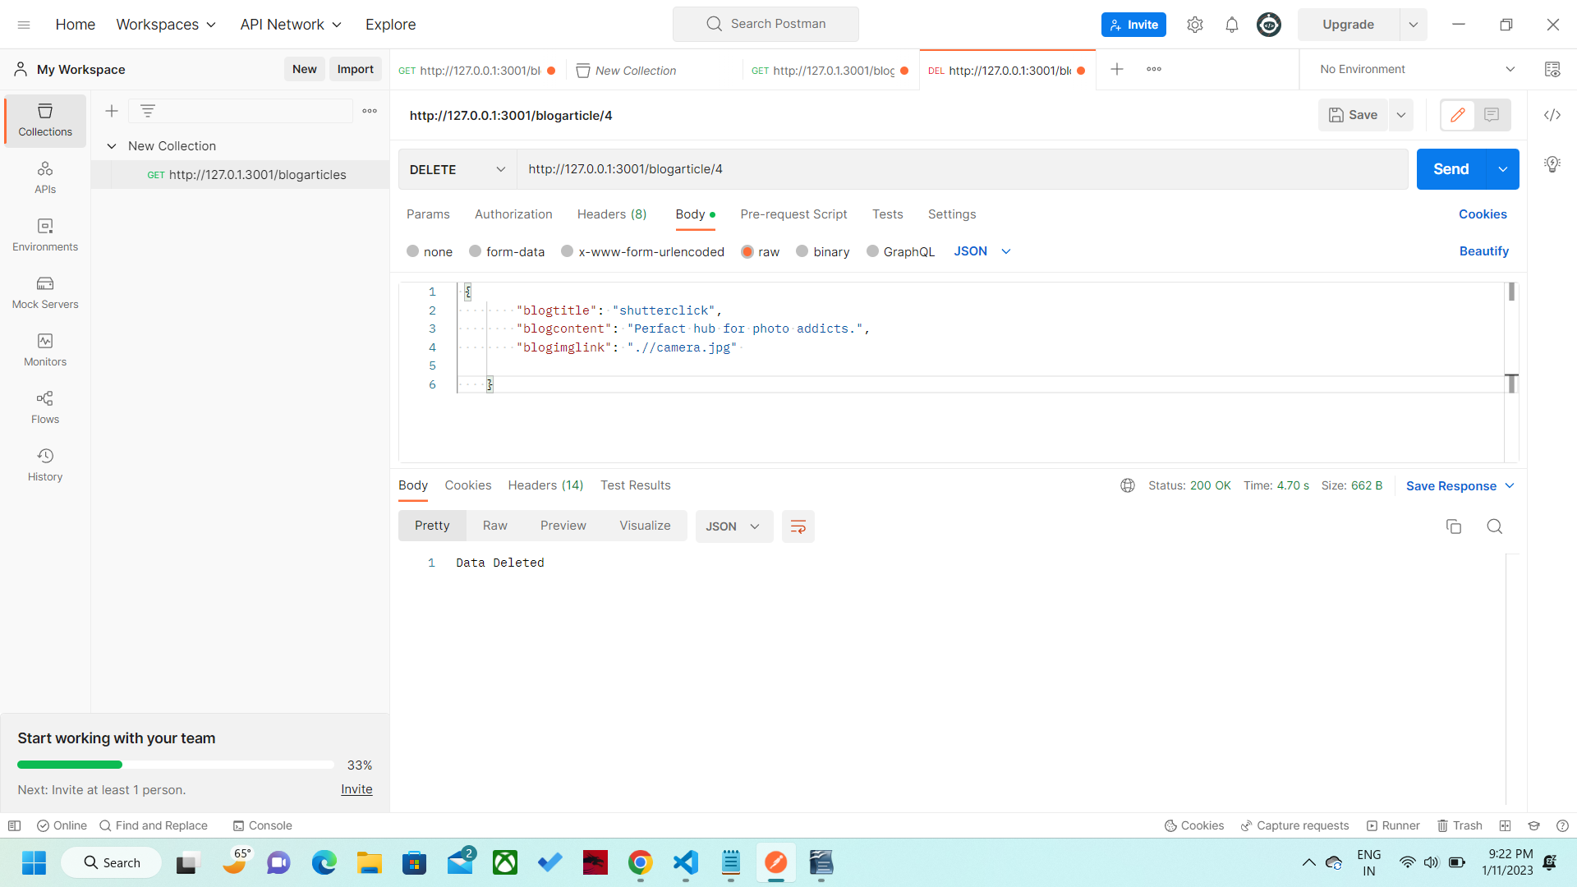
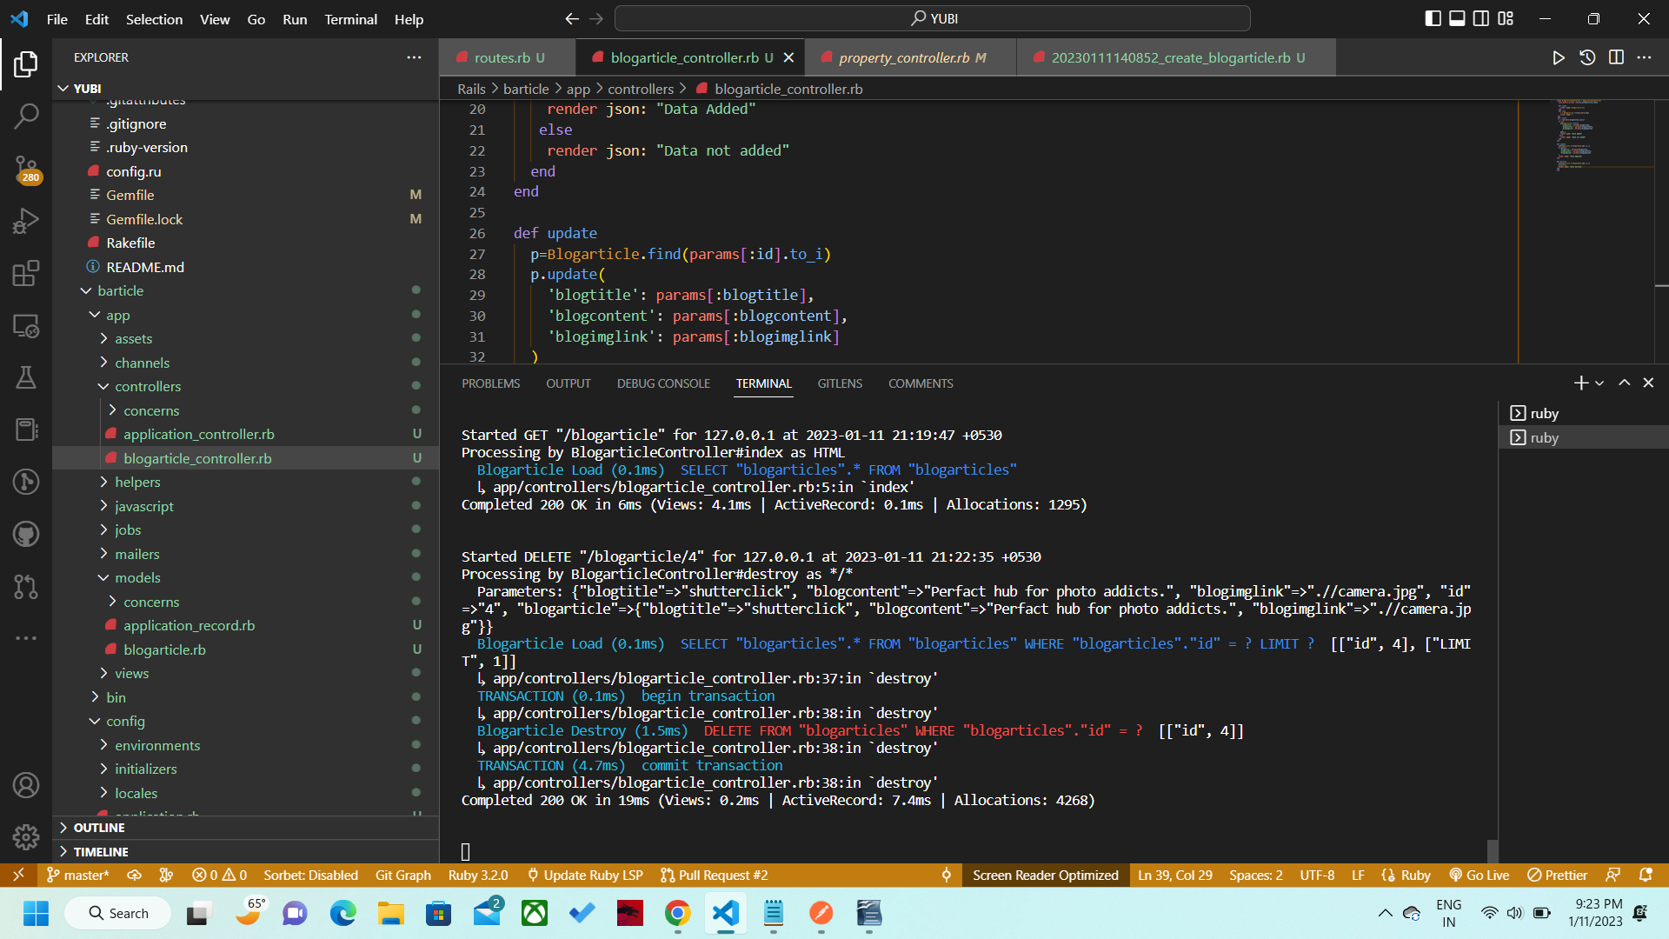
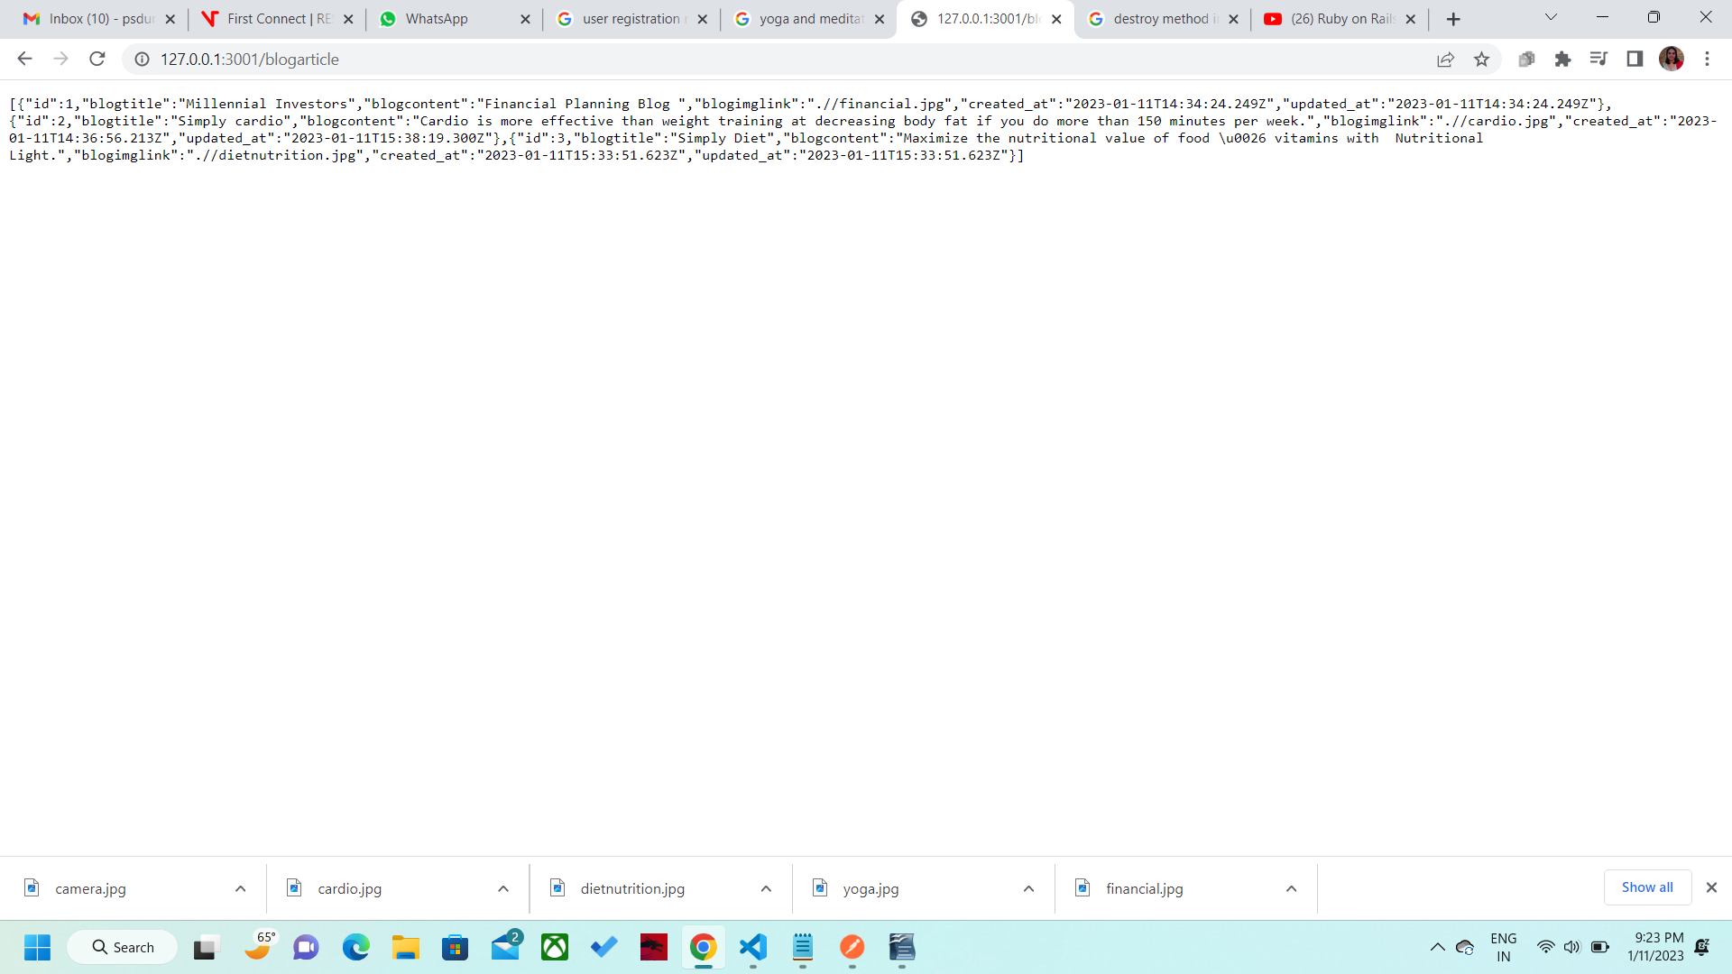
PS D:\YUBI\Rails\barticle> rails routes --expanded
--[ Route 1 ]--------------------------------------------------------------------------------------------------------------------
Prefix | root
Verb | GET
URI | /
Controller#Action | application#landingpage
--[ Route 2 ]--------------------------------------------------------------------------------------------------------------------
Prefix | blogarticle_index
Verb | GET
URI | /blogarticle(.:format)
Controller#Action | blogarticle#index
--[ Route 3 ]--------------------------------------------------------------------------------------------------------------------
Prefix |
Verb | POST
URI | /blogarticle(.:format)
Controller#Action | blogarticle#create
--[ Route 4 ]--------------------------------------------------------------------------------------------------------------------
Prefix | new_blogarticle
Verb | GET
URI | /blogarticle/new(.:format)
Controller#Action | blogarticle#new
--[ Route 5 ]--------------------------------------------------------------------------------------------------------------------
Prefix | edit_blogarticle
Verb | GET
URI | /blogarticle/:id/edit(.:format)
Controller#Action | blogarticle#edit
--[ Route 6 ]--------------------------------------------------------------------------------------------------------------------
Prefix | blogarticle
Verb | GET
URI | /blogarticle/:id(.:format)
Controller#Action | blogarticle#show
--[ Route 7 ]--------------------------------------------------------------------------------------------------------------------
Prefix |
Verb | PATCH
URI | /blogarticle/:id(.:format)
Controller#Action | blogarticle#update
--[ Route 8 ]--------------------------------------------------------------------------------------------------------------------
Prefix |
Verb | PUT
URI | /blogarticle/:id(.:format)
Controller#Action | blogarticle#update
--[ Route 9 ]--------------------------------------------------------------------------------------------------------------------
Prefix |
Verb | DELETE
URI | /blogarticle/:id(.:format)
Controller#Action | blogarticle#destroy
--[ Route 10 ]-------------------------------------------------------------------------------------------------------------------
Prefix | turbo_recede_historical_location
Verb | GET
URI | /recede_historical_location(.:format)
Controller#Action | turbo/native/navigation#recede
--[ Route 11 ]-------------------------------------------------------------------------------------------------------------------
Prefix | turbo_resume_historical_location
Verb | GET
URI | /resume_historical_location(.:format)
Controller#Action | turbo/native/navigation#resume
--[ Route 12 ]-------------------------------------------------------------------------------------------------------------------
Prefix | turbo_refresh_historical_location
Verb | GET
URI | /refresh_historical_location(.:format)
Controller#Action | turbo/native/navigation#refresh
--[ Route 13 ]-------------------------------------------------------------------------------------------------------------------
Prefix | rails_postmark_inbound_emails
Verb | POST
URI | /rails/action_mailbox/postmark/inbound_emails(.:format)
Controller#Action | action_mailbox/ingresses/postmark/inbound_emails#create
--[ Route 14 ]-------------------------------------------------------------------------------------------------------------------
Prefix | rails_relay_inbound_emails
Verb | POST
URI | /rails/action_mailbox/relay/inbound_emails(.:format)
Controller#Action | action_mailbox/ingresses/relay/inbound_emails#create
--[ Route 15 ]-------------------------------------------------------------------------------------------------------------------
Prefix | rails_sendgrid_inbound_emails
Verb | POST
URI | /rails/action_mailbox/sendgrid/inbound_emails(.:format)
Controller#Action | action_mailbox/ingresses/sendgrid/inbound_emails#create
--[ Route 16 ]-------------------------------------------------------------------------------------------------------------------
Prefix | rails_mandrill_inbound_health_check
Verb | GET
URI | /rails/action_mailbox/mandrill/inbound_emails(.:format)
Controller#Action | action_mailbox/ingresses/mandrill/inbound_emails#health_check
--[ Route 17 ]-------------------------------------------------------------------------------------------------------------------
Prefix | rails_mandrill_inbound_emails
Verb | POST
URI | /rails/action_mailbox/mandrill/inbound_emails(.:format)
Controller#Action | action_mailbox/ingresses/mandrill/inbound_emails#create
--[ Route 18 ]-------------------------------------------------------------------------------------------------------------------
Prefix | rails_mailgun_inbound_emails
Verb | POST
URI | /rails/action_mailbox/mailgun/inbound_emails/mime(.:format)
Controller#Action | action_mailbox/ingresses/mailgun/inbound_emails#create
--[ Route 19 ]-------------------------------------------------------------------------------------------------------------------
Prefix | rails_conductor_inbound_emails
Verb | GET
URI | /rails/conductor/action_mailbox/inbound_emails(.:format)
Controller#Action | rails/conductor/action_mailbox/inbound_emails#index
--[ Route 20 ]-------------------------------------------------------------------------------------------------------------------
Prefix |
Verb | POST
URI | /rails/conductor/action_mailbox/inbound_emails(.:format)
Controller#Action | rails/conductor/action_mailbox/inbound_emails#create
--[ Route 21 ]-------------------------------------------------------------------------------------------------------------------
Prefix | new_rails_conductor_inbound_email
Verb | GET
URI | /rails/conductor/action_mailbox/inbound_emails/new(.:format)
Controller#Action | rails/conductor/action_mailbox/inbound_emails#new
--[ Route 22 ]-------------------------------------------------------------------------------------------------------------------
Prefix | edit_rails_conductor_inbound_email
Verb | GET
URI | /rails/conductor/action_mailbox/inbound_emails/:id/edit(.:format)
Controller#Action | rails/conductor/action_mailbox/inbound_emails#edit
--[ Route 23 ]-------------------------------------------------------------------------------------------------------------------
Prefix | rails_conductor_inbound_email
Verb | GET
URI | /rails/conductor/action_mailbox/inbound_emails/:id(.:format)
Controller#Action | rails/conductor/action_mailbox/inbound_emails#show
--[ Route 24 ]-------------------------------------------------------------------------------------------------------------------
Prefix |
Verb | PATCH
URI | /rails/conductor/action_mailbox/inbound_emails/:id(.:format)
Controller#Action | rails/conductor/action_mailbox/inbound_emails#update
--[ Route 25 ]-------------------------------------------------------------------------------------------------------------------
Prefix |
Verb | PUT
URI | /rails/conductor/action_mailbox/inbound_emails/:id(.:format)
Controller#Action | rails/conductor/action_mailbox/inbound_emails#update
--[ Route 26 ]-------------------------------------------------------------------------------------------------------------------
Prefix |
Verb | DELETE
URI | /rails/conductor/action_mailbox/inbound_emails/:id(.:format)
Controller#Action | rails/conductor/action_mailbox/inbound_emails#destroy
--[ Route 27 ]-------------------------------------------------------------------------------------------------------------------
Prefix | new_rails_conductor_inbound_email_source
Verb | GET
URI | /rails/conductor/action_mailbox/inbound_emails/sources/new(.:format)
Controller#Action | rails/conductor/action_mailbox/inbound_emails/sources#new
--[ Route 28 ]-------------------------------------------------------------------------------------------------------------------
Prefix | rails_conductor_inbound_email_sources
Verb | POST
URI | /rails/conductor/action_mailbox/inbound_emails/sources(.:format)
Controller#Action | rails/conductor/action_mailbox/inbound_emails/sources#create
--[ Route 29 ]-------------------------------------------------------------------------------------------------------------------
Prefix | rails_conductor_inbound_email_reroute
Verb | POST
URI | /rails/conductor/action_mailbox/:inbound_email_id/reroute(.:format)
Controller#Action | rails/conductor/action_mailbox/reroutes#create
--[ Route 30 ]-------------------------------------------------------------------------------------------------------------------
Prefix | rails_conductor_inbound_email_incinerate
Verb | POST
URI | /rails/conductor/action_mailbox/:inbound_email_id/incinerate(.:format)
Controller#Action | rails/conductor/action_mailbox/incinerates#create
--[ Route 31 ]-------------------------------------------------------------------------------------------------------------------
Prefix | rails_service_blob
Verb | GET
URI | /rails/active_storage/blobs/redirect/:signed_id/*filename(.:format)
Controller#Action | active_storage/blobs/redirect#show
--[ Route 32 ]-------------------------------------------------------------------------------------------------------------------
Prefix | rails_service_blob_proxy
Verb | GET
URI | /rails/active_storage/blobs/proxy/:signed_id/*filename(.:format)
Controller#Action | active_storage/blobs/proxy#show
--[ Route 33 ]-------------------------------------------------------------------------------------------------------------------
Prefix |
Verb | GET
URI | /rails/active_storage/blobs/:signed_id/*filename(.:format)
Controller#Action | active_storage/blobs/redirect#show
--[ Route 34 ]-------------------------------------------------------------------------------------------------------------------
Prefix | rails_blob_representation
Verb | GET
URI | /rails/active_storage/representations/redirect/:signed_blob_id/:variation_key/*filename(.:format)
Controller#Action | active_storage/representations/redirect#show
--[ Route 35 ]-------------------------------------------------------------------------------------------------------------------
Prefix | rails_blob_representation_proxy
Verb | GET
URI | /rails/active_storage/representations/proxy/:signed_blob_id/:variation_key/*filename(.:format)
Controller#Action | active_storage/representations/proxy#show
--[ Route 36 ]-------------------------------------------------------------------------------------------------------------------
Prefix |
Verb | GET
URI | /rails/active_storage/representations/:signed_blob_id/:variation_key/*filename(.:format)
Controller#Action | active_storage/representations/redirect#show
--[ Route 37 ]-------------------------------------------------------------------------------------------------------------------
Prefix | rails_disk_service
Verb | GET
URI | /rails/active_storage/disk/:encoded_key/*filename(.:format)
Controller#Action | active_storage/disk#show
--[ Route 38 ]-------------------------------------------------------------------------------------------------------------------
Prefix | update_rails_disk_service
Verb | PUT
URI | /rails/active_storage/disk/:encoded_token(.:format)
Controller#Action | active_storage/disk#update
--[ Route 39 ]-------------------------------------------------------------------------------------------------------------------
Prefix | rails_direct_uploads
Verb | POST
URI | /rails/active_storage/direct_uploads(.:format)
Controller#Action | active_storage/direct_uploads#create
PS D:\YUBI\Rails\barticle>

PS D:\YUBI> cd Rails
PS D:\YUBI\Rails> cd barticle
PS D:\YUBI\Rails\barticle> rails s -p 3001
=> Booting Puma
=> Rails 7.0.4 application starting in development
=> Run `bin/rails server --help` for more startup options
*** SIGUSR2 not implemented, signal based restart unavailable!
*** SIGUSR1 not implemented, signal based restart unavailable!
*** SIGHUP not implemented, signal based logs reopening unavailable!
Puma starting in single mode...
* Puma version: 5.6.5 (ruby 3.2.0-p0) ("Birdie's Version")
* Min threads: 5
* Max threads: 5
* Environment: development
* PID: 19364
* Listening on http://[::1]:3001
* Listening on http://127.0.0.1:3001
Use Ctrl-C to stop
Started GET "/" for 127.0.0.1 at 2023-01-11 20:08:37 +0530
ActiveRecord::SchemaMigration Pluck (0.3ms) SELECT "schema_migrations"."version" FROM "schema_migrations" ORDER BY
"schema_migrations"."version" ASC
Processing by ApplicationController#landingpage as HTML
Rendering html template
Rendered html template (Duration: 0.1ms | Allocations: 16)
Completed 200 OK in 76ms (Views: 52.0ms | ActiveRecord: 0.0ms | Allocations: 2370)

Started GET "/blogarticle" for 127.0.0.1 at 2023-01-11 20:08:50 +0530

ActionController::RoutingError (No route matches [GET] "/blogarticle"):

Started GET "/blogarticles" for 127.0.0.1 at 2023-01-11 20:09:09 +0530

ActionController::RoutingError (No route matches [GET] "/blogarticles"):

Started GET "/blogarticles" for 127.0.0.1 at 2023-01-11 20:09:44 +0530

ActionController::RoutingError (No route matches [GET] "/blogarticles"):

Started GET "/blogarticles" for 127.0.0.1 at 2023-01-11 20:09:48 +0530

ActionController::RoutingError (No route matches [GET] "/blogarticles"):

Started GET "/blogarticles" for 127.0.0.1 at 2023-01-11 20:14:17 +0530

ActionController::RoutingError (uninitialized constant BlogarticlesController):

Started GET "/blogarticles" for 127.0.0.1 at 2023-01-11 20:14:20 +0530

ActionController::RoutingError (uninitialized constant BlogarticlesController):

Started GET "/" for 127.0.0.1 at 2023-01-11 20:14:21 +0530
Processing by ApplicationController#landingpage as HTML
Rendering html template
Rendered html template (Duration: 0.0ms | Allocations: 5)
Completed 200 OK in 3ms (Views: 0.9ms | Allocations: 410)

Started GET "/" for 127.0.0.1 at 2023-01-11 20:14:22 +0530
Processing by ApplicationController#landingpage as HTML
Rendering html template
Rendered html template (Duration: 0.1ms | Allocations: 6)
Completed 200 OK in 6ms (Views: 1.4ms | Allocations: 181)

Started GET "/" for 127.0.0.1 at 2023-01-11 20:14:23 +0530
Processing by ApplicationController#landingpage as HTML
Rendering html template
Rendered html template (Duration: 0.1ms | Allocations: 5)
Completed 200 OK in 4ms (Views: 1.2ms | Allocations: 180)

Started GET "/blogarticles" for 127.0.0.1 at 2023-01-11 20:14:29 +0530

ActionController::RoutingError (uninitialized constant BlogarticlesController):

Started GET "/blogarticles" for 127.0.0.1 at 2023-01-11 20:18:37 +0530

ActionController::RoutingError (uninitialized constant BlogarticlesController):

Started GET "/" for 127.0.0.1 at 2023-01-11 20:18:41 +0530
Processing by ApplicationController#landingpage as HTML
Rendering html template
Rendered html template (Duration: 0.0ms | Allocations: 5)
Completed 200 OK in 7ms (Views: 2.3ms | Allocations: 407)

Started GET "/blogarticles" for 127.0.0.1 at 2023-01-11 20:18:46 +0530

ActionController::RoutingError (uninitialized constant BlogarticlesController):

Started GET "/blogarticles" for 127.0.0.1 at 2023-01-11 20:18:47 +0530

ActionController::RoutingError (uninitialized constant BlogarticlesController):

Started GET "/blogarticle" for 127.0.0.1 at 2023-01-11 20:19:04 +0530

ActionController::RoutingError (No route matches [GET] "/blogarticle"):

Started GET "/Blogarticle" for 127.0.0.1 at 2023-01-11 20:19:29 +0530

ActionController::RoutingError (No route matches [GET] "/Blogarticle"):

Started GET "/blogarticle" for 127.0.0.1 at 2023-01-11 20:19:37 +0530

ActionController::RoutingError (No route matches [GET] "/blogarticle"):

Started GET "/blogarticles" for 127.0.0.1 at 2023-01-11 20:22:18 +0530

ActionController::RoutingError (uninitialized constant BlogarticlesController):

Started GET "/blogarticles" for 127.0.0.1 at 2023-01-11 20:22:22 +0530

ActionController::RoutingError (uninitialized constant BlogarticlesController):

Started GET "/blogarticle" for 127.0.0.1 at 2023-01-11 20:24:26 +0530

ActionController::RoutingError (No route matches [GET] "/blogarticle"):

Started GET "/blogarticles" for 127.0.0.1 at 2023-01-11 20:24:30 +0530

ActionController::RoutingError (uninitialized constant BlogarticlesController):

Started GET "/blogarticles" for 127.0.0.1 at 2023-01-11 20:24:36 +0530

ActionController::RoutingError (uninitialized constant BlogarticlesController):

Started GET "/blogarticles" for 127.0.0.1 at 2023-01-11 20:24:55 +0530

ActionController::RoutingError (uninitialized constant BlogarticlesController):

Started GET "/blogarticles" for 127.0.0.1 at 2023-01-11 20:27:06 +0530

ActionController::RoutingError (uninitialized constant BlogarticlesController):

Started GET "/blogarticles" for 127.0.0.1 at 2023-01-11 20:27:09 +0530

ActionController::RoutingError (uninitialized constant BlogarticlesController):

Started GET "/blogarticles" for 127.0.0.1 at 2023-01-11 20:27:11 +0530

ActionController::RoutingError (uninitialized constant BlogarticlesController):

Started GET "/blogarticles" for 127.0.0.1 at 2023-01-11 20:27:56 +0530

ActionController::RoutingError (uninitialized constant BlogarticlesController):

Started GET "/blogarticles" for 127.0.0.1 at 2023-01-11 20:27:57 +0530

ActionController::RoutingError (uninitialized constant BlogarticlesController):

Started GET "/blogarticles" for 127.0.0.1 at 2023-01-11 20:28:01 +0530

ActionController::RoutingError (uninitialized constant BlogarticlesController):

Started GET "/blogarticle" for 127.0.0.1 at 2023-01-11 20:35:46 +0530

ActionController::RoutingError (No route matches [GET] "/blogarticle"):

Started GET "/blogarticle" for 127.0.0.1 at 2023-01-11 20:42:38 +0530
Processing by BlogarticleController#index as HTML
Blogarticle Load (0.1ms) SELECT "blogarticles".* FROM "blogarticles"
↳ app/controllers/blogarticle_controller.rb:3:in `index'
Completed 200 OK in 38ms (Views: 25.6ms | ActiveRecord: 1.0ms | Allocations: 6627)

Started GET "/blogarticle" for 127.0.0.1 at 2023-01-11 20:42:53 +0530
Processing by BlogarticleController#index as */*
Blogarticle Load (0.1ms) SELECT "blogarticles".* FROM "blogarticles"
↳ app/controllers/blogarticle_controller.rb:3:in `index'
Completed 200 OK in 4ms (Views: 2.5ms | ActiveRecord: 0.1ms | Allocations: 1022)

Started GET "/blogarticle" for 127.0.0.1 at 2023-01-11 20:43:06 +0530
Processing by BlogarticleController#index as */*
Blogarticle Load (0.1ms) SELECT "blogarticles".* FROM "blogarticles"
↳ app/controllers/blogarticle_controller.rb:3:in `index'
Completed 200 OK in 4ms (Views: 2.6ms | ActiveRecord: 0.1ms | Allocations: 1018)

Started GET "/blogarticle/2" for 127.0.0.1 at 2023-01-11 20:46:31 +0530
Processing by BlogarticleController#show as */*
Parameters: {"id"=>"2"}
Completed 500 Internal Server Error in 2ms (Allocations: 459)

NameError (undefined local variable or method `blogarticle' for #<BlogarticleController:0x00000000022d80>):

app/controllers/blogarticle_controller.rb:8:in `show'
Started GET "/blogarticle/2" for 127.0.0.1 at 2023-01-11 20:46:48 +0530
Processing by BlogarticleController#show as */*
Parameters: {"id"=>"2"}
Completed 500 Internal Server Error in 3ms (Allocations: 445)

NameError (undefined local variable or method `blogarticle' for #<BlogarticleController:0x000000000230f0>):

app/controllers/blogarticle_controller.rb:8:in `show'
Started GET "/blogarticle/1" for 127.0.0.1 at 2023-01-11 20:47:24 +0530
Processing by BlogarticleController#show as */*
Parameters: {"id"=>"1"}
Completed 500 Internal Server Error in 2ms (Allocations: 445)

NameError (undefined local variable or method `blogarticle' for #<BlogarticleController:0x00000000023410>):

app/controllers/blogarticle_controller.rb:8:in `show'
Started GET "/blogarticle/1" for 127.0.0.1 at 2023-01-11 20:48:06 +0530
Processing by BlogarticleController#show as HTML
Parameters: {"id"=>"1"}
Completed 500 Internal Server Error in 2ms (Allocations: 443)

NameError (undefined local variable or method `blogarticle' for #<BlogarticleController:0x00000000023780>):

app/controllers/blogarticle_controller.rb:8:in `show'
Started GET "/movielists" for 127.0.0.1 at 2023-01-11 20:48:26 +0530

ActionController::RoutingError (No route matches [GET] "/movielists"):

Started GET "/blogarticle/1" for 127.0.0.1 at 2023-01-11 20:48:35 +0530
Processing by BlogarticleController#show as HTML
Parameters: {"id"=>"1"}
Blogarticle Load (0.1ms) SELECT "blogarticles".* FROM "blogarticles" WHERE "blogarticles"."id" = ? LIMIT ?
[["id", 1], ["LIMIT", 1]]
↳ app/controllers/blogarticle_controller.rb:8:in `show'
Completed 200 OK in 20ms (Views: 0.6ms | ActiveRecord: 0.7ms | Allocations: 4997)

Started GET "/blogarticle/2" for 127.0.0.1 at 2023-01-11 20:48:41 +0530
Processing by BlogarticleController#show as HTML
Parameters: {"id"=>"2"}
Blogarticle Load (0.1ms) SELECT "blogarticles".* FROM "blogarticles" WHERE "blogarticles"."id" = ? LIMIT ?
[["id", 2], ["LIMIT", 1]]
↳ app/controllers/blogarticle_controller.rb:8:in `show'
Completed 200 OK in 3ms (Views: 0.8ms | ActiveRecord: 0.1ms | Allocations: 698)

Started GET "/blogarticle/1" for 127.0.0.1 at 2023-01-11 20:49:03 +0530
Processing by BlogarticleController#show as */*
Parameters: {"id"=>"1"}
Blogarticle Load (0.1ms) SELECT "blogarticles".* FROM "blogarticles" WHERE "blogarticles"."id" = ? LIMIT ?
[["id", 1], ["LIMIT", 1]]
↳ app/controllers/blogarticle_controller.rb:8:in `show'
Completed 200 OK in 3ms (Views: 0.8ms | ActiveRecord: 0.1ms | Allocations: 702)

Started POST "/blogarticle%20" for 127.0.0.1 at 2023-01-11 20:53:13 +0530

ActionController::RoutingError (No route matches [POST] "/blogarticle%20"):

Started GET "/blogarticle%20" for 127.0.0.1 at 2023-01-11 20:53:20 +0530

ActionController::RoutingError (No route matches [GET] "/blogarticle%20"):

Started GET "/blogarticle" for 127.0.0.1 at 2023-01-11 20:53:41 +0530
Processing by BlogarticleController#index as HTML
Blogarticle Load (0.1ms) SELECT "blogarticles".* FROM "blogarticles"
↳ app/controllers/blogarticle_controller.rb:5:in `index'
Completed 200 OK in 10ms (Views: 5.0ms | ActiveRecord: 0.9ms | Allocations: 3566)

Started POST "/blogarticle" for 127.0.0.1 at 2023-01-11 20:53:52 +0530
Processing by BlogarticleController#create as */*
Completed 500 Internal Server Error in 2ms (ActiveRecord: 0.0ms | Allocations: 471)

NoMethodError (undefined method `empty?' for nil:NilClass):

app/controllers/blogarticle_controller.rb:12:in `create'
Started GET "/blogarticle" for 127.0.0.1 at 2023-01-11 20:56:13 +0530
Processing by BlogarticleController#index as */*
Blogarticle Load (0.1ms) SELECT "blogarticles".* FROM "blogarticles"
↳ app/controllers/blogarticle_controller.rb:5:in `index'
Completed 200 OK in 5ms (Views: 1.9ms | ActiveRecord: 0.1ms | Allocations: 998)

Started GET "/blogarticle" for 127.0.0.1 at 2023-01-11 21:01:02 +0530
Processing by BlogarticleController#index as */*
Parameters: {"blogtitle"=>"Simply Diet", "blogcontent"=>"Maximize the nutritional value of food & vitamins with Nutritional Li
ght. ", "blogimglink"=>".//dietnutrition.jpg", "blogarticle"=>{"blogtitle"=>"Simply Diet", "blogcontent"=>"Maximize the nutritio
nal value of food & vitamins with Nutritional Light. ", "blogimglink"=>".//dietnutrition.jpg"}}
Blogarticle Load (0.1ms) SELECT "blogarticles".* FROM "blogarticles"
↳ app/controllers/blogarticle_controller.rb:5:in `index'
Completed 200 OK in 4ms (Views: 2.4ms | ActiveRecord: 0.1ms | Allocations: 996)

Started GET "/blogarticle" for 127.0.0.1 at 2023-01-11 21:02:33 +0530
Processing by BlogarticleController#index as */*
Parameters: {"blogtitle"=>"Simply Diet", "blogcontent"=>"Maximize the nutritional value of food & vitamins with Nutritional Li
ght.", "blogimglink"=>".//dietnutrition.jpg", "blogarticle"=>{"blogtitle"=>"Simply Diet", "blogcontent"=>"Maximize the nutritiona
l value of food & vitamins with Nutritional Light.", "blogimglink"=>".//dietnutrition.jpg"}}
Blogarticle Load (0.1ms) SELECT "blogarticles".* FROM "blogarticles"
↳ app/controllers/blogarticle_controller.rb:5:in `index'
Completed 200 OK in 5ms (Views: 2.5ms | ActiveRecord: 0.1ms | Allocations: 1005)

- Gracefully stopping, waiting for requests to finish
=== puma shutdown: 2023-01-11 21:02:56 +0530 ===
- Goodbye!
Exiting
Terminate batch job (Y/N)? y
PS D:\YUBI\Rails\barticle> rails s -p 3001
=> Booting Puma
=> Rails 7.0.4 application starting in development
=> Run `bin/rails server --help` for more startup options
*** SIGUSR2 not implemented, signal based restart unavailable!
*** SIGUSR1 not implemented, signal based restart unavailable!
*** SIGHUP not implemented, signal based logs reopening unavailable!
Puma starting in single mode...
* Puma version: 5.6.5 (ruby 3.2.0-p0) ("Birdie's Version")
* Min threads: 5
* Max threads: 5
* Environment: development
* PID: 6724
* Listening on http://[::1]:3001
* Listening on http://127.0.0.1:3001
Use Ctrl-C to stop
Started GET "/" for 127.0.0.1 at 2023-01-11 21:03:26 +0530
ActiveRecord::SchemaMigration Pluck (0.1ms) SELECT "schema_migrations"."version" FROM "schema_migrations" ORDER BY "schema_mig
rations"."version" ASC
Processing by ApplicationController#landingpage as HTML
Rendering html template
Rendered html template (Duration: 0.0ms | Allocations: 16)
Completed 200 OK in 47ms (Views: 28.4ms | ActiveRecord: 0.0ms | Allocations: 2250)

Started GET "/blogarticle" for 127.0.0.1 at 2023-01-11 21:03:35 +0530
Processing by BlogarticleController#index as HTML
Blogarticle Load (0.1ms) SELECT "blogarticles".* FROM "blogarticles"
↳ app/controllers/blogarticle_controller.rb:5:in `index'
Completed 200 OK in 85ms (Views: 49.4ms | ActiveRecord: 0.6ms | Allocations: 6474)

Started POST "/blogarticle" for 127.0.0.1 at 2023-01-11 21:03:51 +0530
Processing by BlogarticleController#create as */*
Parameters: {"blogtitle"=>"Simply Diet", "blogcontent"=>"Maximize the nutritional value of food & vitamins with Nutritional Li
ght.", "blogimglink"=>".//dietnutrition.jpg", "blogarticle"=>{"blogtitle"=>"Simply Diet", "blogcontent"=>"Maximize the nutritiona
l value of food & vitamins with Nutritional Light.", "blogimglink"=>".//dietnutrition.jpg"}}
TRANSACTION (0.0ms) begin transaction
↳ app/controllers/blogarticle_controller.rb:14:in `create'
Blogarticle Create (1.3ms) INSERT INTO "blogarticles" ("blogtitle", "blogcontent", "blogimglink", "created_at", "updated_at")
VALUES (?, ?, ?, ?, ?) [["blogtitle", "Simply Diet"], ["blogcontent", "Maximize the nutritional value of food & vitamins with N
utritional Light."], ["blogimglink", ".//dietnutrition.jpg"], ["created_at", "2023-01-11 15:33:51.623681"], ["updated_at", "2023-
01-11 15:33:51.623681"]]
↳ app/controllers/blogarticle_controller.rb:14:in `create'
TRANSACTION (4.1ms) commit transaction
↳ app/controllers/blogarticle_controller.rb:14:in `create'
#<Blogarticle:0x00000195442a3de0>
Completed 200 OK in 16ms (Views: 0.5ms | ActiveRecord: 5.4ms | Allocations: 2978)

Started GET "/blogarticle" for 127.0.0.1 at 2023-01-11 21:04:29 +0530
Processing by BlogarticleController#index as HTML
Blogarticle Load (0.1ms) SELECT "blogarticles".* FROM "blogarticles"
↳ app/controllers/blogarticle_controller.rb:5:in `index'
Completed 200 OK in 4ms (Views: 2.6ms | ActiveRecord: 0.1ms | Allocations: 1147)

Started PUT "/blogarticle/2" for 127.0.0.1 at 2023-01-11 21:04:56 +0530
Processing by BlogarticleController#update as */*
Parameters: {"blogtitle"=>"Simply Diet", "blogcontent"=>"Maximize the nutritional value of food & vitamins with Nutritional Li
ght.", "blogimglink"=>".//dietnutrition.jpg", "id"=>"2", "blogarticle"=>{"blogtitle"=>"Simply Diet", "blogcontent"=>"Maximize the
nutritional value of food & vitamins with Nutritional Light.", "blogimglink"=>".//dietnutrition.jpg"}}
Blogarticle Load (0.1ms) SELECT "blogarticles".* FROM "blogarticles" WHERE "blogarticles"."id" = ? LIMIT ? [["id", 2], ["LIMI
T", 1]]
↳ app/controllers/blogarticle_controller.rb:27:in `update'
TRANSACTION (0.0ms) begin transaction
↳ app/controllers/blogarticle_controller.rb:28:in `update'
Blogarticle Update (0.9ms) UPDATE "blogarticles" SET "blogtitle" = ?, "blogcontent" = ?, "blogimglink" = ?, "updated_at" = ? W
HERE "blogarticles"."id" = ? [["blogtitle", "Simply Diet"], ["blogcontent", "Maximize the nutritional value of food & vitamins w
ith Nutritional Light."], ["blogimglink", ".//dietnutrition.jpg"], ["updated_at", "2023-01-11 15:34:56.198806"], ["id", 2]]
↳ app/controllers/blogarticle_controller.rb:28:in `update'
TRANSACTION (4.5ms) commit transaction
↳ app/controllers/blogarticle_controller.rb:28:in `update'
Completed 200 OK in 118ms (Views: 0.1ms | ActiveRecord: 5.5ms | Allocations: 15605)

Started GET "/blogarticle/2" for 127.0.0.1 at 2023-01-11 21:05:04 +0530
Processing by BlogarticleController#show as */*
Parameters: {"blogtitle"=>"Simply Diet", "blogcontent"=>"Maximize the nutritional value of food & vitamins with Nutritional Li
ght.", "blogimglink"=>".//dietnutrition.jpg", "id"=>"2", "blogarticle"=>{"blogtitle"=>"Simply Diet", "blogcontent"=>"Maximize the
nutritional value of food & vitamins with Nutritional Light.", "blogimglink"=>".//dietnutrition.jpg"}}
Blogarticle Load (0.1ms) SELECT "blogarticles".* FROM "blogarticles" WHERE "blogarticles"."id" = ? LIMIT ? [["id", 2], ["LIMI
T", 1]]
↳ app/controllers/blogarticle_controller.rb:8:in `show'
Completed 200 OK in 3ms (Views: 0.8ms | ActiveRecord: 0.1ms | Allocations: 720)

Started PUT "/blogarticle/2" for 127.0.0.1 at 2023-01-11 21:08:19 +0530
Processing by BlogarticleController#update as */*
Parameters: {"blogtitle"=>"Simply cardio", "blogcontent"=>"Cardio is more effective than weight training at decreasing body fat
if you do more than 150 minutes per week.", "blogimglink"=>".//cardio.jpg", "id"=>"2", "blogarticle"=>{"blogtitle"=>"Simply card
io", "blogcontent"=>"Cardio is more effective than weight training at decreasing body fat if you do more than 150 minutes per wee
k.", "blogimglink"=>".//cardio.jpg"}}
Blogarticle Load (0.1ms) SELECT "blogarticles".* FROM "blogarticles" WHERE "blogarticles"."id" = ? LIMIT ? [["id", 2], ["LIMI
T", 1]]
↳ app/controllers/blogarticle_controller.rb:27:in `update'
TRANSACTION (0.2ms) begin transaction
↳ app/controllers/blogarticle_controller.rb:28:in `update'
Blogarticle Update (2.1ms) UPDATE "blogarticles" SET "blogtitle" = ?, "blogcontent" = ?, "blogimglink" = ?, "updated_at" = ? W
HERE "blogarticles"."id" = ? [["blogtitle", "Simply cardio"], ["blogcontent", "Cardio is more effective than weight training at
decreasing body fat if you do more than 150 minutes per week."], ["blogimglink", ".//cardio.jpg"], ["updated_at", "2023-01-11 15:
38:19.300773"], ["id", 2]]
↳ app/controllers/blogarticle_controller.rb:28:in `update'
TRANSACTION (3.7ms) commit transaction
↳ app/controllers/blogarticle_controller.rb:28:in `update'
Completed 200 OK in 16ms (Views: 0.1ms | ActiveRecord: 6.2ms | Allocations: 2510)

Started GET "/blogarticle" for 127.0.0.1 at 2023-01-11 21:08:52 +0530
Processing by BlogarticleController#index as HTML
Blogarticle Load (0.1ms) SELECT "blogarticles".* FROM "blogarticles"
↳ app/controllers/blogarticle_controller.rb:5:in `index'
Completed 200 OK in 5ms (Views: 3.1ms | ActiveRecord: 0.1ms | Allocations: 1157)

Started POST "/blogarticle%20" for 127.0.0.1 at 2023-01-11 21:15:27 +0530

ActionController::RoutingError (No route matches [POST] "/blogarticle%20"):

Started POST "/blogarticle%20" for 127.0.0.1 at 2023-01-11 21:15:45 +0530

ActionController::RoutingError (No route matches [POST] "/blogarticle%20"):

Started POST "/blogarticle%20" for 127.0.0.1 at 2023-01-11 21:16:22 +0530

ActionController::RoutingError (No route matches [POST] "/blogarticle%20"):

Started POST "/blogarticle%20" for 127.0.0.1 at 2023-01-11 21:16:58 +0530

ActionController::RoutingError (No route matches [POST] "/blogarticle%20"):

Started POST "/blogarticle%20" for 127.0.0.1 at 2023-01-11 21:18:02 +0530

ActionController::RoutingError (No route matches [POST] "/blogarticle%20"):

Started GET "/blogarticle%20" for 127.0.0.1 at 2023-01-11 21:18:34 +0530

ActionController::RoutingError (No route matches [GET] "/blogarticle%20"):

Started GET "/blogarticle" for 127.0.0.1 at 2023-01-11 21:18:41 +0530
Processing by BlogarticleController#index as HTML
Blogarticle Load (0.1ms) SELECT "blogarticles".* FROM "blogarticles"
↳ app/controllers/blogarticle_controller.rb:5:in `index'
Completed 200 OK in 15ms (Views: 9.5ms | ActiveRecord: 0.5ms | Allocations: 3349)

Started GET "/blogarticle" for 127.0.0.1 at 2023-01-11 21:18:53 +0530
Processing by BlogarticleController#index as */*
Blogarticle Load (0.2ms) SELECT "blogarticles".* FROM "blogarticles"
↳ app/controllers/blogarticle_controller.rb:5:in `index'
Completed 200 OK in 10ms (Views: 6.3ms | ActiveRecord: 0.2ms | Allocations: 1152)

Started POST "/blogarticle" for 127.0.0.1 at 2023-01-11 21:19:17 +0530
Processing by BlogarticleController#create as */*
Parameters: {"blogtitle"=>"shutterclick", "blogcontent"=>"Perfact hub for photo addicts.", "blogimglink"=>".//camera.jpg", "blo
garticle"=>{"blogtitle"=>"shutterclick", "blogcontent"=>"Perfact hub for photo addicts.", "blogimglink"=>".//camera.jpg"}}
TRANSACTION (0.1ms) begin transaction
↳ app/controllers/blogarticle_controller.rb:14:in `create'
Blogarticle Create (1.9ms) INSERT INTO "blogarticles" ("blogtitle", "blogcontent", "blogimglink", "created_at", "updated_at")
VALUES (?, ?, ?, ?, ?) [["blogtitle", "shutterclick"], ["blogcontent", "Perfact hub for photo addicts."], ["blogimglink", ".//ca
mera.jpg"], ["created_at", "2023-01-11 15:49:17.621753"], ["updated_at", "2023-01-11 15:49:17.621753"]]
↳ app/controllers/blogarticle_controller.rb:14:in `create'
TRANSACTION (5.0ms) commit transaction
↳ app/controllers/blogarticle_controller.rb:14:in `create'
#<Blogarticle:0x000001954466f1e0>
Completed 200 OK in 18ms (Views: 0.2ms | ActiveRecord: 6.9ms | Allocations: 1986)

Started GET "/blogarticle" for 127.0.0.1 at 2023-01-11 21:19:47 +0530
Processing by BlogarticleController#index as HTML
Blogarticle Load (0.1ms) SELECT "blogarticles".* FROM "blogarticles"
↳ app/controllers/blogarticle_controller.rb:5:in `index'
Completed 200 OK in 6ms (Views: 4.1ms | ActiveRecord: 0.1ms | Allocations: 1295)

Started DELETE "/blogarticle/4" for 127.0.0.1 at 2023-01-11 21:22:35 +0530
Processing by BlogarticleController#destroy as */*
Parameters: {"blogtitle"=>"shutterclick", "blogcontent"=>"Perfact hub for photo addicts.", "blogimglink"=>".//camera.jpg", "id"
=>"4", "blogarticle"=>{"blogtitle"=>"shutterclick", "blogcontent"=>"Perfact hub for photo addicts.", "blogimglink"=>".//camera.jp
g"}}
Blogarticle Load (0.1ms) SELECT "blogarticles".* FROM "blogarticles" WHERE "blogarticles"."id" = ? LIMIT ? [["id", 4], ["LIMI
T", 1]]
↳ app/controllers/blogarticle_controller.rb:37:in `destroy'
TRANSACTION (0.1ms) begin transaction
↳ app/controllers/blogarticle_controller.rb:38:in `destroy'
Blogarticle Destroy (1.5ms) DELETE FROM "blogarticles" WHERE "blogarticles"."id" = ? [["id", 4]]
↳ app/controllers/blogarticle_controller.rb:38:in `destroy'
TRANSACTION (4.7ms) commit transaction
↳ app/controllers/blogarticle_controller.rb:38:in `destroy'
Completed 200 OK in 19ms (Views: 0.2ms | ActiveRecord: 7.4ms | Allocations: 4268)

Started GET "/blogarticle" for 127.0.0.1 at 2023-01-11 21:23:18 +0530
Processing by BlogarticleController#index as HTML
Blogarticle Load (0.3ms) SELECT "blogarticles".* FROM "blogarticles"
↳ app/controllers/blogarticle_controller.rb:5:in `index'
Completed 200 OK in 11ms (Views: 6.9ms | ActiveRecord: 0.3ms | Allocations: 1218)

- Gracefully stopping, waiting for requests to finish
=== puma shutdown: 2023-01-11 21:26:28 +0530 ===
- Goodbye!
Exiting
Terminate batch job (Y/N)? y

