**[Subject Code: SLE713]**



**Submitted by**

**Simon Lama**

**224794329**

Submitted in Partial Fulfillment of the Requirements for the **Master of Biotechnology (Professional)** in **Deakin University**, Australia

## DEAKIN UNIVERSITY

**GEELONG, MELBOURNE**

**September, 2024**

**Practical 10:** Enzyme-Linked immunosorbent Assay

**Introduction:**

Enzyme-linked immunosorbent assay (ELISA) is an immunological technique which relies on the specific interaction between a target antigen (the protein of interest) and a primary antibody that attaches to it. The presence of the antigen is confirmed through the enzymatic reaction of an enzyme-linked antibody with a substrate, producing a detectable product. This product can be assessed qualitatively through visual inspection or quantitatively using a luminometer or spectrophotometer. The principle of ELISA, involves adsorbing antibodies specific to the target antigen onto a solid support, typically a polystyrene microtiter plate. After coating and washing, the antigen is added and binds to the adsorbed antibodies. Next, a conjugate—an antibody covalently bound to an enzyme—is introduced to bind to the antigen, enabling detection (Gaastra, 1984). Depending on antigens, antibodies, substrates, and experimental conditions used, ELISA techniques are typically categorized into four main types: direct, indirect, sandwich, and competitive ELISA (Hayrapetyan et al., 2023). In our experiment we performed Competitive ELISA (cELISA) to measure *Treponema pallidum* antibody levels in the serum of patients with clinical signs of Syphilis. The competitive ELISA (cELISA) employs a labeled monoclonal or polyclonal antibody that specifically binds to a designated antigen. This antibody competes with serum antibodies for access to the antigen, allowing for the detection and quantification of pathogen-specific antibodies. Additionally, because cELISA does not need a species-specific secondary antibody, it offers a notable advantage over traditional ELISA by effectively detecting serum antibodies from various animal species. (Chen et al., 2024). Syphilis is a sexually transmitted infection that presents with a range of clinical symptoms, which can be diverse and frequently subtle. It begins with systemic effects, primarily manifesting as vasculitis. Acquired syphilis is categorized into four stages: primary, secondary, latent, and tertiary. It is caused by infection of gram negative bacterium *Treponema pallidum* (Brown and Frank, 2003)*.* In Australia, the status of prevalence of Syphilis has remained for past 90 years (Berger and Gideon science team, 2024).

**Aims**: In this experiment we aimed to measure *Treponema pallidum* antibody levels in the serum of patients with clinical sings of Syphilis using competitive ELISA technique.

**Experimental:**

To perform the competitive ELISA, the wells were first decanted and washed three times with a washing solution. Next, 50 μl of each Treponema pallidum (Tp) antibody standard was dispensed into four replicate wells, along with 50 μl of negative control, positive control, and patient samples. The first column was filled with 50 μl of PBS to serve as a blank. Following this, 50 μl of HRP-labeled Tp antibody was added to all wells except the blank. The plate was incubated at room temperature for 30 minutes and then underwent three additional wash cycles. After washing, 100 μl of TMB enzyme substrate was added to all wells, including the negative control, and the reaction was allowed to proceed in the dark for 15 minutes. To terminate the reaction, 50 μl of 3M sulfuric acid was added to each well, and the optical density (OD) was measured at 490 nm.

**Result and Discussion:**

The absorbance at 490 nm was found to be following:

|  |  |  |  |  |  |  |  |
| --- | --- | --- | --- | --- | --- | --- | --- |
|  | 1 | 2 | 3 | 4 | 5 | 6 | 7 |
| A | -0.003 | 3.097 | 2.935 | 2.735 | 2.508 | 1.056 | 0.743 |
| B | -0.003 | 3.0122 | 3.050 | 2.957 | 2.365 | 1.130 | 0.806 |
| C | 0.007 | 3.137 | 3.026 | 2.822 | 2.283 | 1.162 | 0.684 |
| D | 0.021 | 3.127 | 2.943 | 2.863 | 2.396 | 1.082 | 0.728 |
| E | 0.009 | 3.020 | 2.908 | 2.521 | 1.883 | 0.728 | 0.803 |
| F | -0.028 | 3.064 | 2.883 | 2.622 | 1.736 | 0.793 | 0.807 |
| G | -0.026 | 3.007 | 2.949 | 2.674 | 1.939 | 0.816 | 0.792 |
| H | 0.026 | 2.988 | 2.890 | 2.485 | 1.786 | 0.757 | 0.683 |

**Table 1:** Absorbance Measurements for Each Replicate Well of Standards, Negative Control, Positive Control, and Patient Samples.

Absorbance was plotted against Concentration

**Figure 1:** Calibration Curve of Absorbance vs. Treponema pallidum Antibody Concentration

The linear regression equation was found to be y = -0.0039x + 2.9657 , where y represents the absorbance and x indicates the concentration of antibodies in ng/ml. The slope of -0.003 signifies that as antibody concentration rises, the absorbance decreases, which is common for a competitive ELISA. The intercept of 2.9657 represents the maximum absorbance achievable in the absence of competing antibodies.

The coefficient of determination R² = 0.9749 reveals a strong correlation between antibody concentration and absorbance values, indicating that 97.49% of the variability in absorbance is attributable to changes in concentration. This high R² value indicates how well the calibration data matches the linear model. This high R² value indicates a strong and consistent association between absorbance and concentration (Jain, 2018).

The result intrepretation of negative contol, positive control and patient sample was found as following:

|  |  |  |  |
| --- | --- | --- | --- |
| Sample | Negative control | Positive control | Patient sample |
| Tp antibody | 564.282 | 564.794 | 572.743 |
| Diagnosis | Positive result | Positive result | Positive result |

**Table 2:** Diagnostic Results of Negative Control, Positive Control, and Patient Samples

The competitive ELISA faced several limitations, including potential non-linearity at antibody concentrations, interference from other serum components, and fluctuations due to temperature variations. Moreover, the quality of reagents, inaccuracies in dilution, and instrument calibration issues could impact precision. Future improvements could involve validating the method over a wider concentration range, utilizing advanced technologies like multiplex assays, and enhancing quality control measures (Hosseini et al., 2018b).

Enzyme-Linked Immunosorbent Assay (ELISA) has diverse applications across industries:

-Pharmaceutical Sector: ELISA is crucial for drug development and quality assurance, allowing precise quantification of therapeutic proteins, hormones, and antibodies in formulations.

-Food and Beverage Industry: It plays a vital role in food safety and regulatory compliance by detecting allergens, harmful microorganisms, and contaminants, such as gluten and peanuts, which pose risks to consumers (Hosseini et al., 2018a).

Conclusion:

In this experiment, the Competitive Enzyme-Linked Immunosorbent Assay (cELISA) used successfully quantified *Treponema pallidum* antibody levels in serum from patients with clinical signs of syphilis, revealing a strong correlation between absorbance and antibody concentration (R² = 0.9749). This supports its diagnostic reliability, as consistent results were obtained in both controls and patient samples. However, some limitations, such as non-linearity at elevated concentrations and serum component interference, were noted, suggesting that future research should focus on validating the method over a broader range and exploring multiplex assays.

**Appendices:**

ELISA plate format

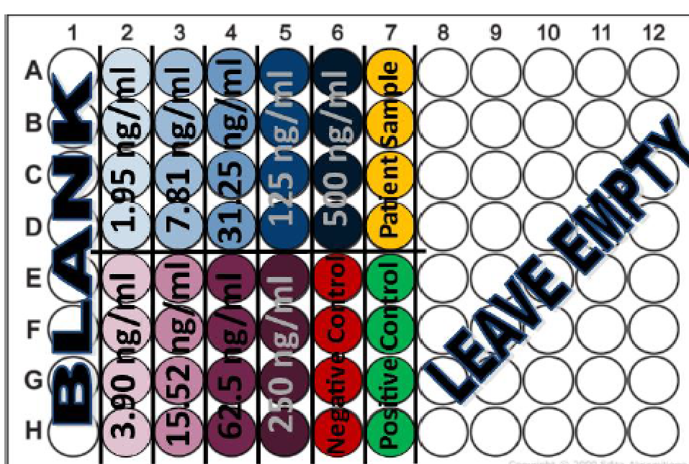

**Fig 1:** ELISA plate format.

(<https://d2l.deakin.edu.au/d2l/le/content/1481543/viewContent/7587132/View>)

**Calculations:**

**#Calculations of Average**

Absorbance from the blank:

-0.003, -0.003, 0.007, 0.021, 0.009, -0.028, -0.026, 0.026

Avearge of blank= $\frac{-0.003-0.003+0.007+0.021+0.009-0.028-0.026+0.026}{8}$ = 0.007625

Absorbance of standard 1:

3.097, 3.0122, 3.137, 3.127

Average of standard 1= $\frac{3.097+3.0122+3.137+3.127}{4}$ = 3.0933

Absorbance of standard 2:

3.020, 3.064, 3.007, 2.988

Absorbance of standard 2= $\frac{3.020+3.064+3.007+2.988}{4}$ = 3.01975

Absorbance of standard 3:

2.935, 3.050, 3.026, 2.943

Absorbance of standard 3: $\frac{2.935+3.050+3.026+2.943}{4}$ = 2.9885

Absorbance of standard 4:

2.908, 2.883, 2.949, 2.890

Absorbance of standard 4: $\frac{2.908+2.883+2.949+2.890}{4}$ = 2.9075

Absorbance of standard 5:

2.735, 2.957, 2.822, 2.863

Absorbance of standard 5: $\frac{2.735+2.957+2.822+2.863}{4}$ = 2.844

Absorbance of standard 6:

2.521, 2.622, 2.674, 2.485

Absorbance of standard 6: $\frac{2.521+2.622+2.674+2.485}{4}$ = 2.575

Absorbance of standard 7:

2.508, 2.365, 2.283, 2.396

Absorbance of standard 7: $\frac{2.508+2.365+2.283+2.396}{4}$ = 2.388

Absorbance of standard 8:

1.883, 1.736, 1.939, 1.786

Absorbance of standard 8: $\frac{1.883+1.736+1.939+1.786}{4}$ = 1.836

Absorbance of standard 9:

1.056, 1.130, 1.162, 1.082

Absorbance of standard 9: $\frac{1.056+1.130+1.162+1.082}{4}$ = 1.108

**#Subtraction of standards with blank**

Standard 1: 3.0933-0.000375= 3.093

Standard 2: 3.01975-0.000375= 3.022

Standard 3: 2.9885-0.000375= 2.989

Standard 4: 2.9075-0.000375=2.91

Standard 5: 2.844-0.000375=2.843

Standard 6: 2.5755-0.000375=2.575125

Standard 7: 2.387-0.000375= 2.387

Standard 8: 1.836-0.000375= 1.8356

Standard 9: 1.108-0.00375= 1.1078

**#Subtarction of controls and sample with blank**

Negative control: 0.7735-0.000375= 0.765

Positive control: 0.74025-0.000375= 0.7326

Patient sample: 0.77125-0.000375= 0.7636

**#Interpretation of ELISA Absorbance Readings**

y= Average absorbance

x= Concentration of Tp sample

c= y-intercept

The linear equation is, $y=mx+c$

$$y=-0.0039x+2.9657$$

Rearranging the equation, $x=\frac{y-c}{m}$

For negative control,

X= $\frac{2.9657-0.765}{0.0039}$ = 564.282 ng/ml

For positive control,

X= $\frac{2.9657-0.732}{0.0039}$ = 572.743ng/ml

For patient sample,

X= $\frac{2.9657-0.763}{0.0039}$ = 564.794 ng/ml

**Abbreviations used:**

ELISA: Enzyme-Linked Immunosorbent Assay

R²: Coefficient of Determination

Tp: Treponema pallidum

ng/ml: Nanograms per Milliliter

C1V1 = C2V2: Concentration 1 × Volume 1 = Concentration 2 × Volume 2

**References:**

BERGER, S. & GIDEON SCIENCE TEAM, G. S. 2024. *Syphilis: Global Status,* Los Angeles, UNITED STATES, Gideon Informatics, Incorporated.

BROWN, D. L. & FRANK, J. E. 2003. Diagnosis and management of syphilis. *American family physician,* 68**,** 283-290.

CHEN, G., HE, X., GAO, Z., FANG, Y., HURISA, T. T., JIA, H., TAN, J., ZHOU, G., FU, B., LI, W. & JING, Z. 2024. Development of a competitive ELISA based on the LSDV A33 antigen. *Virology Journal,* 21**,** 1-8.

GAASTRA, W. 1984. Enzyme-Linked Immunosorbant Assay (ELISA). *In:* WALKER, J. M. (ed.) *Proteins.* Totowa, NJ: Humana Press.

HAYRAPETYAN, H., TRAN, T., TELLEZ-CORRALES, E. & MADIRAJU, C. 2023. Enzyme-Linked Immunosorbent Assay: Types and Applications. *In:* MATSON, R. S. (ed.) *ELISA: Methods and Protocols.* New York, NY: Springer US.

HOSSEINI, S., VÁZQUEZ-VILLEGAS, P., RITO-PALOMARES, M. & MARTINEZ-CHAPA, S. O. 2018a. General Overviews on Applications of ELISA. *Enzyme-linked Immunosorbent Assay (ELISA): From A to Z.* Singapore: Springer Singapore.

HOSSEINI, S., VÁZQUEZ-VILLEGAS, P., RITO-PALOMARES, M., MARTINEZ-CHAPA, S. O., HOSSEINI, S., VÁZQUEZ-VILLEGAS, P., RITO-PALOMARES, M. & MARTINEZ-CHAPA, S. O. 2018b. Advantages, disadvantages and modifications of conventional ELISA. *Enzyme-Linked Immunosorbent Assay (ELISA) from A to Z***,** 67-115.

JAIN, D. A. B., P. K 2018. Linearity of Calibration Curves for Analytical Methods: A Review of Criteria for Assessment of Method Reliability. *In:* BALKAU, S. (ed.) *Calibration and Validation of Analytical Methods - A Sampling of Current Approaches.* IntechOpen.