**Reflection time – AssetStore**

**DOCUMENTATION**

Online documentation: classes and its method, properties, variables you can get there <https://goo.gl/BG3UfW>

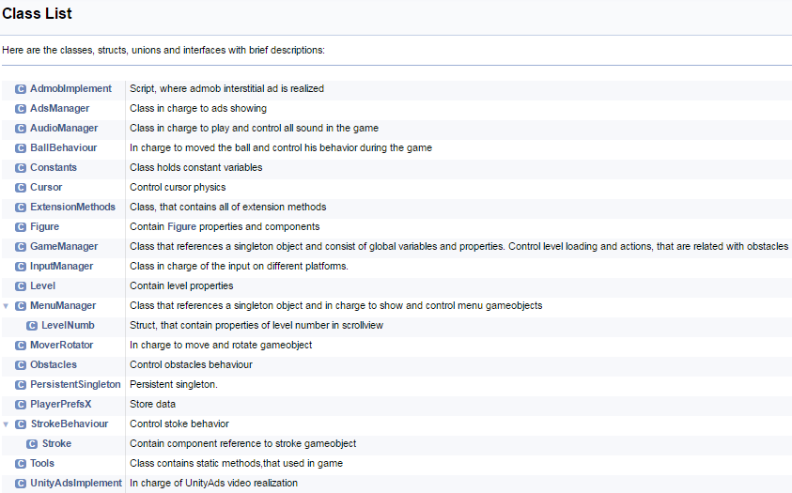

**Ads Integration**

Visit [admob](https://www.google.com/admob/), [unityAds](http://unity3d.com/ru/services/ads) sites to define your ID’s and set them in *AdsManager* scripts, which is attached to *AdsManager* gameobject

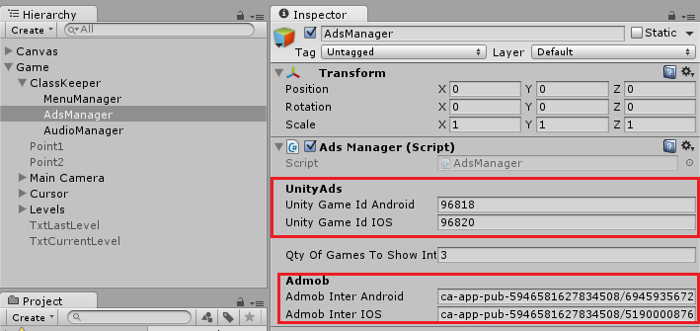

**Interstitial settings**

*qtyOfGamesToShowInter* – value of frequency. Set how many interstitial ad will be after passed level.

For example, default *qtyOfGamesToShowInter* value show, that interstitial ad will be appear every 3-rd game.

**UnityAds settings**

 Set name of your integration id – *defaultZone.*Like on the picture

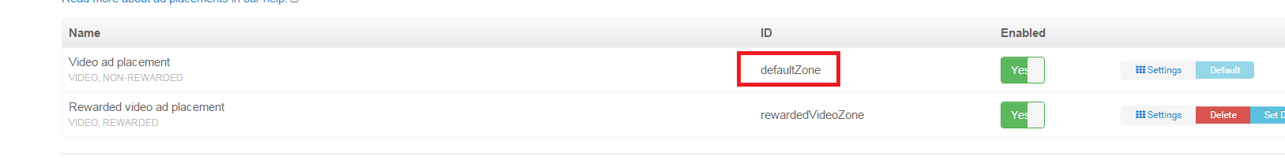

**Customizing levels**

* For testing your level, **turn on test mode** in *GameManager* script.

If “*test mode*” is off – the latest available level is load

Find detail in *GameManager* script in *Start()* method

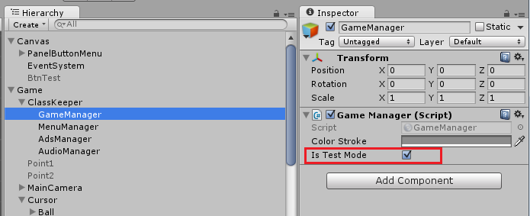

* Create empty gameobject with tag “*Level*” and place under *Levels* gameobject

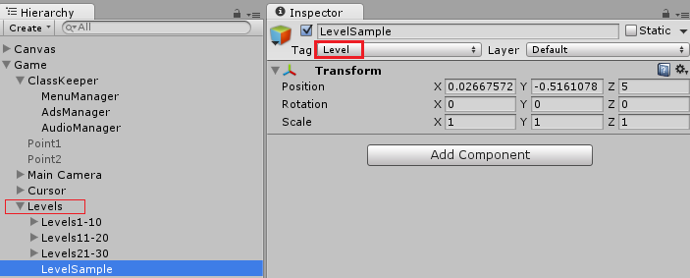

* For building levels you can use figures’ prefabs that are located in *Assets/Reflection_Time/Resources/Prefabs/Figures*

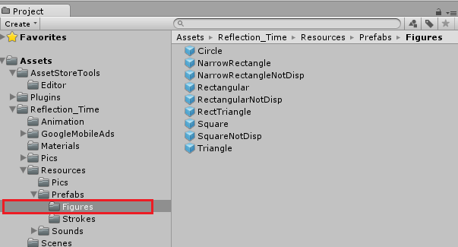

* For implementing new figure: paste figure image with unique name among other figures

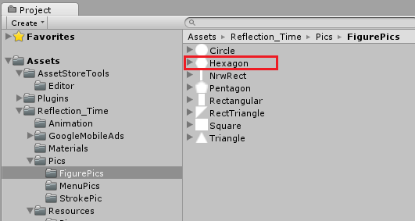

Hexagon stroke’s name **must** consist with prefix of figure’s name (in this case – “*Hexagon*”) and annex “*Stroke*”

It made because, program need to know what kind of stroke is going to appear after hit.

You can look code realization in script *StrokeBehaviour*. Method *StrokeReact()* called from script *Obstacles*

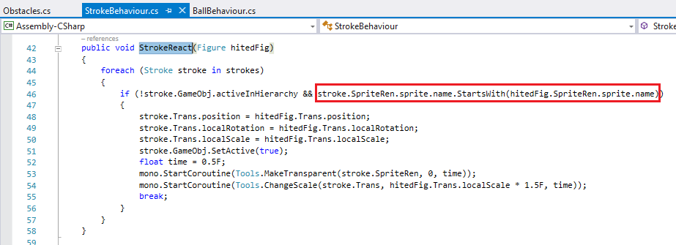

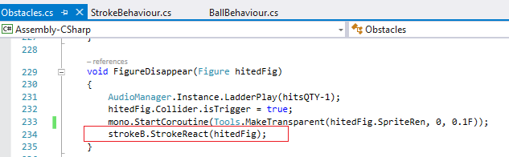

* Save prefabs

Hexagon gameobject must have layer with name “*Hited*” and 2d collider with “*IsTrigger*” false

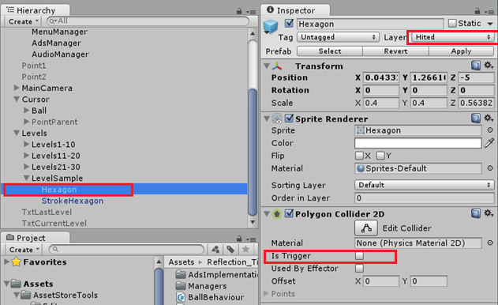

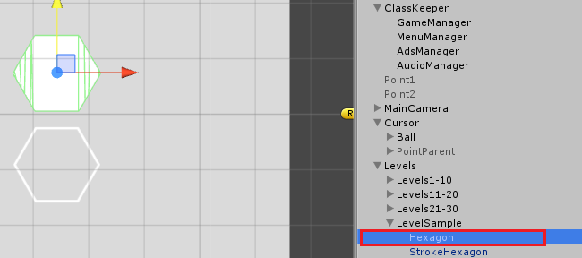

I suggest to save *Hexagon* as a prefab, if you want to use it in next levels

* For figures that, don’t disappear, set “*NotDisappear*” tag, and different color, if you want

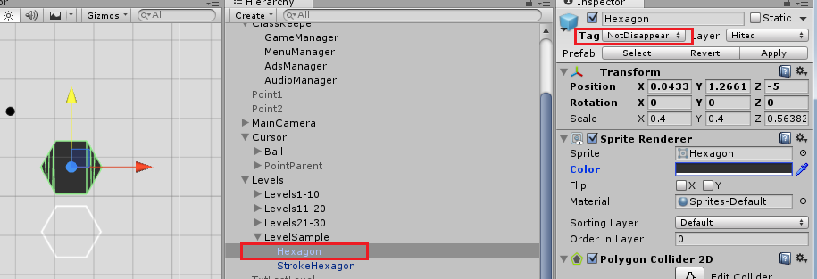

* Strokes must be save as a prefab to *Assets/Reflection_Time/Resources/Prefabs/Strokes*

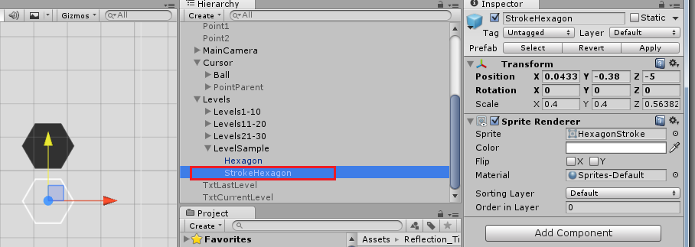

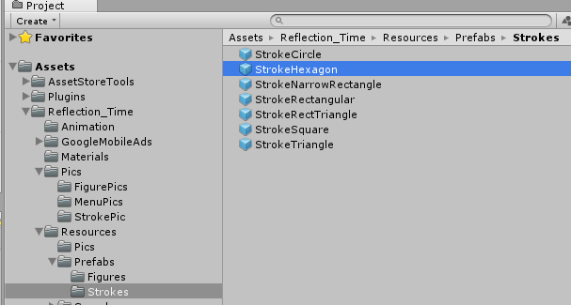

Strokes prefabs are loaded from *Resources* folder inside *StrokeBehaviour* constructor and after, used in pool system

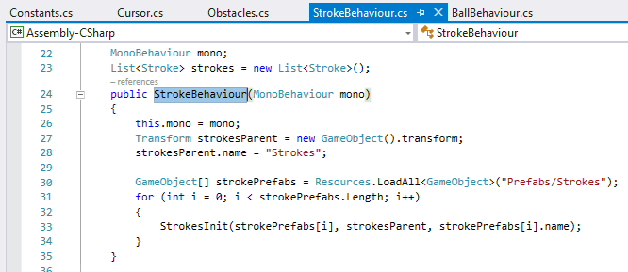

* Hint

Add hint gameobject from *Assets/Reflection_Time /Resources / Prefabs* to your level

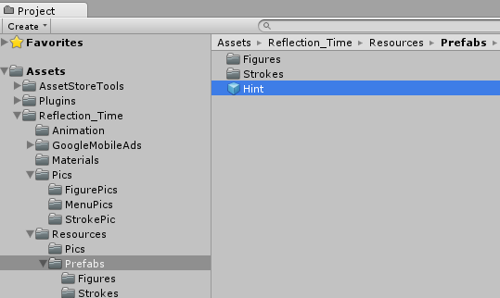

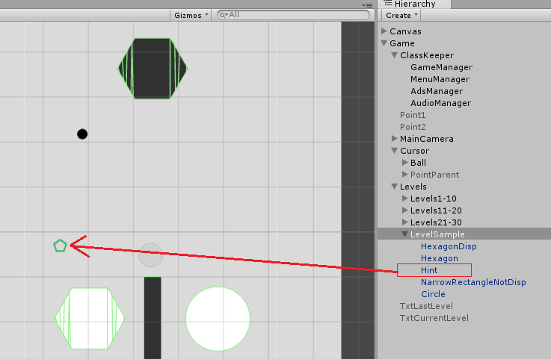

*Hint become active on scene after watching rewarded video

* In ScrollLevels menu add new rows of levels’ numbers, if you need

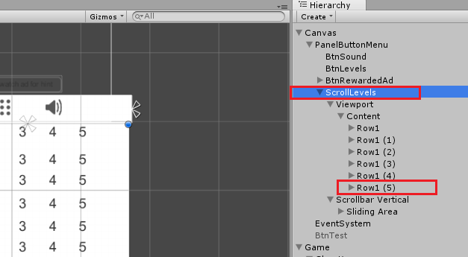

* You can regulate distance between rows: set value of variable *distanceBtwRows* in *MenuManagerscript*

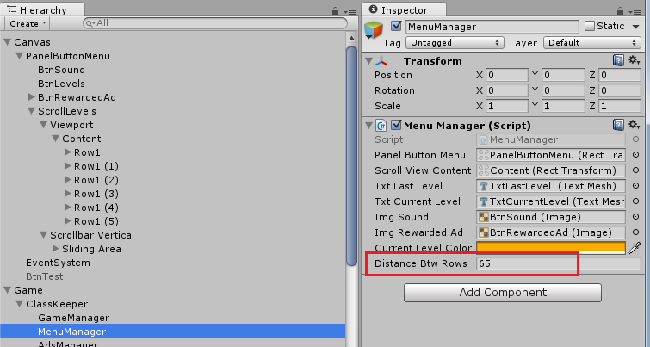

* Don’t forget change size of Content if all levels aren’t shown

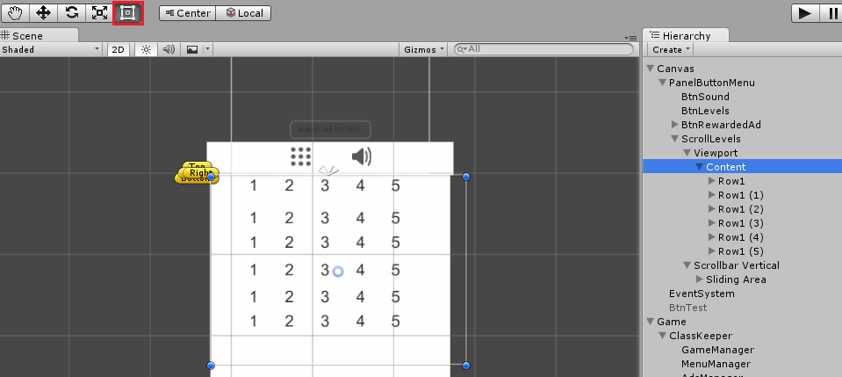

**Errors**

* Advertisement is defined multiple times

Comment all rows in *UnityAdsImplement* script, run the game(obviously, you got the error), then uncomment all rows in *UnityAdsImplement* script and run the games

* The name “Advertisement” does not exist in current context

You can find solution her <http://goo.gl/yzNWkt>

* UnityException: Tag or error with layer

Open *ReadMe* file, which is located in “*Reflection_Time*” root folder and you get answer

**Thanks for your purchasing**

Have a question? - [shorkagames@gmail.com](https://09dfbbdfd8fb1cb418b45cfade1c196eb047e190-www.googledrive.com/host/0ByDQy5V3udWMbmlMWnR4OVF5dHc/index.html)

More our assets: [Publisher link](https://goo.gl/Yby7Dd)

Follow us on Twitter: [twitter.com/ShorkaGames](http://twitter.com/ShorkaGames)

Liked us on Facebook: [facebook.com/ShorkaGames](https://www.facebook.com/ShorkaGames)