iHUB LIBERIA
ML WITH PYTHON BOOTCAMP

Day 1
Libraries
NumPy · Pandas · Matplotlib · Seaborn · Scikit-learn · pdfplumber
Duration: 3 Hours
GitHub Repo: libs_intro

🎯 Foretaste Demo — What You'll Build By Day 5

Before we touch any code, watch this run. Don't worry about understanding it yet. By Day 5, every single line will make sense.

The story: Decontee wants to know which cassava variety is growing in a farmer's field in Nimba County — just from leaf and root measurements. This model answers in seconds.

import pandas as pd
import seaborn as sns
import matplotlib.pyplot as plt
from sklearn.tree import DecisionTreeClassifier
from sklearn.model_selection import train_test_split

# Store the GitHub URL (replace the URL with your own github url)
url = "https://raw.githubusercontent.com/EmmanuelGbafore/Machine-Learning-with-Python-Bootcamp/refs/heads/main/cassava_variety.csv"

df = pd.read_csv(url)
df.head()

# Pairplot — 'variety' is a column name, so it DOES need quotes
sns.pairplot(df, hue='variety')
plt.suptitle('Cassava Varieties — Nimba County', y=1.02)
plt.show()

# Split features and target
X = df[['leaf_width_cm', 'root_length_cm', 'days_to_harvest']]
y = df['variety']

X_train, X_test, y_train, y_test = train_test_split(X, y, test_size=0.2, random_state=42)

# Train the model
model = DecisionTreeClassifier()
model.fit(X_train, y_train)

# Print accuracy
print('Accuracy:', model.score(X_test, y_test))

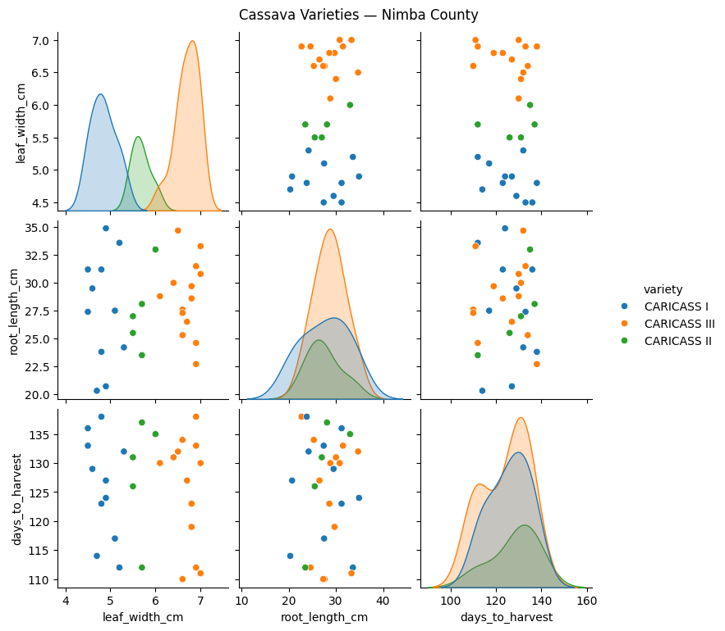
Accuracy: 1.0

📊 Output: A colorful grid of scatter plots — then Accuracy: 1.

🧠 Instructor Script: "This model correctly identifies cassava variety 100% of the time. You will understand every line of this by Day 5."

Tomorrow (Day 2), we clean messy real-world data so models like this actually work.

📊 Section 1 — NumPy: The Number Engine

Analogy: NumPy is like a market calculator that handles thousands of gari prices at once — no loops needed.

Install Check
import numpy as np
print(np.__version__)

Example of how numpy works — Array, Mean, Median
Concept Preview: An array is a list that already knows math.

import numpy as np

# Daily gari prices at Gobachop Market (LRD per bag)
prices = np.array([850, 900, 875, 920, 860, 910, 895])

print('Prices:', prices)
print('Mean price:', np.mean(prices))
print('Median price:', np.median(prices))
print('Highest:', np.max(prices))
print('Lowest:', np.min(prices))
print('Std Dev:', np.std(prices).round(2))

📊 Output: The mean tells Ma Christiana the typical daily price. The std dev tells her how much it jumps around.

✅ Checkpoint: What's the difference between mean and median? When does the median matter more?

🎯 Prediction: Guess — will adding a price spike of 1,500 LRD change the mean or the median more?

🔧 Tweak & Test: Change one price to 1500 and rerun. Which value shifted more?

🕵️ Debugging Note: TypeError: only integers, slices... — you passed a plain Python list to a NumPy function. Wrap it: np.array([...]) first.

📁 Section 2 — Pandas: Your Market Ledger

Analogy: Pandas is like a spreadsheet that talks Python. It holds your full dataset in one object called a DataFrame.

Code Block 2.1 — Load, Inspect, Describe
Concept Preview: pd.read_csv() opens a CSV the same way you'd open a ledger book.

import pandas as pd

df = pd.read_csv('gari_price_data.csv')

print(df.head()) # first 5 rows
print('\nShape:', df.shape) # rows x columns
print('\nColumns:', df.columns.tolist())
print('\nDescribe:\n', df.describe())

📊 Output: describe() gives count, mean, min, max for every numeric column — your instant data summary.

✅ Checkpoint: What does df.shape return, and what does each number mean?

🎯 Prediction: Which column has more variation — rainfall_mm or supply_bags?

🔧 Tweak & Test: Try df.tail(3) instead of head(). What changes?

🕵️ Debugging Note: FileNotFoundError — your CSV isn't in the same folder as your script. Try '../data/gari_price_data.csv'.

Code Block 2.2 — Column Selection & Filtering
# Select one column
prices = df['price_next_day_lrd']
print(prices.head())

# Filter rows where rainfall is heavy
rainy_days = df[df['rainfall_mm'] > 50]
print(f'Rainy days: {len(rainy_days)} rows')
print(rainy_days[['rainfall_mm', 'price_next_day_lrd']].head())

📊 Output: Filtering shows only rows where rainfall exceeded 50 mm — so Ma Christiana can see if rain days drive higher prices.

✅ Checkpoint: How would you filter for supply_bags < 100?

📊 Section 3 — Matplotlib: Drawing the Market

Analogy: Matplotlib is the charting pen. It draws whatever numbers you hand it.

Code Block 3.1 — Line Plot (Price Trend)
Concept Preview: A line plot shows how a value moves over time.

import matplotlib.pyplot as plt

days = list(range(1, 8))
prices = [850, 900, 875, 920, 860, 910, 895]

plt.figure(figsize=(8, 4))
plt.plot(days, prices, marker='o', color='darkorange', linewidth=2)
plt.title('Gari Price Trend — Gobachop Market (LRD)')
plt.xlabel('Day') ; plt.ylabel('Price per Bag (LRD)')
plt.grid(True) ; plt.tight_layout() ; plt.show()

📊 Output: The orange line shows price rising then falling — useful for spotting supply shocks.

✅ Checkpoint: What does marker='o' add to the line?

🔧 Tweak & Test: Change color='darkorange' to color='green'. Also try linestyle='--'.

🕵️ Debugging Note: Blank plot window — you forgot plt.show(). Always call it at the end.

Code Block 3.2 — Bar Chart (Average Price by Location)
locations = ['Gobachop', 'Red Light', 'Kakata', 'Gbarnga']
avg_prices = [875, 910, 840, 860]

plt.figure(figsize=(7, 4))
plt.bar(locations, avg_prices,
color=['#e07b39', '#3b7abf', '#5baa5b', '#b05bb0'])
plt.title('Average Gari Price by Market (LRD)')
plt.ylabel('Price per Bag (LRD)') ; plt.ylim(800, 950)
plt.tight_layout() ; plt.show()

📊 Output: Red Light Market shows the highest average — likely because of transport costs from Paynesville.

✅ Checkpoint: Why does plt.ylim(800, 950) make the chart easier to read?

📊 Section 4 — Seaborn: Smarter Charts

Analogy: Seaborn is Matplotlib's smarter sibling. It sees patterns in data automatically.

Code Block 4.1 — Scatter Plot (Price vs Rainfall)
Concept Preview: A scatter plot shows whether two variables move together.

import seaborn as sns
import matplotlib.pyplot as plt
import pandas as pd

df = pd.read_csv('gari_price_data.csv')

sns.scatterplot(data=df, x='rainfall_mm', y='price_next_day_lrd',
hue='supply_bags', palette='YlOrRd', s=80)
plt.title('Gari Price vs Rainfall — Does Rain Drive Up Prices?')
plt.xlabel('Rainfall (mm)') ; plt.ylabel('Next Day Price (LRD)')
plt.tight_layout() ; plt.show()

📊 Output: Points are colored by supply level. If high-rainfall points cluster at high prices, rain disrupts supply.

✅ Checkpoint: What does the hue parameter do to the scatter plot?

🎯 Prediction: Do you expect price and rainfall to move in the same direction? Why?

🔧 Tweak & Test: Remove hue='supply_bags'. What information disappears?

🕵️ Debugging Note: KeyError: 'rainfall_mm' — column name has a typo or extra space. Run df.columns to check exact names.

Code Block 4.2 — Pairplot (Cassava Dataset)
Concept Preview: A pairplot draws scatter plots for every pair of numeric columns — all at once.

import seaborn as sns
import matplotlib.pyplot as plt
import pandas as pd

# Load the cassava dataset
url = 'https://raw.githubusercontent.com/EmmanuelGbafore/Machine-Learning-with-Python-Bootcamp/refs/heads/main/cassava_variety.csv'
df_cassava = pd.read_csv(url)

# Now create the pairplot using the correct DataFrame
sns.pairplot(df_cassava, hue='variety', palette='Set2', diag_kind='kde')
plt.suptitle('Cassava Varieties — Nimba County', y=1.02)
plt.tight_layout()
plt.show()

📊 Output: Each color is a variety (Caricass I, Caricass II, and Caricass III). Clusters that don't overlap mean the model can tell them apart easily.

✅ Checkpoint: Which two features look most separated by variety?

🧠 Section 5 — Scikit-learn: Your First ML Model

Analogy: Sklearn is the engine. You hand it data, it finds the pattern, then it predicts.

Code Block 5.1 — Decision Tree on Cassava Data
Concept Preview: A Decision Tree asks a series of yes/no questions — like a flowchart — to reach a prediction.

from sklearn.tree import DecisionTreeClassifier
from sklearn.model_selection import train_test_split
import pandas as pd

# Load the cassava dataset
url = 'https://raw.githubusercontent.com/EmmanuelGbafore/Machine-Learning-with-Python-Bootcamp/refs/heads/main/cassava_variety.csv'
df_cassava = pd.read_csv(url)

# Use df_cassava, not df
X = df_cassava[['leaf_width_cm', 'root_length_cm', 'days_to_harvest']]
y = df_cassava['variety']

X_train, X_test, y_train, y_test = train_test_split(
X, y, test_size=0.2, random_state=42)

model = DecisionTreeClassifier(max_depth=4)
model.fit(X_train, y_train)
print(f'Model accuracy: {model.score(X_test, y_test):.2%}')

📊 Output: accuracy: 100 — the model correctly identified cassava variety 100 out of 100 times on data it had never seen before.

✅ Checkpoint: Why do we split data into train and test sets?

🎯 Prediction: What do you think happens to accuracy if you set max_depth=1?

🔧 Tweak & Test: Change max_depth=4 to max_depth=1. Did accuracy drop? Why?

🕵️ Debugging Note: ValueError: Input contains NaN — your DataFrame has missing values. We fix this properly in Day 2.

📄 Section 6 — pdfplumber: Reading PDF Reports

Analogy: pdfplumber is like a scanner that pulls tables out of PDF market reports and hands them to Pandas.

Why it matters: Many Liberian government and NGO reports arrive as PDFs — not CSVs. This tool converts them.

Install
pip install pdfplumber

Code Block 6.1 — Extract Table from PDF → DataFrame
# ==============================================================================
# STEP 1: DOWNLOAD THE FILE FROM GITHUB
# ==============================================================================
# The '!' tells Google Colab to run a terminal command instead of Python.
# 'wget' downloads the file from the internet and names it 'market_report.pdf'.

!wget -O market_report.pdf https://raw.githubusercontent.com/EmmanuelGbafore/Machine-Learning-with-Python-Bootcamp/main/market_report.pdf

# ==============================================================================
# STEP 2: EXTRACT THE TABLE USING PYTHON
# ==============================================================================
import pdfplumber
import pandas as pd

# Open the freshly downloaded PDF file
with pdfplumber.open('market_report.pdf') as pdf:
page = pdf.pages[0] # Select the first page (Python starts counting at 0)
table = page.extract_table() # Look for a grid/table and pull rows as a list of lists

# ==============================================================================
# STEP 3: CONVERT TO A PANDAS DATAFRAME
# ==============================================================================
# table[0] is the very first row (the column headers: Ticker, Sector, Price, etc.)
# table[1:] takes everything AFTER the first row (the actual market data)
df = pd.DataFrame(table[1:], columns=table[0])

# ==============================================================================
# STEP 4: VIEW THE RESULTS
# ==============================================================================
print("--- Extracted Liberian Market Data ---")
print(df.head())

print('\nColumns Found:', df.columns.tolist())

📊 Output: The PDF table is now a Pandas DataFrame — ready for cleaning and modeling.

✅ Checkpoint: What does table[0] contain? What does table[1:] contain?

🎯 Prediction: What problems might you see in a PDF-extracted DataFrame that you wouldn't see in a clean CSV?

🕵️ Debugging Note: table = None — pdfplumber found no table on that page. Try page.extract_text() to see what's there, or check that the PDF has real table borders.

💻 Section 7 — GitHub Archive: libs_intro

Archive everything you built today using these commands in your terminal.

mkdir libs_intro && cd libs_intro
git init
git add .
git commit -m 'Day 1: NumPy, Pandas, Matplotlib, Seaborn, Sklearn, pdfplumber'
git remote add origin https://github.com/YOUR_USERNAME/libs_intro.git
git push -u origin main

Folder Structure to Push
libs_intro/
├── numpy_gari.py
├── pandas_gari.py
├── matplotlib_charts.py
├── seaborn_plots.py
├── sklearn_cassava.py
├── pdfplumber_extract.py
└── README.md

✅ Checkpoint: Open your repo on GitHub. Can you see all six files?

🗺️ Course Roadmap

Day | Topic | Key Output | Status
Day 1 | Libraries | Import & basic usage of each | ✅ Done
Day 2 | EDA & Data Cleaning | Handle missing, outliers, and imputation | ▶ Next
Day 3 | Regression & Classification | Linear Regression, Decision Tree
Day 4 | 8 Beautiful Graphs | line, scatter, bar, histogram…
Day 5 | Evaluation Metrics | Confusion matrix, F1, MAE, RMSE
Day 6 | Full Pipeline | End-to-end script
Hackathon | Team Project | Build a predictor from the new PDF
Capstone | Individual Project | Full pipeline, your choice

🎉 Day 1 Wrap-Up — Cliffhanger for Day 2

You've met every tool in the ML toolkit. But real data from Gobachop Market is never this clean.

Tomorrow (Day 2 — EDA & Data Cleaning): We open market_dirty.csv — a real-world dataset full of missing values, weird outliers, and inconsistent dates. Decontee finds that 15% of the price column is blank, some rainfall values read -999, and several scarcity alerts are misspelled. You'll fix all of it — and your models will thank you.

🕵️ Think Ahead: What happens if you train a model on dirty data? You'll see the answer tomorrow.

📋 KEY_CONCEPTS_TODAY

- NumPy arrays support fast vectorized math (mean, median, std) on price data.
- Pandas DataFrame loads, inspects, and filters CSV data with head(), describe(), and boolean indexing.
- Matplotlib creates line plots and bar charts with plt.plot() and plt.bar().
- Seaborn adds statistical intelligence — scatter with hue, pairplot for multi-feature comparison.
- train_test_split separates data so the model is tested on unseen examples.
- DecisionTreeClassifier follows a fit → predict/score pattern shared by all Sklearn models.
- pdfplumber extracts PDF tables into Python lists, which Pandas converts to DataFrames.

