FoodShare Tracker Software Requirements Specification
  - Deliverable 2 group report
Version 1.6 | Evidence aligned revision | 23 October 2026
Item | Details
Unit | FIT1056 Introduction of Software Engineering
Team | MA Team 04
Members | Muhammad Hassan; Chong Ka Chuan; Voo Wayne Sann; Yong Hao Chan
Baseline | Supplied SRS version 1.5 dated 8 October 2026
Implementation | Streamlit 1.66.0 and Python sqlite3; one site and one pickup desk
Evidence cutoff | Manual evidence dated 22 October 2026 MYT; prepared automated run 23 October 2026 MYT
Manual tester | DeanChan, as identified by the tester in the accompanying conversation
Peer code reviewer | Unknown / Not completed

This revision replaces planned-only implementation claims with inspected code, 306 passing automated cases, retained screenshots and tester-confirmed manual outcomes. It retains the functional and quality requirement identifiers and states where acceptance remains partial or unknown.
The prototype implements the core donation-to-collection workflow and the additional swap, feedback and queue features. Full acceptance is not established: the five-person usability study and another team member's review remain Unknown / Not completed; queue disconnection, deployment security, performance and timed failure recovery have specific evidence gaps.
Scope is the group deliverable. Individual reflections, personal contribution statements and unperformed reviewer sign-off are outside this revision.

Document control
Version | Date | Change
1.3 | 10 Sep 2026 | Supplied Deliverable 1 design baseline, as recorded in v1.5.
1.4 | 8 Oct 2026 | Clarified stock, swaps, privacy, queue, recovery and acceptance criteria.
1.5 | 8 Oct 2026 | Extended Sections 9 to 15 with plans and unverified evidence registers.
1.6 | 23 Oct 2026 | Aligned the architecture with Streamlit/sqlite3, replaced planned-only test reporting, revised diagrams and added explicit deviations and evidence limitations.

Historical elicitation and revision information are retained from the supplied SRS; they have not been independently re-interviewed. All authored report text is English. Original screenshots remain unchanged, including operating-system or browser text.
Evidence labels: Pass means the stated executed scope met its expectation. Pass with tester confirmation means some steps rely on DeanChan's recorded account. Partial means only part of an acceptance condition is demonstrated. Unknown / Not completed means the activity was not performed or no sufficient outcome was supplied. These labels do not convert missing measurements into passes.
Build identity: 4324bcbaefe765b10c90209ab1708f8164afe9fc55d79d5468c797bd295e8639
This SHA-256 identifies the application, test and tool source set recorded in validation.json. No final Git commit was supplied or invented. Documentation and diagrams are additional release artifacts; their hashes are in the release manifest.

Contents
Document control 2
1 Introduction 6
1.1 Purpose 6
1.2 Audience and reading guidance 6
1.3 Scope and boundaries 6
1.4 Terms and conventions 6
2 Problem statement 7
2.1 Current situation 7
2.2 Impact 7
2.3 Goals and measurable targets 7
3 Stakeholder analysis 7
3.1 Stakeholders and influence 7
3.2 Personas 8
3.3 Elicitation findings 9
4 System features and requirements 9
4.1 Feature scope and priority 9
4.2 Functional requirements 10
4.3 Non functional requirements 15
4.4 Acceptance criteria 16
4.5 Delivery and change control 25
5 Use case diagram 25
6 Class diagram 29
6.1 Implemented classes and concepts 29
6.2 Account and operational record relationships 31
6.3 Stored records and invariants 32
6.4 Component mapping 33
7 System context analysis 34
7.1 Operational context 34
7.2 Behavioral context 34
7.3 Ecological context 34
7.4 Sociocultural context 34
7.5 System context 35
7.6 Context implications 35
8 System architecture 35
8.1 Architecture overview 35
8.2 Transaction and request boundaries 36
8.3 Technology choice and tradeoffs 37
8.4 Security preservation and recovery 37
9 Usability evaluation 37
9.1 Method and participants 37
9.2 Heuristic inspection 38
9.3 User testing scenarios 38
9.4 Findings and limits 39
10 Sequence diagrams 39
10.1 Receive an accepted donation 40
10.2 Record actual collection 41
10.3 Approve a private swap 42
10.4 Submit anonymous feedback 43
11 Quality assurance plan and executed results 44
11.1 Strategy environment and evidence identity 44
11.2 Automated tests with pytest 44
11.3 Manual functional and end to end tests 45
11.4 Defects observations and release gates 48
12 Implementation and MVP evidence 49
12.1 Implemented features 49
12.2 Key implementation excerpts 50
12.3 Error handling and fault tolerance 51
12.4 Repository and installation quality 51
12.5 Deviations unmet criteria and limitations 52
13 Deliverable 1 updates and change log 53
14 Requirements design and test traceability 54
14.1 Functional requirements 54
14.2 Non functional requirements 58
15 Conclusion 58
References 59
Appendix A Executed test alias register 59
Appendix B Evidence locations and report use 62
Appendix C Selected original screen evidence 63
Appendix D Outstanding human activities 67

List of figures
Figure 1 Stakeholder influence and importance 8
Figure 2 Public Donor use cases 25
Figure 3 Recipient use cases 26
Figure 4 Staff and Volunteer use cases 27
Figure 5 Management security and local operator use cases 28
Figure 6 Actual Python classes and exception inheritance 30
Figure 7 Logical account profile session and task relationships 31
Figure 8 Logical donation inventory allocation and pickup relationships 32
Figure 9 Actors and system context 35
Figure 10 Implemented Streamlit service domain and SQLite layers 36
Figure 11 Donation receiving sequence 40
Figure 12 Atomic collection sequence 41
Figure 13 Private swap approval sequence 42
Figure 14 Anonymous feedback submission sequence 43
Figure 15 Accepted donation receipt and recorded quantity 63
Figure 16 On hand reserved and available stock after allocation 64
Figure 17 Staff approved private replacement 64
Figure 18 Recipient collection history for the observed allocation 65
Figure 19 Protected page requires sign in after logout 65
Figure 20 Deactivated account cannot sign in 66
Figure 21 Queue refresh state with its update timestamp 66
Figure 22 Restored Demo values after the manual backup test 67

List of tables
Table 6.3 Implemented record catalogue 32
Table 9.2 Heuristic observations on the implemented prototype 38
Table 11.1 Executed verification environment 44
Table 11.2 Automated result totals by module 45
Table 11.3 Manual execution register 46
Table 11.4 Full copied dataset recovery comparison 48
Table 11.5 Actual defect and observation register 48
Table 12.1 Feature implementation and evidence 49
Table 12.5 Explicit deviations and incomplete acceptance 52
Table 13 Response to baseline and tutor feedback 53
Table 14.1 Functional requirement traceability 54
Table 14.2 Quality acceptance and evidence limits 58
Table A1 Representative executed tests 59
Table B1 Retained evidence paths 62

1 Introduction

1.1 Purpose
FoodShare Tracker supports one community food bank's receiving, stock, needs, allocation and collection records. This SRS states expected behavior, the implemented design and the evidence available for the assessed prototype. Requirements remain distinct from test outcomes so future changes can be evaluated without losing the original acceptance targets.

1.2 Audience and reading guidance
Audience | Recommended sections
Food bank stakeholders | Sections 2 to 5 and 7 for needs, scope and supported workflows.
Developers and maintainers | Sections 4, 6, 8, 10 and 12 for rules, code boundaries and transaction behavior.
Testers and assessors | Sections 9, 11, 12.5 and 14 plus Appendices A to C for outcomes, gaps and traceability.

1.3 Scope and boundaries
Direct actors are IT Admin, Organisation Manager, Organisation Staff, Volunteer, Donor and Recipient. Donor is a public actor, not an authenticated role in the implementation. The five account roles are admin, manager, staff, volunteer and recipient.
Public users can schedule and check a donation and submit anonymous feedback. Signed-in Recipients maintain their needs, preview their own allocations, request private swaps, read notices and view their own queue estimate. Internal roles receive only the pages and actions appropriate to their authority or assigned shift.
The prototype excludes payments, accounting, grants, fundraising, third-party SMS/email, automatic beneficiary ranking, multi-site coordination and a fully offline native application. Physical food inspection, consent and allocation fairness remain human responsibilities. An approximate queue time is not a guaranteed appointment.

1.4 Terms and conventions
Term | Definition
On hand | Physical units recorded for a food batch; stored as batches.quantity.
Reserved | Units in active uncollected allocation items; derived from committed allocations rather than a separate stored total.
Available | On hand minus reserved. Allocation additionally requires safe, unexpired food.
Pickup window | Stored pickup date/time plus a configurable duration; evaluated in Asia/Kuala_Lumpur.
Actor | Current authenticated user passed from a validated session to a service function.
Tx | Persistence helper for read snapshots, loaded dictionaries and transactional updates.
Evidence ID | Stable screenshot or test reference, not a fabricated Git commit or human review.

2 Problem statement

2.1 Current situation
Separate paper forms, spreadsheets and informal messages can leave donation, stock, needs and collection records inconsistent. A busy handout period makes repeated receipt entry, stale quantities and unsuitable substitutions harder to notice. The baseline evidence came from peer role-play, not measured operations at a real food bank.

2.2 Impact
An outdated stock figure can promise the same food twice. Missed expiry or damage updates can leave unsafe food appearing usable. Repeated needs records can miss allergy or cultural changes; discussing these at pickup can expose personal circumstances. Unclear volunteer shifts create duplicated work, and broad pickup windows leave Recipients uncertain about transport and waiting.

2.3 Goals and measurable targets
Goal | Target | Current evidence
Consistent stock | No partial or duplicate completion in specified failure and contention scenarios. | Automated transaction, replay and 50-round contention tests pass; Section 11.
Safe food selection | Reject expired, held, unconfirmed or known unsuitable food without issuing it. | Automated negative and boundary scenarios pass.
Learnable workflows | At least 4 of 5 first-time Staff complete three tasks after at most one hour of training. | Unknown / Not completed; NFR-02.
Response time | At least 95 of 100 operations within two seconds with 1,000 records and five concurrent users. | Not measured; NFR-05.
Private pickup visibility | Only own queue details; refresh within 30 seconds; unavailable estimate on failure. | Privacy tests pass; manual timing tester-confirmed; complete offline behavior remains partial.

3 Stakeholder analysis

3.1 Stakeholders and influence
Actor | Need and authority | Influence and importance
IT Admin | Account authority, security audit and controlled local recovery. | High / High
Manager | Staff/Volunteer accounts, task oversight, settings, reporting and feedback review. | High / High
Staff | Receive food, maintain stock, record needs with consent, allocate, collect, review swaps and operate queue. | Medium / High
Volunteer | Clear assigned receiving/distribution shift; minimal necessary access. | Medium / High
Donor | Short account-free booking and reference-based receipt confirmation. | Low / Medium
Recipient | Suitable food, private needs and swaps, clear notices and own waiting estimate. | Low / High

Low organisational influence does not reduce the importance of Recipient privacy and dignity. Internal authority is split deliberately: an IT Admin does not automatically receive ordinary access to private swap reasons or food-bank operations.
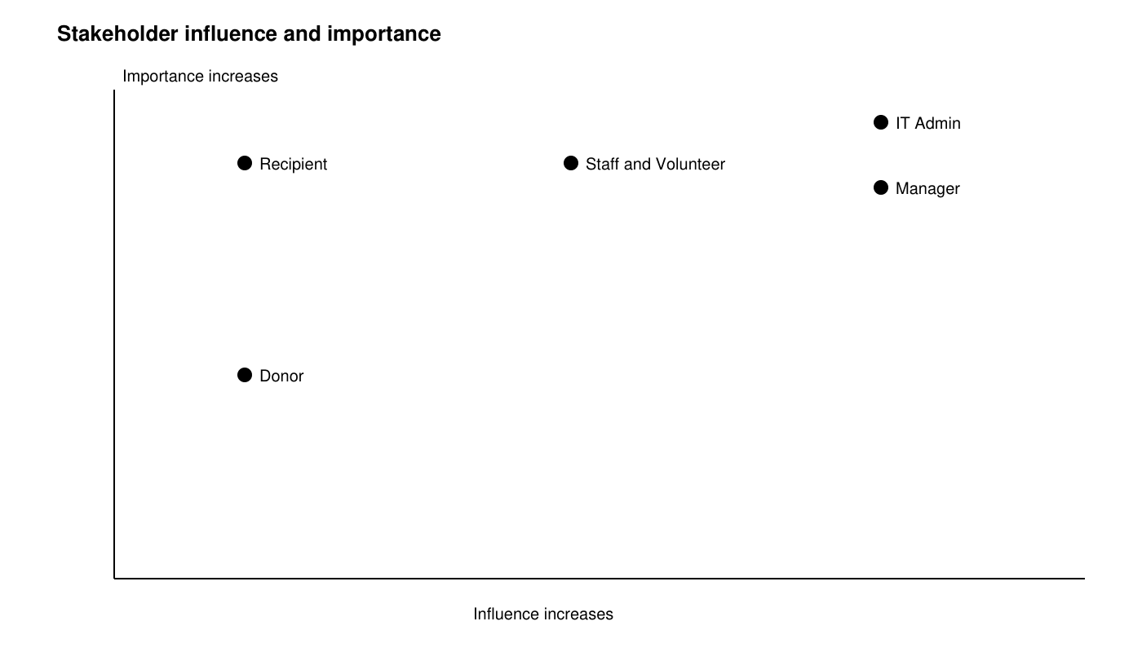
Figure 1 Stakeholder influence and importance

3.2 Personas
Persona | Goals and constraints | Typical task
Staff | Medium digital confidence; works under time pressure; needs current stock and concise safe-allocation information. | Allocate suitable food, handle a private swap and record actual collection.
Volunteer | Low to medium confidence and limited training; needs clear instructions and task-scoped permissions. | Open own receiving shift and receive accepted quantities against a donation reference.
Donor | Occasional user with varied digital confidence; avoids unnecessary account creation. | Book a donation, keep its reference and check receipt status.
Recipient | May use a shared device or limited connection; needs understandable optional fields and private assistance. | Update needs, preview own food, request a swap and check pickup information.

3.3 Elicitation findings
The supplied baseline records structured peer role-play on 26 August 2026 across the six stakeholder perspectives. Peers were not external food-bank representatives. The following retains that baseline's findings; no new interviews, participant counts or verbatim quotations are invented. Later requests R1 and R2 introduced anonymous feedback and the estimated queue.
Source | Retained finding | Requirement links
I1 | Outdated structure and documentation hinder maintenance. | NFR-06
I2 | Access should match the information needed by each role. | FR-03; NFR-01
I3 | Workforce creation and revocation need controlled authority. | FR-04 to FR-07
I4 | Stock, expiry and quantities are daily safety concerns. | FR-13 to FR-16; FR-23
I5 | Need/urgency indicators support staff judgment without ranking people. | FR-20; FR-21
I6 | Volunteer shifts need clear tasks and limited access. | FR-24; FR-25
I7 | Donors need a short process and receipt confirmation. | FR-08 to FR-12
I8 | Forms need plain wording and an explanation of data purpose. | FR-17; FR-18; NFR-07
I9 | Saved pickup changes must be visible to the Recipient. | FR-26
I10 | Allergy, cultural and optional-reason data require restricted visibility. | FR-19; FR-34

4 System features and requirements

4.1 Feature scope and priority
Original feature IDs are retained. Priority describes the intended delivery order; it is not proof of acceptance. The prepared code contains all eleven feature areas, including the F-07 notice dependency required by the F-05 MVP.
Feature | Capability | Baseline priority
F-01 | User account and role management | Must / MVP
F-02 | Donation management | Must / MVP
F-03 | Inventory and expiry tracking | Must / MVP
F-04 | Beneficiary profile and needs | Must / MVP
F-05 | Food allocation and distribution | Must / MVP
F-06 | Volunteer task assignment | Should / Iteration 2
F-07 | Notifications and alerts | Must / MVP dependency
F-08 | Operational reporting | Could / Iteration 3
F-09 | Private food swap request | Should / Iteration 2
F-10 | Anonymous feedback box | Should / Iteration 2
F-11 | Estimated pickup queue | Should / Iteration 2

4.2 Functional requirements
The following preserves all 57 baseline functional requirement statements and their IDs. The original reserved-quantity wording is interpreted through the derived reservation model in Section 6.3. The closed-window queue restriction has a recorded implementation exception in Section 12.5; preserving its statement does not imply that exception was accepted.

4.2.1 F-01 User account and role management
ID | Required behavior
FR-01 | The system shall allow self-registration only for Recipient accounts.
FR-02 | The system shall authenticate each internal user and Recipient before protected functions are granted; account-free donation scheduling and anonymous feedback shall remain public.
FR-03 | The system shall enforce role-based permissions for every protected view and action.
FR-04 | Organisation Managers shall be able to create, update and deactivate Organisation Staff and Volunteer accounts.
FR-05 | IT Admins shall be able to create, update and deactivate Organisation Manager accounts.
FR-06 | The system shall request confirmation before an authorised user deactivates an account.
FR-07 | Authorised Organisation Staff or IT Admins shall be able to deactivate a Recipient account after recording that the request was verified; the action shall invalidate existing sessions and retain an audit event without the verification document or sensitive narrative.
FR-38 | The designated deployment operator with local server access shall create the first IT Admin through a one-time bootstrap command when no active IT Admin exists. It shall prompt for credentials, hash the password, record a bootstrap audit event and expose no public bootstrap route.
FR-39 | An active IT Admin shall be able to create, update and deactivate another IT Admin after re-authentication and confirmation. The system shall reject any action that leaves zero active IT Admins, including self-deactivation of the last active Admin. Managers shall have no IT Admin administration authority.
FR-40 | If all IT Admin credentials are lost, the designated deployment operator shall run a documented local recovery command to reset one existing active IT Admin credential after organisational verification. Recovery shall invalidate that account sessions, record an audit event and shall not create a public recovery endpoint.

4.2.2 F-02 Donation management
ID | Required behavior
FR-08 | The system shall allow a Donor to schedule a donation by entering item type, approximate quantity and preferred drop-off date and time without creating a full account.
FR-09 | The system shall generate one unique donation reference after a valid donation schedule is submitted.
FR-10 | Volunteers and Organisation Staff shall be able to validate a received donation against its donation reference and record it as collected.
FR-11 | After a donation is validated, the system shall display a receipt confirmation on the donation record.
FR-12 | When a donation is validated, the system shall add only its accepted items and quantities to inventory in the receipt transaction; a repeated validation of the same donation shall not create additional stock.

4.2.3 F-03 Inventory and expiry tracking
ID | Required behavior
FR-13 | Organisation Staff shall be able to add and search inventory batches and edit descriptive fields. Quantity corrections shall use FR-41 and FR-42. Volunteers shall have only the inventory access needed for an authorised receiving or distribution task.
FR-14 | The system shall record and display each batch expiry date, on-hand quantity, reserved quantity and available quantity, where available equals on-hand minus reserved and both stored quantities are non-negative.
FR-15 | The system shall flag a batch as near expiry when its expiry date is within the next seven calendar days, including the seventh day.
FR-16 | The system shall block allocation, swap approval and distribution of batches expiring before the site current date. Staff shall be able to mark unsafe batches unavailable and record a reason; the block event shall be audited and held reservations shown for staff resolution.
FR-41 | Organisation Staff shall record spoilage, damage or recount adjustments against a batch with signed quantity delta, reason code and note. The same transaction shall retain before and after on-hand values and acting user. An adjustment producing on-hand below reserved quantity or below zero shall be rejected until affected allocations are revised or cancelled.
FR-42 | Organisation Staff shall correct an erroneous stock adjustment by creating one linked reversing entry rather than deleting history. A second reversal or a reversal breaching FR-41 invariants shall be rejected. Donation and distribution mistakes shall require a linked correction adjustment with a reason, without deleting their source records.

4.2.4 F-04 Beneficiary profile and needs
ID | Required behavior
FR-17 | Recipients, or Organisation Staff acting with their permission, shall be able to create and update a profile containing household size, allergies, dietary restrictions, cultural or religious food needs, accessibility needs, preferred pickup times and urgency indicators.
FR-18 | Each profile field shall state whether it is required or optional and briefly explain why the information is requested.
FR-19 | During allocation, Organisation Staff shall see a concise needs summary while personal details unrelated to allocation remain hidden under FR-03.

4.2.5 F-05 Food allocation and distribution
ID | Required behavior
FR-20 | Organisation Staff shall be able to allocate available, unexpired and safe inventory using recorded needs and urgency indicators. The save shall reject known allergy or dietary conflicts and reserve selected quantities atomically without ranking Recipients.
FR-21 | The system shall present need and urgency indicators without automatically ranking recipients or deciding beneficiary priority.
FR-22 | Organisation Staff and authorised Volunteers shall be able to record actual collection date and item quantities against an uncollected allocation; repeated completion shall not create a second distribution.
FR-23 | On collection, the system shall create one distribution record, deduct actual issued quantities from on-hand stock and release all reservations for that allocation in one transaction. Unissued reserved units shall become available; over-collection, negative stock and repeat completion shall be rejected. Cancelling an uncollected allocation shall release its reservations without reducing on-hand stock.

4.2.6 F-06 Volunteer task assignment
ID | Required behavior
FR-24 | Organisation Managers or Organisation Staff shall be able to assign a Volunteer a receiving or distribution task for a specified shift.
FR-25 | A Volunteer shall be able to view each assigned task with its task type, shift time and instructions.

4.2.7 F-07 Notifications and alerts
ID | Required behavior
FR-26 | When an authorised user saves a pickup date or time change, the system shall commit the schedule and exactly one unread in-system notice for that change in the same transaction; the updated details shall be visible on the Recipient next account view. This requirement shall ship with F-05 in the MVP.
FR-27 | The system shall show Staff alerts for near-expiry batches and item totals at or below a configurable available-stock threshold. Authorised Staff or Managers shall be able to save a non-negative integer threshold per item type, with an audited configuration change.

4.2.8 F-08 Operational reporting
ID | Required behavior
FR-28 | Organisation Managers and Organisation Staff shall be able to generate an on-screen report for a selected date range showing donations received, distributions completed and current stock quantities.
FR-29 | The system shall export the report defined in FR-28 as a CSV file containing the same displayed records and totals.

4.2.9 F-09 Private food swap request
ID | Required behavior
FR-30 | A Recipient shall be able to preview the items in their current allocation before collection.
FR-31 | Before collection and before the pickup window end, a Recipient shall be able to select one allocated item and submit a private swap request with an optional reason.
FR-32 | The system shall reject a second active swap request for the same allocated item.
FR-33 | After a valid swap request is submitted, the system shall record its status as Pending and display that status to the Recipient.
FR-34 | Only Organisation Staff shall be able to view the optional swap reason and approve or decline a Pending request; the owning Recipient shall be able to view their own request and outcome. Volunteers, Managers and IT Admins shall not receive the reason through ordinary application access.
FR-35 | At swap approval, Staff shall select a replacement batch and quantity that are safe, unexpired, available and consistent with the Recipient current allergy, dietary and cultural or religious food restrictions. Unknown suitability shall require staff clarification before approval.
FR-36 | In one transaction, an approved swap shall release the original item reservation, reserve the replacement quantity, replace the allocation item reference and quantity, and record Approved plus an audit event. Neither batch on-hand quantity shall change because collection has not occurred. An unsafe original shall remain unavailable under FR-16; shortages or invalid request states shall roll back every change.
FR-37 | When a request is declined, the system shall allow Organisation Staff to record a respectful response and shall display the Declined status and response to the Recipient.
FR-43 | The system shall close a Pending swap as Expired when the pickup window ends, Closed after collection when collection commits first, or Cancelled when its allocation is cancelled or its target item is removed. It shall check closure before every read and decision and save affected closures with the triggering transaction. Closed requests shall not change stock and shall show the Recipient a respectful explanation.
FR-44 | The system shall permit a swap decision only for a current Pending request on an uncollected allocation within its pickup window. Concurrent decision and collection shall commit at most one valid outcome using a request version check; stale attempts shall leave allocation and stock unchanged.

4.2.10 F-10 Anonymous feedback box
ID | Required behavior
FR-45 | The system shall provide a public Anonymous Feedback Box where a Recipient can submit a plain-text experience message without registration or login, including while an account is already signed in.
FR-46 | The system shall trim a feedback message and accept between 1 and 500 Unicode characters inclusive. It shall reject empty or oversized input with respectful guidance, render all messages as escaped text, and show submission confirmation only after one record is saved.
FR-47 | Anonymous feedback shall store only a generated feedback ID, message, submission calendar date and review status, with no submitter account, allocation, queue, donation, contact, IP address or persistent device identifier. The feedback route shall ignore signed-in identity and shall suppress submission body, identity and network address in request and application logs; the form shall ask users to omit identifying details.
FR-48 | Only Organisation Staff and Organisation Managers shall review anonymous messages and mark them New, Reviewed or Archived. Messages shall not be shown publicly or linked to a Recipient, and review shall not affect food eligibility or allocation priority.
FR-49 | The public feedback form shall use a short-lived single-use form token to prevent replay and permit at most five successful submissions per ten minutes per transient anonymous browser token. These tokens shall be held in memory, expire within ten minutes, and shall not be saved with feedback or tied to an account or IP. Raw feedback older than 90 calendar days shall be deleted by the maintenance routine.

4.2.11 F-11 Estimated pickup queue
ID | Required behavior
FR-50 | For an uncollected allocation with a defined pickup window, authorised Staff or a distribution-authorised Volunteer shall check in a Recipient and create at most one active queue entry per allocation; repeat check-in shall return the existing entry.
FR-51 | The system shall order Waiting entries by server check-in time and queue ID as the tie-breaker. Staff shall control Serving, Completed, Cancelled and No-show transitions; authorised distribution Volunteers may start service and complete their assigned pickups. Only Staff shall mark Cancelled or No-show. A Completed entry shall require a committed distribution.
FR-52 | A Recipient shall see only their own queue status, approximate position, estimated wait range and last-updated time. The response shall contain no other Recipient names, needs, account IDs or individual queue records; Staff may give the same estimate through an assisted workflow.
FR-53 | For one pickup service desk, let a be the number of earlier Waiting or Serving entries and m the configured average service minutes, a positive integer initially 5. A Waiting Recipient position shall be a+1 and estimated wait shall be a*m to (a+1)*m minutes. The estimate shall be labelled approximate; Serving and closed entries shall show their state instead of a wait range.
FR-54 | After a queue transition, the system shall recalculate subsequent estimates on the next view; an open queue page shall refresh at intervals no longer than 30 seconds and show the last-updated timestamp. If fresh data cannot be loaded, it shall show Estimate unavailable and retain only the timestamp of the last confirmed update.
FR-55 | Staff or Managers shall be able to configure the pickup window, average service minutes and queue open or paused state. A paused queue shall display Queue paused with no wait estimate; closed-window or cancelled allocations shall not admit new check-ins. Completing distribution shall close its active queue entry and pending swaps in the same transaction.

4.2.12 Shared audit requirements
ID | Required behavior
FR-56 | The system shall retain an audit event for bootstrap or recovery, account and role changes, deactivation, unsafe-batch blocks, stock adjustments and reversals, allocation or distribution changes, swap decisions or closures, queue transitions and configuration changes. Each event shall hold actor ID or local-operator label, server time, action, target ID and result; relevant quantity or status changes shall be retained without passwords, session tokens, sensitive profile fields, swap reasons or feedback messages.
FR-57 | Only IT Admins shall view security and account-administration audit events; only Staff and Managers shall view operational audit events. Anonymous feedback submission shall create no actor-linked audit event. Staff feedback review shall log only reviewer ID, action and result without feedback ID, message or submission time. Audit events shall not be editable or deletable through application screens.

4.3 Non functional requirements
The measurable targets are retained. In particular, the five-user performance baseline, five-person usability study and 30-minute service-resumption objective are still requirements; they have not been replaced by easier assertions. Section 14.2 reports actual acceptance status.
ID and quality | Requirement
NFR-01 Privacy and security | The system shall deny every protected view or action when the authenticated user's role is not authorised for the requested data or function.
NFR-02 Usability | At least four of five representative first-time Organisation Staff users shall complete donation recording, inventory search and beneficiary-needs viewing after no more than one hour of training, without facilitator correction.
NFR-03 Reliability | After validation or save failure, all previously committed records shall remain unchanged and no partial donation, allocation, distribution, swap, stock adjustment, queue transition or related notice shall be committed.
NFR-04 Data preservation | A release migration shall preserve all stored records, including feedback, queue and audit records within their retention periods. A failed migration shall restore the verified pre-update database and resume the local service within 30 minutes; the recovery point shall be the last committed transaction before the controlled update.
NFR-05 Performance | On the stated local demonstration server with 1,000 operational records and five concurrent test users, at least 95% of 100 scripted login, inventory search, save and status-update operations shall finish within 2 seconds. Full CSV export and migration or recovery tasks are excluded and measured separately.
NFR-06 Maintainability | Each release shall pass the team's code-structure and documentation checklist, and documentation for a changed public interface or module shall be updated in the same release.
NFR-07 Respectful communication | Every recipient-facing label, instruction, validation message, notice and decision response shall use plain, respectful and non-stigmatising wording.
NFR-08 Accessibility | No user-facing status, warning or required action shall be communicated by colour alone; each shall include a visible text label or instruction.
NFR-09 Authentication and session security | Authenticated accounts shall use passwords of 15 to 128 characters, stored only as salted password hashes. Five failed logins per account within 15 minutes shall delay further attempts for 15 minutes with generic error text. Server-enforced idle timeout shall be 15 minutes and absolute lifetime 8 hours. Logout, deactivation and credential recovery shall invalidate sessions on the next request.
NFR-10 Data accuracy and concurrency | In 50 repeated two-session contention tests, no batch shall violate 0 <= reserved <= on-hand, no allocation shall complete twice, and no stale swap decision shall commit. Available quantities and report totals shall exactly match committed source records.
NFR-11 Feedback anonymity | For every anonymous feedback test, stored feedback and feedback-route logs shall contain zero submitter identities, account links, IP addresses, persistent device identifiers or raw submission bodies outside the permitted anonymous message record. No analytics or third-party tracker shall run on the feedback page.
NFR-12 Queue freshness and privacy | Under the NFR-05 test environment with connectivity available, an open queue page shall refresh current estimates within 30 seconds. After a failed refresh it shall label the estimate unavailable. Every Recipient response shall contain zero other-Recipient personal or per-entry data.
NFR-13 Audit and request protection | All FR-56 event types shall have complete role-restricted audit coverage. Logs shall contain no passwords, session secrets, profile-sensitive text, swap reasons or anonymous feedback contents. Every state-changing browser request shall validate an anti-CSRF token; feedback shall also reject form replay. Non-loopback demonstration access shall use HTTPS and Secure, HttpOnly, SameSite session cookies.

4.4 Acceptance criteria
All 80 functional acceptance statements are retained below. Former Planned / TC labels are procedural references, not current outcomes. Representative executed tests appear in Section 14.1 and Appendix A; the presence of a related passing test does not sign off every clause or deployment condition.

Acceptance for F-01
ID | Linked requirement and expected outcome
AC-01 | FR-01  Given a new public user, when self-registration is completed with valid data, then the created account has the Recipient role and no internal role option is offered.
AC-02 | FR-01, FR-03  Given a self-registration request altered to include an internal role, when it is submitted, then the request is rejected and no privileged account is created.
AC-03 | FR-02, FR-03  Given valid internal credentials, when login succeeds, then an authenticated session is created for that account and a request outside its role is denied without returning protected data.
AC-04 | FR-03  Given a Volunteer account, when the Volunteer requests restricted beneficiary personal details, then access is denied and the details are not returned.
AC-05 | FR-04, FR-06  Given a Manager deactivating a Volunteer account, when the Manager confirms the action, then the account becomes inactive and can no longer log in.
AC-06 | FR-05  Given an IT Admin account, when a valid Manager account is created, then the new Manager can log in and receives only Manager permissions.
AC-07 | FR-07, FR-56  Given a verified Recipient deactivation request, when Staff save deactivation, then the account is inactive, its existing session is rejected and an audit event records the acting Staff user and target without sensitive verification text.
AC-51 | FR-38  Given no active IT Admin, when the designated local operator completes bootstrap with valid credentials, then one active IT Admin and one bootstrap audit event exist and no public URL can perform bootstrap.
AC-52 | FR-39  Given one active IT Admin, when that account attempts self-deactivation, then the action is rejected and the active IT Admin count remains 1; a Manager attempt to create an IT Admin also changes zero accounts.
AC-53 | FR-39, FR-56  Given two active IT Admins, when one re-authenticates and confirms deactivation of the other, then the target becomes inactive, its sessions fail on next request and one audit event records the authorised actor.
AC-54 | FR-40  Given lost IT Admin credentials, when verified local recovery resets an existing active Admin, then the new password authenticates, the old password and old session fail, and one recovery audit event exists.
AC-22 | FR-03, FR-19  Given a Volunteer account, when the Volunteer requests the full Recipient profile, then access is denied and no profile data is displayed.
AC-32 | FR-03, FR-24  Given a Volunteer account, when the user attempts to assign a task to another Volunteer, then the action is denied and no task is created.

Acceptance for F-02
ID | Linked requirement and expected outcome
AC-08 | FR-08  Given complete valid donation details, when a Donor submits the schedule without an account, then one donation record is created.
AC-09 | FR-08  Given a donation form missing the item type or drop-off date, when it is submitted, then no record is created and the missing field is identified.
AC-10 | FR-09  Given two valid donation submissions, when both are saved, then each receives a non-empty reference and the two references differ.
AC-11 | FR-10, FR-11, FR-12  Given an existing donation reference, when authorised Staff validate accepted items, then the donation is Collected and receipt confirmation is displayed; repeated validation creates zero additional inventory units.
AC-12 | FR-12  Given five accepted and two rejected units, when the donation is validated, then inventory increases by five units and excludes the two rejected units.

Acceptance for F-03
ID | Linked requirement and expected outcome
AC-13 | FR-13  Given an inventory batch with a known name, when Staff search by that name, then the matching batch is returned with its current details.
AC-14 | FR-13, FR-03  Given a Volunteer without an inventory task, when edit access is requested, then editing is denied.
AC-15 | FR-14  Given a batch with on-hand 10 and reserved 3, when Staff view it, then on-hand is 10, reserved is 3 and available is 7 in the stored and displayed values.
AC-16 | FR-15  Given a batch expiring exactly seven calendar days from today, when inventory is viewed, then the batch is labelled Near expiry.
AC-17 | FR-16  Given a batch whose expiry date is yesterday, when allocation is attempted, then allocation is blocked and the batch quantity remains unchanged.
AC-55 | FR-41  Given on-hand 10 and reserved 2, when Staff record spoilage of 3, then on-hand is 7 and reserved is 2 and one adjustment plus audit event retain delta -3, reason and before/after values.
AC-56 | FR-41  Given on-hand 4 and reserved 3, when damage adjustment -2 is attempted, then it is rejected, on-hand remains 4, reserved remains 3 and no adjustment is committed.
AC-57 | FR-42  Given a committed adjustment -3 from 10 to 7, when Staff reverse it once, then one linked +3 entry restores on-hand to 10; a second reversal creates no entry and leaves stock at 10.
AC-58 | FR-41, FR-42  Given on-hand 7/reserved 2, when a verified recount correction +2 commits, then on-hand is 9 and reserved is 2; when a Volunteer attempts the same adjustment, no entry or quantity change occurs.

Acceptance for F-04
ID | Linked requirement and expected outcome
AC-18 | FR-17  Given a valid Recipient profile containing an allergy and household size, when it is submitted, then both values are saved and displayed on the Recipient's profile.
AC-19 | FR-17  Given Staff editing a profile with the Recipient's permission, when valid changes are saved, then the profile is updated and the acting Staff user is recorded.
AC-20 | FR-18  Given the profile form, when it is displayed, then every field is marked Required or Optional and includes a plain-language purpose explanation.
AC-21 | FR-19  Given Staff performing allocation, when a Recipient is selected, then the needs summary is visible and unrelated personal details are hidden.

Acceptance for F-05
ID | Linked requirement and expected outcome
AC-23 | FR-20  Given available unexpired stock and a recorded allergy, when Staff prepare an allocation, then only items that do not conflict with the recorded allergy can be selected.
AC-24 | FR-21  Given two Recipients with different urgency indicators, when Staff review them, then both indicators are shown, no priority rank is generated and zero allocations or reservations are created until Staff make and save a selection.
AC-25 | FR-22  Given an existing allocation, when authorised Staff record collection, then one distribution record is created with the actual collection date and quantities.
AC-26 | FR-20, FR-23  Given on-hand 10 and reserved 3 for an allocation, when collection of 3 succeeds, then on-hand is 7, reserved is 0 and exactly one distribution record is committed.
AC-27 | FR-23, NFR-03  Given two units in stock, when a distribution of three is attempted, then the operation is rejected, stock remains two and no distribution record is created.
AC-59 | FR-20, FR-23  Given on-hand 10, when Staff reserve 3 and later issue only 2, then the allocation save leaves on-hand 10/reserved 3 and collection leaves on-hand 8/reserved 0 with issued quantity 2.
AC-60 | FR-23  Given an uncollected allocation reserving 3 units from on-hand 10, when Staff cancel it, then on-hand stays 10, reserved becomes 0 and no distribution is created.

Acceptance for F-06
ID | Linked requirement and expected outcome
AC-28 | FR-24  Given a valid Volunteer and shift, when Staff assign a receiving task, then one task appears for that Volunteer on that shift.
AC-29 | FR-24  Given a task without a shift time, when Staff submit it, then the task is not created and the missing time is identified.
AC-30 | FR-25  Given an assigned task, when the Volunteer opens current tasks, then the task type, shift time and instructions are displayed.
AC-31 | FR-25  Given no tasks for the selected shift, when the Volunteer opens that shift, then a clear No tasks assigned message is displayed.

Acceptance for F-07
ID | Linked requirement and expected outcome
AC-33 | FR-26  Given a valid pickup-time change, when Staff save it once, then the new time and exactly one unread notice are stored in the same commit and returned to the owning Recipient on their next account view.
AC-34 | FR-26  Given a pickup update that fails to save, when the operation ends, then the previous schedule remains and no new notice is created.
AC-35 | FR-27  Given a batch entering the seven-day near-expiry period, when Staff open alerts, then an alert identifies that batch and shows the Near expiry text label.
AC-36 | FR-27  Given stock equal to the configured low-stock threshold, when alerts are refreshed, then a low-stock alert identifies the item.
AC-37 | FR-27  Given Staff change the low-stock threshold, when the new value is saved, then subsequent alerts use the new threshold.

Acceptance for F-08
ID | Linked requirement and expected outcome
AC-38 | FR-28  Given a valid date range, when Staff generate a report, then donation and distribution totals match the stored records in that range.
AC-39 | FR-28  Given a start date after the end date, when the report is requested, then no report is generated and the date-range error is identified.
AC-40 | FR-28  Given a valid range with no donations or distributions, when a report is generated, then both event totals are 0, current stock totals equal the database values and no operational records are changed.
AC-41 | FR-29  Given a generated report, when CSV export is selected, then a readable CSV file is produced with the same rows and totals shown on screen.
AC-42 | FR-28, FR-03  Given a Volunteer account, when operational report access is requested, then access is denied and no report data is returned.

Acceptance for F-09
ID | Linked requirement and expected outcome
AC-43 | FR-30  Given an uncollected current allocation, when the Recipient opens Allocation preview, then each allocated item and quantity is displayed.
AC-44 | FR-31, FR-33  Given an uncollected allocated item, when the Recipient submits a swap without a reason, then one request is saved with Pending status.
AC-45 | FR-31  Given an allocation already marked Collected, when a swap request is attempted, then the request is rejected and the allocation remains unchanged.
AC-46 | FR-32  Given a Pending request for an allocated item, when a second request for that item is submitted, then no second active request is created.
AC-47 | FR-34  Given a Volunteer account, when the user requests a swap's optional reason, then access is denied and the reason is not displayed.
AC-48 | FR-35  Given a Pending request and a proposed replacement that conflicts with a recorded allergy, when Staff attempt approval, then approval is blocked and both inventory quantities remain unchanged.
AC-49 | FR-35, FR-36  Given original batch on-hand 10/reserved 2 and replacement on-hand 8/reserved 0, when Staff approve a suitable replacement of 2 units, then original becomes 10/0, replacement becomes 8/2, the allocation references the replacement and exactly one Approved decision and audit event commit.
AC-50 | FR-37  Given a Pending request, when Staff decline it with respectful response text, then the status becomes Declined and only the Recipient and authorised Staff can view the response.
AC-61 | FR-43  Given a Pending request and a pickup window ending at 12:00, when it is first read at 12:00 or later, then the request is saved as Expired with an owner-visible explanation and all stock values remain unchanged.
AC-62 | FR-43, FR-44  Given a Pending request, when collection commits before a swap decision, then collection closes the request as Closed after collection; a subsequent approval is rejected and does not reserve or replace an item.
AC-63 | FR-43  Given a Pending request, when its allocation is cancelled or its target item removed, then the request is Cancelled, its explanation is visible only to the owner and Staff, and no swap stock change occurs.
AC-64 | FR-36, FR-44  Given one Pending request read by two Staff sessions, when both submit approval, then exactly one decision and one set of reservation changes commit; the stale attempt creates zero additional changes.

Acceptance for F-10
ID | Linked requirement and expected outcome
AC-65 | FR-45, FR-46  Given no account or session, when a Recipient submits a trimmed 30-character feedback message, then exactly one anonymous record is saved and confirmation appears without a login prompt.
AC-66 | FR-46  Given feedback inputs of 0, 1, 500 and 501 trimmed characters, when submitted, then only lengths 1 and 500 create records; the rejected lengths create zero records and receive respectful guidance.
AC-67 | FR-47, NFR-11  Given a signed-in Recipient submits feedback, when stored records and request/application logs are inspected, then zero submitter IDs, allocation IDs, IP addresses, persistent device identifiers or message bodies exist outside the anonymous feedback record; only its permitted fields are stored.
AC-68 | FR-46, FR-48  Given feedback containing HTML script text, when Staff review it, then it displays as escaped text and executes no script; an unauthorised Volunteer or public request returns zero feedback messages.
AC-69 | FR-48  Given a New message, when Staff mark it Reviewed and a Manager archives it, then statuses persist, all Recipient eligibility and allocation records remain unchanged, and review logs contain only reviewer ID, action and result without feedback ID or message.
AC-70 | FR-49  Given one transient browser token, when six distinct valid forms are submitted within ten minutes, then the first five save and the sixth saves zero records; replay of any consumed form token saves zero extra records and token state is absent from feedback storage.
AC-71 | FR-49  Given messages aged 89, 90 and 91 calendar days, when maintenance runs, then 89- and 90-day records remain and the 91-day record is deleted; no identity linkage is created.

Acceptance for F-11
ID | Linked requirement and expected outcome
AC-72 | FR-50  Given an uncollected allocation during its open pickup window, when Staff check the Recipient in twice, then both responses refer to the same active queue entry and the active-entry count is 1.
AC-73 | FR-51, FR-53  Given three earlier Waiting or Serving entries and m=5, when the Recipient views their Waiting entry, then position is 4 and estimated wait is 15 to 20 minutes; tied check-in times are ordered by queue ID.
AC-74 | FR-51, FR-54  Given position 4 with three earlier entries, when an earlier entry becomes Completed and the page refreshes, then position is 3 and wait is 10 to 15 minutes, with a new server timestamp within 30 seconds of a successful refresh.
AC-75 | FR-52, NFR-01  Given two Recipient accounts, when one alters the queue request to target the other allocation, then access is denied and zero queue or profile data for the other Recipient are returned.
AC-76 | FR-54, FR-55  Given a paused queue or failed refresh, when a Recipient opens the queue view, then Queue paused or Estimate unavailable is shown, no current wait range is asserted and the last confirmed timestamp is clearly labelled.
AC-77 | FR-51, FR-55  Given an active queue entry and Pending swap, when collection commits, then one distribution, its stock changes, queue Completed and swap Closed after collection commit together; an injected failure preserves every previous state.
AC-78 | FR-53, FR-55  Given m=5, when Staff save m=0, then validation rejects it and m stays 5; when a Manager saves m=6, subsequent estimates use 6 and one configuration audit event exists.
AC-79 | FR-50, FR-51, FR-55  Given a closed pickup window or cancelled allocation, when check-in is attempted, then no entry is created; given an earlier No-show or Cancelled entry, subsequent position excludes it.

Shared audit acceptance
ID | Expected outcome
AC-80 | FR-56, FR-57  Given account deactivation, stock adjustment, swap approval and queue transition events, when authorised audit views are opened, then each has actor, time, action, target and result; role-inappropriate events and sensitive values are absent, and editing an audit event is denied.

Non functional acceptance
ID | Linked requirement and expected outcome
NAC-01 | NFR-01  Given the agreed permission matrix and every protected route, when each of the six actor roles and an unauthenticated user attempt allowed and forbidden actions, then 100% of forbidden actions return no protected data and create no record changes.
NAC-02 | NFR-02  Given five first-time peers role-playing Staff and at most one hour of training, when each records a donation, searches inventory and views needs, then at least four complete all three tasks without facilitator correction.
NAC-03 | NFR-03  Given committed fixtures, when failure is injected at each multi-record save boundary, then 100% of attempts leave all domain records and dependent notices or queue states at their prior committed values; separate failure-result logging may be appended without changing domain state.
NAC-04 | NFR-04  Given a verified pre-update backup and paused writes, when a migration fails, then restoration resumes service within 30 minutes and record counts plus selected key values match the last pre-update commit exactly.
NAC-05 | NFR-05  Given 1,000 operational records and five concurrent users on a documented local server, when 100 specified operations execute, then at least 95 finish within 2 seconds and the nearest-rank 95th percentile is at most 2 seconds.
NAC-06 | NFR-06  Given a release with changed interfaces, when peer review and the release checklist finish, then every changed interface has same-release documentation and no unresolved checklist item remains.
NAC-07 | NFR-07  Given all recipient-facing pages and messages, when two team reviewers apply the plain-language and dignity checklist, then no message blames or stigmatises Recipients, demands an optional reason or promises a guaranteed queue time.
NAC-08 | NFR-08  Given every status and warning page in grayscale, when a keyboard-only reviewer navigates it, then every state remains understandable through text and every form control can be reached and used with visible focus.
NAC-09 | NFR-09  Given password lengths 14, 15, 128 and 129, when set, then only 15 and 128 pass; after five failed logins a correct attempt is delayed until the 15-minute window ends; sessions fail at 15-minute idle or 8-hour absolute expiry and after logout, deactivation or recovery.
NAC-10 | NFR-10  Given two sessions each reserve the last available unit or complete the same allocation, when 50 contention trials execute, then each trial permits at most one conflicting commit, no stock is negative, no completion duplicates and final totals reconcile exactly.
NAC-11 | NFR-11  Given public and signed-in feedback submissions, when all persistent records, logs and browser network calls are inspected, then the count of prohibited identity fields, tracking requests and body copies is 0.
NAC-12 | NFR-12  Given a queue change and successful connectivity, when an open Recipient page refreshes, then fresh estimates appear within 30 seconds; after failure it shows Estimate unavailable, and inspected responses expose 0 other-Recipient entries.
NAC-13 | NFR-13  Given every required audit event and state-changing route, when valid and invalid requests execute, then all event types are covered, 100% of invalid CSRF or replay requests cause zero domain changes, prohibited log values number 0, and non-loopback access uses HTTPS with the stated cookie flags.

4.5 Delivery and change control
The implementation now uses Streamlit, direct sqlite3 persistence and a layered modular monolith. JSON remains the encoding for nested lists inside selected SQLite columns; it is not the live standalone database. The final code package excludes virtual environments, local databases, private backups and caches.
Changes to business rules should preserve requirement IDs and add a decision record, affected tests and evidence. Current verification is tied to the source hash on the cover. A final repository commit, deployment installation and human review must be recorded when actually performed.

5 Use case diagram
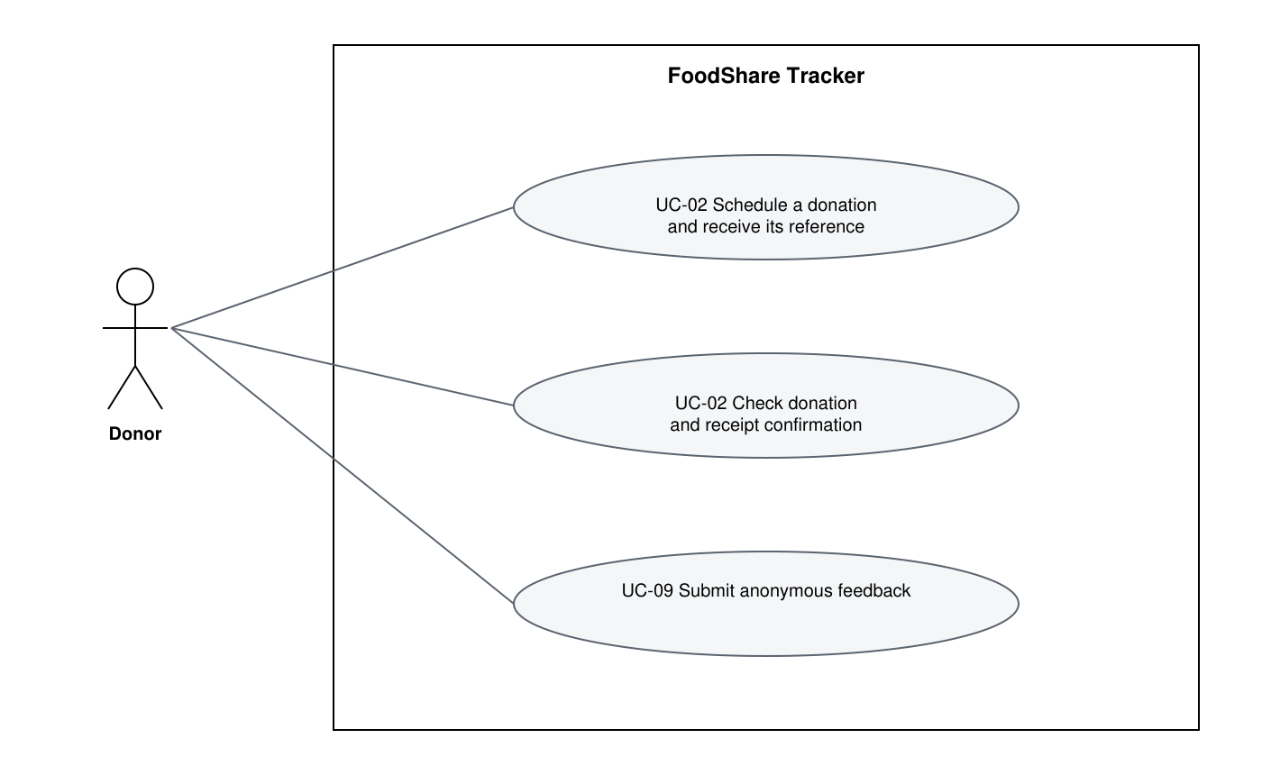
Figure 2 Public Donor use cases
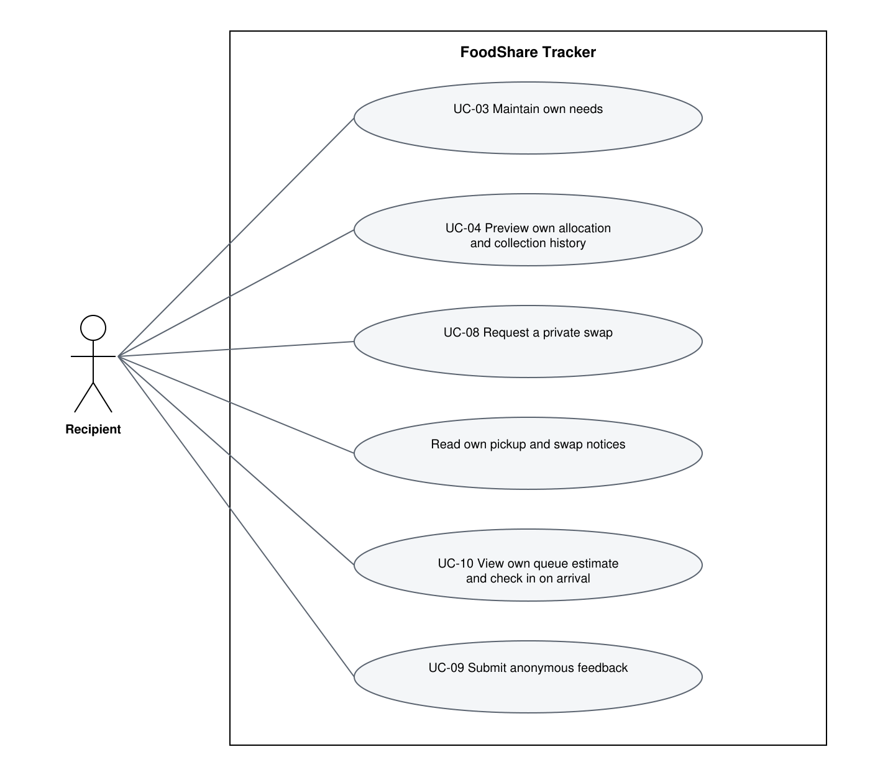
Figure 3 Recipient use cases
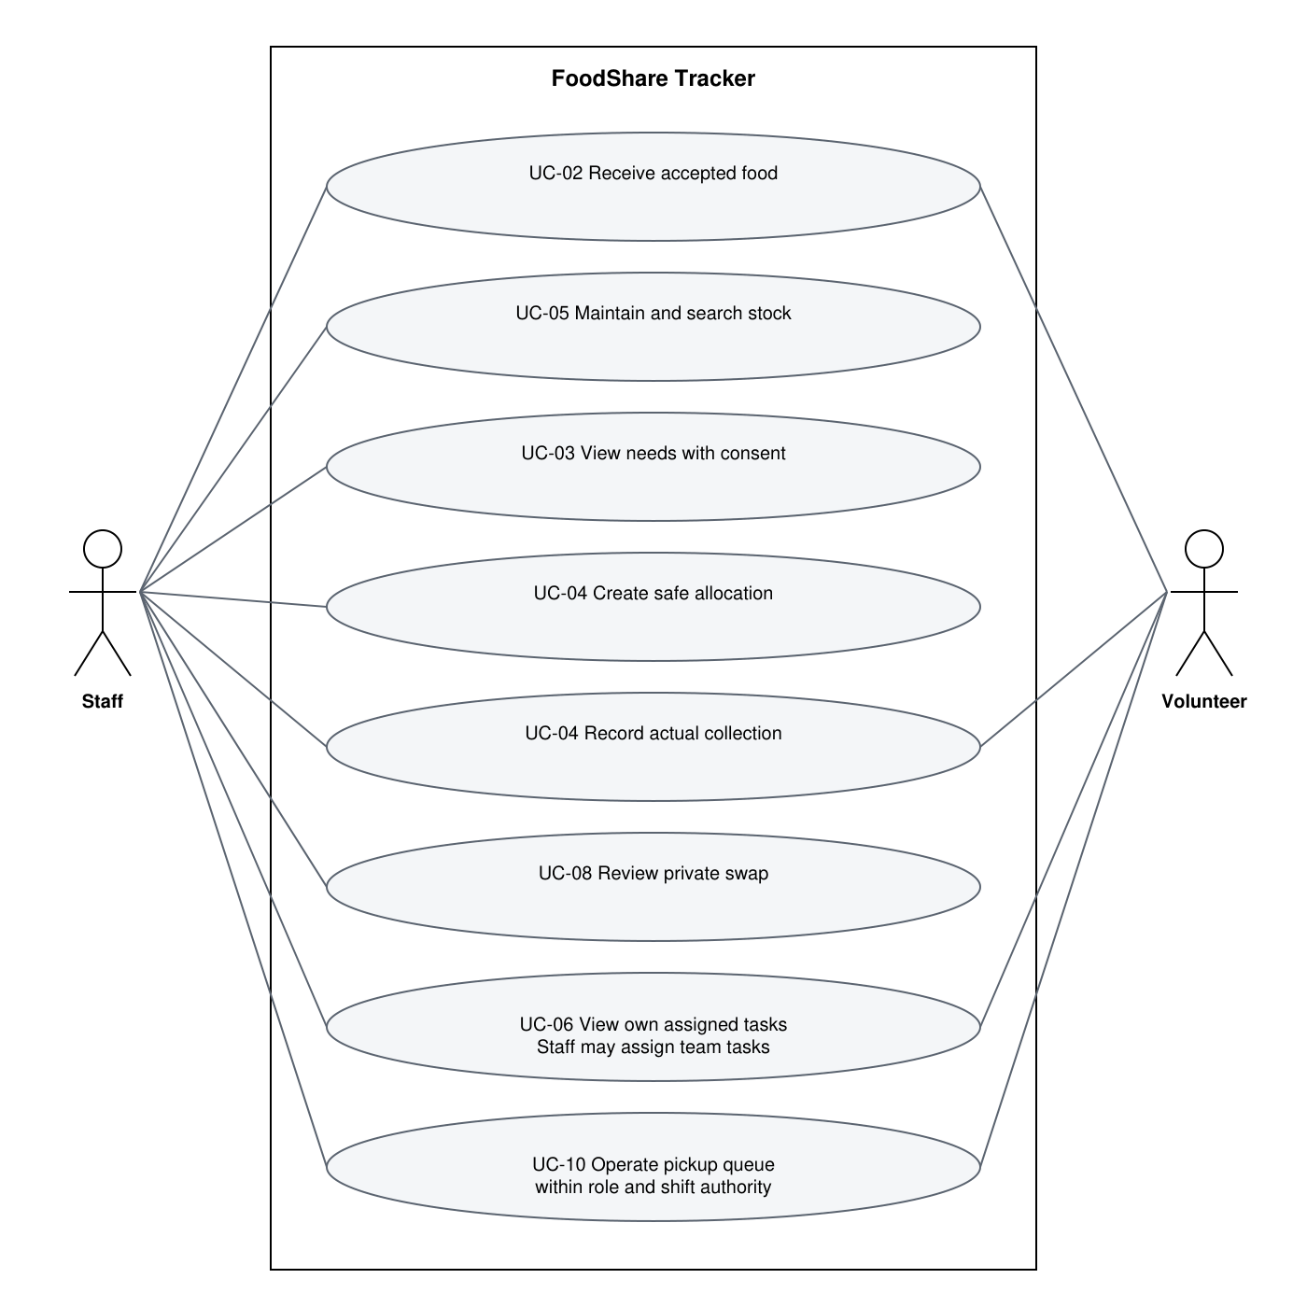
Figure 4 Staff and Volunteer use cases
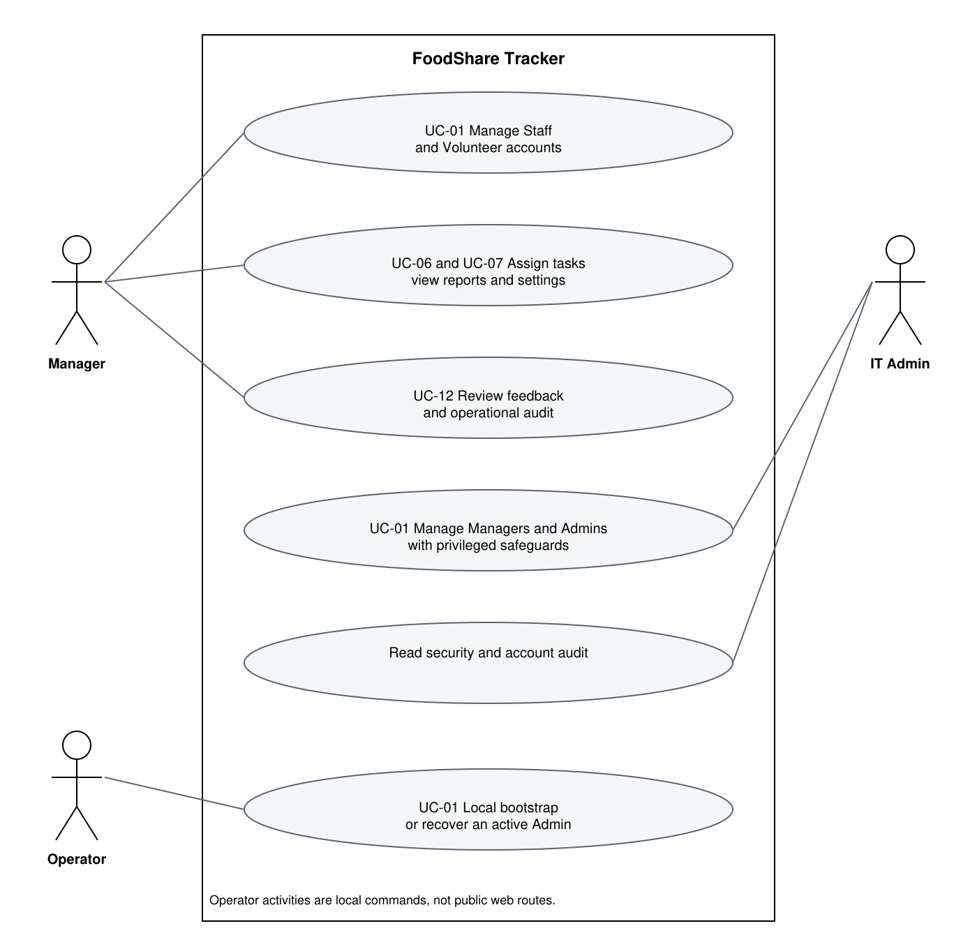
Figure 5 Management security and local operator use cases
The use case diagrams show role associations. The following actor-to-use-case matrix defines detailed authority; module diagrams do not grant permissions. Public donation and feedback activities are separate from protected account functions.
Use case | Main flow and actor | Alternative and links
UC-01 Administer user access | Manager manages Staff/Volunteer; IT Admin manages Managers/Admins; Staff/Admin verifies Recipient deactivation; local operator bootstraps or recovers an Admin. | Invalid authority, missing confirmation or last-Admin removal is denied.  F-01
UC-02 Schedule and receive donation | Public Donor books and keeps a reference; Staff or assigned Receiving Volunteer confirms accepted safe items. | Bad reference, unassigned shift or repeated receipt leaves stock unchanged.  F-02
UC-03 Maintain own needs | Recipient saves own profile; Staff assists only with recorded consent. | Stale version, missing required confirmation or unrelated access is refused.  F-04
UC-04 Allocate and collect | Staff chooses safe stock; Staff or assigned Distribution Volunteer records actual issue quantities once. | Unsafe/stale stock or duplicate completion is rejected; partial issue releases the remainder.  F-03; F-05; F-07
UC-05 Maintain stock visibility | Staff adds batches and edits labels; authorised readers search current safe/held/expiry state. | Quantity changes use adjustments, not destructive metadata editing.  F-03
UC-06 Assign volunteer tasks | Staff/Manager assigns, updates or cancels shifts; Volunteer reads own tasks. | Cancelled or unrelated shift cannot authorise receiving or collection.  F-06
UC-07 View alerts and reports | Staff/Manager views low-stock alerts and date-range report; exports matching CSV. | Bad range or role fails; CSV text is protected from spreadsheet formulas.  F-07; F-08
UC-08 Request and decide private swap | Recipient requests own uncollected item; Staff chooses a suitable replacement or declines respectfully. | Duplicate, expired, stale or unsuitable decision cannot move reservations.  F-09
UC-09 Submit anonymous feedback | Any visitor, including a signed-in user, sends a short message without a submitter link. | Blank, oversized, replayed, expired or quota-exceeded form is refused.  F-10
UC-10 Manage own pickup queue | Recipient checks in or Staff/assigned Volunteer assists; owner sees approximate private estimate. | Paused/closed admission is blocked except documented Staff late exception; completed issue closes queue.  F-11
UC-11 Correct stock history | Staff records signed correction and reason; one linked reversal corrects an error. | Below-reservation stock or repeated reversal is rejected; original history remains.  F-03
UC-12 Review anonymous feedback | Staff/Manager reads and reviews or archives messages privately. | No public list or account attribution; review audit has no feedback-message link.  F-10; Shared

6 Class diagram

6.1 Implemented classes and concepts
The earlier conceptual entity classes are not Python ORM classes in this build. SqliteStore and Tx are the persistence classes. DomainError is the workflow exception base; PermissionDenied, EditConflict and UnsafeFood specialise failure handling. Feature services are modules containing functions. Persisted users, batches and allocations are dictionaries mapped to explicit SQLite tables.
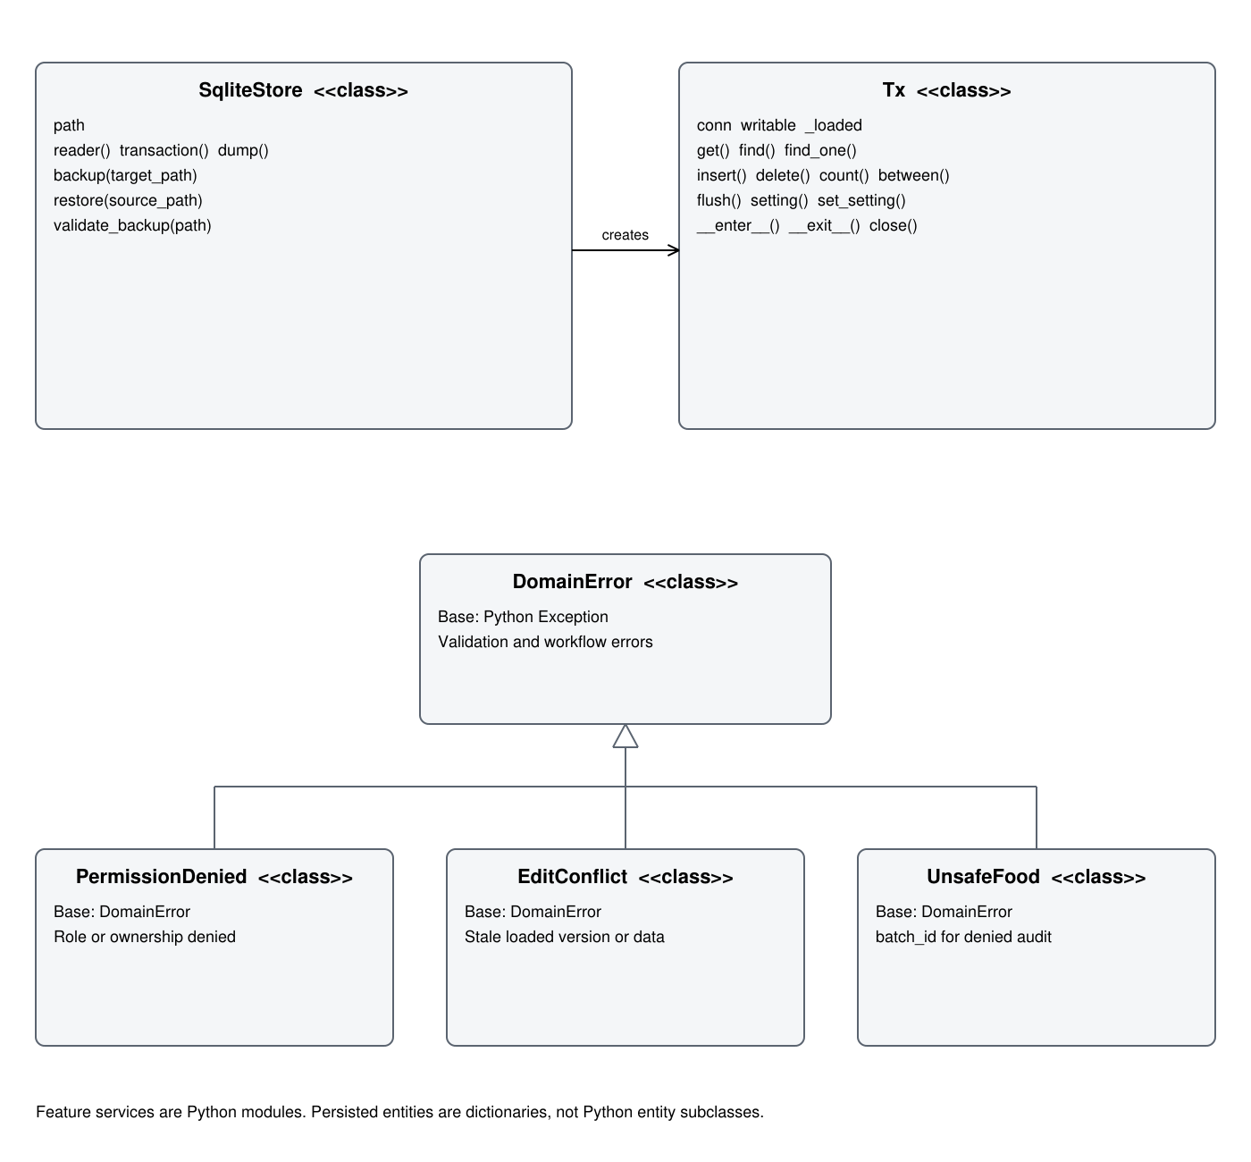
Figure 6 Actual Python classes and exception inheritance

6.2 Account and operational record relationships
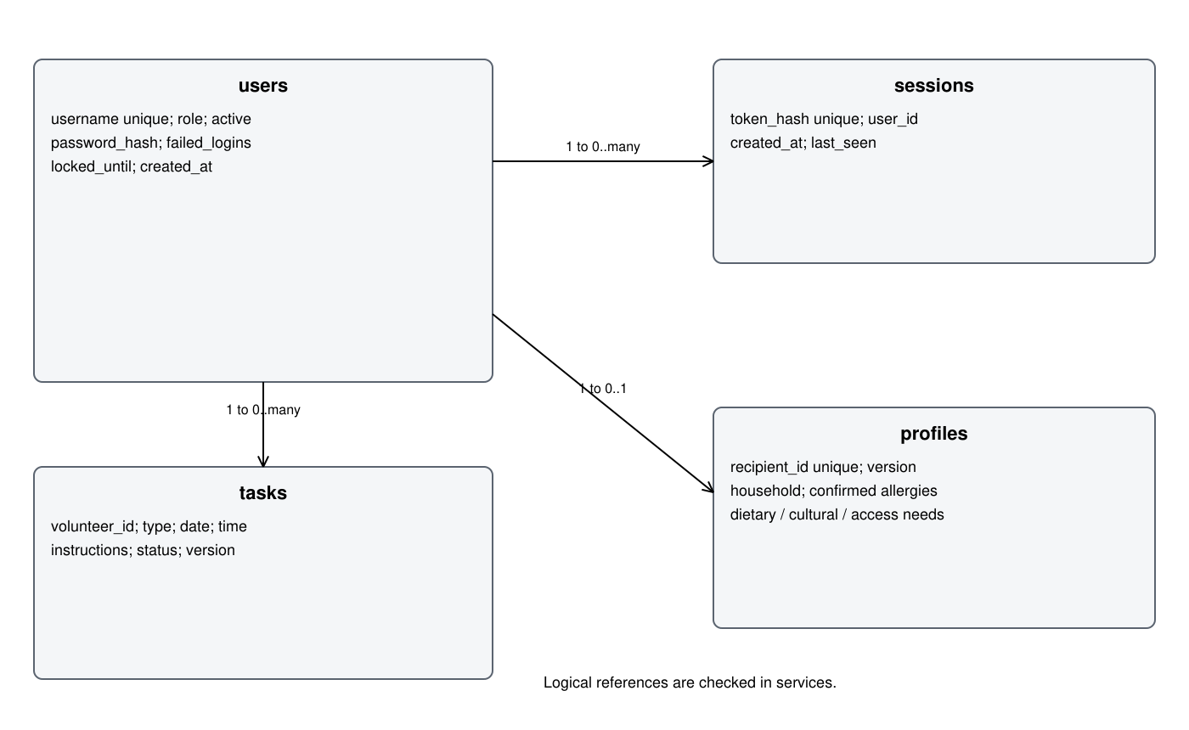
Figure 7 Logical account profile session and task relationships
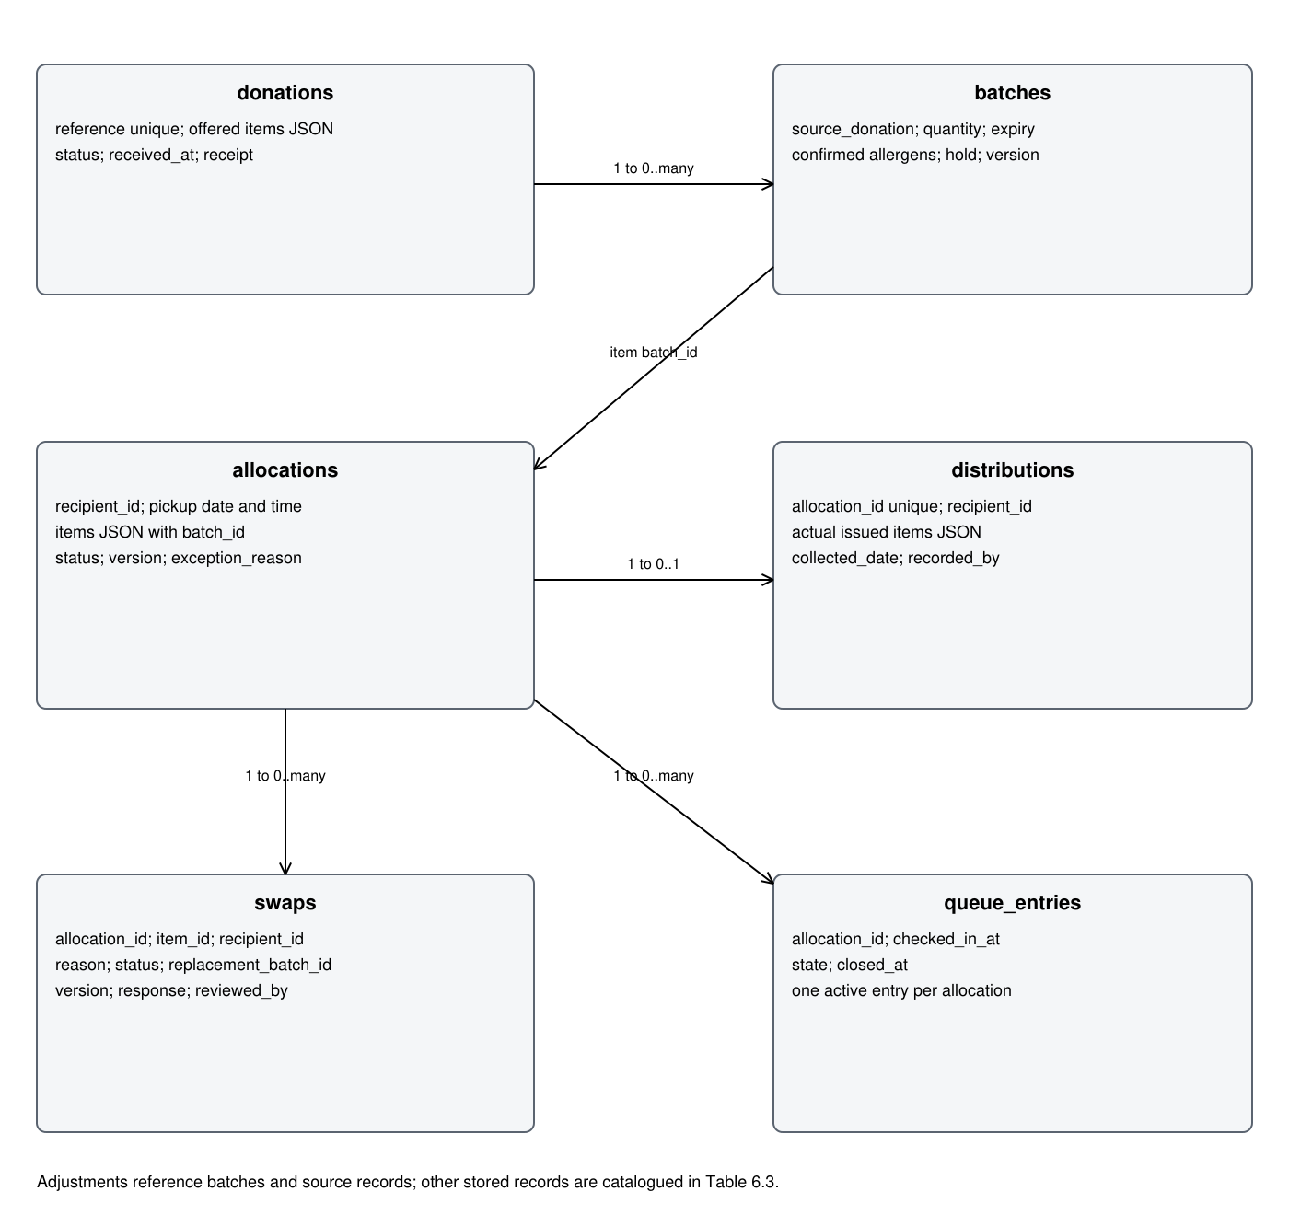
Figure 8 Logical donation inventory allocation and pickup relationships
Relationships in the account and operational record diagrams are logical ID links. SQLite uniqueness constraints cover important duplicates, but not every logical link is declared as a foreign key. Allocation and donation items remain JSON lists; their item IDs and batch references are validated by services.

6.3 Stored records and invariants
Table 6.3 Implemented record catalogue
Record | Stored meaning | Constraint
users | Role, active flag, salted password hash, failed-login state and verification metadata. | Unique username; account authority checked in services.
sessions | Token hash, user ID, created and last-seen timestamps. | 15-minute idle and 8-hour absolute policy; never raw token storage.
profiles | Household and confirmed allergies, dietary/cultural/access needs, urgency and version. | One per Recipient; consent and stale-version checks.
donations | Unpredictable reference, offered/accepted items, receipt and received time. | One reference; repeated receipt rejected.
batches | On-hand quantity, expiry, confirmed allergens, dietary tags, hold and version. | Reservation derived from active allocation items.
adjustments | Delta, before/after, reason code, actor, source link and reversal link. | Append-only triggers; one reversal per source adjustment.
allocations | Recipient, state, pickup date/time, item list, version and queue metadata. | Active items reserve stock; no automatic ranking.
distributions | Allocation, actual issued items and collection date. | Unique allocation ID prevents duplicate completion.
swaps | Item/request owner, private reason, status, response and replacement. | Pending/version/window checks before decisions.
tasks | Volunteer, shift, task type, instructions, status and version. | Current task checked before delegated action.
queue_entries | Allocation, arrival time, state and close time. | Partial unique index allows one active entry.
notifications | User, kind, message, unread flag and creation time. | Pickup change and unread notice commit together.
feedback | Message, submission date, reviewed and archived flags. | No submitter relationship, account, IP or persistent token.
audit | Actor/category, server time, action, target, redacted details and result. | Role separated; update/delete triggers reject mutation.
public_limits | Anonymous site-wide counters by scope and time bucket. | No submitter or IP key for feedback.
settings | Key/value operational configuration and schema metadata. | Authorised changes audited.

For every batch, reserved equals the sum of its active uncollected allocation items and available equals on hand minus reserved. Valid operations preserve 0 <= reserved <= on hand. A swap changes allocation references and thus reservations without changing physical stock. Collection deducts actual issued units and closes the allocation, releasing its remaining reserved units.

6.4 Component mapping
Concept | Code boundary
Presentation | app.py and foodshare/views; navigation, forms, text, validation feedback and queue fragments.
Use-case service | foodshare/services; actor permissions, record ownership, current state and transactional orchestration.
Domain rules | foodshare/domain.py; dates, suitability, normalisation, policies and exceptions.
Repository and transaction | foodshare/storage.py; SqliteStore, Tx, SQL, schema migration and backup/restore.
Password and HTTP helpers | passwords.py for scrypt; http_security.py for same-origin cookie exchange.

7 System context analysis

7.1 Operational context
The target is a local demonstration at one food-bank site with one pickup desk. The capacity target is five concurrent users and 1,000 operational records; it remains a test baseline rather than observed real-site usage. Local HTTP is loopback only. Network launch requires certificate/key configuration and HTTPS; deployment acceptance is outstanding.

7.2 Behavioral context
Public users book donations and send feedback without an account. Staff control allocation and food-safety decisions. Volunteers act only within a current assigned receiving or distribution shift. Recipients receive only their own records and can request changes privately. Managers and IT Admins have separate oversight and security authority.

7.3 Ecological context
Expiry labels and visible available stock support waste-aware decisions, but no measured reduction in food waste is claimed. A lost server connection prevents new confirmations; retained UI content must not be treated as current. Service-aware fallback exists for queue refresh errors, while total server shutdown still needs complete Recipient-side verification.

7.4 Sociocultural context
Needs distinguish allergy confirmation, dietary restrictions and cultural or religious food requirements. Optional swap reasons do not determine eligibility. Staff-assisted profile changes need consent. Feedback has no account link and must not influence allocation priority. Shared-device users need reliable logout and timeout behavior.

7.5 System context
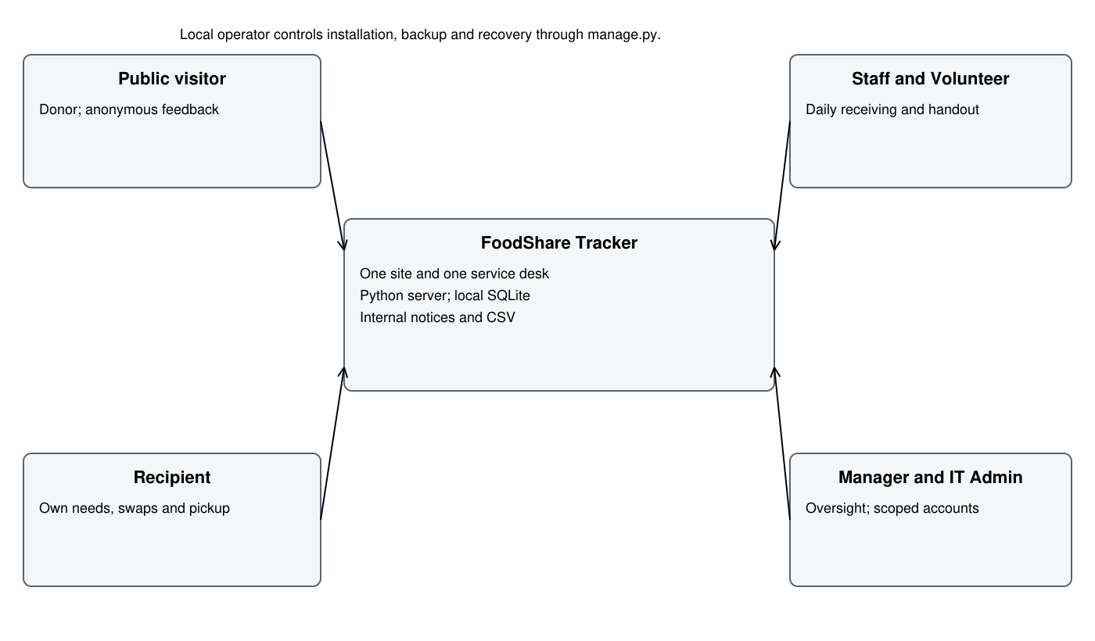
Figure 9 Actors and system context

7.6 Context implications
Context constraint | Design consequence | Evidence
Shared devices and sensitive needs | Own-record projections, consent and revocable sessions. | SESSION-01 to 04; role/service tests.
Busy stock changes | BEGIN IMMEDIATE, current-state rechecks, versions and unique completion. | 50 rounds across three two-connection races.
Limited recipient connectivity | Own approximate queue estimate with last confirmation and error wording. | Online refresh confirmed; full offline outcome partial.
Classroom installation | Pinned dependencies, local venv, clear Demo/normal paths. | README and setup syntax; current native installer not executed here.

8 System architecture

8.1 Architecture overview
The implemented style is a layered modular monolith: one Python server and one selected SQLite database. Browser requests run Streamlit pages. Pages call application service functions; services use domain rules and SqliteStore/Tx. SQL stays in storage.py. There is no Flask route layer, SQLAlchemy session, ORM entity hierarchy or separate database server in this release.
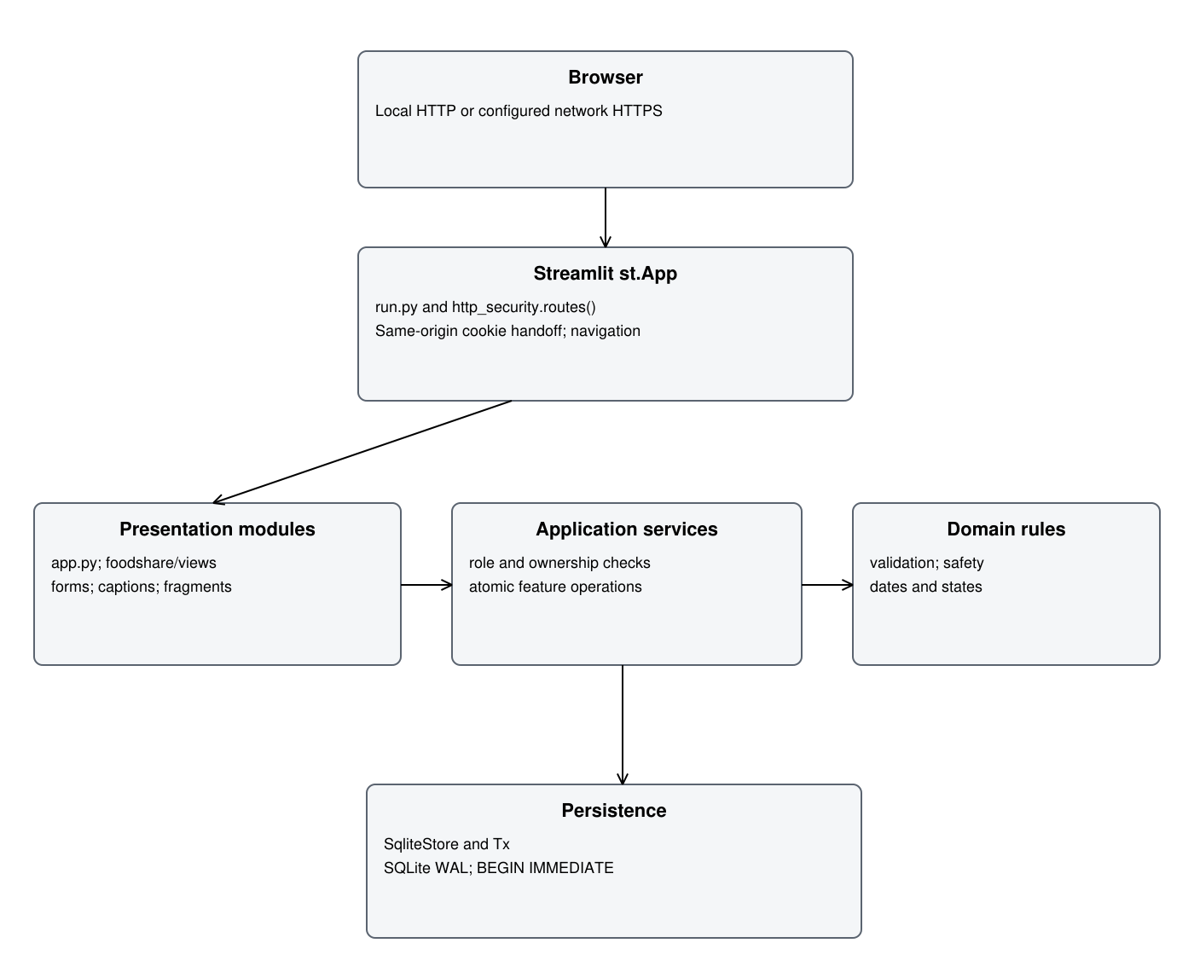
Figure 10 Implemented Streamlit service domain and SQLite layers

8.2 Transaction and request boundaries
SqliteStore.transaction opens a connection, issues BEGIN IMMEDIATE, yields a writable Tx, flushes changed loaded records and commits. Any BaseException during the block or flush rolls back the transaction and closes the connection. SQLite's documented transaction model explains the single-writer boundary [R5]; the actual implementation and failure tests establish this project's behavior.
A read path uses a consistent read transaction with query_only enabled. Tx remembers only records that are loaded, converts selected JSON columns, and flushes changed dictionaries. A uniqueness index protects each distribution's allocation and each active queue entry; append-only triggers protect stock history and audit rows.
Services perform role and record checks before or inside use-case operations as appropriate. Protected views resolve the current session before invoking them. Passive queue refresh uses touch=False so it does not extend idle lifetime. The same-origin cookie exchange has CSRF and one-use-handle tests; a general claim that every deployed WebSocket/request path was penetration-tested is not supported.

8.3 Technology choice and tradeoffs
Decision | Benefit | Limit
Streamlit UI | Python pages, forms and testable AppTest workflows for the assessed prototype. | Rerun and fragment lifecycle differs from conventional request controllers; disconnected server cannot execute new UI code.
sqlite3 and local SQLite | Explicit transactions and portable local storage without an ORM server setup. | One writer; not a tested multi-site/high-load service.
JSON columns for nested lists | Direct mapping of allocation and donation item structures. | Some integrity rules and links are service enforced rather than fully normalised SQL constraints.
Derived reservations | One source of truth in active allocations; swap changes do not deduct physical stock. | Reservation queries and lifecycle expiry must remain consistent.
In-memory anonymous forms | No persistent identity/token link in feedback. | Assumes one server process; multiple workers need coordinated transient state.

8.4 Security preservation and recovery
Passwords use salted scrypt. Server sessions store token hashes with idle and absolute expiry. Logout and deactivation revoke sessions; recovery resets an existing active Admin through a local command. These thresholds are project policy, with OWASP used as supporting security guidance rather than proof of compliance [R4].
Feedback stores only the permitted message/date/review fields, while transient replay/rate tokens stay in memory. Application code disables Streamlit usage analytics. Actual server/proxy request-log inspection remains outstanding. Needs and other records are plaintext in SQLite; disk protection, Windows access controls, backup access and trusted network certificates remain deployment responsibilities.
Backup and restore select the configured FOODSHARE_DB. Demo defaults to data/demo.sqlite3; normal mode defaults to data/foodshare.sqlite3. run.py --demo creates synthetic accounts only for a missing Demo database. Normal mode does not create a Staff account. Startup maintenance can expire old allocations, so restore comparisons should be captured before unrelated maintenance where exact historical equality is required.

9 Usability evaluation

9.1 Method and participants
This section evaluates the implemented screens using the supplied screenshots and DeanChan's recorded manual checks. It is an evidence-led interface inspection and a single tester's workflow account. It is not the planned five-person moderated study. Screenshot times establish the manual evidence date as 22 October 2026 MYT; exact browser versions, training duration, task timings and an assistance log were not retained.
NFR-02 / NAC-02 requires five first-time Staff users. Manual check 7 remains Unknown / Not completed. Manual check 9 requires another actual team member to inspect code, UI and README; it remains Unknown / Not completed, with no reviewer name assigned. DeanChan is the manual tester for completed checks, not an invented independent code reviewer.

9.2 Heuristic inspection
The ten inspection dimensions below paraphrase Nielsen's established framework [R3]. Severity is a provisional analyst assessment: 0 means no issue observed in the reviewed scope, 1 minor, 2 moderate, 3 serious and 4 critical. It is not participant-measured severity or whole-interface certification.
Table 9.2 Heuristic observations on the implemented prototype
Dimension | Evidence led observation | Severity and action
Clear status | Pending, Approved, Waiting and Collected appear as text; save and session-end notices are visible. | 0 in observed paths. Offline queue remains a separate gap.
Familiar language | Needs and pickup pages describe household, allergies and actual collection quantities. | 0 observed; test comprehension with first-time Staff.
Cancel and correct | Cancellation, respectful swap decisions and linked stock reversals are implemented. | 0 in tested scope; independent usability observation still needed.
Consistent wording | Most workflow labels agree across Staff and Recipient views; one pickup selector retained an earlier time. | 2 provisional; OBS-01 requires focused reproduction.
Prevent mistakes | Consent, allergy confirmation, inactive-account checks and save validation have code/test support. | 0 in tested decisions; no claim that all mistakes are impossible.
Visible choices | Allocation items, needs summaries and status text reduce memory demands. | 0 observed; new-user recognition remains unmeasured.
Efficient repeated work | Role-specific menus and automatic queue fragments reduce repeated navigation. | 1 provisional; repeated-work timing not measured.
Focused screens | Recipient views show own needs/food; Staff allocation summary excludes unrelated private fields. | 0 in observed displays; direct tampered browser access not manually recorded.
Helpful recovery | Logout/session messages guide sign-in; disconnection dialog identifies a connection error. | 2 provisional; full Recipient estimate-unavailable behavior not demonstrated.
Available help | Revised English README covers local venv, installation, tests, Demo and backup commands. | 1 residual; native Windows fresh-install execution of exact setup remains outstanding.

9.3 User testing scenarios
Task | Persona and success measure | Actual study result
UT-01 | First-time Staff records an accepted donation without correction after the permitted training. | Unknown / Not completed
UT-02 | First-time Staff finds a named batch and identifies available/expiry state without correction. | Unknown / Not completed
UT-03 | First-time Staff opens a Recipient needs summary and identifies a food restriction without correction. | Unknown / Not completed
UT-04 | Recipient previews own allocation, requests a private swap and interprets the outcome. | Workflow manually exercised by DeanChan; no independent participant result.
UT-05 | Keyboard-only user reaches form controls, sees focus and understands text states at 150%/200% zoom. | DeanChan reported Pass; dedicated focus/zoom screenshots and grayscale record not retained.

For the eventual NFR-02 study, record participant codes P01 to P05, experience, training minutes, each task's completion, corrections, elapsed time and anonymised comments. At least four participants must complete all three core tasks without correction. No row is pre-filled with a fictional result. The code package includes docs/USABILITY_SESSION_TEMPLATE.md.

9.4 Findings and limits
Finding | Outcome and evidence | Next action
UF-01 | DeanChan confirmed keyboard entry and form operation; observed statuses use readable text. | Retain as manual confirmation; complete grayscale and independent-user checks.
UF-02 | DeanChan confirmed 150% and 200% zoom checks matched expectations. | Retain as confirmation; no specialist assistive-technology claim.
UF-03 | Connection error appears on Recipient and Staff screens, but explicit Recipient estimate-unavailable and timestamp behavior is not captured. | Retain Partial for QUEUE-02; test the actual queue with server/service/network failures separately.
UF-04 | A changed pickup detail and notice agree while an earlier selector label shows the old time. | Investigate OBS-01; do not invent a fix or label the whole workflow failed.
UF-05 | One allocated Recipient screenshot no longer shows the queue card. | OBS-02 remains unclassified without exact lifecycle and clock context.
UF-06 | No five-user study or independent group review was supplied. | Keep check 7 and check 9 Unknown / Not completed.

No exact participant success rate, satisfaction average, time-saving claim or all-pages accessibility pass is justified. The manual business workflow and keyboard observations remain useful evidence within their stated scope.

10 Sequence diagrams
Each sequence below uses implemented view/service names and a combined alternative fragment. Services and views are module lifelines, not fictitious Python controller classes. The diagrams describe relevant transaction boundaries and failure outcomes; they do not claim every branch was manually recorded. Individual diagram authorship remains unassigned pending actual group confirmation.

10.1 Receive an accepted donation
UC-02; FR-10 to FR-12. views.stock.receive calls services.receive_donation. Staff or a current assigned Receiving Volunteer validates accepted quantities. The transaction inserts batches and their history, marks the donation Collected and saves receipt/audit records. A repeat or invalid receipt produces no extra stock. The injected receipt-history failure test verifies rollback.
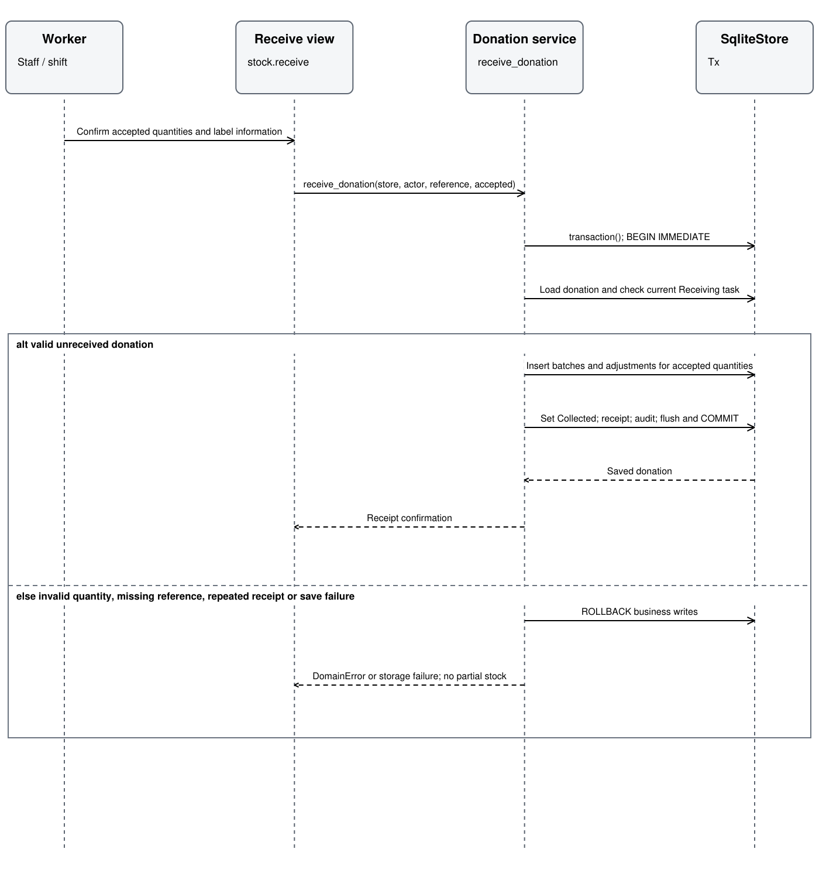
Figure 11 Donation receiving sequence

10.2 Record actual collection
UC-04; FR-16, FR-22, FR-23, FR-43, FR-55 and FR-56. views.food.collection_form calls record_collection with actual quantities and the form's shown batch IDs. The service rechecks current account, needs, stock and lifecycle, deducts actual units, records one distribution and closes queue/swaps. Failure rolls back business writes. A redacted denied unsafe-food audit can be appended separately after rollback.
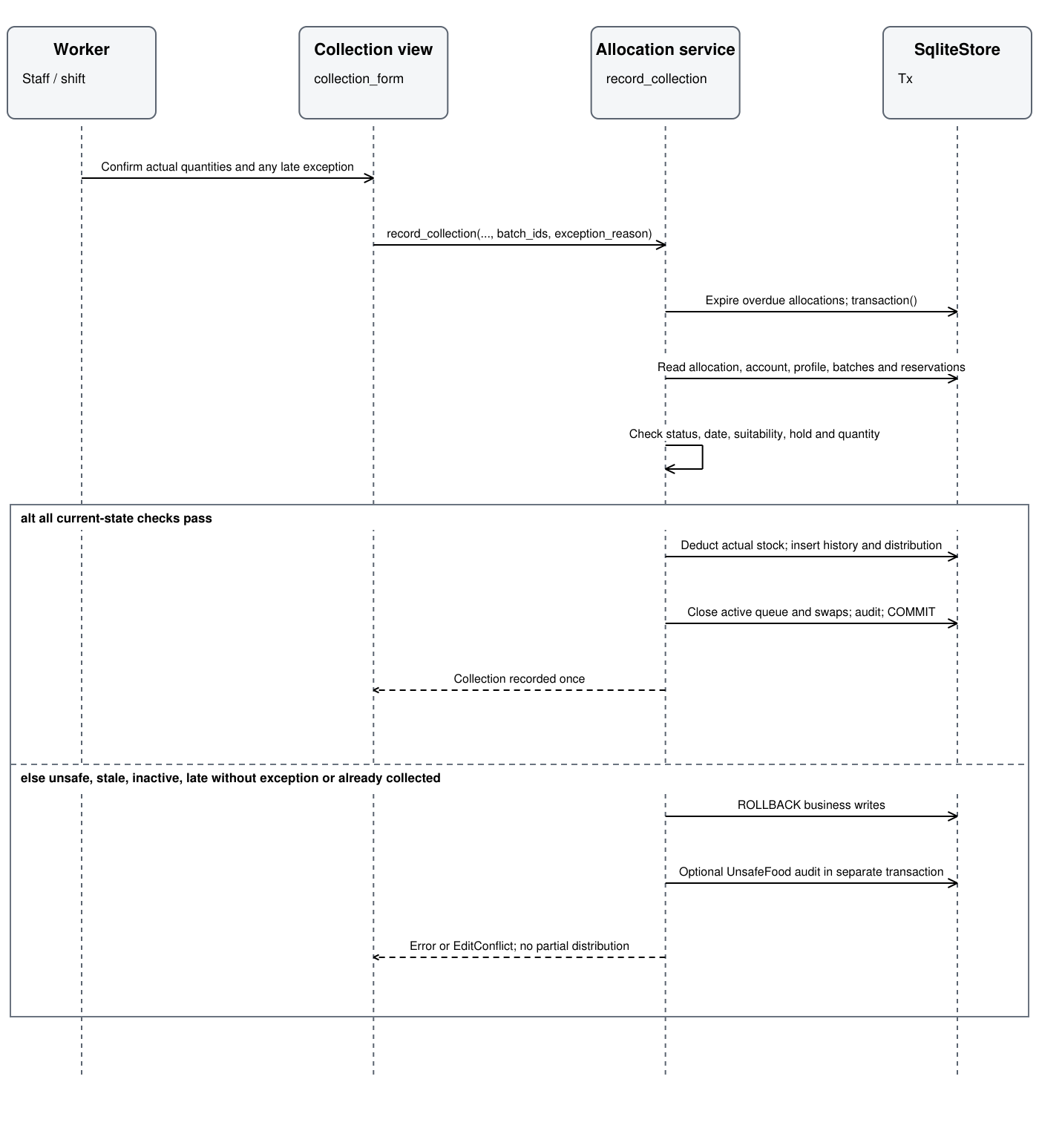
Figure 12 Atomic collection sequence

10.3 Approve a private swap
UC-08; FR-34 to FR-36 and FR-43 to FR-44. views.food.swap_decision passes loaded_version to approve_swap. Lifecycle refresh persists due closures before the decision. A current Pending request with suitable available replacement changes the allocation item, notice, request and audit together; physical on-hand quantities do not change. A stale or closed decision is rejected.
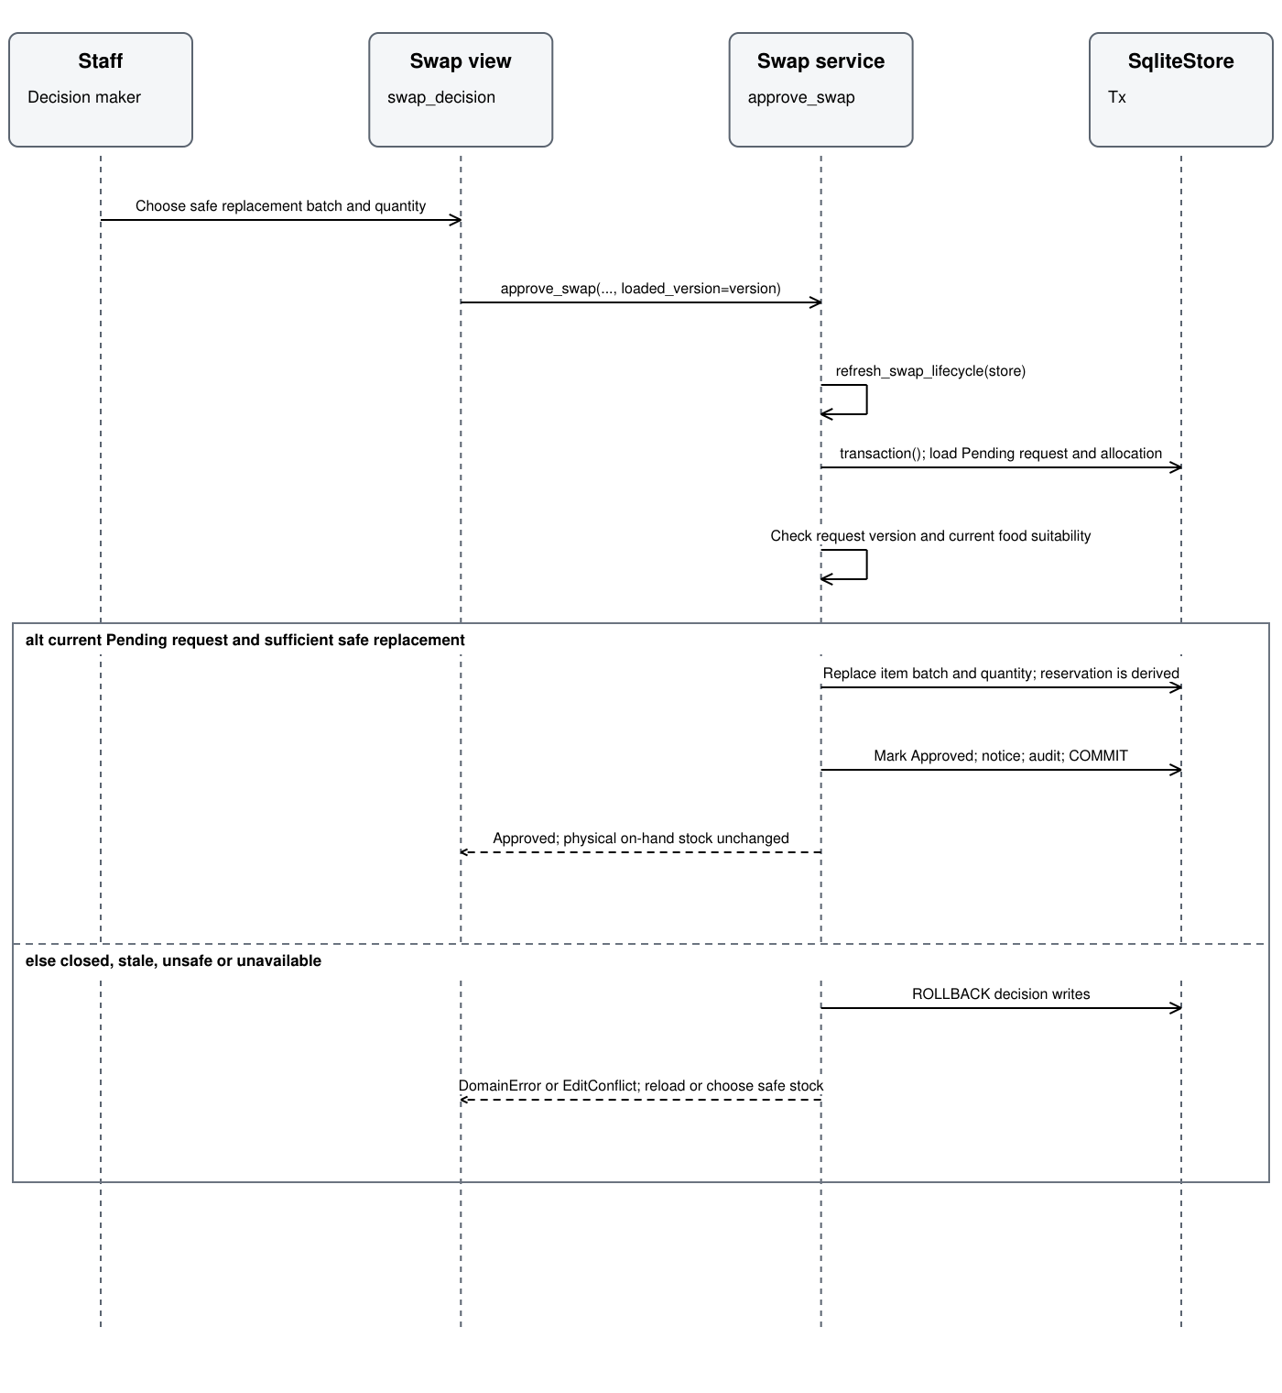
Figure 13 Private swap approval sequence

10.4 Submit anonymous feedback
UC-09; FR-45 to FR-49. views.public.feedback calls submit_feedback with transient browser/form tokens. save_feedback_once validates binding, expiry, replay and quota under an in-memory lock, then calls the save callback. Only after the SQLite insert succeeds are success count and consumed-form state retained. No submitter relationship is passed to _save_feedback.
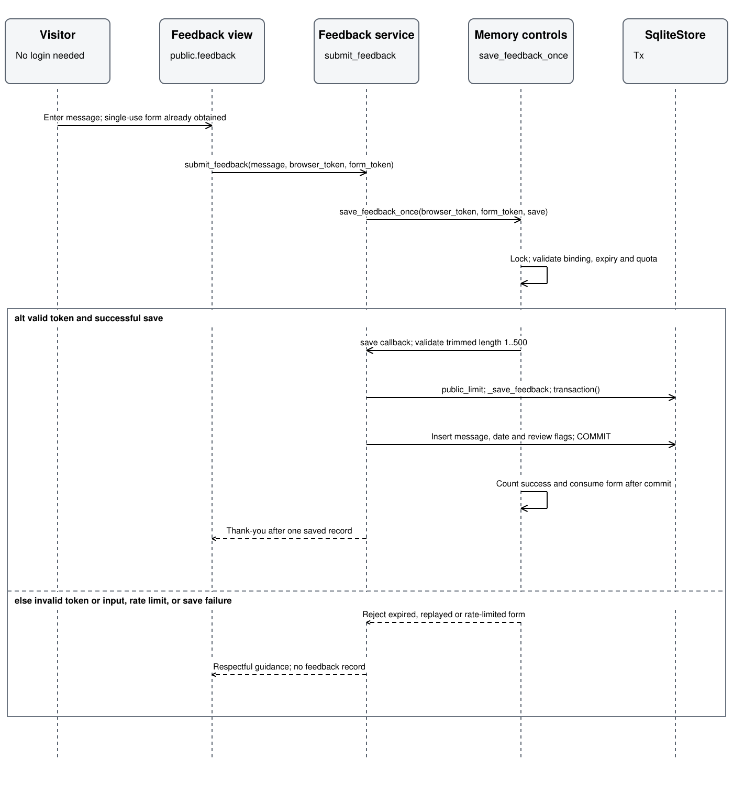
Figure 14 Anonymous feedback submission sequence
The persisted lifecycle closures that run before a swap/collection decision are distinct from the decision transaction itself. This prevents an error explanation from implying all lifecycle housekeeping was rolled back. Source pointers and exact passing test functions are listed in Section 14 and Appendix A.

11 Quality assurance plan and executed results

11.1 Strategy environment and evidence identity
QA combines domain boundaries, service integration, persistence failure injection, competing SQLite connections, Streamlit AppTest and manually exercised browser flows. Fresh temporary databases isolate automated cases. The test-data clock follows the application's Asia/Kuala_Lumpur date; selected tests freeze time for precise expiry and session boundaries.
Table 11.1 Executed verification environment
Attribute | Recorded value
Current command | python -m pytest -ra --junitxml=docs/evidence/pytest-results.xml
Current start | 23 October 2026 00:17:36 MYT / 22 October 2026 16:17:36 UTC
Current finish | 23 October 2026 approximately 00:19:20 MYT
Platform | Linux; Python 3.12.14; SQLite 3.53.1
Direct dependencies | Streamlit 1.66.0; pytest 9.1.1; tzdata 2026.2
Result | 306 passed; 0 failed; 0 errors; 0 skipped
JUnit suite time | 103.399 seconds; not browser latency or operational recovery time
Windows submitted run | Python 3.14.2; SQLite 3.50.4; 306 passed; historical source record
Manual browsers | Chrome as Staff, Edge as Recipient, according to DeanChan; exact versions not recorded
Manual dataset | Demo test data; screenshots dated 22 October 2026 MYT

The current JUnit XML, terminal output and validation.json agree. Their application/test hashes were rechecked before packaging. The historical Windows record predates the current installer and the five test-date corrections; its business-source hashes match. Pytest does not exercise native Windows installation. A separate PowerShell parser check passed for the exact setup.ps1; a fresh Windows install remains unexecuted here.
The initial Linux reproduction produced 299 passes and 7 failures because some tests used the host date while the application used the Malaysian site date. Only date-dependent fixture construction in five test files changed. Expected outcomes and business rules were retained. The original failure report is saved, and the corrected full run passed all 306 cases.

11.2 Automated tests with pytest
The saved result is an executed suite, not the earlier list of planned test definitions. Parameterized inputs count as separate cases. The following totals come directly from pytest-results.xml; no code-coverage percentage was measured. Pytest's JUnit output provides a portable individual-case record [R6].
Table 11.2 Automated result totals by module
Test module | Cases passed | Scope
test_app.py | 103 | Streamlit AppTest page flows, role menus, needs, donation, allocation, queue and notices.
test_concurrency.py | 6 | Parallel saves, oversell prevention, stale forms and notice races.
test_final_regressions.py | 61 | Safety, atomic receipt, deactivation, late exceptions, CSV, feedback, sessions, migration and audit.
test_final_views.py | 9 | Required-field purpose, queue error fallback, current navigation and display behavior.
test_new_features.py | 12 | Public feedback, private inbox, queue behavior and related post-MVP functionality.
test_passwords.py | 9 | Password hashing, verification and malformed input.
test_review_fixes.py | 39 | Permissions, session policies, stock corrections, lifecycle, backup and recovery.
test_services.py | 25 | Core acceptance examples for accounts, donations, needs, stock, collection, swaps and reports.
test_submission_review.py | 42 | Contention repetitions, independent safety decisions, privacy, request protection and documentation support.
Total | 306 | 0 failures, errors or skips

11.2.1 Executed example test
Listing 1 Actual partial collection regression test
245 def test_partial_collection_puts_the_rest_back(store):
246 ready_pickup(store)
247 staff = user(store, "staff")
248 s.record_collection(store, staff, 1, {1: 1, 2: 1}) # took 1 rice of the 2 set aside
249 rice = s.get_batch(store, staff, 1)
250 assert rice["quantity"] == 19 and rice["reserved"] == 0 and rice["available"] == 19

This test verifies that partial collection reduces physical stock and releases the remaining reservation. Separate tests verify that a repeated completion cannot issue food twice. It runs on a temporary database. It is not a replacement for end-to-end browser observation.

11.3 Manual functional and end to end tests
Manual tester: DeanChan. Date: 22 October 2026 MYT, as recorded by the screenshot series and tester. All Pass labels below are limited to the described scope. The screenshot index retains the original files and hashes. The exported CSV is retained unchanged.
Table 11.3 Manual execution register
ID | Check | Outcome | Actual result and evidence
FLOW-01 | Donation booking and receipt | Pass | Grapes accepted 111; inventory shows 111. E-211519, E-211557, E-211847, E-211927.
FLOW-02 | Needs and consent | Pass | Household 2, peanut allergy and halal needs agree; Staff save without consent denied. E-212310 to E-212450.
FLOW-03 | Allocation and reservation | Pass | No.4; Rice 10 on shelf, 2 set aside, 8 available. E-213535 and E-213603.
FLOW-04 | Private swap approval | Pass | Pending to Approved, Halal chicken replacement, changed reservations and notice. E-213746 to E-213901.
FLOW-05 | Pickup change and notice | Pass in observed save flow | Revised details and notice agree; old selector label retained as OBS-01. E-213937, E-213951 and E-214000.
FLOW-06 | Check-in and collection | Pass | No.4 Collected on both sides; chicken 6 to 4. E-214050 to E-214226, E-220100 and E-220315.
FLOW-07 | Report and CSV | Pass in observed export | Report view and opened CSV. E-214328, E-214428 and retained CSV.
MULTI-01 | Separate-browser synchronization | Pass with tester confirmation | Chrome Staff / Edge Recipient; matching food, quantities and state. Per-step refresh mechanism and exact elapsed time not recorded.
MULTI-02 | Own-record page isolation | Pass in normal navigation | Own swaps, needs, notices, feedback form and home. E-220749 to E-220808. Direct tampered record URL not manually demonstrated.
SESSION-01 | Refresh preserves login | Pass | Tester confirms refresh; own profile and notices retained. E-220902 and E-220909.
SESSION-02 | Logout blocks re-entry | Pass | Refresh, copied URL and Back did not restore protected access. E-221056, E-221104, E-221109 plus tester confirmation.
SESSION-03 | Idle timeout | Pass with timing limitation | Tester confirms at least 15 minutes idle; session ended in E-223208. Exact start/end not retained.
SESSION-04 | Deactivation and old session | Pass with tester confirmation | Deactivated recipient2; old session ended; inactive login denied. E-223927, E-223935, E-223955. Blocked save/access after refresh confirmed without a further screenshot.
QUEUE-01 | Automatic update within 30 seconds | Pass with tester confirmation | E-225227 and E-225334 show changed update times. Exact seconds not logged. Missing card in E-225645 retained as OBS-02.
QUEUE-02 | Offline estimate and last confirmation | Partial | Connection error and Staff last-update time captured. Recipient estimate-unavailable wording and retained Recipient confirmation time not demonstrated.
UI-01 | Keyboard and visible focus | Pass with tester confirmation | Tester states operation matched expected checks; no dedicated recording retained.
UI-02 | 150% and 200% zoom | Pass with tester confirmation | Tester states checks matched expectations; dedicated zoom screenshots not retained.
UI-03 | Text states and wording | Pass in tester scope | Visible text statuses plus tester confirmation; no two-reviewer dignity sign-off or grayscale run recorded.
RECOVERY-01 | Demo backup modify restore | Pass with tester confirmation | Chicken 4 to 7 to 4; urgency Standard to Soon to Standard. E-232017 through E-234600; full baseline checks confirmed.
CHECK-07 | Five-person usability study | Unknown / Not completed | No sessions, training measurement or participant outcomes.
CHECK-09 | Independent group code and UI review | Unknown / Not completed | Not a summary of previous tests. Another actual team member's code, UI and README review has not been supplied; reviewer unassigned.

11.3.1 Boundaries and independent decisions
Area | Executed examples | Limit
Password | 14/15/128/129 length boundaries; five failed attempts; pause reset; idle and 8-hour absolute lifetime. | Timed service tests, with manual idle confirmation rather than exact browser timestamps.
Food suitability | Baseline allowed; expired only, held only, allergy only and shortage only denied; unknown allergy and current-needs changes denied. | Focused independent-condition demonstration, not whole-program MC/DC or branch coverage.
Feedback | Blank/whitespace, 1, 500 and 501 Unicode characters; replay; expired forms; rate limits and retention. | Actual browser/proxy log audit remains outstanding.
Dates and windows | Seven-day inclusive expiry, past booking, cross-midnight windows, late exceptions and no-show boundaries. | Controlled clocks and narrow manual flows; not all possible calendar environments.
Stock/history | Partial collection, quantity below reservations, duplicate completion, one reversal and append-only triggers. | Representative state/rollback tests; no claim to exhaustive fault enumeration.

11.3.2 Concurrency atomicity and recovery
The passing test test_fifty_rounds_of_two_connection_stock_collection_and_swap_contention performs 50 rounds with three synchronized races per round: competing reservations of one unit, competing decisions on one swap and competing completion of one allocation. Both connections share one on-disk database. Each round checks stock invariants, one successful competing commit and exact report/distribution totals. This is 150 races inside one pytest case, not 150 additional cases or a five-browser load benchmark.
Other tests inject failed receipt history, pickup notice and migration work; exercise stale needs/stock forms and collection after a changed swap; and check feedback replay. Successful receipt, schedule notice, stock issue, queue completion and pending-swap closure use transaction boundaries shown in Section 10. Separate lifecycle maintenance and redacted denied-event audits must not be confused with partial business saves.
DeanChan's manual Demo restore reverted chicken from 7 to 4 and urgency from Soon to Standard. Exact manual recovery start/end and service-resumption duration were not retained. The original Demo backup file was not found in the uploaded archive; the only retained input backup belonged to the empty normal database. It is not used as evidence for that Demo operation.
An independent rehearsal used a temporary copy of the full uploaded Demo dataset. After restore, all application tables and settings matched the baseline before post-restore login; Staff authentication also succeeded. The original dataset was not mutated. The following counts are taken from recovery-result.json.
Table 11.4 Full copied dataset recovery comparison
Record | Rows at restored baseline
users | 8
sessions | 3
profiles | 4
donations | 4
batches | 9
adjustments | 14
allocations | 7
distributions | 5
swaps | 1
tasks | 2
queue_entries | 3
public_limits | 3
notifications | 3
feedback | 3
audit | 45

The rehearsal's restore-and-comparison time was 0.014581 seconds on that small offline copy. It excludes browser restart, operator work and a real failed release update. It cannot establish NFR-04's 30-minute service-resumption objective. Automated v1 migration/failure fixtures pass, but a real retained older database upgrade and failed-upgrade browser rehearsal were not performed.

11.4 Defects observations and release gates
Table 11.5 Actual defect and observation register
ID and type | Finding | Action and retest | Status
DEF-001 Confirmed test defect | Host date differed from site date: 7 initial test failures. | Corrected only date-dependent fixture construction in five files; full retest 306 passed. Initial result retained. | Closed
DEF-002 Confirmed documentation defect | Uploaded README was older than the supplied later installation guidance. | Merged full English venv/PowerShell/Git Bash/Demo guidance; corrected reported execution time and evidence scope. | Closed by document inspection
DEF-003 Confirmed packaging defect | Uploaded archive contained .venv, caches and runtime data despite packaging guidance. | Updated .gitignore; excluded runtime artifacts; archive integrity and tested-source hashes verified. | Closed by archive inspection
OBS-01 Unclassified UI observation | Earlier pickup selector retained former time while saved detail/notice agreed. | No runtime fix claimed; reproduce against current final build and check widget/options refresh. | Open observation
OBS-02 Unclassified queue observation | Allocated Recipient screenshot lacked queue card. | Exact lifecycle/time context absent; no fault or pass inferred from this image alone. | Open observation
GAP-QUEUE Acceptance gap | Recipient offline fallback not fully demonstrated. | Test actual queue under backend load error, network disconnection and full shutdown separately. | Partial acceptance

These IDs are assigned in this revision to real findings; they do not imply a prior team defect-management system or named human owner. No code change or retest is invented for the two screenshot observations. Unperformed studies and missing measurements are gaps, not automatically runtime bugs.
Executed automated gates are green. Full release acceptance remains incomplete while usability, independent review, performance, full queue offline behavior and deployment checks remain open. The report therefore supports an implemented and tested prototype, not a blanket claim that every AC and NAC has passed.

12 Implementation and MVP evidence

12.1 Implemented features
Table 12.1 Feature implementation and evidence
Feature | Implementation state | Code and manual evidence | Test aliases
F-01 User account and role management | Implemented and tested in stated scope | services.accounts  SESSION-01 to 04; own-record display. Full direct-tamper browser coverage not recorded. | T01, T02, T03, T04, T05, T06, T07, T35, T36, T37
F-02 Donation management | Implemented and tested in stated scope | services.donations  FLOW-01: donation reference, accepted 111 and receipt. | T08, T09, T10, T11, T12
F-03 Inventory and expiry tracking | Implemented and tested in stated scope | services.stock  FLOW-03/06; stock 10/2/8, swap reservations and actual deduction. | T13, T14, T15, T16, T38
F-04 Beneficiary profile and needs | Implemented and tested in stated scope | services.people  FLOW-02: needs/consent and saved values agree. | T17, T18, T19
F-05 Food allocation and distribution | Implemented and tested in stated scope | services.allocations  FLOW-03/06: allocation, check-in and collection No.4. | T20, T19, T21, T22
F-06 Volunteer task assignment | Implemented and tested in stated scope | services.people  Automated view and current-task checks; dedicated manual assignment evidence not supplied. | T23, T24
F-07 Notifications and alerts | Implemented and tested in stated scope | services.allocations and stock  FLOW-05 and swap notices; exact atomicity additionally tested. | T25, T26
F-08 Operational reporting | Implemented and tested in stated scope | services.insights  FLOW-07 plus original CSV; numerical assertions additionally tested. | T27, T28
F-09 Private food swap request | Implemented and tested in stated scope | services.swaps  FLOW-04: Pending to Approved, private outcome and reservation changes. | T29, T30, T31, T32, T33, T34, T39, T14
F-10 Anonymous feedback box | Implemented; acceptance partial | services.insights and public_controls  Public/own feedback form captured; submission/privacy/replay primarily automated. | T40, T41, T42, T43
F-11 Estimated pickup queue | Implemented; acceptance partial | services.queue  QUEUE-01 tester-confirmed; QUEUE-02 Partial; Staff late-admission deviation documented. | T44, T45, T46

All Must/MVP areas have runnable code and executed automated support. This feature-level statement does not erase wider NFR gaps. F-07 is implemented with the pickup-change service, rather than deferred behind F-05. Beyond the MVP, reports, tasks, swaps, feedback and queue functions are also present.

12.2 Key implementation excerpts
Listing 2 Actual transaction boundary in SqliteStore
211 @contextmanager
212 def transaction(self):
213 """Run the block as one database transaction: all of it is saved, or none of it."""
214 conn = self._connect()
215 try:
216 conn.execute("BEGIN IMMEDIATE") # one writer, including across processes
217 tx = Tx(conn, writable=True)
218 yield tx
219 tx.flush()
220 conn.execute("COMMIT")
221 except BaseException:
222 if conn.in_transaction:
223 conn.execute("ROLLBACK")
224 raise
225 finally:
226 conn.close()
227

The context manager flushes changed records before COMMIT and rolls back on failures. A service can save related stock, history, distribution, queue and notice records through one writable Tx. Tests deliberately fail dependent writes to check business-state preservation.
Listing 3 Actual minimal feedback save
90 def _save_feedback(store, message):
91 """No login, and nothing that identifies the person is stored:
92 no account, name, IP address or exact time (only the date)."""
93 message = (message or "").strip()
94 if not message:
95 raise DomainError("Please write a message of 1 to 500 characters.")
96 if len(message) > d.FEEDBACK_MAX_LENGTH:
97 raise DomainError(f"Please keep your feedback under {d.FEEDBACK_MAX_LENGTH} characters.")
98 with store.transaction() as tx:
99 return tx.insert("feedback", {
100 "message": message,
101 "submitted_on": d.today().isoformat(),
102 "reviewed": False,
103 "archived": False,
104 })

The save receives the message without an actor and stores no submitter, IP, account or token field. The wrapper enforces transient replay/rate policies before the save. Full deployed request/proxy-log anonymity is a separate incomplete acceptance check.

12.3 Error handling and fault tolerance
Failure | Implemented response | Evidence limit
Invalid or unsuitable input | DomainError, PermissionDenied, EditConflict or UnsafeFood guidance; failed transaction rolled back. | Executed negative and injection tests; not every possible storage/OS fault.
Stale allocation or profile | Loaded-version or shown-batch check rejects overwriting newer needs/swaps. | Automated stale-form cases.
Inactive or expired session | Next protected request resolves no valid session; asks user to sign in. | Automated policy checks plus SESSION-01 to 04 with recorded qualifications.
Database refresh error | Queue fragment displays Estimate unavailable and last confirmed timestamp when the handler executes. | Simulated AppTest passes; full server-disconnect Recipient display not demonstrated.
Restore source invalid | Backup validation rejects invalid data; safety copy/restore routines preserve current data as documented. | Automated tests and copied-dataset rehearsal; real update failure not executed.

12.4 Repository and installation quality
The English README now separates first-time venv creation, dependency installation, everyday launch and optional activation. PowerShell paths use .venv\Scripts\python.exe; Git Bash examples use forward slashes. setup.ps1 can locate a suitable standard Windows Python, reuse a valid local venv or explicitly recreate it after finding a valid base interpreter. Its syntax check is not a Windows execution result.
requirements.txt pins Streamlit 1.66.0, pytest 9.1.1 and tzdata 2026.2. The source ZIP contains no machine-specific venv. .gitignore covers nested environments, caches, runtime databases, backups, local secrets and TLS keys. Existing tracked venv files still need an explicit Git index removal; an ignore rule alone does not untrack prior commits.
Path | Responsibility
run.py / app.py | Server, mode, HTTP-cookie routes and application navigation.
manage.py / seed.py | Controlled local administration/recovery and synthetic Demo data.
foodshare/views | UI pages and shared session/queue helpers.
foodshare/services | Account, stock, needs, donation, allocation, task, swap, feedback, reporting and queue operations.
domain.py / storage.py | Business rules and exceptions / SQLite schema, transactions, migration and recovery.
tests / tools | 306-case suite and reproducible verification tool.
docs/evidence | Executed outputs, manual screenshots/CSV, recovery evidence and evidence register.
docs/report / docs/diagrams | This report, editable source, report figures and implementation diagrams.

12.5 Deviations unmet criteria and limitations
Table 12.5 Explicit deviations and incomplete acceptance
ID and requirement | Finding | Evidence or action | Status
D-01 Architecture and modelling | Earlier Flask/SQLAlchemy and conceptual Python entity-class descriptions do not describe this release. | Sections 6, 8 and 10 now describe Streamlit, service modules, dictionaries and sqlite3. Baseline design changed; functional targets retained. | Reconciled documentation
D-02 FR-55 closed-window admission | Code permits a same-day late check-in by Staff with a reason, while the baseline says closed-window allocations shall not admit new check-ins. | queue.check_in and late-collection tests enforce a restricted exception; Volunteers/Recipients cannot use it. Decide explicitly whether to approve a requirement amendment or remove the exception. | Behavioral deviation open
D-03 FR-14 reservation representation | Baseline refers to recorded/stored reserved quantities; code derives reservations from active allocation items. | Derived values enforce the quantity equation without duplicate counters; the report explicitly explains the representation. | Design clarification
D-04 FR-43 / NFR-03 transaction wording | Lifecycle maintenance may commit expired allocations/swaps before a later decision transaction fails; the baseline groups affected closures with the triggering transaction. | refresh_swap_lifecycle and expire_overdue_allocations are separate maintenance transactions. Diagrams show this explicitly. Clarify the requirement or refactor; a failed decision does not undo prior legitimate expiry work. | Boundary deviation open
G-01 NFR-02 / NAC-02 | Five first-time Staff study and 4/5 success result absent. | Manual check 7; no participant/training/timing data. | Unknown / Not completed
G-02 NFR-06 / NAC-06 | Another team member's code/UI/README review absent. | Manual check 9; DeanChan is the completed manual tester, not a substituted independent reviewer. | Unknown / Not completed
G-03 FR-54 / NFR-12 / NAC-12 | Complete Recipient disconnected estimate/unavailable/timestamp behavior not demonstrated. | Simulated service-error fallback passes; actual connection screenshots cover only part of requirement. | Partial
G-04 NFR-05 / NAC-05 | Five-user, 1,000-record, 100-operation latency target not measured. | Concurrency invariants and suite duration do not measure this baseline. | Not demonstrated
G-05 NFR-04 / NAC-04 | 30-minute service resumption after a real failed release migration not measured. | Manual restore passed functionally; copied-dataset restore matched every table/settings; real old-database failure rehearsal absent. | Partial
G-06 NFR-11 / NAC-11 | Browser/server/proxy-log inspection for deployed anonymity incomplete. | Minimal schema, no submitter path and replay tests pass; voluntarily typed identifiers remain possible. | Partial
G-07 NFR-13 / NAC-13 | Actual network certificate/cookie, tampered WebSocket/request and all-event deployment review incomplete. | HTTP CSRF/session and audit tests pass; no end-to-end security certification claimed. | Partial
G-08 NAC-07 / NAC-08 | Two-reviewer wording check and full grayscale/assistive checks not completed. | One tester confirmed keyboard/zoom/text states; retain this narrower result. | Partial
G-09 Installation acceptance | Exact current setup.ps1 not installed in a clean native Windows environment here. | Latest uploaded script matches; PowerShell parser passes. Execute Windows instructions before installer sign-off. | Not demonstrated
G-10 Traceability and authorship | Final Git commit, per-member sequence authorship and human review date not verified. | Use source hashes and unassigned contribution fields; do not invent attribution. | Unknown
O-01 Pickup selector observation | Saved pickup detail/notice agree but earlier selector shows former time. | OBS-01; reproduce current widget/options lifecycle. | Unclassified
O-02 Queue-card observation | Allocated Recipient later lacks queue card in one image. | OBS-02; inspect actual time/state and current database before classifying. | Unclassified

A documented difference is not automatically a confirmed runtime defect. Conversely, passing automated cases cannot silently amend the normative requirement. D-02 remains a real baseline/code difference requiring a conscious decision; all other incomplete conditions retain their original target.

13 Deliverable 1 updates and change log
Table 13 Response to baseline and tutor feedback
Area | Earlier position | Current revision and evidence
Implementation evidence | No runnable build supplied; all features unverified. | Inspected code, exact source hashes, 306-case result and scoped manual register.
Framework/persistence | Proposed Flask and SQLAlchemy with layered repository design. | Actual Streamlit, sqlite3, SqliteStore/Tx and JSON columns; no ORM classes invented.
Class/sequence diagrams | Conceptual or proposed designs; mapping open. | Actual persistence/exception classes, logical record model and four view/service/storage sequences.
Stock and collection | Reservation, atomic issue and safety rules planned. | Implemented derived reservations, current suitability checks, partial issue release and unique completion; tests and screenshots.
F-07 dependency | Pickup notice required with MVP. | Schedule and exactly one change notice transaction implemented and tested.
Sessions/security | Detailed targets planned. | Hashing/session/CSRF/audit tests plus manual refresh/logout/idle/deactivation; deployment gaps explicit.
Usability/peer review | Sessions and review planned. | Single-tester inspection distinguished from check 7 and check 9, which remain Unknown / Not completed.
Recovery | Plan only. | Manual before/after evidence and independent full-copy comparison; timed failed-release resumption still incomplete.
Packaging | Old README and distributed local environment. | Current English README, .gitignore, clean ZIP and evidence index.

The tutor feedback preceded the supplied implementation. Its observations about absent code are addressed by the code and executed evidence, while its call for measured usability, human review and honest partial outcomes remains relevant. The scope has not been inflated to claim new stakeholder research or unexecuted operational benefits.

14 Requirements design and test traceability

14.1 Functional requirements
Every FR is retained and linked below to its original acceptance IDs, implemented module and at least one exact executed test alias. Appendix A resolves aliases to real pytest functions verified in the current JUnit result. These are representative links rather than a claim of exhaustive acceptance coverage. Manual links are in Sections 11.3 and 12.1.
Table 14.1 Functional requirement traceability
Requirement | Acceptance | Module | Executed support and qualification
FR-01, F-01 | AC-01, AC-02 | accounts | T01  Executed automated support
FR-02, F-01 | AC-03 | accounts | T02  Executed automated support
FR-03, F-01 | AC-02, AC-03, AC-04, AC-14, AC-22, AC-32, AC-42 | base / accounts / people | T03  Executed automated support
FR-04, F-01 | AC-05 | accounts | T04  Executed automated support
FR-05, F-01 | AC-06 | accounts | T05  Executed automated support
FR-06, F-01 | AC-05 | accounts | T06  Executed automated support
FR-07, F-01 | AC-07 | accounts | T07  Executed automated support
FR-08, F-02 | AC-08, AC-09 | donations | T08  Executed automated support
FR-09, F-02 | AC-10 | donations | T09  Executed automated support
FR-10, F-02 | AC-11 | donations / people | T10  Executed automated support
FR-11, F-02 | AC-11 | donations | T11  Executed automated support
FR-12, F-02 | AC-11, AC-12 | donations | T12  Executed automated support
FR-13, F-03 | AC-13, AC-14 | stock | T13  Executed automated support
FR-14, F-03 | AC-15 | stock / allocations | T14  Executed automated support
FR-15, F-03 | AC-16 | domain / stock | T15  Executed automated support
FR-16, F-03 | AC-17 | stock / allocations | T16  Executed automated support
FR-17, F-04 | AC-18, AC-19 | people | T17  Executed automated support
FR-18, F-04 | AC-20 | views.people / domain | T18  Executed automated support
FR-19, F-04 | AC-21, AC-22 | people / domain | T19  Executed automated support
FR-20, F-05 | AC-23, AC-26, AC-59 | allocations | T20  Executed automated support
FR-21, F-05 | AC-24 | people | T19  Executed automated support
FR-22, F-05 | AC-25 | allocations | T21  Executed automated support
FR-23, F-05 | AC-26, AC-27, AC-59, AC-60 | allocations | T22  Executed automated support
FR-24, F-06 | AC-28, AC-29, AC-32 | people | T23  Executed automated support
FR-25, F-06 | AC-30, AC-31 | people / views.people | T24  Executed automated support
FR-26, F-07 | AC-33, AC-34 | allocations | T25  Executed automated support
FR-27, F-07 | AC-35, AC-36, AC-37 | stock | T26  Executed automated support
FR-28, F-08 | AC-38, AC-39, AC-40, AC-42 | insights | T27  Executed automated support
FR-29, F-08 | AC-41 | insights | T28  Executed automated support
FR-30, F-09 | AC-43 | allocations / views.food | T29  Executed automated support
FR-31, F-09 | AC-44, AC-45 | swaps | T30  Executed automated support
FR-32, F-09 | AC-46 | swaps | T30  Executed automated support
FR-33, F-09 | AC-44 | swaps | T29  Executed automated support
FR-34, F-09 | AC-47 | swaps | T31  Executed automated support
FR-35, F-09 | AC-48, AC-49 | swaps / allocations | T32  Executed automated support
FR-36, F-09 | AC-49, AC-64 | swaps | T33  Executed automated support
FR-37, F-09 | AC-50 | swaps | T34  Executed automated support
FR-38, F-01 | AC-51 | accounts / manage | T35  Executed automated support
FR-39, F-01 | AC-52, AC-53 | accounts / views.people | T36  Executed automated support
FR-40, F-01 | AC-54 | accounts / manage | T37  Executed automated support
FR-41, F-03 | AC-55, AC-56, AC-58 | stock | T38  Executed automated support
FR-42, F-03 | AC-57, AC-58 | stock | T38  Executed automated support
FR-43, F-09 | AC-61, AC-62, AC-63 | swaps | T39  Executed automated support
FR-44, F-09 | AC-62, AC-64 | swaps | T14  Executed automated support
FR-45, F-10 | AC-65 | views.public / nav | T40  Executed automated support
FR-46, F-10 | AC-65, AC-66, AC-68 | insights / views.public | T41  Executed automated support
FR-47, F-10 | AC-67 | insights / storage | T42  Executed support; deployment inspection incomplete
FR-48, F-10 | AC-68, AC-69 | insights | T43  Executed automated support
FR-49, F-10 | AC-70, AC-71 | public_controls / maintenance | T42  Executed automated support
FR-50, F-11 | AC-72, AC-79 | queue | T44  Executed automated support
FR-51, F-11 | AC-73, AC-74, AC-77, AC-79 | queue | T45  Executed automated support
FR-52, F-11 | AC-75 | queue | T44  Executed automated support
FR-53, F-11 | AC-73, AC-78 | queue | T44  Executed automated support
FR-54, F-11 | AC-74, AC-76 | views.common / views.food | T46  Partial actual offline evidence; G-03
FR-55, F-11 | AC-76, AC-77, AC-78, AC-79 | queue / allocations | T44  Baseline exception; D-02
FR-56, Shared | AC-07, AC-53, AC-80 | base / all services | T16  Executed support; deployment inspection incomplete
FR-57, Shared | AC-80 | insights / storage | T47  Executed support; deployment inspection incomplete

14.2 Non functional requirements
Table 14.2 Quality acceptance and evidence limits
Requirement | Actual evidence | Remaining condition | Status
NFR-01 / NAC-01 | Role/menu/ownership/task tests; MULTI-02; logout and deactivation. | Pass for tested paths; full deployed/tampered access matrix not signed off. | Partial acceptance
NFR-02 / NAC-02 | No five-person sessions supplied. | Check 7 remains unknown; no 4/5 result. | Unknown / Not completed
NFR-03 / NAC-03 | Transaction rollback and injected dependent-write failures. | Pass in executed fault scenarios; no exhaustive all-fault claim. | Supported in tested scope
NFR-04 / NAC-04 | Migration fixtures, manual restore, full copied-dataset comparison. | Functional recovery supported; real failed release and timed service resume absent. | Partial
NFR-05 / NAC-05 | No specified 100-operation measurement. | Five-user/1,000-record 95th-percentile target unverified. | Not demonstrated
NFR-06 / NAC-06 | Modules, README, source hashes and diagrams prepared. | Check 9 human review/sign-off absent. | Unknown / Not completed
NFR-07 / NAC-07 | Plain text and optional-reason inspection; tester confirmation. | Two actual reviewers did not sign off all messages. | Partial
NFR-08 / NAC-08 | Text states; tester-confirmed keyboard and zoom. | Complete grayscale and all-control review not retained. | Partial
NFR-09 / NAC-09 | Password, lockout, token, idle/absolute and revocation tests; SESSION-01 to 04. | Pass within tested local policy paths; exact manual idle start/end not recorded. | Supported with evidence limits
NFR-10 / NAC-10 | 50 rounds of three two-connection races with report/stock reconciliation. | Pass for specified repeated contention scenarios; not five-user latency acceptance. | Pass in executed scenarios
NFR-11 / NAC-11 | Minimal schema; signed/public feedback, no actor link, replay and retention tests. | Actual browser/proxy/log inspection incomplete. | Partial
NFR-12 / NAC-12 | 20-second fragment; private queue projection; tester-confirmed update. | Online scope supported; full disconnected fallback and stated load not demonstrated. | Partial
NFR-13 / NAC-13 | Audit redaction/role/trigger and CSRF-cookie tests; HTTP smoke. | Actual network/cookie/WebSocket and all-event operational acceptance incomplete. | Partial

15 Conclusion
FoodShare Tracker now has a runnable Streamlit/sqlite3 implementation, a documented layered design and an executed 306-case suite with no recorded failures. The observed donation, needs, allocation, swap, notice, collection, session and restore workflows provide concrete evidence beyond the earlier planning-only draft.
The evidence supports an implemented and tested semester prototype. Full acceptance remains incomplete for the five-person study, independent peer review, specified load measurement, complete disconnected queue display, timed failed-update recovery and selected deployment security/privacy checks. These conditions remain visible in Section 12.5 and are not converted into passes.

References
[R1] MA Team 04. (2026). FoodShare Tracker Software Requirements Specification, version 1.5, dated 8 October 2026. Supplied group baseline; historical elicitation and requirement identifiers.
[R2] Monash University. (2026). FIT1056 Software Deliverable 2 assessment brief and FIT1056 SRS template S2 2026. Supplied assessment sources; individual submission sections excluded from this group revision.
[R3] Nielsen, J. (1994, updated 2020). 10 usability heuristics for user interface design. Nielsen Norman Group. https://www.nngroup.com/articles/ten-usability-heuristics/
[R4] OWASP Foundation. (n.d.-c). Session management cheat sheet. https://cheatsheetseries.owasp.org/cheatsheets/Session_Management_Cheat_Sheet.html
[R5] SQLite. (n.d.). Transaction. https://www.sqlite.org/lang_transaction.html
[R6] pytest development team. (n.d.). Managing pytest output and JUnit XML. https://pytest.org/en/stable/how-to/output.html
[R7] Streamlit. (n.d.). Working with fragments. https://docs.streamlit.io/develop/concepts/architecture/fragments
[R8] MA Team 04. (2026). Prepared source build, validation.json, pytest-results.xml and recovery-result.json; docs/evidence in the accompanying project. Current source build SHA-256 appears in Document control.
[R9] DeanChan. (2026, 22 October). Supplied manual screenshots, exported CSV and tester-confirmed workflow/session/accessibility/recovery outcomes. Private assignment test evidence; not independent participant research.
[R10] OWASP Foundation. (n.d.-a). Authentication cheat sheet. https://cheatsheetseries.owasp.org/cheatsheets/Authentication_Cheat_Sheet.html
[R11] OWASP Foundation. (n.d.-b). Logging cheat sheet. https://cheatsheetseries.owasp.org/cheatsheets/Logging_Cheat_Sheet.html
OWASP n.d.-a, n.d.-b and n.d.-c citation labels in the retained requirements refer to R10, R11 and R4 respectively. Public technical references were checked while preparing this revision. Reported behavior and test outcomes are grounded in the submitted source and retained evidence, not inferred solely from general documentation.

Appendix A Executed test alias register
Each alias below names a real test function present in the current saved result. Parameterized functions may contribute several cases. Aliases keep the requirement matrix readable; original test paths remain unchanged in the ZIP. Every listed function's current result is Pass.
Table A1 Representative executed tests
Alias | Exact pytest function | Result
T01 | test_services.py  test_ac01_self_registration_creates_recipient | Pass
T02 | test_app.py  test_sign_in | Pass
T03 | test_app.py  test_team_pages_refuse_a_recipient | Pass
T04 | test_app.py  test_manager_creates_a_volunteer | Pass
T05 | test_services.py  test_ac06_admin_creates_manager_only | Pass
T06 | test_services.py  test_ac05_manager_deactivates_volunteer_after_confirmation | Pass
T07 | test_final_regressions.py  test_deactivation_cancels_reservations_swaps_notices_and_sessions | Pass
T08 | test_services.py  test_ac08_to_ac10_schedule_and_unique_reference | Pass
T09 | test_final_regressions.py  test_donation_references_are_long_unpredictable_tokens | Pass
T10 | test_final_regressions.py  test_cancelled_task_removes_receiving_and_distribution_authority | Pass
T11 | test_services.py  test_ac11_ac12_receive_adds_only_accepted | Pass
T12 | test_final_regressions.py  test_failed_receipt_rolls_back_batch_and_history | Pass
T13 | test_app.py  test_staff_add_stock | Pass
T14 | test_submission_review.py  test_fifty_rounds_of_two_connection_stock_collection_and_swap_contention | Pass
T15 | test_services.py  test_ac15_ac16_near_expiry_boundary | Pass
T16 | test_final_regressions.py  test_unsafe_block_is_audited_after_business_rollback | Pass
T17 | test_services.py  test_ac19_staff_needs_permission | Pass
T18 | test_final_views.py  test_profile_fields_explain_required_optional_and_purpose | Pass
T19 | test_final_regressions.py  test_needs_summary_minimizes_private_fields_without_ranking | Pass
T20 | test_submission_review.py  test_allocation_safety_decisions_change_independently | Pass
T21 | test_final_regressions.py  test_late_staff_exception_still_allows_only_one_collection | Pass
T22 | test_review_fixes.py  test_partial_collection_puts_the_rest_back | Pass
T23 | test_final_regressions.py  test_task_edit_conflict_permissions_and_cancellation | Pass
T24 | test_app.py  test_volunteer_sees_only_their_tasks | Pass
T25 | test_final_regressions.py  test_pickup_notice_is_atomic_and_noop_change_does_not_duplicate_it | Pass
T26 | test_final_regressions.py  test_individual_item_thresholds_and_held_report_stock | Pass
T27 | test_services.py  test_ac39_bad_range_and_ac42_volunteer_denied | Pass
T28 | test_final_regressions.py  test_csv_neutralizes_formula_text_without_changing_numeric_cells | Pass
T29 | test_app.py  test_recipient_asks_for_a_private_swap | Pass
T30 | test_services.py  test_ac44_to_ac46_swap_request_rules | Pass
T31 | test_services.py  test_ac47_volunteer_cannot_see_reason | Pass
T32 | test_final_regressions.py  test_swap_replacement_quantity_and_stale_version | Pass
T33 | test_services.py  test_ac48_ac49_approve_swap | Pass
T34 | test_services.py  test_ac50_decline_visible_to_recipient | Pass
T35 | test_review_fixes.py  test_admin_bootstrap_only_when_there_is_no_admin | Pass
T36 | test_final_regressions.py  test_admin_management_requires_reauthentication_and_keeps_last_admin | Pass
T37 | test_review_fixes.py  test_admin_recovery_resets_the_pause_and_ends_old_sessions | Pass
T38 | test_final_regressions.py  test_stock_correction_has_before_after_reason_code_and_source | Pass
T39 | test_final_regressions.py  test_late_collection_closes_expired_swap_as_expired_not_closed | Pass
T40 | test_app.py  test_every_menu_page_opens_for_its_role | Pass
T41 | test_final_regressions.py  test_feedback_unicode_boundaries | Pass
T42 | test_final_regressions.py  test_feedback_replay_rate_window_and_exact_storage_schema | Pass
T43 | test_new_features.py  test_feedback_inbox_is_staff_and_manager_only | Pass
T44 | test_final_regressions.py  test_queue_wait_formula_and_volunteer_transitions | Pass
T45 | test_final_regressions.py  test_queue_ties_use_checkin_entry_id_not_allocation_id | Pass
T46 | test_final_views.py  test_queue_failure_keeps_last_confirmed_timestamp | Pass
T47 | test_submission_review.py  test_feedback_review_audit_has_no_feedback_link | Pass

Appendix B Evidence locations and report use
Table B1 Retained evidence paths
Artifact | Report use
docs/evidence/validation.json | Environment, source SHA-256 set, command and current 306-case totals.
docs/evidence/pytest-output.txt | Current full terminal result.
docs/evidence/pytest-results.xml | Current per-case machine-readable output.
docs/evidence/automated/windows-submitted | Retained historical Windows run; not a current installer certificate.
docs/evidence/automated/linux-initial | Original seven-failure date-basis reproduction before fixture correction.
docs/evidence/manual/screenshot-index.csv and .json | All screenshot IDs, original filenames, descriptions and hashes.
docs/evidence/manual/foodshare_report_2026-10-22_2026-10-23.csv | Original manually exported report.
docs/evidence/recovery | Rehearsal script, output and all-record copied-dataset restore result.
docs/evidence/server-smoke.json | Health/root/CSRF and normal-mode database smoke checks.
docs/RELEASE_REVIEW.md and RELEASE_MANIFEST.json | Packaging changes, release-file integrity and remaining limits.

Section | Use of manual and automated results
6 and 8 | Actual class/record and architecture boundaries replace proposed Flask/SQLAlchemy mappings.
9 | Usability observations, keyboard/zoom/wording checks; check 7 stays Unknown / Not completed.
10 | Actual method names, transaction decisions, alternatives and test links.
11 | Executed pytest, workflow/session/queue/recovery outcomes and real defect/observation records.
12 | Implemented feature evidence, code excerpts, deployment limitations and deviations.
13 and 14 | Feedback response and full FR/NFR traceability.

The manual screenshot collection is evidence for the tested historical dataset, not a promise that a fresh seeded Demo database will contain dean chan, allocation No.4 or those stock quantities. Fresh Demo data remains synthetic and date-relative. Runtime datasets are excluded from the distributed project.

Appendix C Selected original screen evidence
The following selected originals illustrate the tested workflow. Full-resolution files and the full index are retained in the ZIP; a report image alone cannot prove unrecorded timing, interaction or direct-access behavior.
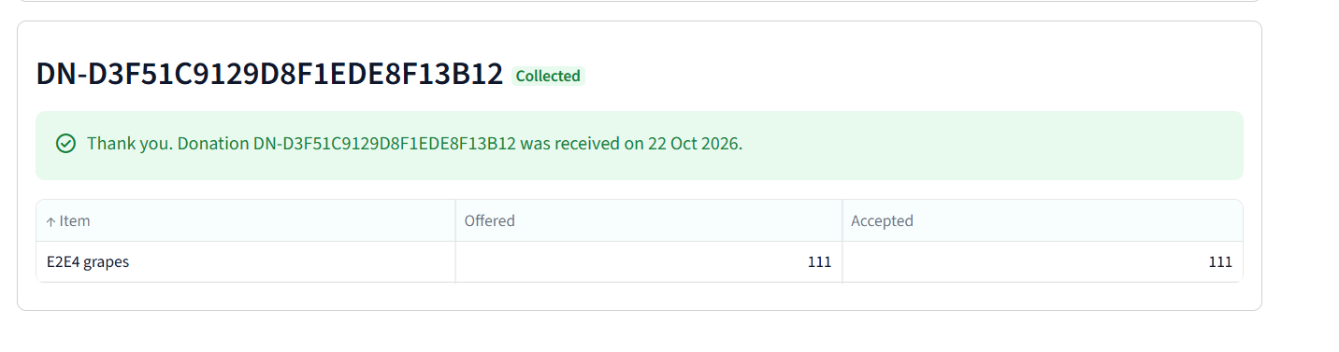
Figure 15 Accepted donation receipt and recorded quantity
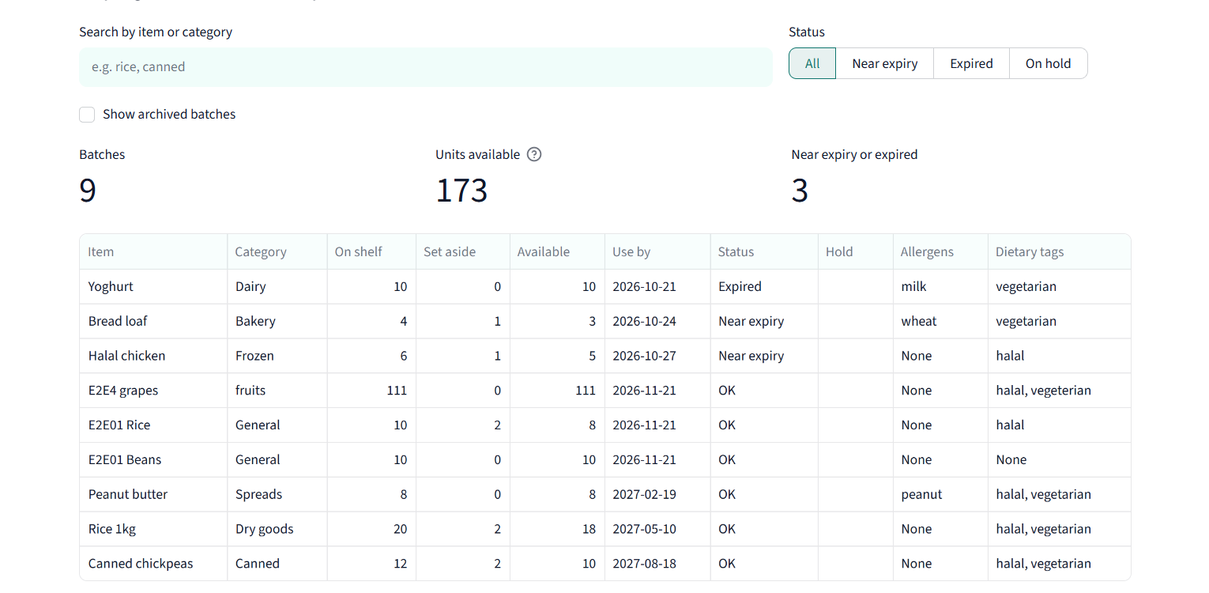
Figure 16 On hand reserved and available stock after allocation
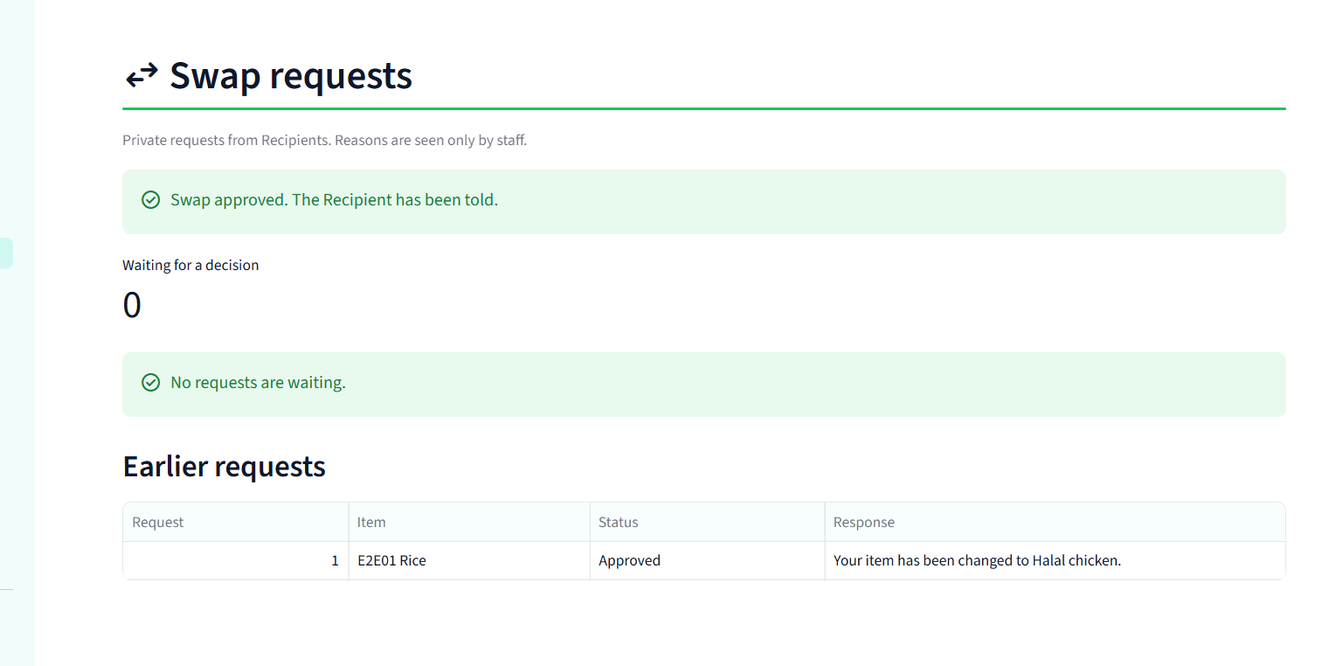
Figure 17 Staff approved private replacement
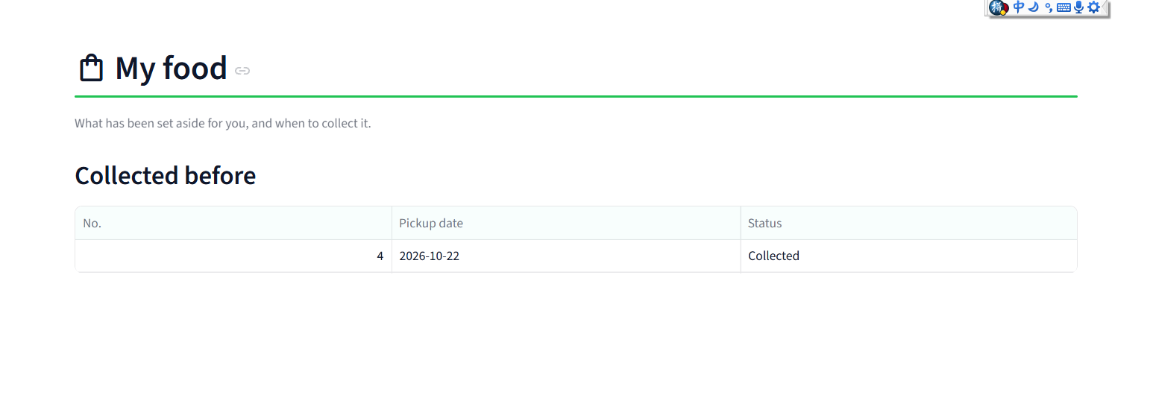
Figure 18 Recipient collection history for the observed allocation
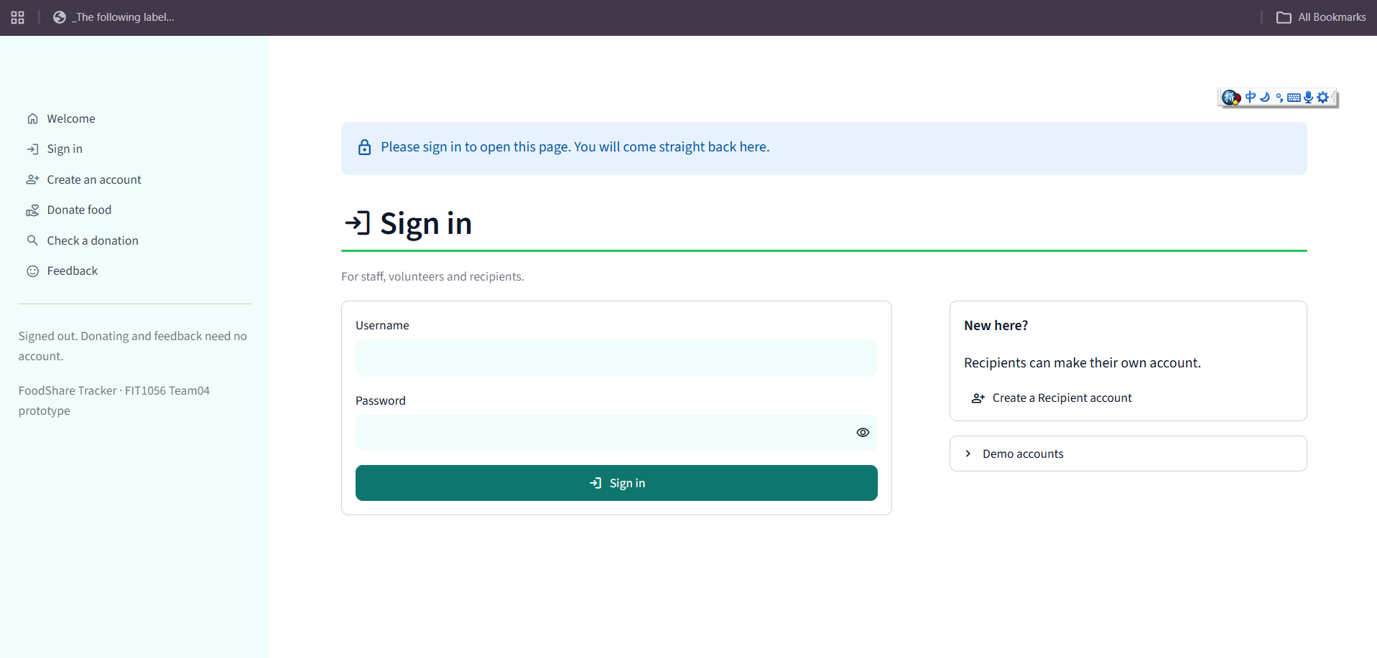
Figure 19 Protected page requires sign in after logout
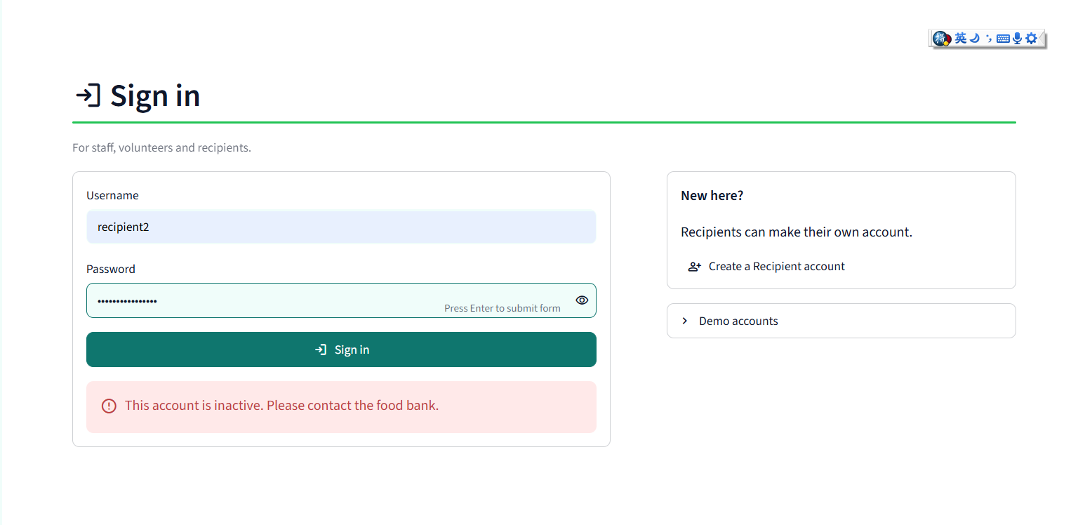
Figure 20 Deactivated account cannot sign in
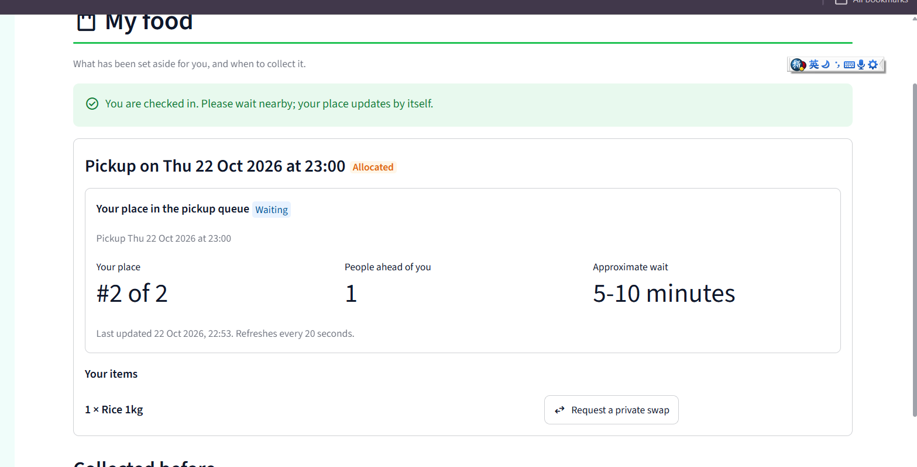
Figure 21 Queue refresh state with its update timestamp
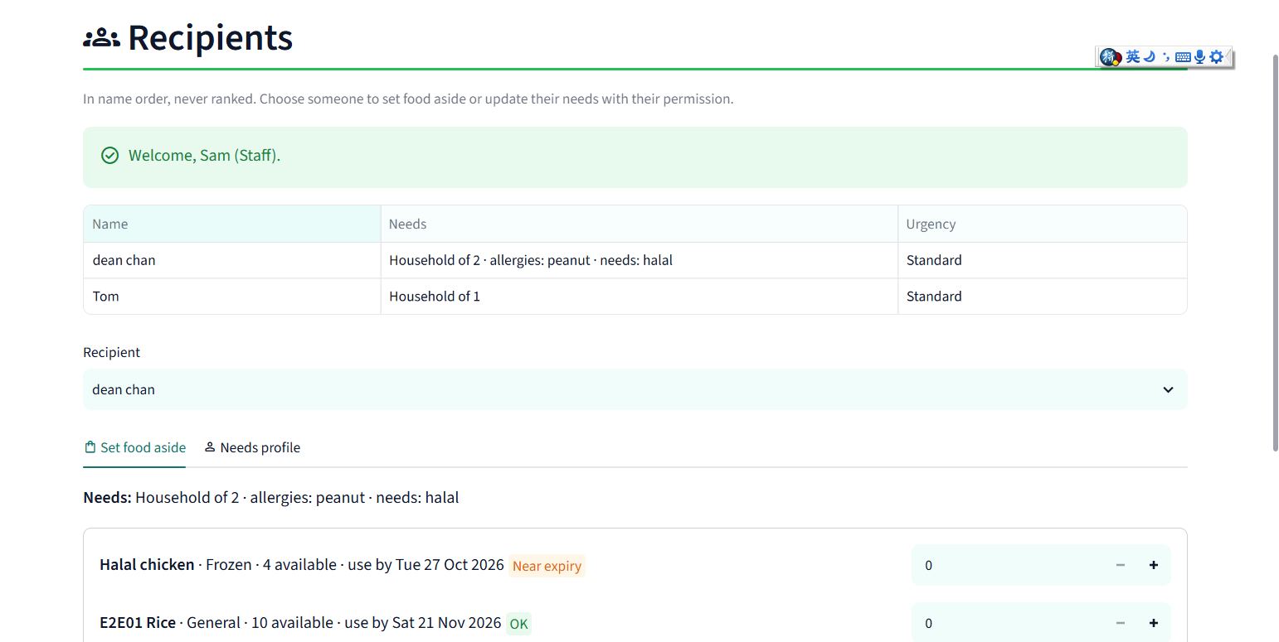
Figure 22 Restored Demo values after the manual backup test

Appendix D Outstanding human activities
Check 7 is the five-person moderated usability exercise. It requires actual participant/training/task records. Check 9 is another team member's inspection of business code, errors, permissions, UI, README and evidence consistency. It is not a summary of DeanChan's earlier tests. Both remain Unknown / Not completed, as requested.
No participant or peer reviewer names, dates, findings, signatures or per-member sequence contributions are supplied by this revision. When those activities occur, retain their actual results and the reviewed commit/build. DeanChan remains the tester attribution for the completed manual checks only.

