Viva Engage Community Creation Sample

How to import this Power App into your environment

# Introduction

This Power App and its associated Flow are intended to be used as a sample that shows how to use the [Viva Engage Community Creation API](https://learn.microsoft.com/en-us/graph/api/employeeexperience-post-communities?view=graph-rest-beta&tabs=http) to create new communities. It is not intended for production use and provided with no guarantees or warranties. Please adapt & customize it to your specific business needs.

# Steps

* **Create a new Enterprise App registration**
  1. In the [Entra ID portal](https://entra.microsoft.com/), under Applications -> App Registrations, select “New registration”
  2. Give it a name that will make sense to someone looking at it later
  3. Make no other changes on the first screen and select ‘Register’
  4. On the next screen, select ‘API Permissions’ from the left menu
  5. Add and consent to the following **application** (*not* delegated) permissions so your application will have the correct rights to be able to create a new community:

* 1. In the ‘Certificates & Secrets’ section for this new app registration, select “New client secret”
  2. Give it a description that’ll make sense to others that may be in here, then set it to expire after a time you feel comfortable with, then click ‘Add’.
  3. Keep the value handy, as you’ll need it later.

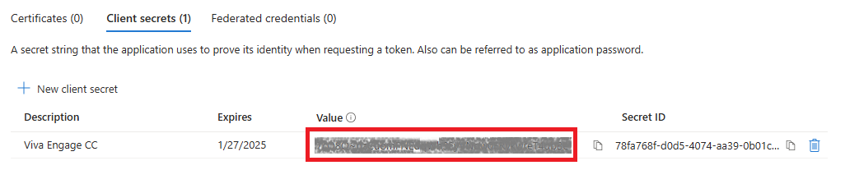

* 1. Back in the Overview section of new app registration, grab the Application (client) ID and the Directory (tenant) ID, as you’ll need those later as well:

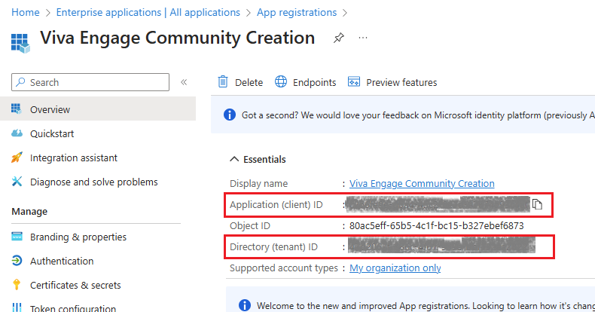

* **Import the Viva Engage Community Creation App**
  1. Open the [Power Apps portal](https://make.powerapps.com/)
  2. Select ‘Apps’ in the left nav menu
  3. Select ‘Import canvas app’ along the top menu, and in the next screen, the app package you downloaded from the FastTrack GitHub repository.
  4. Once upload completes, you should be able to review the package content in the bottom half of the screen, and it should look similar to this:

* 1. Before you can import, you’ll need to select a connection for the Office 365 Users Connection. Click ‘Select during import’, and create a new connection for the ‘Office 365 Users’ connector as shown below. Note that this will open in a new tab:

* 1. Once created, switch back to the tab where you’re importing the Power App and click ‘Refresh List’ on the Import Step flyout:

* 1. Select the connection and click ‘Save’
  2. Click ‘Import’. Once this finishes, you should see the new app in your apps list in the Power Apps portal. Move on to the next set of steps.
* **Update the HTTP Action in the Flow with auth information**
  1. Edit your ‘New Viva Engage Community’ app in the Power Apps portal

* 1. You should now be in the canvas for the app. In the left nav, select ‘Power Automate’. You should see the ‘Viva Engage CC Flow’ in the list of flows in the app.
  2. At this point we’re going to go ahead and remove/re-add the flow to head off a couple of issues
     + Remove:

* + - Re-add:

* 1. Next up: edit this flow

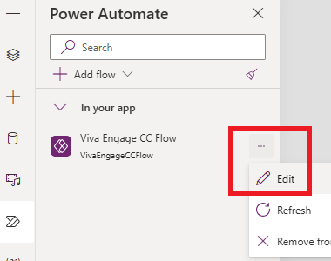

* 1. Inside the flow, click on the Get Access Token action to expand it. Here’s where you need the 3 GUIDs from when you created the new enterprise app:

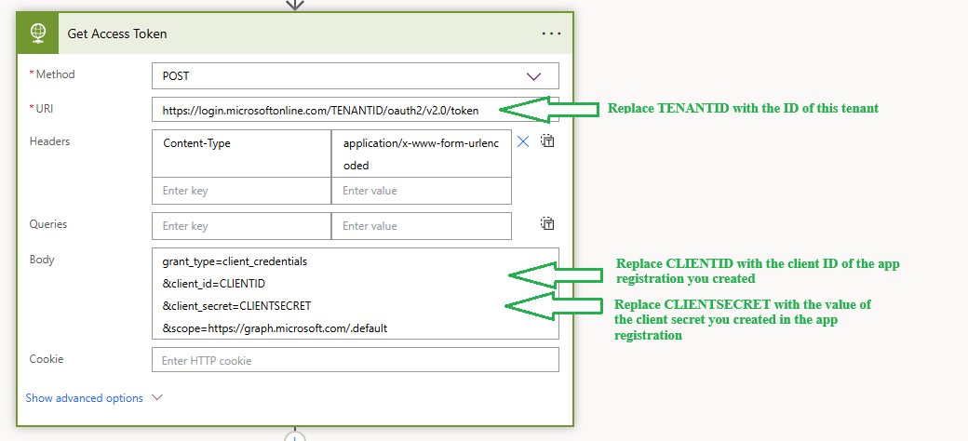

* 1. The end result should look like this, just with your values for each of those 3 items:

* 1. Save the changes to the flow and exit the flow editor. Now you’ll need to go into the [Power Automate portal](https://make.powerautomate.com/) and enable the flow. Once there, go in to “My Flows”, click the ellipsis next to the Viva Engage CC flow and select ‘Turn on’:

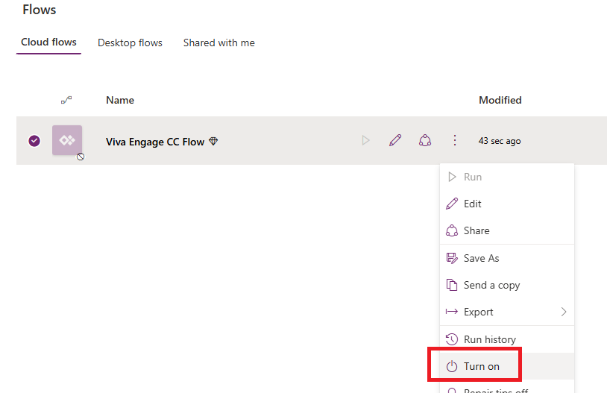

**At this point, you should be good to save the app, publish it, and test it out!**