

Project: Heat Transfer within a Pipe

Dean Devereaux - R00116198

Kevin Garcia - R00111281

Ayrton O’Shea - R00111658

Barry O Halloran - R00015764

Table of Contents

1. System 3

2. Team Planning 5

3. Characteristic of heating the pipe 5

4. The Characteristics of heat loss from the pipe 6

5. Modeling the system 7

Flow balance model 9

Linear System model – Transfer function 9

6. Closed Loop On-Off control 9

7. Proportional control 11

8. PI Control 13

9. System stability 14

10. Conclusions 15

11. Logbook and experimental plan 16

## System

Description of the system. Include details of how the PC controls the system and any characteristics of the system of importance to its control. Include sensor calibration.

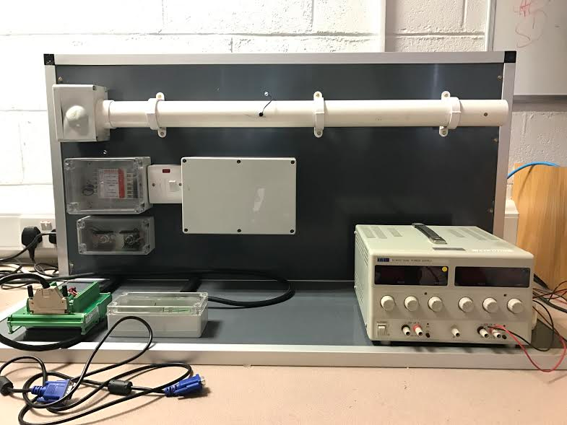*Figure.1 Pipe Heating System*

This system based on a pipe heating system where the main components are a pipe, fan,heating element and a temperature sensor (*Figure 1*) .

The system is controlled using matlab software on a PC linked to the model through a serial bus connector to a junction box on the model .

Power for the model is supplied by TTI dual power supply and is set to a constant of 0.4 amps and 11 volts for all experiments we carried out (*Figure 2*) .

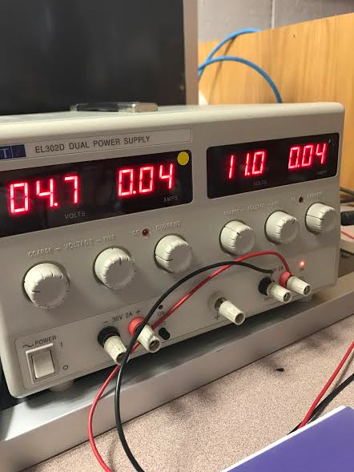*Figure 2. Voltage Settings*

The model operates by applying a voltage to a heating element which in turn heats air and this air is pushed by a fan operating at a constant voltage .

The temperature sensor which is located fifteen inches from the elements position will sense the air temperature generated by the heating elements but will incur a delay in responding to any changes in temperature variations due to the distance between the element and temperature sensor .

When carrying out experiments a number of limitations were encountered when modelling this system .

Due to the heating element being encased in PVC plastic which can lead to the plastic melting around the heating element due to it not rated for high temperatures this put a maximum ceiling on our operational temperature of our heating element of 70 degrees which transpired to be limit our input voltage to .35V .

Another limitation we discovered during our experiments was that any obstruction to the outflow of air from the pipe would cause disturbances to our model and should be avoided in order to obtain correct model data .

During experimenting with this model we found the system to be quite fast when responding to changes in input but still diligence was required after each experiment to ensure that the heating element had cooled sufficiently in order for another experiment to take place with the starting temperature at the same point for the start of each experiment .

We used MATLAB 2015b for modelling our chosen system whether we choose to model open loop or closed loop , proportional ,proportional integral or proportional integral and derivative control , MATLAB was an excellent platform for providing us with model data but also provided us with the capability to graph this data in order to provide us with a visual understanding of the processes taking place which aided our understanding of the fundamentals of control .

MATLAB also provided us with the capabilities to identify process variables, system outputs and identify trends with reference to these variables

## Team Planning

Team approach, responsibilities and data management policy.

Firstly we had to assess exactly what this project required before we could decide where we would start and who would do what. Each week we decided on our tasks and tried to spread out the tasks evenly. We planned so that we weren't doing the same job every week so that we could all get experience for each task. At the start we also set the plan in the place to fill our logbooks at the end of each lab as we had the information fresh on our mind and it prevents us from having to fill them all at the end. All data was saved to excel files and distributed to each member of the group to avoid loss of data as well as allowing all of us access the data to understand what the results are showing.

## Characteristic of heating the pipe

Before the pipe was heated for measurement we had to analyse the temperature of the sensor each time in order for the results to be correct based on the room temperature.

A limitation of 0.35V was put on the fan for heating the pipe of our heating system. This voltage allowed valid information to be retrieved from results in good time. Of course when using this voltage the system had to be carefully watched for any damage of the system as the material surrounding the fan cannot tolerate temperatures exceeding 60°C.With the PVC as the material of the pipe and its thermometric properties, we know that with low thermal conductivities, are poor thermal conductors. Therefore these will transfer small amounts of heat over time. As we continue to simulate the model, we reached various peak voltages of which are dependent on the voltage and time. v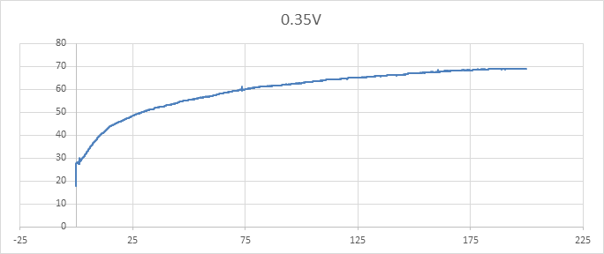

## The Characteristics of heat loss from the pipe

The characteristics of heat loss from the pipe was tested by, first “Heating the pipe (Part 3)” then cooling it and gathering the results.This was done by placing the voltage of 0.35v into the model whilst the pipe was at room temperature before the model was simulated over a period of 3 minutes. After reaching a peak temperature of 70°C. It was necessary to disperse the heat from the pipe in order to get an instantiated constant result of heat loss. From this, we switched off the fan (0v) and then left the pipe to cool down to room temperature (30°C) over natural convection (air) within a time period of 400 seconds (6.6minutes). The result from the simulation was graphed in excel and then a polynomial trendline was added onto the slope which had to be a good fit to the data. This shows the derivative of the fit line which gives us the values for each point in time(*Figure 4*).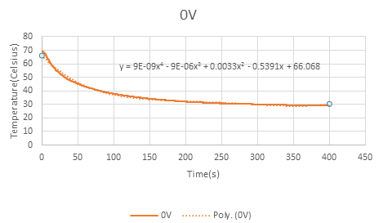.

*Figure 4. Heat loss Graph ( Temperature & Time).*

From the graph, we get

we then calculate the derivative and equates to

this is then placed into the model which complete the system response.

## Modelling the system

If we want to design a controller for any system it is useful to come up with reliable system model. The model of system is designed, then validated on real

data.

We developed a model by physically understanding the system and by building it from first-principle. With the heat system model we used the same formulae as with the flow balance.

**Flow Balance**

For any of the integrating system such as our model (heating) the difference between the input and the output values is changed in the controlled variable. Sample values was then used to model the flow balance of the heat at each sample interval.

We then built the model from the heat and cool cycles rate which is dependent on the temperature respectively. The results plotted in the graph shows different input voltages.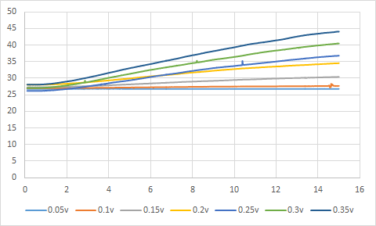 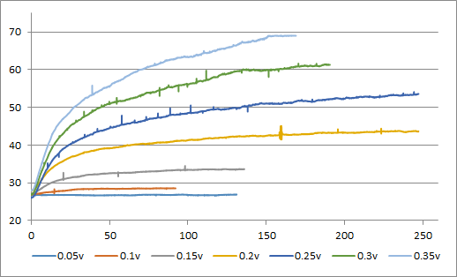

*Figure 6. Measured heat data at different voltages*

where is used for the slope of the level line is used to compute for each input voltage. From this we know that:

so after calculation: Qin = ???? * Vin - ???

therefore the slope in the graph (*figure 6)* is the equation Qin is what is required for the model *.*

*W*e then set up the equipment to run with the model in simulink..

The step size was set to increment at steps of 0.5 with a saturation limit set to 0.35v.This is due to the material tolerance of the equipment being used. We did not want to overheat or melt the equipment used in the experiment.

## Flow balance model

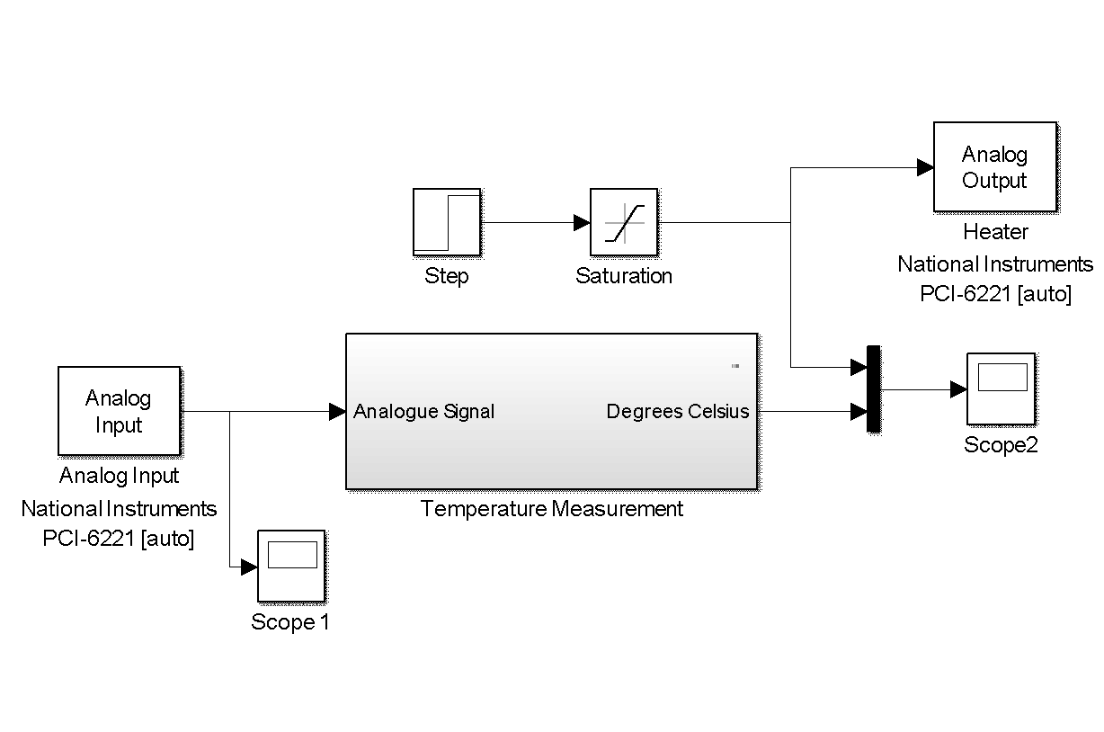

## 

## 

## 

## 

## 

## 

*Figure 6*.System Model

## Linear System model – Transfer function

## Closed Loop On-Off control

On-Off control simply allows a system to alter around a set temperature based on the feedback of the present temperature. This technique was used on our model with a setpoint of 40°C on all exercises. The relay used in the model allowed us to set a temperature above or below the setpoint which would cause the system to switch on -off thus the term On-Off control. The saturation was then used to allow the fan power to not go above our limit, 0.35V or test out lower fan power values.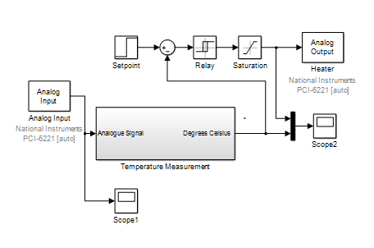

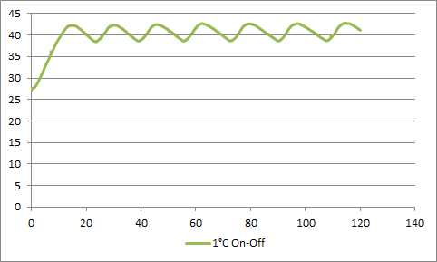

For our first measurement we used an on-off point of 1°C between 40°C and left this run for 2 minutes which gave us the following results. For our system this would not be logical to use as the on-off points are clearly too close within the range of the desired temperature and switches the system on-off every 5 seconds

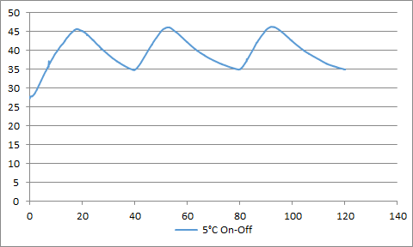

Next the on-off point was changed to 5°C we tested this with 0.35V and 0.25V for 2 minutes each. Due to the speed at which our system can heat again this voltage point causes very rapid on-off changes.

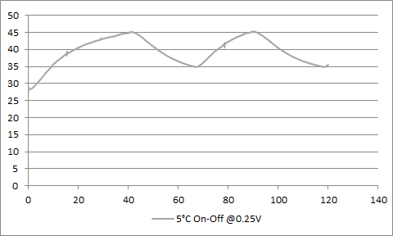

Looking at the results of the 0.25V it would seem this model could work with our system if the voltage was brought down to 0.15V and the on-off points at individual values. For example 10°C above 40°C and 5°C under to give sufficient time.

## Proportional control

In this experiment we attempted to model the response of the process variable to a step input .

The goals for this experiment are as follows:

1. Design and implement a proportional control strategy for the process at our given setpoint.
2. Test the proportional controller with different gains with our model.
3. Test the satisfactory controller on the system.
4. Comment on the model and identify any advantages or limitations of the system.

Before beginning to model this experiment some critical model information was needed to be ascertained before we could proceed with the experiment .

1. The amplitude of the set point was to remain the same as the previous experiment and was set to 0.3V
2. Saturation was also set to 0.35V to prevent damage to the model from overheating the PVC pipe .
3. The transport delay was ascertained and represents the time between the step input and response from the temperature sensor due to the distance between the components and the speed at which the fan can move the heated air towards the temperature sensor.
4. The elements of the transfer delay are KSS , Ts +1.

KSS is our desired temper which is 34.6 degrees divide by our input step of .3v which

equals 115.36.

Ts +1 equals ⅕ of the settling time minus our transport delay of 2.5 sec which equals

34.81 plus 1 equals 35.81.

5. A constant was also introduced into this model and this was to represent the room

temperature of the lab due to the system model never being able to cool below

this ambient temperature and was set to 26.68.

Observing the MATLAB model and graph we have below for proportional control has lead to some confusion for me .

This model represents the model's response to a step input on the system with the pedigree information we have for the system already vs a control modelled on matlab as a reference and does not accurately represent proportional control as I have learnt previously and subsequently I must concede that some of our models and graph information must have been lost .

Proportional control in essence is the applying of the difference between the set point and the output to the gain block which is consequently applied to the process variable in the controller .The circuit is a closed loop feedback back circuit as the output is feed back to the difference block where the error is calculated.

The output should never reach the set-point due to there always being an error between the setpoint and output and the applied gain is proportional to the error .

We can also state that when applying different gains to the system that as you apply higher and higher gains that subsequently reduces the time constant but ultimately this benefit seems to fade away the more gain is increased so when applying these principles to our physical system we ll find there is a physical limit to the benefit we see from increasing the gain as this may cause overflow.

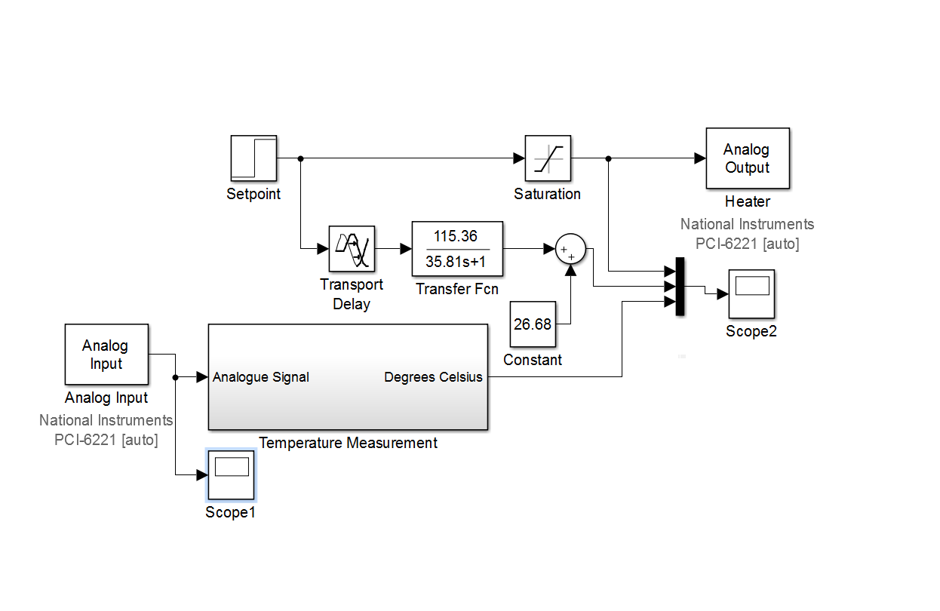

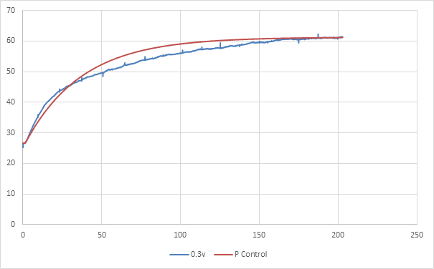

This type of control uses the feedback, output is subtracted from the set point, result is error of system, output of regulator is error multiplied with gain.

**Sensitivity to gain**

**Sensitivity to leakage**

**Conclusion proportional control**

## PI Control

In this section, In order for us to create the PI control we put together what have learnt from previous models and class lectures, such as the feedback, flow balance, on-off system.There are a few Advantage and Disadvantage;

Advantage

* Eliminates any offsets so that we get zero and accurate tracking

Disadvantage

* It can result in very slow responses or quite oscillatory responses

PI control is the addition of both Proportional control and Integral control.

you use the P term to get fast responses and the I term to eliminate an offset.

When we ran a PI model we expected to see a zero steady state error and control signal increases when the error is not zero.

With PI for the design you have Kp which is the proportional gain and Ki which is known as the integral gain. PI controller design involves choosing the best values of Kp and Ki for the application.

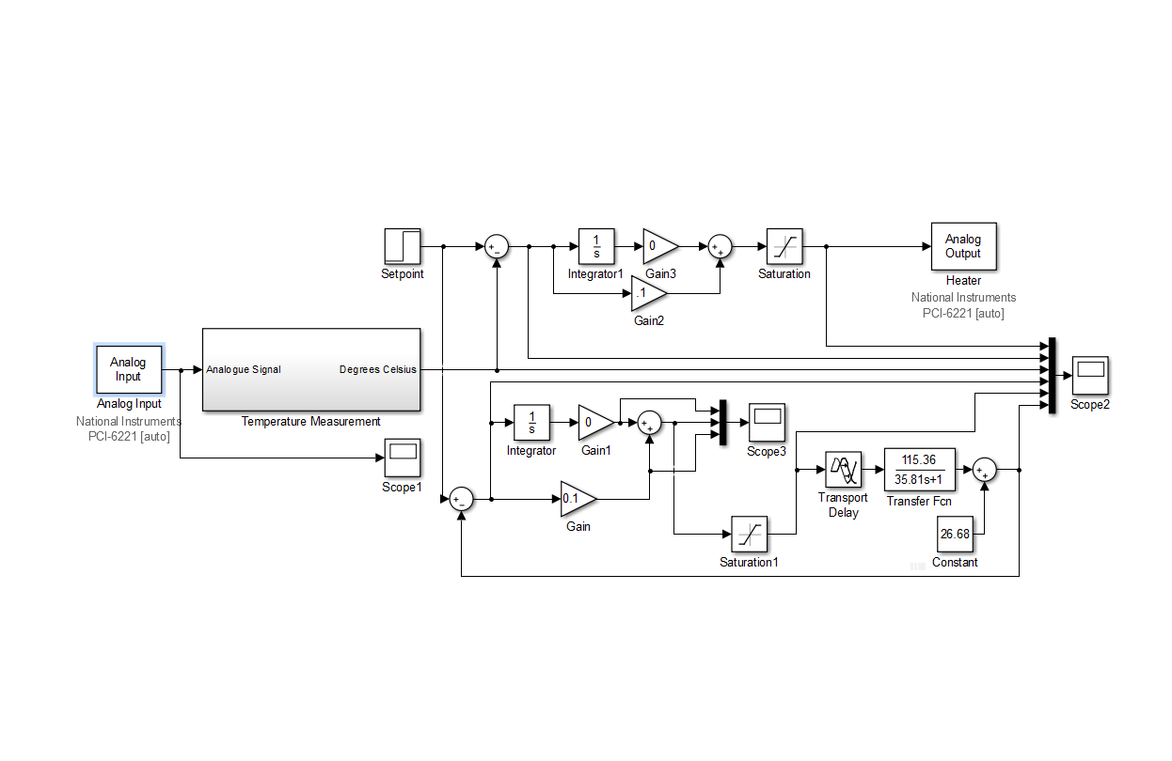

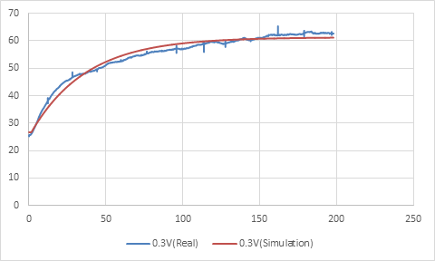

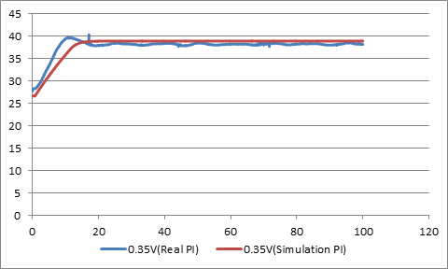

## System stability

In this section we evaluated our system's stability though this section was not an area we covered as a group in the lab I will attempt to explain stability ,offer examples of methods to ascertain KP or KI which will aid stability and also comment on the stability of our system.

Previously in third year of electronic engineering we learned about laplace and the application of general transfer function .

We learnt that the numerator represents the zeros and the denominator represents the closed loop poles .

These closed loop poles and zeros may be drawn out on a s-plane graph or done using root locus software on MATLAB .

Previously in our academic year we learnt any poles on the right hand side of the s-plane is unstable as it grows exponentially and any pole on the left hand side of the s-plane is stable as it decays exponentially.

It's the position of these poles that we are interested in as these poles will give an indication to us of the ideal KI (integral gain )and KP(proportional gain) in order to minimise output overshoot and to reduce the settling time of the output .

In class we learnt about two methods used in industry today .

Ziegler nichols (process reaction tuning ) and ultimate cycle but for this i will choose to discuss process reaction tuning which is based on a formula proved by zieger nichols .

|  |  |  |
| --- | --- | --- |
|  | KP | KI |
| Proportional |  | 0 |
| Proportional/integral |  |  |

If we use this method we find our ideal KP and KI for our system are (.116) and (.120) respectively .

## Conclusions

******** note . for whoever is doing this section :you can say when we experimented with pid we found practicularly no effect on the system becasue our system is so slow and PID WOULD BE MORE SUITED TO VERY FAST SYSTEMS ************duck sauce Barbra Streisand i want naggins now .you wouldnt drink water

**Kevin Conclusion**

When we started the Heat system model simulation,We learned a lot of useful information that is necessary to run a model successfully. Throughout this experiment we learnt to use the basics of control systems, which was then put into use into creating and running the model of the heat system in the lab. Although the most of the notes was on leakage, we gained the knowledge to apply these a such to our model in order to successfully execute the task set out at hand. When running the simulation we first made sure that the setting of the power source was constant throughout the whole experiment to get a constant and accurate result. With the flow balance we know that the derivative of the value of each point in time is placed into the model which completes the system response.

For the On and off Control we learnt the use of MATLAB to implement the On-Off controller system which brings us the performance data for operating with the flow balance model.

For the System Modelling we learnt that there are 2 ways in which we can develop a modelling method, one from first principle and the second from experiment data extraction.We also learned to examine the accuracy of the models from the inflow and outflow of the heat.

For the PID, When we experimented we saw now effect on the actual system itself as our system is slow and that the PID would be better suited for faster systems.

**Ayrton’s Conclusion**

In conclusion we found that doing this project we have a better understanding of control fundamentals. We learned a lot about the process of heating the pipe between knowing our cut off power and letting the pipe cool for long enough that our next reading isn’t distorted. We found that our cut off was 0.35V and if we went above this we would be damaging the pipe as we would be heating it past the materials tolerance. We also found out our power source had to constant in order to get an accurate result. We also learned that there was 2 methods of modelling, going from first principle, or experiment with data extraction. We built ours from first principle as it was the better option for us. Through this project we got to use Simulink models a lot more and we have become a lot more familiar with them because of this. Even though we found bits of the project difficult I think over all we have a much better understanding of control.

**Dean’s Conclusion**

Through these experiments a lot has been processed with the use of our heating system. I can say that I have becomes familiar with the system and how it works through the use of MAT Lab. There were many limits unique to our system that were overcome to get the right results and not damage our system such as power supplied to the fan and time delay between the fan and temperature sensor. The Flow and Leak rate of this system was very simple to figure out and a benefit of our system was the pace at which the temperature increased leaving no time to waste. Through the three methods of heating examined for this system I can say that my knowledge of control has improved and I can implement this information into future systems.

## Logbook and experimental plan

Here you need to keep a record of work undertaken each week. This should include your measurement plan which we can review in advance of making any tests. It should also include a statement to demonstrate that you are aware of the significance of the data measured, simulations undertaken and the results of any data analysis. The objective is to ensure you are clear on the purpose for the week’s work and on the relevance of the outcomes.

This section must be kept up to date.

**Logbook Template**

|  |  |
| --- | --- |
| Date: |  |
| Work plan for this week. Objectives and method statement. | |
| Summarise the work you completed this week. What are the major results in the context of the final report? | |
| Summarise the work your team completed this week | |
| What would you do differently if you were to repeat this weeks work? | |
| Additional Comments | |
| Attendance Record – Dates in attendance | |