Project Plan for the
Regulation of Heat Transfer to a Household via Wood Stove

Distribution: Fergus O’Reilly& Dean Devereaux

Contents
1. Overview 3
2. Goals and Scope 3
2.1 Project Goals 3
2.2 Project Scope 3
2.2.1 Included 3
2.2.2 Excluded 4
3. Stakeholders 4
4. Proposed Solution Diagram 4
4.1 Solution Diagram/Representation 4
4.2 Compliance Matrix of Solution 4
5. Schedule and Budget 5
5.1 Work Breakdown Structure and provisional Schedule 5
5.2 Schedule Chart 5
5.3 Deliverables and Milestones 5
5.4 Budget 6
6. Risk Management 6
7. Revision 6

Overview

The aim of this project is to regulate the intake of heat being produced by a wood fuel stove while also controlling the burning rate of the fuel. This project will cause the stove to have a reduced amount of manual work as it will automatically change allowing the house to have the right amount of heat. The idea is to have a desired temperature or use the pipe bringing heat back to the stove and compare these to the room or heat being retrieved by the stove’s pipe.

The price of the components for this project will not be expensive. Using only a motor, temperature sensors, display, buttons and of course a PIC18F452 microcontroller it should only be under €50. With about 12 weeks of work the human resources comes to just €5400.

Ireland is a big supplier of stoves and this project would be appealing towards manufactures of this product as smart devices are becoming the future of household appliances. The technology and tools are there to make this project a reality in wood fuel stoves.

Goals and Scope

Project Goals

Goals/Objectives | Priority | Comment/Description/Reference
Phase 1 Goals: |  | For details see the Project Requirements Specification Error: Reference source not found
#1 | 2 | The project will use the PIC18F452 to connect all peripherals
#2 | 1 | The project will use C programming to implement the behaviors desired for the microcontroller
#3 | 1 | The project will measure temperature of a room and pipes of a stove. The results will be saved and compared to the preferred temperature
#4 | 2 | The project will control an air vent via motor which will change position based on temperature reading of the room
#5 | 1 | The project will maintain temperature once it reaches the desired temperature
#6 | 3 | The project will be able to choose a desired temperature using two buttons to increment or decrement the value
#7 | 3 | The project will use a LCD display to show preferred and current room temperature

Project Scope

Included
- The project will be able to measure the temperature of the room the stove is located and the temperature of the pipes transferring air in and out of the stove
- The project will maintain the temperature of the room once the stove heats the room to a preferred value
- The project will control the burn rate of the fire based on a preferred value
- The project will control the movement of an air vent via motor
- The project will control the peripherals with a PIC18F452 using C programming
- The project will allow the temperature desired to be altered in a typical range

Excluded
- The project will not measure the temperature of the stove itself
- The project will not heat the room or keep the fire ignited.
- The project will not move the air vent every time the temperature changes
- The project will not be connected to a stove internal
- The project will not have the desired temperature set on a constant value

Stakeholders

Name/Person/Organization | Impact/Importance
Dean Devereaux | Researching and producing the project
Fergus O’Reilly (Supervisor and Lecture) | Will give advice and help with providing equipment if necessary
Stove Manufacturers (National and International) | Improve/alter their branded stove with a controlled heating device
Consumers | If this project became reality, then individuals who buy stoves with this device can maintain the temperature without manually changing the air vents

Proposed Solution Diagram

Solution Diagram/Representation

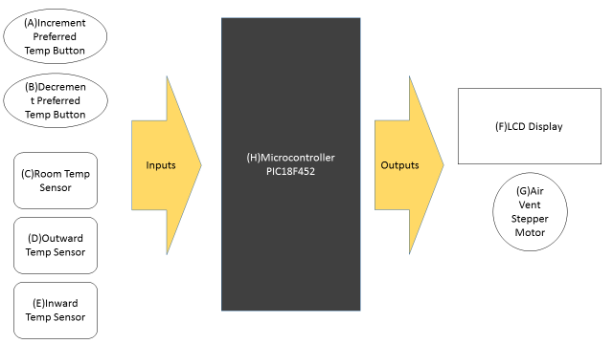

Compliance Matrix of Solution

Objective | Blocks involved
1: Use PIC18F452 to connect all peripherals | A, B, C, D, E, F, G, H
2: C Programming to implement the behavior of the heat regulator | A, B, C, D, E, F, G, H
3: Measuring temperature of a room and pipes of a stove. The results will be stored and compared to the preferred temperature/inward pipe | C, D, E, H
4: Control an air vent via motor which will change position based on temperature reading of the room | C, D, E, G, H
5: Maintain temperature once it reaches the desired temperature | C, D, E, G, H
6: Choose a desired temperature using two buttons to increment or decrement the value | A, B, H
7: LCD display to show preferred and current room temperature | C, D, E, F, H

Schedule and Budget

Work Breakdown Structure and proposed Schedule

Work Tasks | Description | Duration
1 | Look over previous notes on PIC18F452 and pick key functions needed for project | 7 days
2 | Research heat transfer based on the movement of heat within pipes | 7 days
3 | Interfacing temperature sensors with PIC | 4 days
4 | Interfacing stepper motor with PIC | 7 days
5 | Interfacing LCD with PIC | 7 days
6 | Purchase components that will be adequate for the project objective | 7 days
7 | Create circuit on proteus and simulate | 7 days
8 | Flow chart for program | 1 days
9 | Section of C program for temperature sensors | 7 days
10 | Section of C program for displaying temperature on LCD | 7 days
11 | Section of C program for precise movement of a bipolar stepper motor based on temperature values | 7 days
12 | Produce real-world circuit by connecting peripherals to their designated ports of the PIC18F452 | 5 days
13 | Program real-world circuit | 3 days
14 | Revise program for improvements | 4 days

Schedule Chart

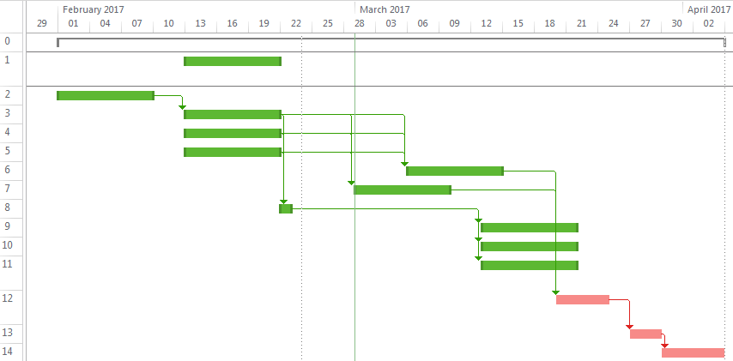

Deliverables and Milestones

Milestones |  | Description | Planned Date
M0 |  | Controlling stepper motor with PIC18F452 | 03/03/2017
D0 |  | Project Plan | 05/03/2017
M1 |  | Produce very precise and effective program for heat regulator | 17/03/2017
D1 |  | Project Presentation | 15/03/2017
M2 |  | Design schematic for heat regulator | 31/03/2017
D2 |  | Final Project Presentation | 03/05/2017
M3 |  | Fully functional PCB of heat regulator | 07/04/2017
D3 |  | Project Report | 03/05/2017

Budget

Category | Budget
Human Resources (internal) | €20 per hour @ 10 hours weekly: €2400  @ 12 weeks
Human Resources (external) | Fergus O’Reilly: €50 per hour @ 5 hours weekly: €3000 @ 12 weeks
Purchases (COTS) | - Bipolar stepper motor | €14
Purchases (COTS) | - L295D Driver | €2
Purchases (COTS) | - PIC18F452 | €7
Purchases (COTS) | - LM35 Temp Sensor x3 | €9
Purchases (COTS) | - LCD Display | €6
Purchases (COTS) | - Button x2 | €2
Purchases (COTS) | Total of Purchases | €40
Total | €5440

Risk Management

Risk | Description
Risk 1: | Components don’t arrive on time
Risk 1: Recovery | Find an alternate provider
Risk 2: | Error with PCB
Risk 2: Recovery | Print an extra PCB
Risk 3: | Error in precision
Risk 3: Recovery | Re-check all calculations of stepper motor and temperature sensors

Revision
Rev. ind. | Page (P)  Chapt. (C) | Description | Date  Dept./Init.
- | --- | Original version | 27/02/2017

