

Assignment Three:

New Frontier

**Module: Technology Entrepreneurship**

**Lecturer: Finbarr Sheehan**

**Written by:**

**Dean Devereaux - R00116198**

**Electronic Engineering - ELX4**

**Date: 24/05/2018**

**New Frontier**

# Introduction

For this assignment three companies will be examined which were part of the 2016 new frontier. These companies were chosen out of five and are:

* RASH’R
* Cook + Cure
* Firemole

The examination will fall under three headings, Individual entrepreneur, Feasibility concept and Opportunity and creativity. The data for this examination will come from their short new frontier video and websites along with social media presence and applications.

RASH’R is a Cork based company which is in the water clothing industry and produces rash vests for the water sport community globally through the use of social media. Cook + Cure Ltd is a company which deals with educating on the benefits of foods and what foods would be best for people with certain health problems as everyone is different and Firemole Ltd is another Cork based company that manufactures temperature alarms that can alert for temperatures greater than 54 degrees for electronic device and chargers alike.

# RASH’R

# The Individual Entrepreneur

Tom Cotter is the founder and CEO of the RASH’R Company. Two reasons he created this company were to exploit an opportunity and take from his hobby. He explains in the new frontier video that he has been involved in water sport for many years and that he saw an opportunity to make the rash vest trendier as it hasn’t been changed since its creation 50 years back. This idea was taken from other companies outside of the water sport clothing industry. Water sports are global and tom also saw this as an opportunity with the help of the internet to take a chance and not start off in Ireland but worldwide.

# Opportunity & Creativity

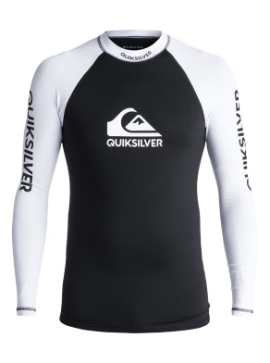Creativity is defined as the ability to bring something new into existence or the ability to combined ideas in a unique way. This company has done this by combining the rash vest of water sports with design ideas through the use of 360 degree printing technique

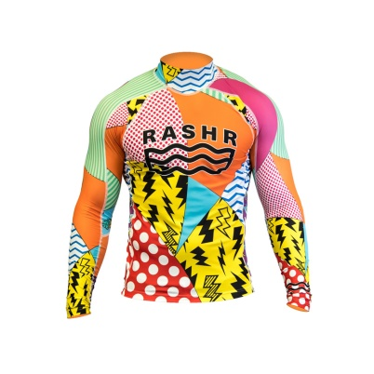This company was built on the opportunity of making the rash vest used within the water sport industry more trendy with colourful and eye-catching designs. This was a very creative move and gave the water sports community the unique style it was missing. These styles can also be seen in outdoor activity sports.

By helping with challenges to creativity this company has also allowed the customer the opportunity to customize their very own rash vest if the company’s limited styles are not what they desire. This company can create more styles in the future if need be but allowing the customer to be the creative one allows for a safe measure.

Social media is a great way to promote and advertise a company. This company needed this as an opportunity to become worldwide. Looking at Instagram RASH’R already has 11k followers being its major media with Facebook at 1k followers.

# Feasibility of the concept

This idea is quiet fresh and at the moment has no competition within this industry for branded and unique vests. This gives the company a good start to be recognized by the water community. The vests created are made from a fabric blend of 78% PA and 22% EA which is eco-friendly and appealing to those who care about the environment. The company already has a market which is the global water sports industry and outdoor activity companies which sell these products. They communicate with this market through the use of social media which is an advantage as the company doesn’t have to move location or set up international.

The viability of this has been tested with vest already being shipped to New Zealand, Canada, and America to name a few. The company can be seen to be making a profit from the 2 year old video and the website today. Prices of vests have gone down from €70 to €50 and also they give the opportunity of free shipping if the total spend is more than €80 otherwise the shipping will cost €7.99. A risk with the idea of a trendy design for rash vests is that a known/popular company can easily follow suit and create their own colourful designs making RASH’R not unique anymore.

# Cook + Cure

# https://scontent.fdub5-1.fna.fbcdn.net/v/t1.0-1/p200x200/27072882_1590090104407400_6585614280905082285_n.png?_nc_cat=0&oh=f5c83e90cdfdb253b7dc8583707ecc5e&oe=5B872DCBThe Individual Entrepreneur

The founders of this company are Kait, Ben and Emma. All three have a history with medical problems and created this application to sort their nutritional needs along with the needs of others. Kait is the founder who came up with the idea, highly due to the fact of her husband being diagnosed with Lyme disease and her brother with M.S.

In today’s day and age if somebody is sick google is the first place they go to find out how to help with their problem. This is how Kait came up with the app concept. Instead of searching in the endless answers of the internet she saw an opportunity to create an app which would educate oneself on how to look after an illness or health problem with the use of food. Along with this Kait also talks of another app idea which would be beneficial to pregnancy nutrition which show her commitment and determination in helping others deal with their health.

# Opportunity and Creativity

The company acknowledged that everyone looks for a remedy or nutritional advice for their own health problems or an illness that needs to be taken care of and seen that creating this app helped solve the problem of searching online. Everybody is different and react differently to foods. This app will help people choose foods better based of conditions such as migraines, anxiety, depression, stress etc. Not only does it inform individuals on the benefits of food but also the disadvantages of consuming a food based on their status.

All this information can be found online but to have it in one place and easily found based on your needs with the touch of a button is highly creative and gives people globally the opportunity to look after their health. This app is the first of its kind which gives advice from experts around the globe and also has the prospect of branching out into other categories of apps such as the “bump and bean” app idea.

# Feasibility of the Concept

This application is only available through apple products and has no presence on the play store leaving out a major marketing area. The app is priced at €5 which does give it a source of income through the app store but if people don’t wish to buy the app they can view the blog on the Cook and Cure website. Cook and Cure also has a social media presence with Facebook being their major media at 13k followers and Instagram having 3k followers. No idea how the app is doing within the market but the bump + bean app hasn’t been made available yet.

# Firemole

# The Individual Entrepreneur

Sean O’Tuama is the founder of Firemole Ltd and through of this device through his employment and his own experience. Sean mentions that he is an electrician and notices an increase in fires and also has experienced an incident with a fire from increased temperatures of a device himself. Sean noticed that there was no way to detect this hazard from happening therefore he exploited an opportunity to create a device which would. From his work experience he also pulled this influence.

# Opportunity and Creativity

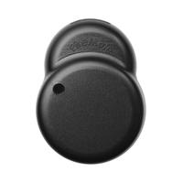Firemole was created through the opportunity that is needed today in this age to help with the problem of electronics heating up unnoticed and becoming fire hazard. This company saw the opportunity to manufacture a device which warns of rising temperatures from chargers and electronic devices and stop them becoming fire hazards.

The two colours this device is available in are white and black and this would be due to these being the universal colour of electronic devices which would blend the temperature sensor in with them. The design of the device is unknown and can only be speculated that it’s due to the battery and sensor being used.

# Feasibility of the Concept

The device created by Firemole took about 9 months to become a reality from idea to manufacturing. Firemole had a great deal of help with funds from cork city local enterprise who gave €15,000 of feasibility funds and Enterprise Ireland who gave an innovation voucher worth €5000. Firemole has social media presence on twitter, Facebook and Instagram with their highest amount of followers being 2k on twitter with Facebook and Instagram being at 1k which gives them not much of an audience.

Firemole sell their device on their website and can cost, between €13 to €9 depending on the quantity of devices being bought. This price is quiet expensive for a senor device that doesn’t have of yet a notification application. This device would seem to be a repeat purchase item and can only be used with one electronic device at a time with having replacements such as the lithium battery which lasts 18 months and adhesive pad.

# Who to invest in?

RASH’R and Cook + Cure would be the two companies to invest in with Firemole. These companies already have a global presence and have gathered a good amount of followers on social media.

Rash vests are going to be needed no matter what and this trendy and unique creation has put a new style on the market for water sport clothing. This company also doesn’t seem to have a problem financially as they have reduced the price in their rash vests and also are offering free shipping over €80 of products bought. This company also has the opportunity to expand into other water sport clothing such as wet suits or even outdoor activity sports.

Cook + Cure is also in talks of expanding although this was two years ago and the bump + bean app has yet to be on the market along with them missing out on android devices this application is a great idea that is in need globally and can help a lot with health problems. People will find an interest in this app as it will be based around them as an individual and also has the beneficial health factor.

Firemole is a great idea to start off with however it hasn’t been thought out fully it would seem. The device itself can only be used with one device at a time and if you want to change device the adhesive has to be undamaged or will have to be replaced. The device itself is a very awkward looking device and not universally designed. The cost of the device is too high that many people wouldn’t actually buy it. In modern day people own a lot of devices such as TV’s, Phones, Laptops, Tablets, Kitchen appliances etc. therefore if someone was actually serious about this they would buy one for each device but unfortunately the high cost is a turn down. Again Firemole is a great idea but has to be brainstormed more in order to improve the design and lower cost.

# References

<https://rashr.com/> - RASH’R web site

<https://www.instagram.com/teamrashr/> - RASH’R Instagram

<https://www.facebook.com/pg/TeamRashR/community/?ref=page_internal> - RASH’R Facebook

<https://cookandcure.com/the-blog/> - Cook + Cure Website

<https://www.facebook.com/cookandcure> - Cook + Cure Facebook

<https://www.instagram.com/cookandcure/> - Cook+ Cure Instagram

<https://firemole.com/> - Firemole web site

<https://www.instagram.com/firemoleltd/> - Firemole Instagram

<https://twitter.com/FiremoleLTD> - Firemole Twitter

<https://www.facebook.com/firemole/> - Firemole Facebook