**Student Name:** Dean Dolan

**Student Number:** x22104801

**Course Name:** Computing (BSCHIFSC2)

**GitHub link to repository:**

**Class Diagram:**  
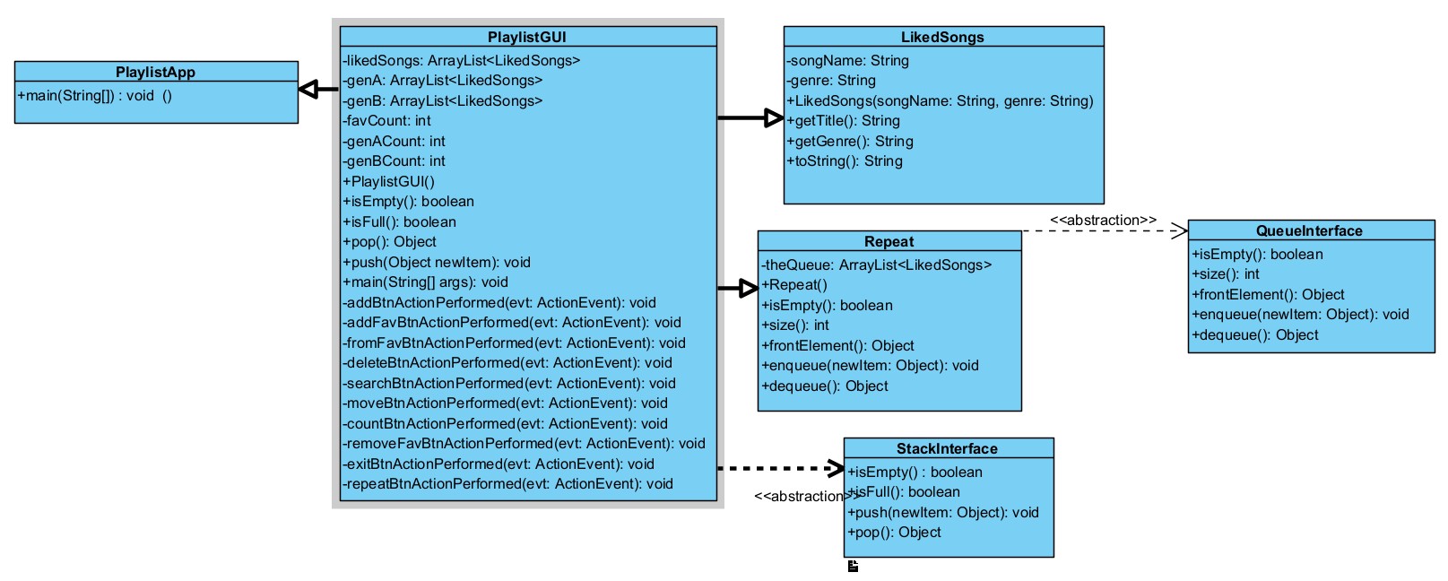

**Summary:**

In this project I have used a total of 3 Array Lists. I have also used the Stack Interface (ADT) in order to perform one of the tasks which was adding a song from “liked” (called Favourites in my project) playlist to another playlist. For this I followed the slides and solutions posted on Moodle and I had no real problems besides some syntax errors which were easily fixed. The stack ADT comes into play when you press the button labelled “Add Last From Favourites”.

For one of the tasks outlined in the brief, it was needed of us to give the user the capability to allow the user to repeat a playlist. For this I used the Queue Interface (ADT) which allowed me to enqueue and dequeue songs. The only real problem I had when carrying out this task was the message the system prints out which repeated the same message alongside each song name. I have yet to figure out the problem but because I could not start this project until Friday for personal reasons, I have sadly run out of time by the end. For the user to choose what playlist they want to repeat, they need to click the button labelled “Repeat Playlist”, and from there they will be giving several options (via JOptionPane.showInputDialog), where they can choose from the 3 playlists. This will then print out the songs within that playlist and also print the fact that they are set to repeat.

With the knowledge I gained of Array Lists from last semesters Object Orientated Programming module, I was able to easily implement an add, search and delete button which gives the user the capability to easily add and delete songs to a playlist, but also to search a song by it’s name (title) and the application is able to print out which exact playlist that song is located.

With many buttons for add and delete, I thought it would be best to add a counter for each playlist which will add 1 or minus 1 from the count so the system will understand how many songs are in each playlist. To display the song count for each playlist I have implemented a button labelled “Display Song Count” which does exactly that.

The biggest issue I have had with the project is the move button. The move button functions the way it should, by moving the songs to the next playlist, however, it is not printing correctly on screen for the user which was the plan.

Once I had functionality working for majority of the project, I did some styling to a black and white design. I also made sure to test every button thoroughly so if you try to test it by leaving blanks or invalid inputs, you will receive appropriate messages printed out.