Unit 8 Assignment

**ANLY:520-51 (Fall 2016)**

Dean D’souza

H.U. ID: 168424

# **Solutions:**

1. **Consider the sentence** *Kim arrived or Dana left and everyone cheered***. Write down the parenthesized forms to show the relative scope of** *and* **and** *or***. Generate tree structures corresponding to both of these interpretations.**

The parenthesized forms are as follows:

For scope of and: Kim arrived or (NP Dana left and everyone cheered.)

For scope of or: (NP Kim arrived or Dana left) and everyone cheered.

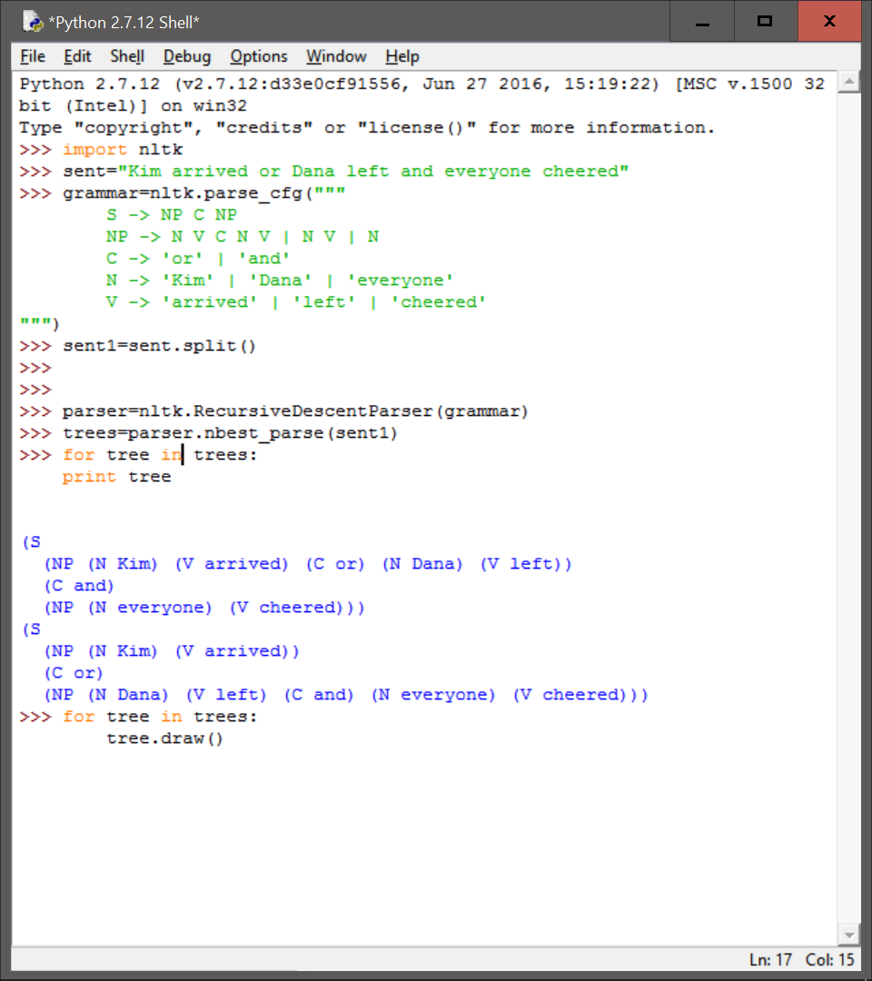

We generate the tree structures as follows:

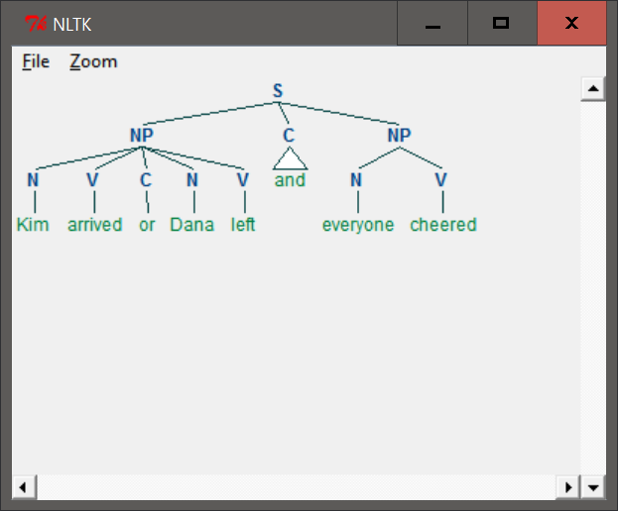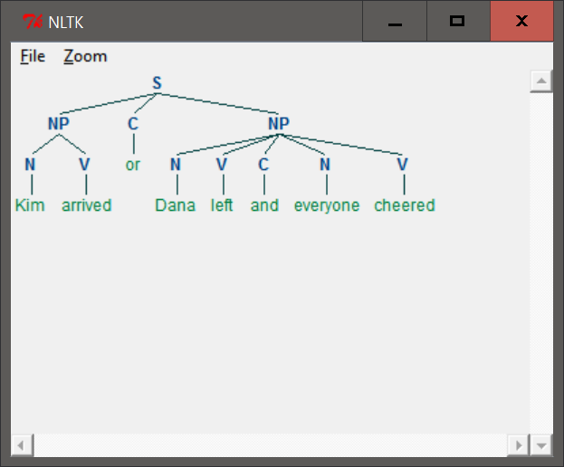

1. **The Tree class implements a variety of other useful methods. See the Tree help documentation for more details, i.e. import the Tree class and then type help(Tree).**

We perform the commands as follows (the entire output is not shown so as to save space):

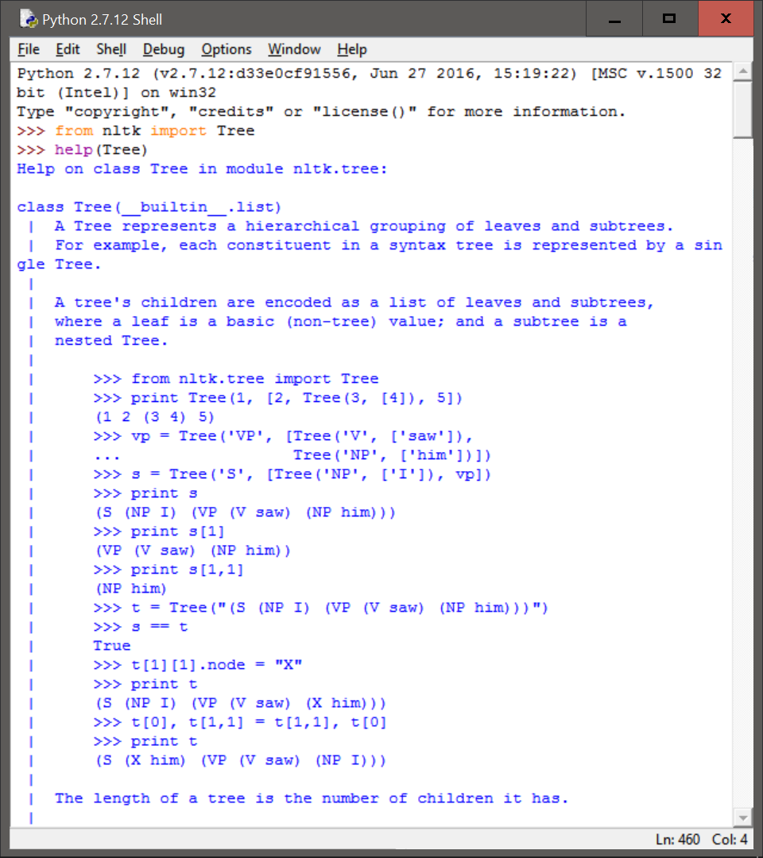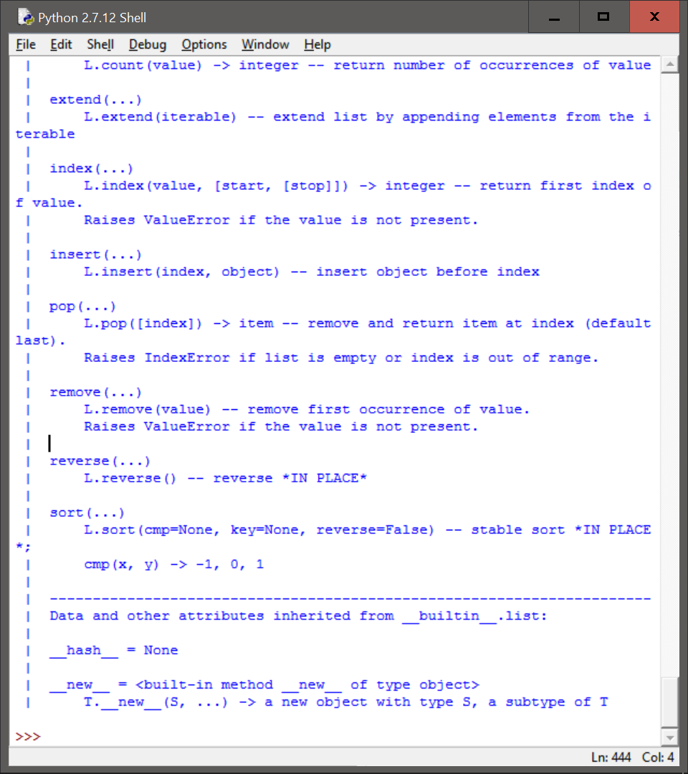

1. **In this exercise, you will manually construct some parse trees.**
2. **Write code to produce two trees, one for each reading of the phrase** *old men and women***.**

We perform the required commands as follows:

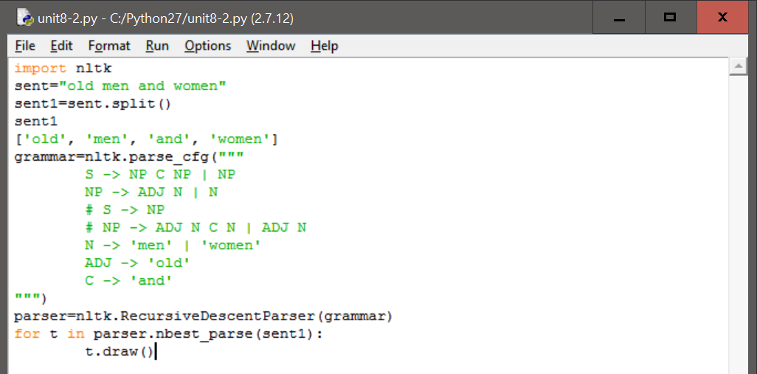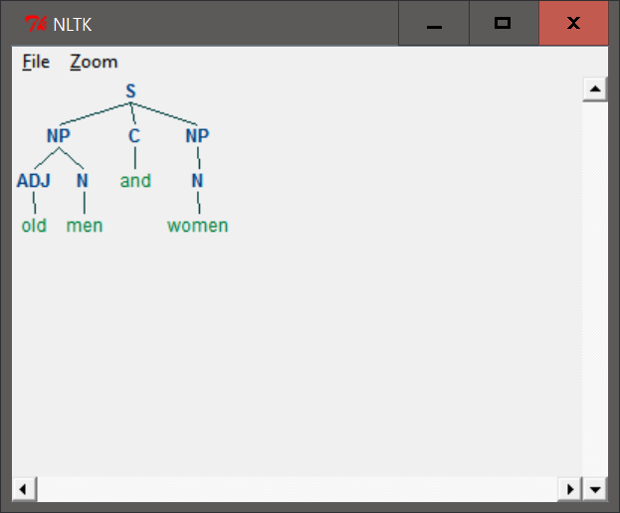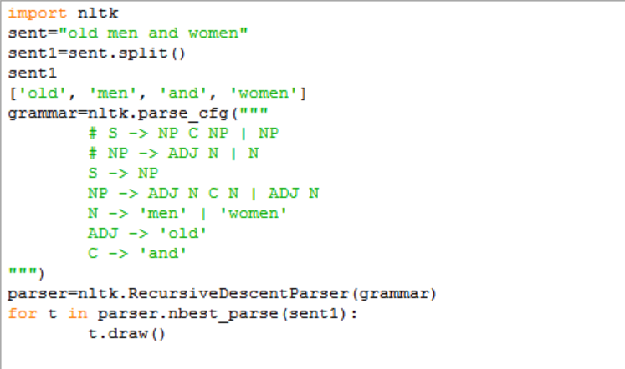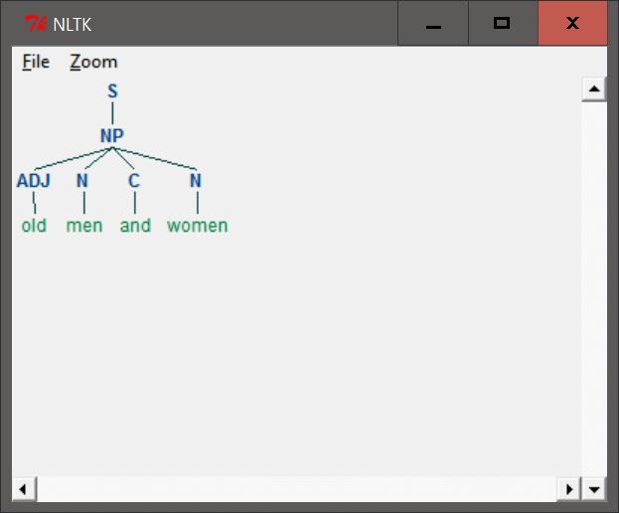

1. **Encode any of the trees presented in this chapter as a labeled bracketing and use nltk.Tree() to check that it is well-formed. Now use draw() to display the tree.**

We perform the required commands as follows:

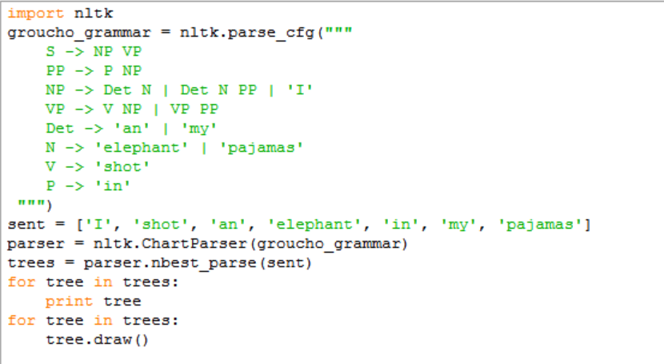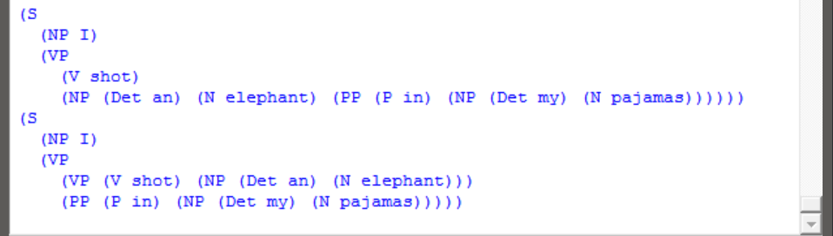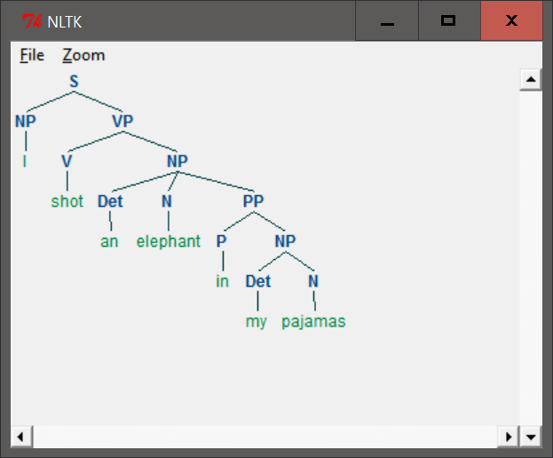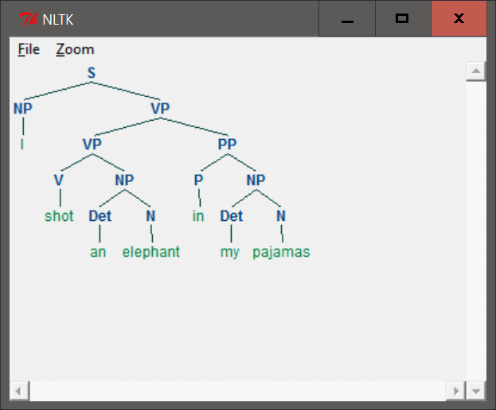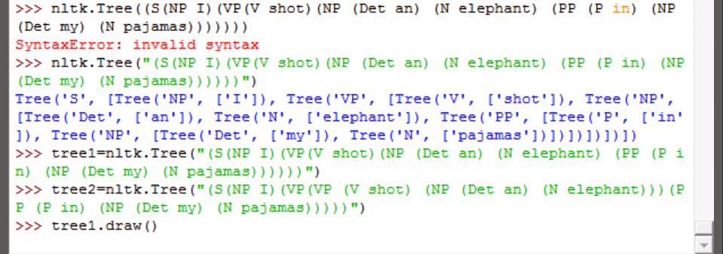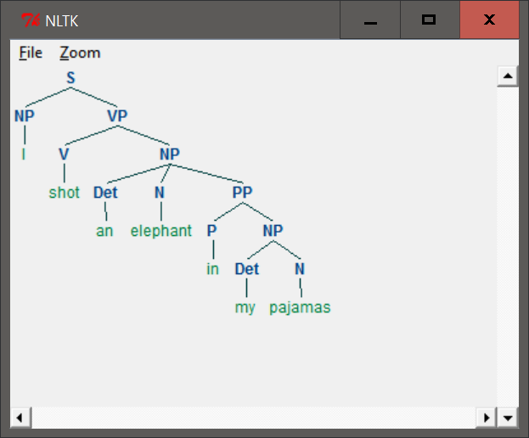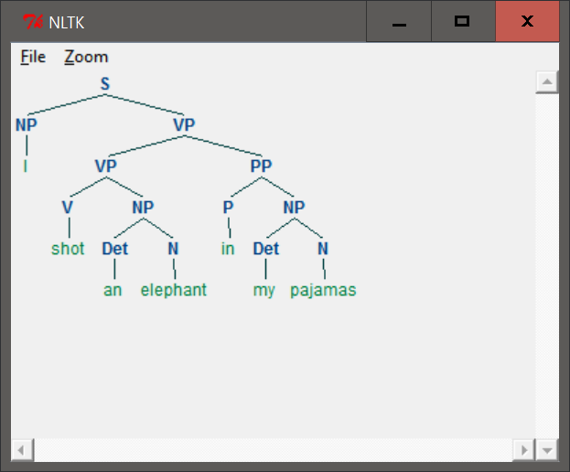

1. **As in (a) above, draw a tree for** *The woman saw a man last Thursday***.**

We draw the tree as follows:

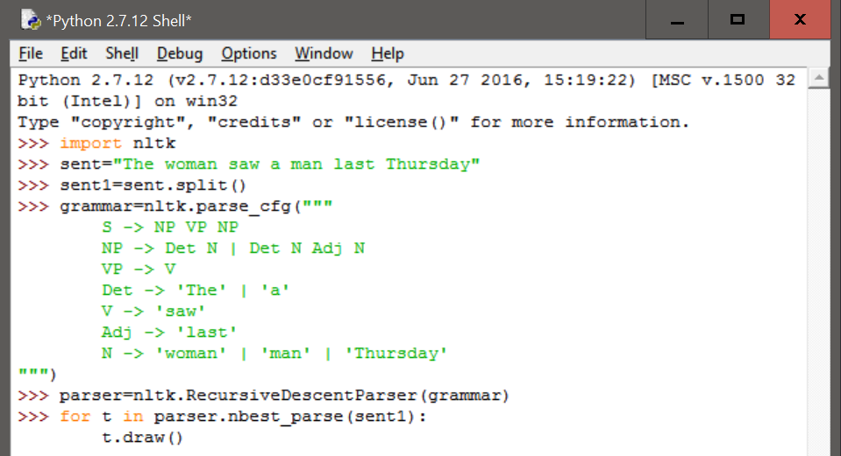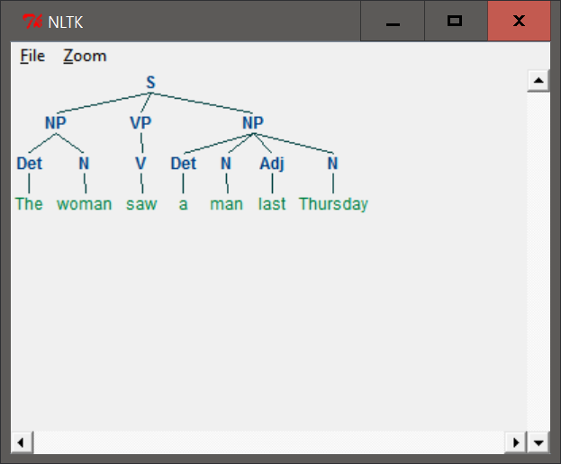

1. **Analyze the A.A. Milne sentence about Piglet, by underlining all the sentences it contains then replacing these with S (e.g. the first sentence becomes S when:lx` S). Draw a tree structure for this "compressed" sentence. What are the main syntactic constructions used for building such a long sentence?**

We analyzed the sentence as follows:

In after-years he liked to think that he had been in Very Great Danger during the Terrible Flood, but the only danger he had really been in was the last half-hour of his imprisonment, when Owl, who had just flown up, sat on a branch of his tree to comfort him, and told him a very long story about an aunt who had once laid a seagull's egg by mistake, and the story went on and on, rather like this sentence, until Piglet who was listening out of his window without much hope, went to sleep quietly and naturally, slipping slowly out of the window towards the water until he was only hanging on by his toes, at which moment, luckily, a sudden loud squawk from Owl, which was really part of the story, being what his aunt said, woke the Piglet up and just gave him time to jerk himself back into safety and say, "How interesting, and did she?" when — well, you can imagine his joy when at last he saw the good ship, Brain of Pooh (Captain, C. Robin; 1st Mate, P. Bear) coming over the sea to rescue him...

We construct the compressed tree structure as follows:

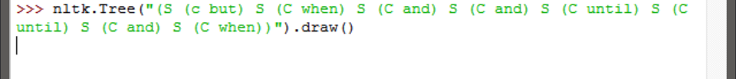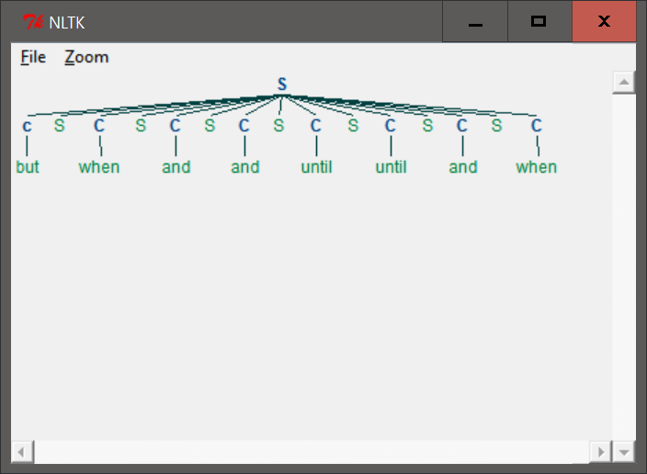

The main syntactic constructions used to make such long sentences include the use of a number of conjunctions.

1. **In the recursive descent parser demo, experiment with changing the sentence to be parsed by selecting Edit Text in the Edit menu.**

We change the sentences as follows (the first is the default sentence and the last sentence was unable to be matched):

