Unit 9 Assignment

**ANLY:520-51 (Fall 2016)**

Dean D’souza

H.U. ID: 168424

# **Solutions:**

1. **What constraints are required to correctly parse word sequences like I am happy and she is happy but not *you is happy or *they am happy? Implement two solutions for the present tense paradigm of the verb be in English, first taking Grammar (8) as your starting point, and then taking Grammar (20) as the starting point.**

The constraints that need to be put on the grammar include ensuring that the correct form of the verb is used based off the subject (in the examples case a personal pronoun), namely for he and she we would use ‘is’ while for they and you we would use ‘are’ and for I we would use ‘am’.

We demonstrate the examples as follows:

1. Using (8) from the textbook we have:

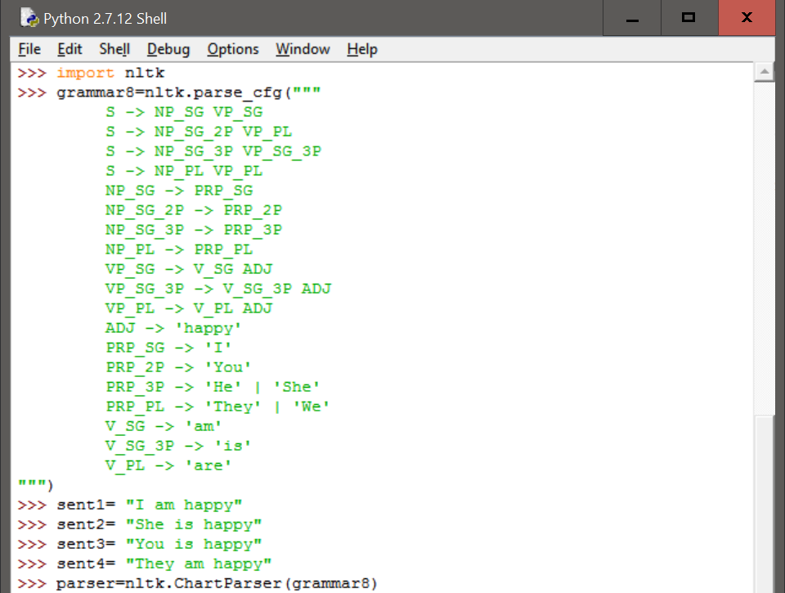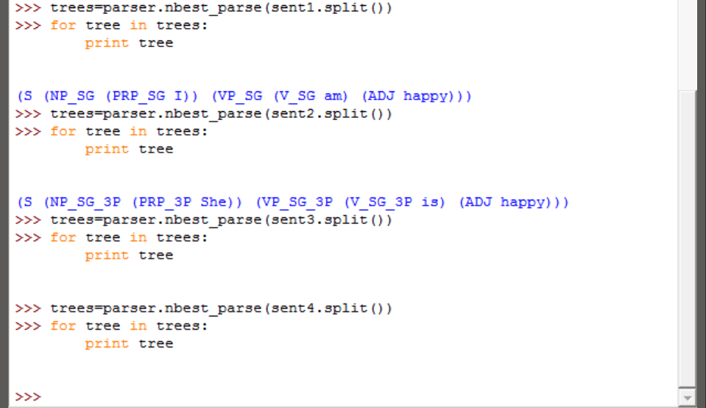

1. Using (20) from the textbook we have (due to problems in parsing the grammar as a string using nltk 2.0.4, nltk was upgraded to 3.2.1, additionally load_parser could not be used due to a number of errors and so the FeatureEarleyChartParser was used):

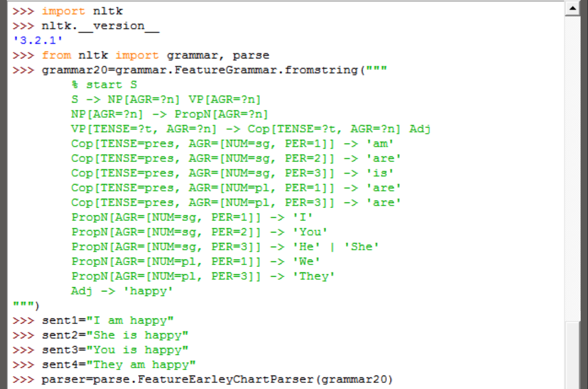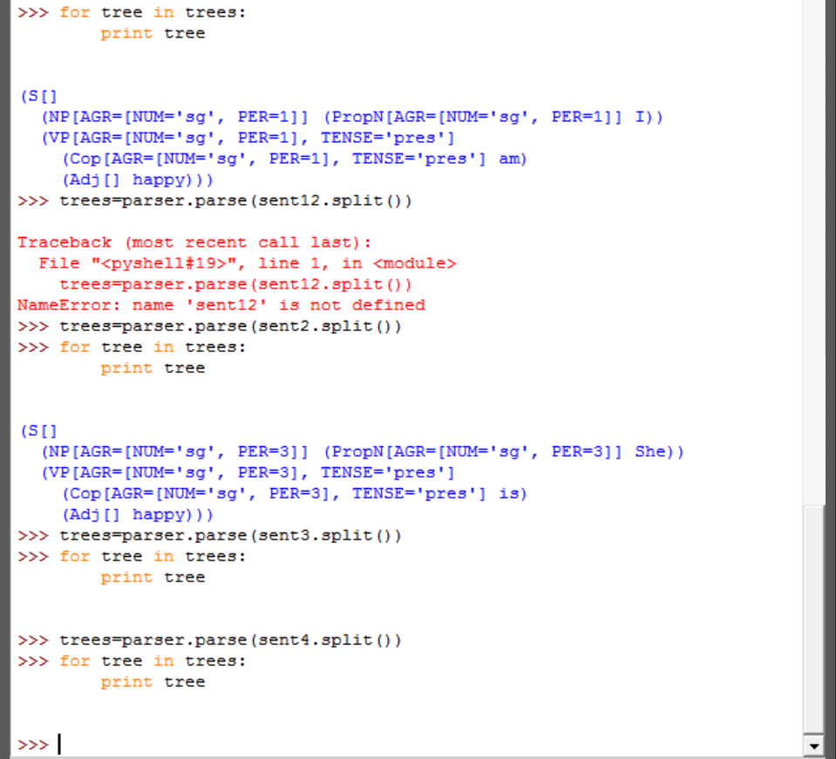

1. **Develop a variant of grammar in 9.1 that uses a feature count to make the distinctions shown below:**

**(56)**

**a. The boy sings.**

**b. *Boy sings.**

**(57)**

**a. The boys sing.**

**b. Boys sing.**

**(58)**

**a. The boys sing.**

**b. Boys sing.**

**(59)**

**a. The water is precious.**

**b. Water is precious.**

We develop the grammar and provide the examples as follows:

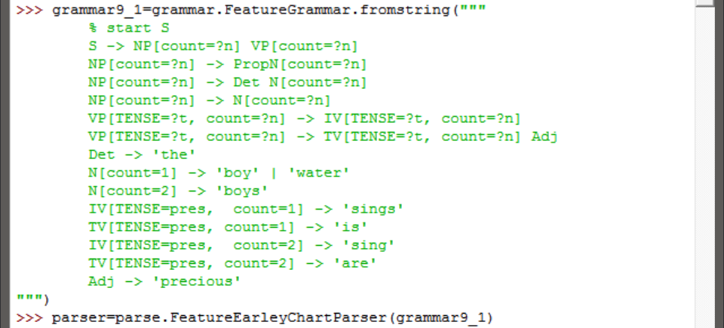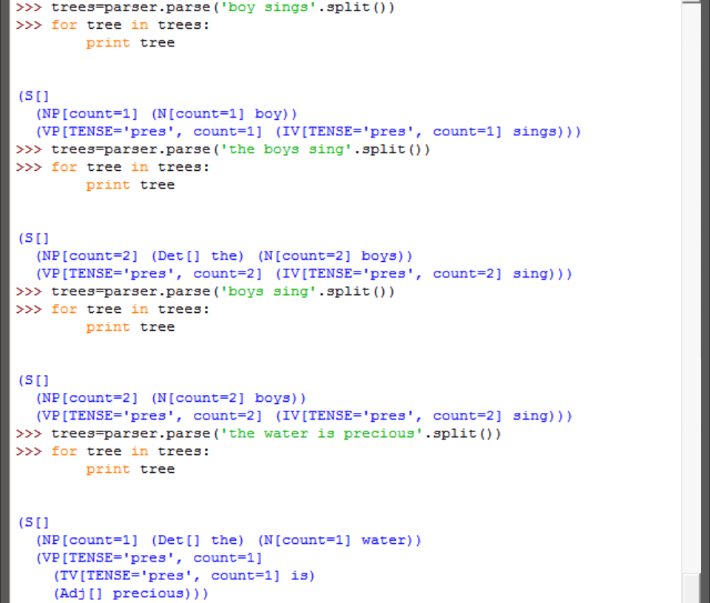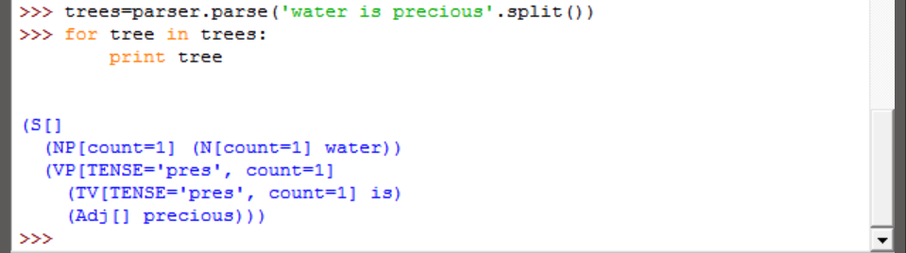

1. **Write a function subsumes() which holds of two feature structures fs1 and fs2 just in case fs1 subsumes fs2.**

The function is defined and implemented as follows (it should be noted that the understanding of the question is that, for two feature sets, the function should return true if fs0 subsumes fs1):

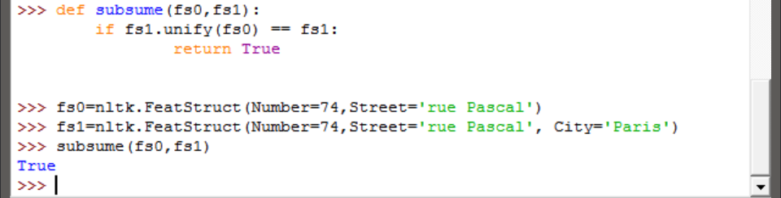

1. **Modify the grammar illustrated in (30) to incorporate a bar feature for dealing with phrasal projections.**

We modify the grammar in (30) of the text book as required and show an example as follows:

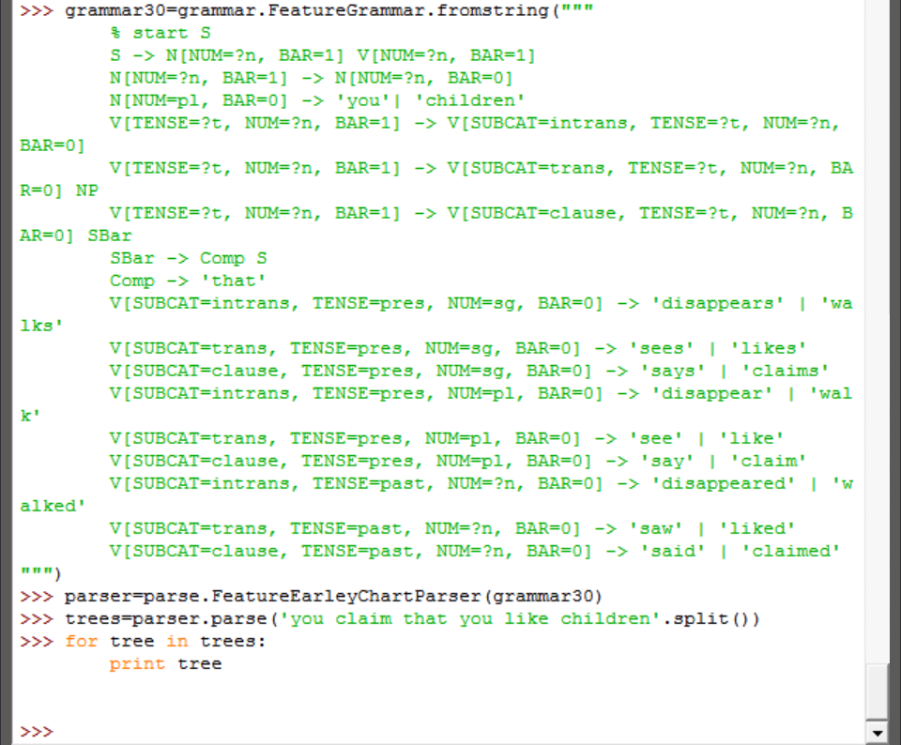

However, no output was obtained which indicates that the grammar may not have been modified correctly. (I wasn’t able to see what was wrong as such)

1. **Modify the German grammar in 9.5 to incorporate the treatment of subcategorization presented in 9.3.**

We modify the grammar shown in section 9.5 of the text book as follows:

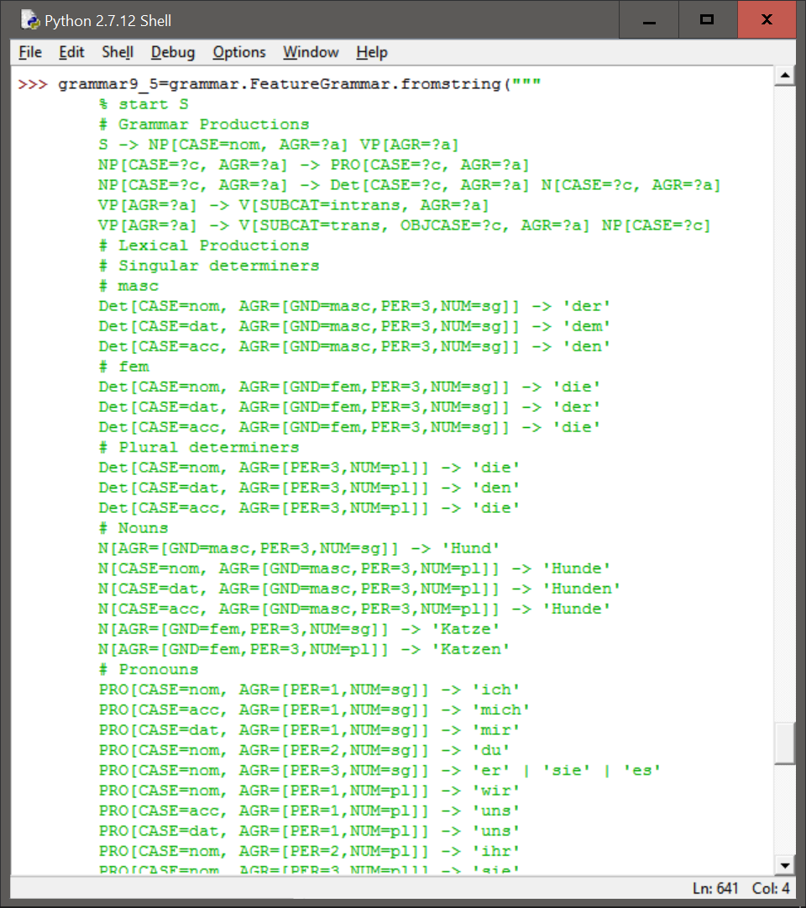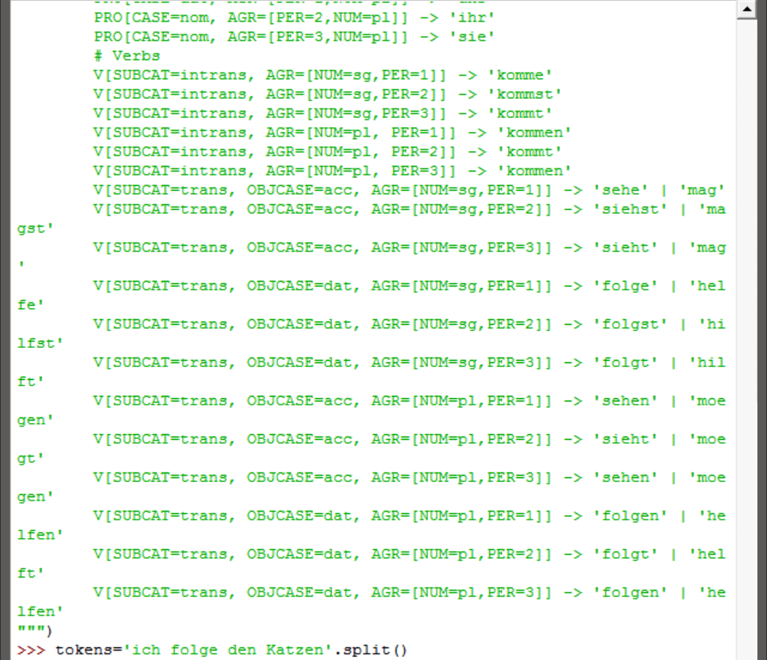

An example of its functioning is shown as follows:

