**Assignment 05**

Hands-on: Feature Selection

**Name: Dean D’souza**

**H.U. ID: 168424**

# Solutions:

**Consider the training example shown in the table below:**

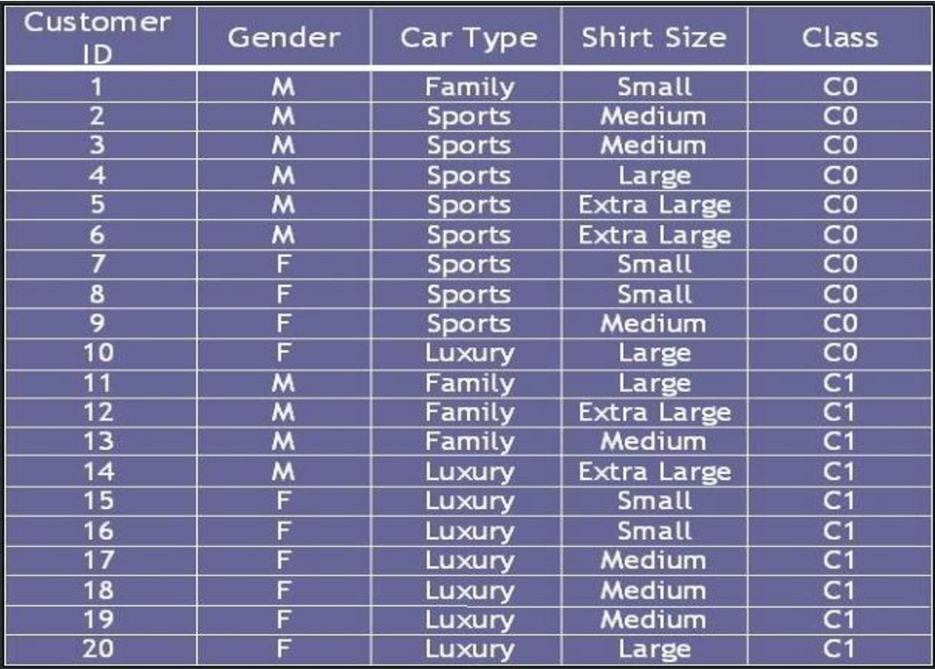

**a) Compute the Gini index for the overall collection of the training examples.**

**b) Compute the Gini index for the Customer ID attribute.**

**c) Compute the Gini index for the Gender attribute.**

**d) Compute the Gini index for the car type attribute using multiway split.**

**e) Compute the Gini index for the Shirt Size attribute using multiway split.**

**f) Which attribute is better, Gender, Car Type, or Shirt Size?**

**g) Explain why customer ID should not be used as the attribute test condition even though it has the lowest Gini.**