**Assignment 06**

Hands on Frequent Pattern Mining

**Name: Dean D’souza**

**H.U. ID: 168424**

# Solutions:

**Consider the following transaction database:**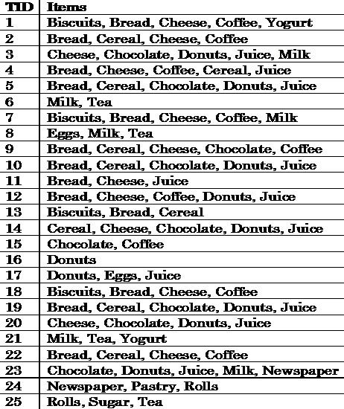

1. **Use the *Apriori algorithm* to find the frequent itemsets in D.**
2. **Extract all the strong association rules (has min conf say, 70%)**