Text-messaging format of Digital Storytelling

**ISEM:502_51 Human-Centered Design – Perspectives and Methods**

Dr. Tamara Peyton

Professor, Human Centered Design- Perspective and Methods,

Harrisburg University of Science and Technology

[Tpeyton@my.harrisburgu.edu](mailto:Tpeyton@my.harrisburgu.edu)

Dean Philip D’souza

Student, Harrisburg University of Science and Technology

[Dpdsouza@my.harrisburgu.edu](mailto:Dpdsouza@my.harrisburgu.edu)

Submission Date: 03/16/2017

# Abstract

Storytelling is an ancient art which has evolved over time due to technological advances. It has taken a new form known as ‘Digital Storytelling’ which combines text, images, audio, and video along with a narration. Digital Storytelling is also changing and various combinations of text and media exist that tells the stories of individuals and of history. This paper looks at a form of Digital Storytelling which uses a text-messaging based format, and can be seen in applications such as Hooked-Chat Stories, Amazon Rapids, and Lifeline. This paper tries to find the best features of each and how Human Centered Design is used in them.

*Keywords: Digital Storytelling, Human Centered Design, Text-messaging*

# Introduction

‘Digital Storytelling’ is a term used to describe the practice of using digital tools to tell ‘stories’. It involves the use of technical tools such as digital images, graphics, digital audio, and digital video to narrate a story on varied subjects which may be personal, political, fantasy, etc. taking the form of web-based stories, interactive stories, narrative computer games, etc.

Wikipedia gives an alternative definition for Digital Storytelling as “the process by which diverse people share their life story and creative imaginings with others” [1].

Digital storytelling can be thought of as an evolution of the ancient art of storytelling, which came about because of technological development which made media production techniques, hardware, and software more accessible and easy to use. The constant development of media sharing platforms such as YouTube, Vimeo, etc. have also contributed towards making such stories easy to share and in producing competition between storytellers to produce engaging and quality content.

One of the first models of Digital Storytelling took the form of a documentary ‘The Civil War’, by Ken Burns, which used first-person accounts, narration, archival images, modern cinematography, and music to depict the heart and emotions behind the American Civil War. This methodology was later refined by Dana Atchley at the American Film Institute to create ‘Short narrated films’ in 1993 [1] and was further refined by Joe Lambert in the mid-1990s as a method of training by the San Francisco Bay Area-based Center for Digital Storytelling [1].

Digital stories were usually the product of intensive workshops which resulted in short films that would combine narrated pieces of personal writing, images (both photographic and still images) along with a musical soundtrack. A variety of television channels would then go on to use these techniques as a means of entertainment and education of the masses.

Recent developments on technology and ways in which most people access media has changed the landscape and nature of how such stories are told, but the basic characteristics of most digital stories remains the same, in that they do not conform to the traditional conventions of storytelling as they can combine still imagery, sound and text for their narratives and can further include aspects of being non-linear and have interactive features.

Many of the more modern forms of digital stories now take the form of short videos and films, interactive presentations, interactive websites, and applications which can be easily viewed on any personal computer or laptop. However, with the advances in technology, consumers are actively moving on from using their personal computers or laptops as their primary platform of media consumption, towards smartphones, which have the capability of providing access to media on the go and from almost anywhere in the world.

Smartphone usage has especially increased with improvements in the development of manufacturing techniques and processes which have resulted in faster mobile CPUs, larger memory capacities, audio output improvements and display improvements. Operating systems and applications for these devices have also seen significant improvements in the last decade, which has resulted in smartphones acting as tiny computers or laptops on their own.

While the target audience for most of the Digital Storytelling platforms (such as YouTube) have remained the same, and while traditional means of Digital Storytelling remains relevant, new methods of interaction and hence, new evolutions of Digital Storytelling are required to be more palatable to the new generation of Digital Story consumers.

# Importance of Storytelling

Digital storytelling is actively being used as a tool in various fields, especially in education, for a variety of purposes that extend from building engagement and multimedia literacy in education to being a means of communication between developers and customers to obtain feedback about the market potential of products.

Some of the more active fields of use are as follows:

1. Education

Education is probably the most important field (other than entertainment) where Digital Storytelling forms and practices are being given increasing importance. It is also one of the fields which has had ties with storytelling since more than a millennium. Before there existed writing systems, storytelling was the only tool available for communities to pass down their beliefs, traditions, and experiences.

Students could improve their learning through the five stages of storytelling, namely story finding, story telling, story expanding, story processing and story reconstruction []. While storytelling has always been an instructional tool in education, Digital Storytelling has provided a new means of facilitating the convergence of four student-centered learning strategies, i.e., “student engagement, reflection for deeper learning, project-based learning, and the effective integration of technology into instruction” [2].

Varied use of Digital Storytelling techniques at the different education levels can improve the learning outcomes, such as the use of vibrant pictures, age-appropriate music and narration with subtitles in short videos or presentations at the primary grade level can result in improved vocabulary and understanding of abstract or layered concepts.

Many studies have been conducted into the use of Digital Storytelling in education, as a tool used by the students as well, which have resulted in positive results which included improved engagement and participation of students as well as improved teacher student relations [2].

A few teachers have also adopted Digital Storytelling on the mobile platform, to create a collaborative environment where both teachers and students create short digital stories without the need of expensive editing software.

1. Museums and Libraries

A few libraries around the world have begun to create public spaces for people to create digital stories in the form of digital story stations. These stations are created with the purpose of encouraging people to archive oral stories from a public perspective and includes oral stories focused on personal experience and incidents describing a place or witnessing an event. Bilingual library staff further edit these stories to include video, audio, and images, to be made available to the public in a more presentable and engaging format [1].

Many museums around the world are also integrating technology with their exhibits to tell stories of the exhibit items in an interactive manner. While some museums have, interactive displays used to tell the story of the exhibit item they are viewing, other museums have developed applications that places visitors in the shoes of characters from another time to solve mysteries, such as the application developed for The Metropolitan Museum of Art, which encourages visitors to interact with most of the displays through their smartphone for catching a killer.

1. Business

Businesses actively implement Digital Storytelling in marketing, and utilize it as a tool of user-generated content, so that consumers can give their opinions based on their own experiences. Along with big businesses, startups also use Digital Storytelling to pitch their ideas to investors and to communicate with future potential customers about their product and to obtain feedback from these customers.

1. Entertainment

Digital Storytelling is an important part of entertainment industry, particularly with platforms such as YouTube, Vimeo, etc. Every day, thousands of content creators upload digital stories to these platforms, which are viewed by thousands (and sometime millions) of users around the world. These stories range over a variety of subjects, and have a variety of formats such as short films, interactive stories, podcasts, etc.

# Smartphone Storytelling

Smartphones have become an essential part of the daily life of the average human being. Whether it’s communicating with friends through Facebook, Instagram or any other such app, or booking tickets for an event through apps such as Eventbrite, or finding a quick route to work, smartphones are being constantly used in one way or the other.

While websites such as YouTube and Vimeo have their own applications across the various smartphone Operating Systems of Android, IOS and Windows, they provide the same form of interaction as would be expected with their website counterparts and, for the most part, do not actively engage users on these devices.

However, there are a few applications that have come up with innovative ways for leveraging smartphone capabilities and the habits that are formed with their continued usage. To do so, they employ a text-messaging format of storytelling with some having interactive elements.

## Evaluation Parameters

The applications that are analyzed in this paper are evaluated based on the following parameters:

1. Usability: A general analysis of the User interface and its ease of use
2. Overall Design: An analysis into the overall design and whether it achieves its goal
3. Usefulness: Does the application perform what it set out to do? Does it take into account user emotions and needs?

## Applications

It should be noted that the samples of these applications were taken on the android platform and they might vary from IOS and windows versions.

1. **Hooked-Chat Stories**

Hooked is an innovative mobile application that takes a text messaging based approach to storytelling. Aimed at the millennials or the ‘snapchat generation’, hooked provides a platform on which several stories from various genres can be read in short bursts.

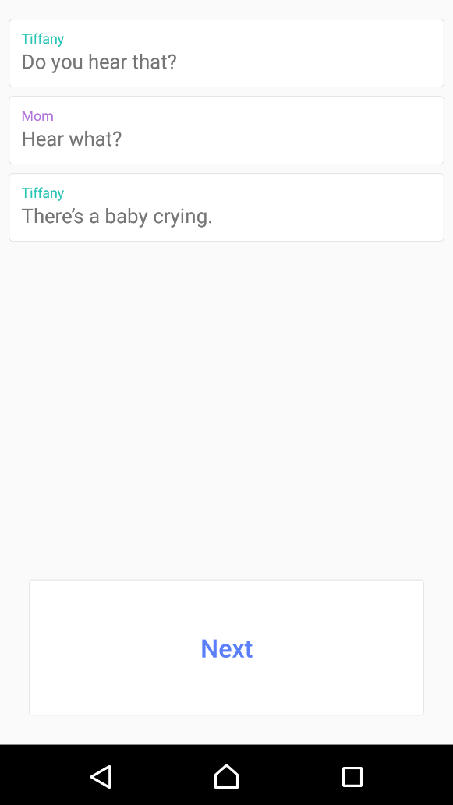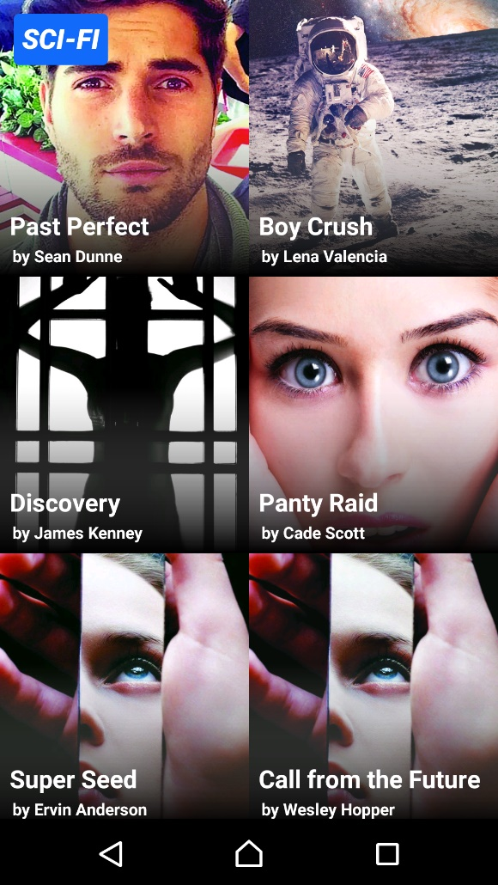

Figure 1 Hooked-Chat Stories Interface

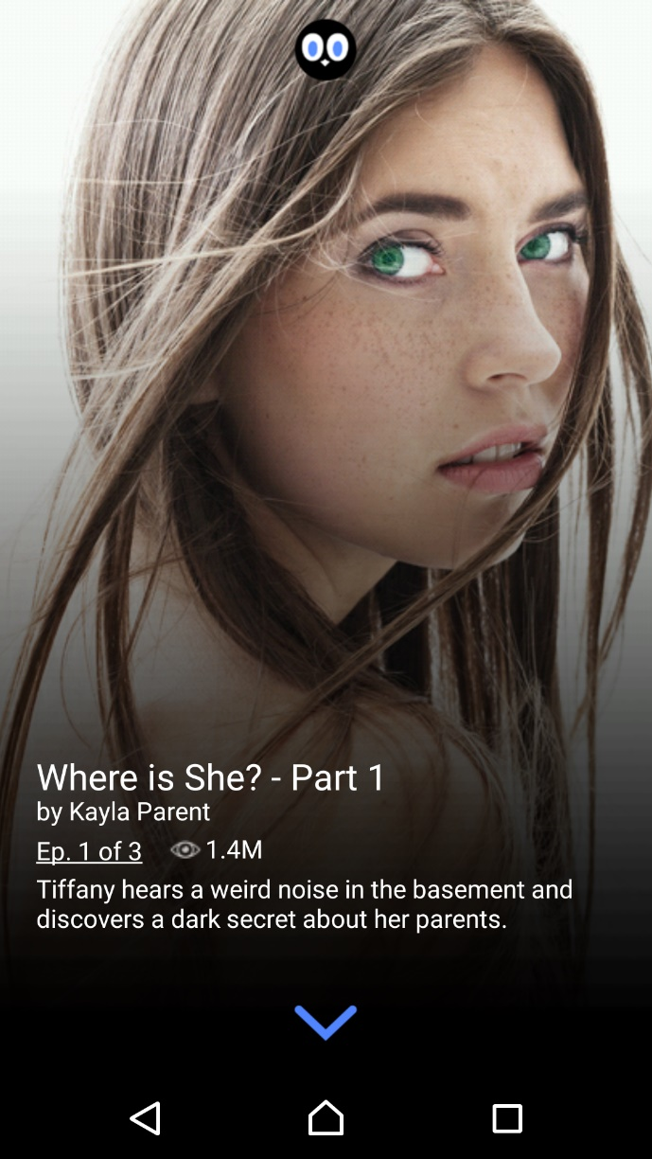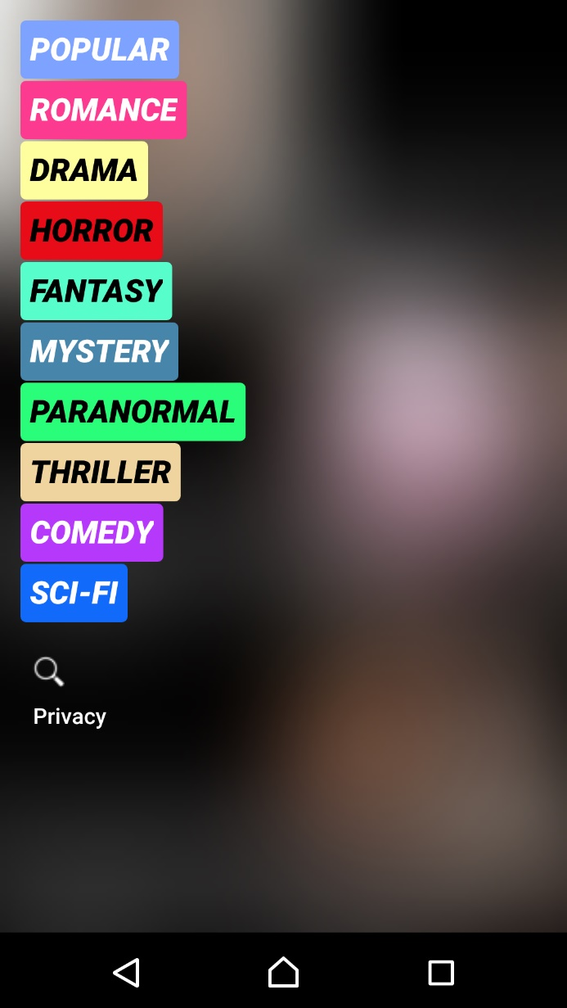

Figure 2 Hooked Chat Stories Interface continued

*Usability:* Hooked provides a very simple interface from the get go. After starting the application, it immediately starts the narration for one of the most popular stories. The narration is quite simple and all the user must do is keep clicking the ‘Next’ button at the bottom of the screen to go to the next message. If the user wants a full list of stories or wants to change stories, they need to swipe right which brings up the back button and the story title.

Once at the story selection screen, the user can see several stories with an associated picture to give the user an idea of the nature of the story. A small icon at the top of the screen allows to switch between genres.

*Overall Design:* The interface design consists of a simple white background on which text messages appear in white boxes with different colors for the different story characters. While it is easy to move through a narration by simply clicking the next button, the only feedback that one gets are the next textbox appearing. Switching stories is not evident from the start and only after swiping all possible ways does the dropdown bar with the story name and back button appear, this could create some confusion and if the dropdown doesn’t appear then it could lead to a lot of frustration for the user.

Once at the story selection screen it is not evident that clicking on the hooked icon will lead to the genre selection page. The application gives no clear indication or tutorial on how to perform these tasks.

A search icon is present near the privacy link, and often, attempts to click the icon just results in being redirected to the privacy policy screen. There are no clear indicators on how to create stories as well.

*Usefulness:* The application provides a nice platform on which stories can be easily narrated in text messaging based format. Depending on the type of user subscription, the application also provides friendly reminders that more of the story can be viewed. The application provides a simple means of entertainment for users on the go and the content posted by users also seems to get better and better as the library is expanded. However, frustrations can be encountered while attempting to navigate through the application.

1. **Amazon Rapids**

Amazon rapids is like hooked in that it presents stories in a text-messaging based format. The difference is that this application is aimed to get younger audiences (particularly children between the ages of 5-12) to be more interested in reading and be more accessible to their needs. Users can choose from a variety of genres and the application presents its content with a variety of colors.

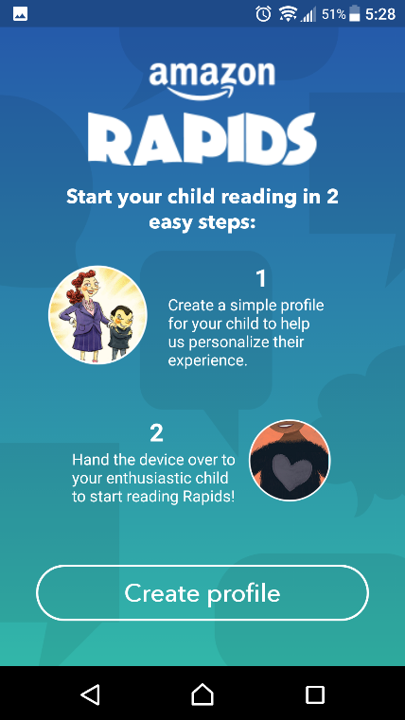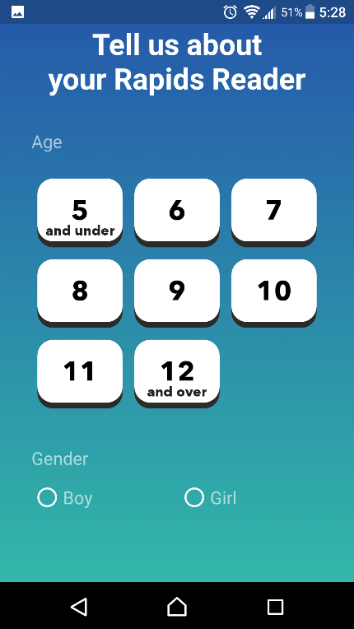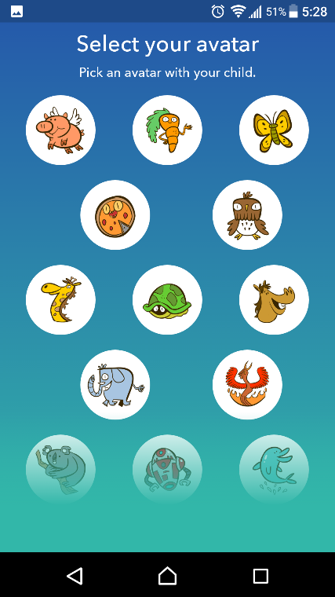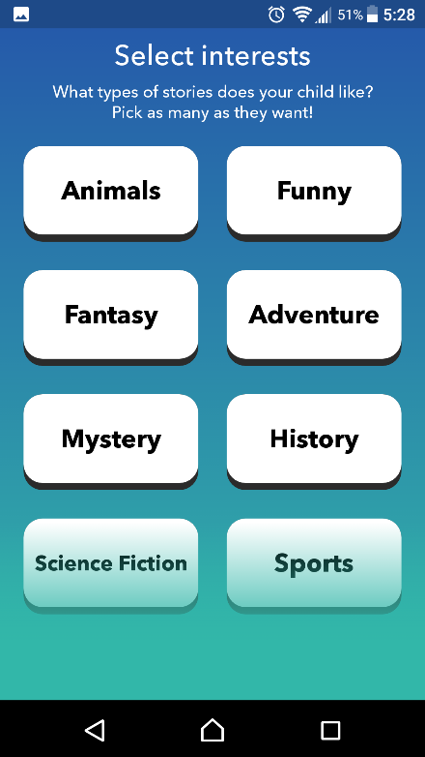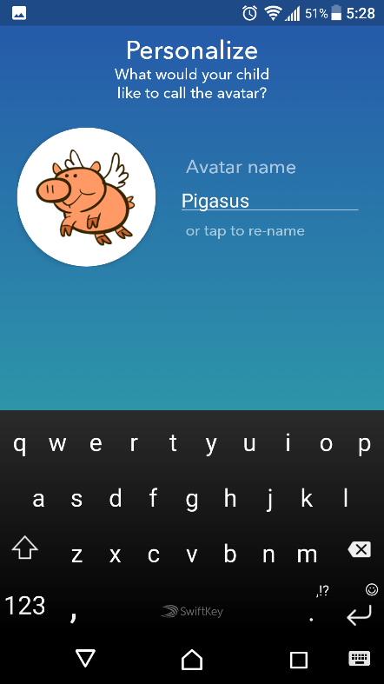

Figure 3 Amazon Rapids Interface

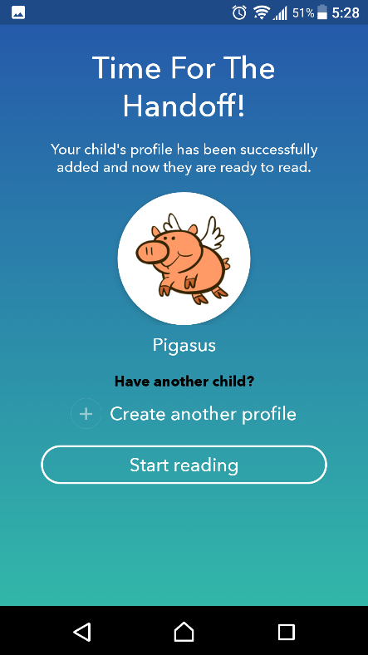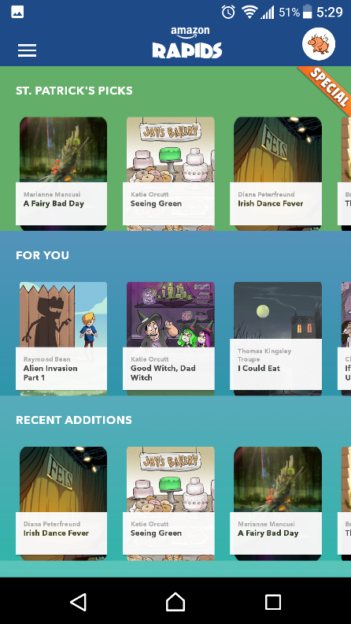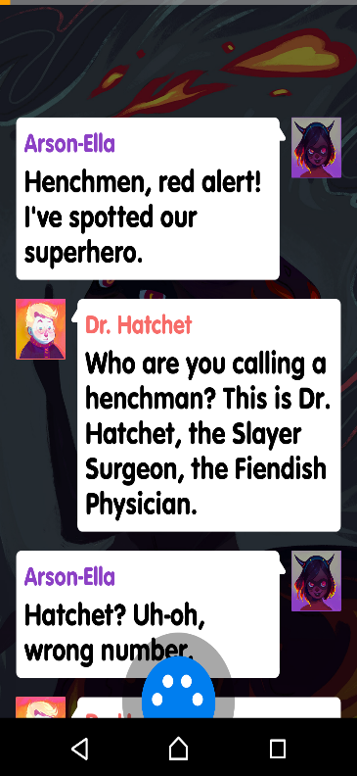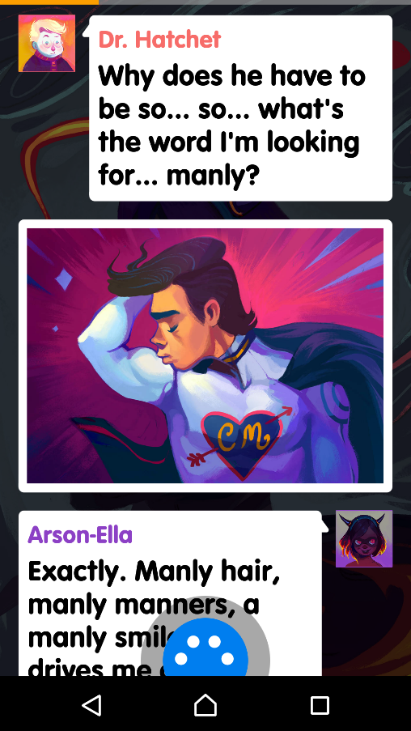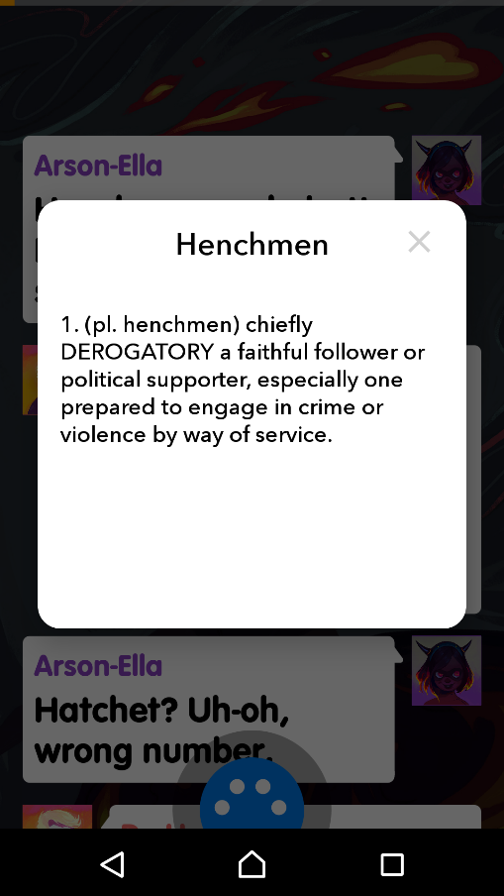

Figure 4 Amazon Rapids Interface continued

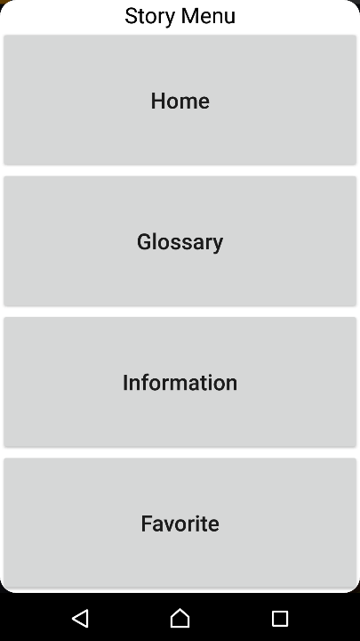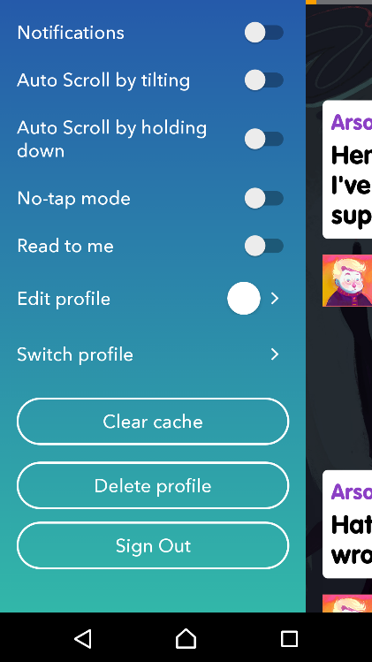

Figure 5 Amazon Rapids Interface continued

*Usability:* The application starts off with having to log in after which the application guides you through the process of creating a profile (as can be seen in the images above). After selecting the age of user and the interests the application gives the user the option to choose one of many cartoony avatars and further customizing the name of the avatar. Once the profile is created, the application presents a list of all books with clear indications of which genre they belong to. After selecting a book the user need only tap the screen to bring up the next message or click on a word to find out its meaning. The user is also provided with a button at the bottom which brings up the options to go back to the homepage, to check words in a user created glossary, information on the book and the option to favorite the book. Swiping from the right also brings up several useful options.

*Overall Design:* The application provides an easy to navigate interface with conventional indicators placed appropriately. The UI also tries to consider that most readers would have smaller fingers and made the methods for returning to the homepage from a story relatively accessible. The bright colors and use of cartoony avatars for the user as well as during narration also provides for a more attractive interface for the target audience of children.

*Usefulness:* The application provides a good platform to get children more interested in reading. The structure of the narration in a text-messaging format with colorful backgrounds, avatars, and the inclusion of images to further help in imagining scenarios helps to keep children interested and engaged. The ability to long press on a word to obtain its definition which can then be added to a self-customized glossary also helps in developing the vocabulary of the target audience. The options provided in the settings also provide sufficient customization to prevent irritation when installed on a parent’s device while also encouraging the user to read more when installed on a child’s device.

1. **Lifeline**

Lifeline is a single-story narrative that tells the story of an astronaut stranded on a distant planet with the user being the only person he can communicate with. The user must guide the astronaut on what to do and help him survive till he is rescued.

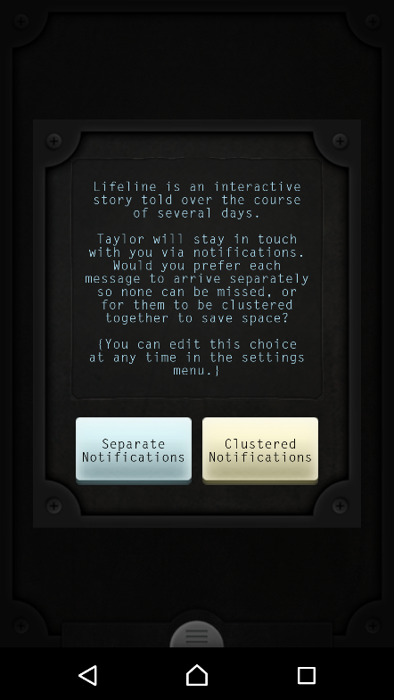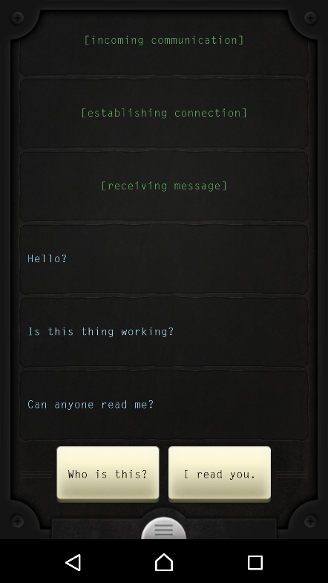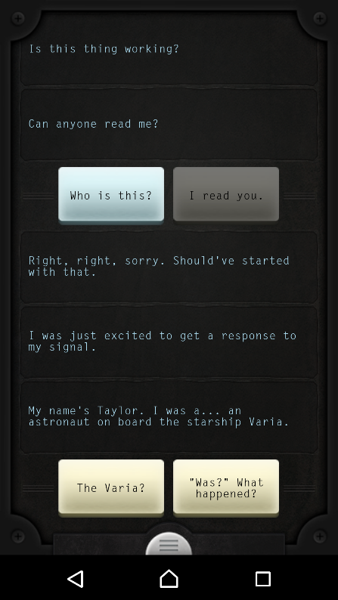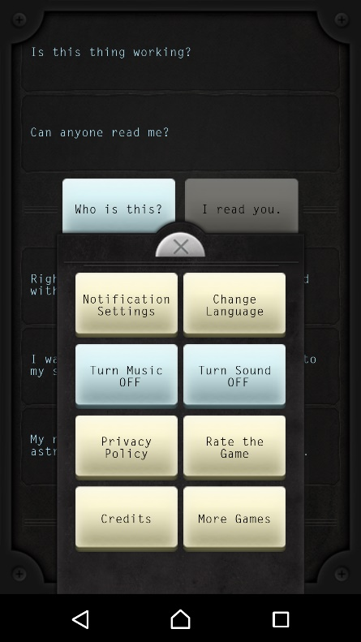

Figure 6 Lifeline Interface

*Usability:* The user interface of lifeline is very simple. The application starts by emulating a connection followed by a few messages from the astronaut. The user is given choices on what to respond as clearly marked buttons and the options provided help to simulate a normal conversation effectively.

*Overall Design:* The user interface of the application is quite simple and has a dark background on which legible text appears. The buttons for the responses are also clear and gives feedback in the form of greying out the button after a pressed down animation and continuing the narration. The semicircular button at the bottom of the screen brings up a popup menu of options to change various settings.

*Usefulness:* The application provides an effective narration of the story it depicts. The dark background and the background music sets up an atmosphere which effectively communicates the theme of the application and the variation of the music also helps give a sense of urgency or calm depending on the situation depicted in the narration. The options provided in the settings also provides sufficient options which considers that the user may not want to be disturbed by notifications. At the same time, having the notifications on helps emulate a real-time text messaging system as notifications take time to appear depending on the situation (such as a communication after an hour of walking). The atmosphere created by the combination of the background music, real-time messages and the change in narration depending on the responses by the user creates a sense of having an emotional connection with the fictional astronaut.

# Conclusions

Digital storytelling has evolved over the years into creative applications which can keep the user engaged for a long time. While traditional storytelling methods and forms are still relevant and work well over all platforms, storytelling on smartphones have evolved to consider user needs and constraints.

Applications such as Hooked-Chat Stories provides a convenient means for story tellers and readers to easily access stories in a relatable and attractive format. The use of the text-messaging format makes it easier for users to read stories in short bursts in a variety of places. However, it is much more suited for a mature audience.

Applications such as Amazon Rapids are more suited for younger audiences and provides a good template on which educational applications of similar formats can be built. The inclusion of profile customization and the option to favorite books helps to create an emotional bond with the books in the favorites library. The ability to get the meaning of a word by long pressing also helps to improve vocabulary and gives a more understandable format of usage.

Applications such as lifeline on the other hand, provides a truly interactive experience that invokes an emotional bond with the fictional character of the astronaut as the story progresses, making the user think carefully of which option they should choose as a response.

While all the mentioned applications perform their tasks well, important features of each can be incorporated into the others to create a more meaningful user experience that can invoke emotions in the users effectively.

# References

[1] Wikipedia, “Digital Storytelling”, last modified: 1st February 2017, Available at: <https://en.wikipedia.org/wiki/Digital_storytelling>

[2] Shuyan Wang, Hong Zhan, “Enhancing Teaching and Learning with Digital Storytelling”, International Journal of Information and Communication Technology Education, 6(2), 76-87, April-June 2010

[3] Sweeney-Burt, Nuala (2014) "Implementing Digital Storytelling as a Technology Integration Approach with Primary School Children",

Irish Journal of Academic Practice: Vol. 3: Iss. 1, Article 4.

Available at:http://arrow.dit.ie/ijap/vol3/iss1/4

[4] Kate Pullinger, “The way we tell stories id evolving along with our smartphones”, June 22, 2015, Available at: <http://theconversation.com/the-way-we-tell-stories-is-evolving-along-with-our-smartphones-42707>