Usability Analysis of the PlayStation Application for Android

ISEM:502-51 Human-Centered Design – Perspectives and Methods

Tamara Peyton, Ph. D.

Professor, Human Centered Design- Perspective and Methods

Harrisburg University of Science and Technology

Tpeyton@harrisburgu.edu

Dean Philip D’souza

Student, Harrisburg University of Science and Technology

*Dpdsouza@my.harrisburgu.edu*

**Submission Date:** 04/23/2017

# Abstract

The PlayStation application is a companion application designed to extend the experience of the users of the PlayStation 4 game console. It allows for users to always have access to their console and to their PlayStation Network account whenever they need. This paper looks at the various features of the PlayStation Application from a design and usability perspective and aims to find the strengths and weaknesses of the application while attempting to provide solutions when possible.

*Keywords: PlayStation, Design, Usability*

# Introduction

The paper attempts to provide an analysis of the usability of the PlayStation Application (for Android and iOS), which was created by PlayStation Mobile Inc. with the goal of providing PlayStation 4 (PS4) users with the means to always stay connected with the PlayStation Network (PSN) and their PS4 system. The application attempts to bring several functionalities to make PS4 users feel more in control of their systems and have a more rich and enjoyable experience, even when separated from their console.

PlayStation (PS) has been one of the most renowned brands in game culture for a long time and as technology has improved, so have the consoles and their User Interfaces (UI). The latest console, the PS4, has an iteration of Sony’s Xross Media Bar UI, which uses a row of horizontal tiles for its UI. While opinions on the UI vary depending on a person’s familiarity with the PlayStation family of consoles, the PlayStation Application (from here on referred to as PS App) for smartphones and tablets, which takes inspirations from the PS4 UI, provides a common ground for all users (old and new). It also provides fresh grounds on which an analysis of the usability of such companion applications can be conducted, which may help to improve user experience not only on the mobile platform but also in the entire PlayStation ecosystem. By analyzing the merits and flaws in the application, guidelines for a more user friendly and robust companion type application can be made.

The PS App provides several features to the user, which includes managing the user’s PlayStation profile, adding friends on the PSN, messaging friends on the PSN, staying up to date on friends, communities and events, viewing livestreams of players broadcasting their gameplay, connecting to the user’s PS4 and viewing the system, and accessing the PlayStation Store, News and Support. While some features are handled through additional applications (a Remote Play, Messaging, and Communities application), for the analysis, we can consider these additional applications as modules of the PS App to analyze the entire User Experience. These features are then analyzed using Shneiderman’s “Eight Golden Rules of Interface Design”. [1]

The PlayStation Application proves to be well designed albeit with a few issues such as improper error handling, issues in design consistency and in use of certain features. These can be easily remedied by tweaking a few of the design elements and functions to provide a better and less frustrating application experience.

# Background

PlayStation is a gaming brand created and owned by Sony Interactive Entertainment, which not only has four of some of the most popular home video gaming consoles (PS1 to PS4) in its roster, but also media centers, online services, a line of controllers, handheld gaming devices, magazines, etc. [2] The brand was established around December 3, 1994 with the launch of the original PlayStation console in Japan and has grown over the years to be one of the most recognized names in the video game industry. The latest console in the PlayStation series is the PS4, which was one of the best-selling consoles when it was released.

Over the years, the PlayStation UI has undergone several changes to make it more appealing not only to the devoted fans of the consoles, but also to newcomers to the family of PlayStation console gamers. With the development of smartphones and their Operating Systems (OS), such as Google’s Android OS and Apple’s iOS, the PlayStation brand found a new avenue to extend its services to video gamers, through the PlayStation Application which serves as a means of accessing various PlayStation Networks services and as a companion type application for the PS4 allowing users to manage their games and even remotely play them over the internet. The PS App tries it’s best to provide these features through a familiar interface and style, inspired from styles of the PS4 UI, while accounting for the difference of the platform on which it is presented. It’s only competitors in the market include the Xbox application for the Xbox and Windows 10 Personal Computer (PC), and the Steam mobile application, out of which only the Xbox application provides very similar features. A possible future competitor includes the mobile application for the Nintendo Switch, which as of the writing of this paper is still to be made available to the public.

The most notable features of the PS App include adding games and queueing them for download through the PlayStation store, remotely accessing the PS4 for controlling it and playing games over the internet (with the help of a Dualshock controller), adding and messaging friends over the PlayStation network, accessing PlayStation network communities, etc. Its competitor, the Xbox application, provides many similar features, with differences in the way the features are handled as well as how media is controlled. Additionally, it also tries to reflect the same style on the various platforms of smartphones, tablets, and PCs.

# Method

The paper attempts to analyze the key features of the PlayStation Application by structuring the analysis according to the usability and design guidelines from Shneiderman’s “Eight Golden Rules of Interface Design”. [1] These guidelines are briefly stated as follows:

1. **Strive for consistency:** This guideline reminds designers that all actions, terminology, and commands should be consistent throughout the similar situations found in the applications.
2. **Enable frequent users to use shortcuts:** This guideline reminds designers that with increased frequency of use, users tend to desire faster access to the functions they use frequently, with the help of shortcuts, macros, etc.
3. **Offer informative feedback:** This guideline reminds designers that for every action, users expect some form of feedback or response to know that the system is still functioning appropriately.
4. **Design dialog to yield closure:** This guideline reminds designers that sequences of the interactions should be organized into groups and have a beginning, a middle and an end to each interaction. Feedback also plays a part here to help users feel like they have accomplished a task and can focus on the next group of tasks.
5. **Offer simple error handling:** This guideline reminds the designers that the system should be designed to prevent the user from committing serious errors. In case errors are unavoidable, there should be a simple and understandable mechanism of handling such errors.
6. **Permit easy reversal of actions:** This guideline reminds designers that users would feel more comfortable if it is frequently (if not always) possible to undo actions especially when errors can be made.
7. **Support internal locus of control:** This guideline reminds designers that with experience, users tend to want to feel in control of the system, such that the system responds to actions initiated by the user. Actions should always be designed for users to be the initiators rather than the responders.
8. **Reduce short-term memory load:** This guideline reminds designers of the limitation of human information processing in the short-term memory, which requires that various screens be kept simple, consolidating multiple page displays, reducing window-motion frequency, and designed so that sufficient time is present for training the users on the sequences of actions.

The key features or tasks of the PS App that underwent the analysis are as follows:

1. **Viewing the user Profile:** This feature involves the tasks of viewing the user’s own Profile and viewing the trophies and achievements they have collected by playing their purchased games.
2. **Keeping up to date with friends:** This feature consists of the tasks of searching for friends, adding them, and viewing updates on their gaming activities through the PS App.
3. **Keeping up to date with PSN Communities:** This feature involves the task of joining communities as well viewing their updates through the PS App.
4. **Accessing messages:** This feature involves starting conversations and viewing them on the PS App.
5. **Connecting to the PS4:** This feature involves the tasks of connecting to the PS4 console, controlling it via the provided interface and remotely playing games via this connection.
6. **Viewing Livestreams:** This feature involves finding and viewing livestreams of games which are streamed by other players.

The above-mentioned features were then evaluated on an android system with the Android N (Nougat) OS, with the help of Shneiderman’s Golden Rules. Additional important features, that could not be tested effectively on this system due to technical issues for which the application needs to be updated to the specifications of the OS, include:

1. **Accessing the PS store:** This feature allows users to manage their digital purchases and downloads to their PS4 via links to the mobile version of the PS store. The PS App also provides links to various other sales and deals. It also provides links to a separate store for purchasing additional accessories for the console.
2. **Editing the user Profile:** While viewing the user profile is done natively, the feature of editing the profile involves being redirected to the mobile web version of the profile editing page, which is presently not accessible.
3. **Accessing Documentation and Support:** This feature is provided through links to the mobile web version of the associated documentation and support information.

The above-mentioned features cannot be accessed through the application presently due to its reliance on the web app viewer function of the OS. As the specifications were changed in Android Nougat, which disables the web app viewer, the application needs to be updated to make use of the new specification of properly directing such links to the Google Chrome web browser. Hence, they were not included in the analysis.

# 5. Results

After going through the tasks and action flows of the PS App on the device, and comparing them with Shneiderman’s Golden Rules, some important insights were obtained into the design and usability of the application. These insights are presented as follows:

## 5.1 Visual Design

The PS App tries it’s best to provide an interface that feels more like a part of the PS4 ecosystem. This is evident through the background, which is the familiar blue background of the PS4 system. It also presents most of the main content and links through tile like rectangular buttons and square containers. Much of the style in which content and menus are presented makes the application feel more a part of the PS4 system than a separate device or application.

However, to account for the change of platform, the application provides an overhead toolbar, which provides easy access to the PlayStation store, notifications, communities, events, messages, and profile. It also groups the various features into three pages which can be easily reached by swiping left or right on the screen. The three pages are the ‘Connect to PS4’ page, ‘PSN’ page, and the ‘Links’ page.

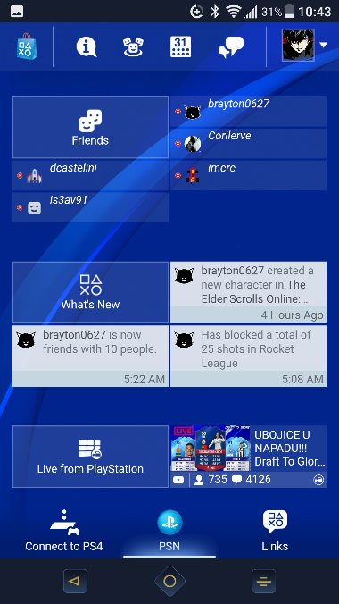

Figure 1 PS App General Layout

The ‘Connect to PS4’ page is quite simple and offers three tile like buttons which indicate the type of connection to initiate, namely ‘Second Screen’, ‘PS4 Guest Login’ and ‘PS4 Remote Play’. The ‘PSN’ page gives the ‘Friends’ tile, with a few friends listed around it with their online or offline status, the ‘What’s New’ tile, which gives three of the most recent updates from friends and communities around it, and finally the ‘Livestream’ tile, which has a screenshot of one of the most popular or relevant streams next to it. The ‘Links’ page consists of nine square tiles, which act as links to various PS store and support services, along with a rectangular banner which acts as an advertisement for PlayStation Plus, the paid subscription service which offers many benefits.

Other than the main pages, the pages such as ‘Friends’, ‘What’s new’, etc. usually have the format of a toolbar with a ‘back’ icon, name of the selection, a ‘home’ icon and an additional button depending on the context such as ‘add friend’ in the ‘Friends’ page. Additionally, depending on the context, there is a drop-down bar which provides for sorting of displayed items based on categories such as ‘online’, ‘offline’, ‘favorites’, etc. as well as for searching in that category.

The sub-modules of ‘Remote Play’, ‘Messages’ and ‘Communities’ however, presents its content in a more mobile centered way and borrows many of its design choices from simple ‘SMS messaging’ applications and other such group applications. The ‘Messaging’ and ‘Communities’ modules provide similar styles of three tabs and the contents below. The ‘Communities’ application still uses tiles to display the community listings. The ‘Remote Play’ module however keeps options minimal, allowing to connect a Dualshock controller and connecting for remotely playing games. If no Dualshock controller is connected, the module does provide touch controls which are overlaid on the PS4’s stream in landscape mode and provided separately in portrait mode.

This grouping of relevant items into three pages helps to reduce short-term memory load and gives an understandable layout for novice users to quickly get accustomed to.

## 5.2 Errors and action reversal

The opportunities for errors in the base PS App itself are not as much, but when we consider the modules of ‘Messages’, ‘Communities’ and ‘Remote Play’, there are more chances of errors being made. Still the severity of such errors is minimal and easily reversible. For example, while creating an event it is possible to cancel the creation of the event and to edit the event once it has been created. The presence of a ‘back’ icon or cancel button in almost all creation and editing screens allows to easily reverse selections and actions.

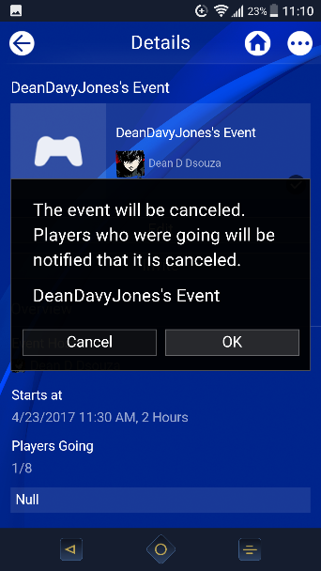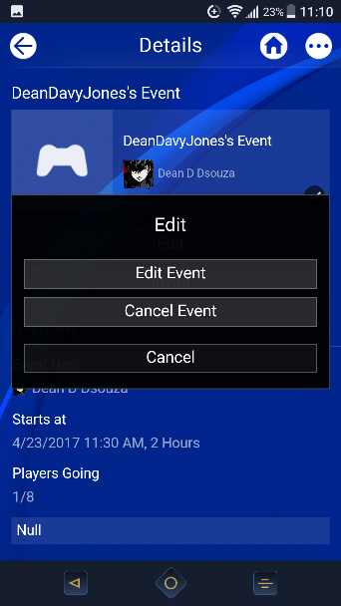 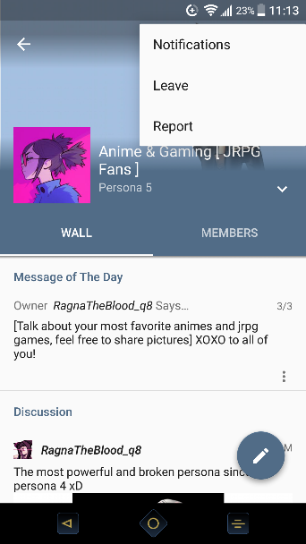

Figure 2 PS App Action Reversal

Other actions such as joining communities or chat groups can be easily reversed through the options provided in the settings of the individual groups and communities.

## 5.3 User Feedback

Feedback is provided to the user in several ways, the simplest of which is the highlighting of tiles and buttons on being pressed. Swiping on through the main pages also gives feedback in the form of highlighting the main page selection in the bar below. While refreshing as well, the application displays a small spinning wheel icon on the right side below the toolbar. This helps users to be aware of their selection and helps them feel more in control of the system.

When it comes to tasks such as creating communities or events, the PS App gives feedback at every step of the way reminding them of what their actions and selections would mean and how their PS4 or the PSN would handle it. Tasks such as sending friend requests also ask for confirmation prior to sending them.

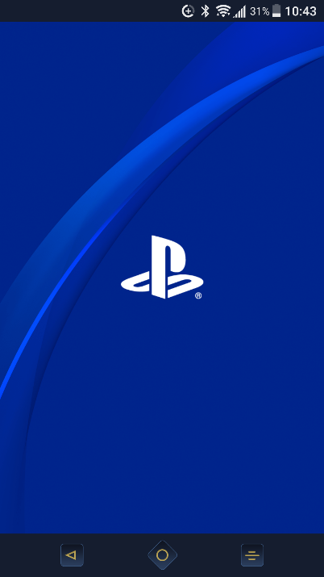 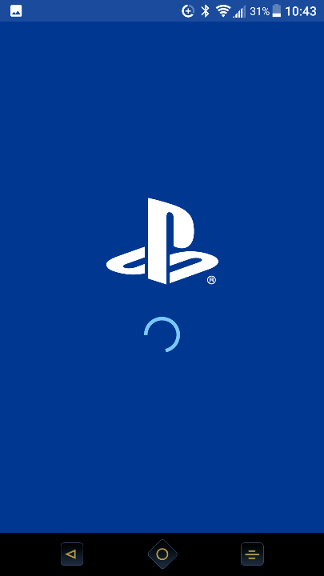 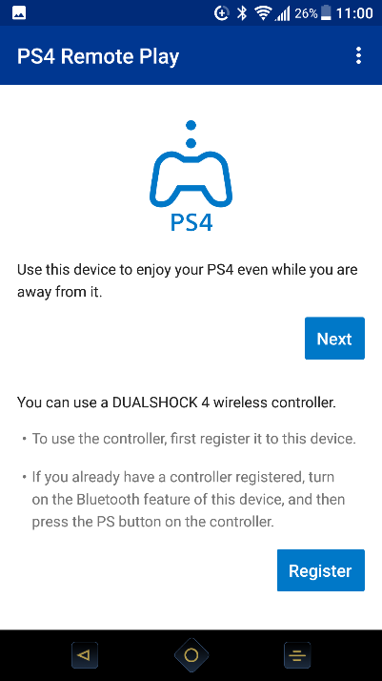

Figure 3 PS App Feedback

Feedback is also provided when the PS App switches over to one of its modules such as the ‘Messages’ module by displaying the PS logo with a spinning wheel animation. The modules themselves also provide feedback and instructions while performing tasks such as ‘Connecting for remote play’ or ‘Connecting the Dualshock controller’.

## 5.4 User Recall and Replicability

Many of the tasks carried out on the various pages involve the same or similar steps and provide similar options. Examples include, the task of searching for friends or communities and the task of creating events and groups.

Once many of the initial setup steps have been dealt with it also becomes quite easy to carry out tasks such as connecting for ‘Remote Play’ or ‘Connecting the Dualshock controller’. The modules and the application itself still provide directions to make sure the user remembers the steps involved and does not need to search elsewhere for instructions.

## 5.5 Action Flows

As already mentioned, many of the tasks of creating and editing follow similar action flows and have similar options. Viewing updates and accessing features also becomes a matter of just selecting the right tile.

Whether intentional or due limitations on performance, the idea of separating the modules of ‘Remote Play’, ‘Messages’ and ‘Communities’ into separate applications that complement the PS App is actually an advantage of the application. The user need not visit the PS App always to access messages or view communities and their details. The separation of these features allows for the user to create their own shortcuts on their device either through icons on the home screen or shortcuts accessed through other means. This flexibility allows to shorten access times, helping the user to feel less frustrated with additional steps.

A summary of the results is presented in the following table:

|  |  |
| --- | --- |
| **Shneiderman’s Rules** | **Implementation** |
| Strive for Consistency | In the main PS App, the main pages follow a similar structure with a toolbar and lower page indication bar. Much of the structure of the main pages are similar with the use of rectangular tile and square tiles. Other pages of selections also have a similar top bar with contents displayed below in a similar fashion. |
| Enable Frequent users to use shortcuts | The separation of modules allows for users to create custom shortcuts on their system. The toolbar also provides constant access to certain features. |
| Offer informative feedback | The PS App offers instructions and feedback at every step and highlights user selections where required. It also provides feedback to inform user of screen updates or changes in modules. |
| Design dialog to yield closure | Many of the actions in the PS App follow similar flows and have similar forms for intermediate steps. They are clearly divided into beginning, middle, and end. |
| Offer simple error handling | Errors are handled in a very similar manner in the PS App. If an action cannot be completed then the user is redirected to start with all changes being discarded or with the screen displaying an error code. |
| Permit easy reversal of actions | Most actions can be easily reversed through edit and cancel options along with the ability to go back a step discarding changes. In terms of groups and communities however, this is handled through options in the group or community menu. |
| Support internal Locus of controls | The user always initiates actions and tasks in the application with only relevant information being provided at the start. While creating events or groups, the user has full control on the type of group, which users are involved and other such options. Additionally, when features fail to load it provides a refresh option so the user can refresh that section if they want to do so. |
| Reduce Short-term memory load | The PS App groups the most important features into understandable groups that are presented in no more than 3 pages. Additionally, each action flow takes no more than 5 pages to complete. |

# 6. Recommendations

While the PS App does several things right when it comes to considering user needs and frustrations, there is still room for improvements. Some of the issues are as follows:

1. Error Handling and feedback: Presently, errors are handled very simply, by returning the user to the start page of the application or the action, or by giving an error code. However, most of the times the user is left wondering what went wrong and why such errors happen, especially when the application shows the PS logo which some would think indicates an action being performed. For example, the PS Store and other web app viewer dependent functions do not make it apparent immediately as to why the user is being redirected to the start screen. Only after scouring the web on forums and support can one make sense of what went wrong. This can lead to a lot of user frustration especially since these are core features of the application. The application should provide more feedback regarding errors and if a feature relies on additional applications or system support. Similar is the case for editing the user profile, which brings the user back to the start of the application.
2. Consistency even among modules: While the modules can efficiently perform their intended functions, they break the immersion of being part of a single ecosystem. The design of the modules can be made to be more like the PS App in terms of background, icons and even ways in which searches are performed in the different modules. For example, while the pages in the PS App provide the search option in the dropdown, the modules of ‘Messages’ and ‘Communities’ provide these as separate icons or separate sections. This option needs to be standardized throughout the application and its modules as the application is marketed with these features as core parts of it. One could argue that as they are separate applications they need not follow the same design ideas, but for making the user feel like it exists in the same ecosystem, I believe certain ideas need to stay consistent.
3. Media Controls in ‘Second Screen Mode’: The second screen mode is marketed as a means for controlling the PS4 with the smartphone screen and using the smartphone’s keyboard to enter text on the PS4 (which has a controller based keyboard which can be frustrating to use for novices). While it mostly functions well, this feature is prone to crashes. Additionally, it does rely a bit too much on touch gestures for controlling the PS4 and needs additional software buttons for control, especially when it comes to controlling media.

# 7. Conclusions

The market place of companion applications for consoles mainly consist of the PlayStation Application and the Xbox application, with the Xbox application providing many similar features with some improvements such as additional software buttons for controlling media. Due to lack of competition, and innovation in the market place for such applications, and due to familiarity with the PlayStation ecosystem, I chose to analyze the PlayStation Application.

Using Shneiderman’s “Eight Golden Rules of Interface Design” as the design guidelines to structure the analysis, I looked at the various features and elements of the PS App, with concentration on viewing the user Profile, keeping up to date with friends, keeping up to date with PSN Communities, accessing messages, connecting to the PS4, and viewing Livestreams.

The PlayStation Application is designed quite well, and tries to consider user requirements and capabilities at every step, but suffers issues from improperly handling of errors and breaks in action flows that are not addressed immediately. This leads to a lot of user frustration, and as the features that suffer this can be easily accessed through a web browser, the applications worth slowly diminishes. The fact that some of the core and frequently used features are available as separate applications leads to the PS App functioning no more than a tutorial and access point for obtaining the correct module applications. This can lead to users forgetting about the main application completely, until they are reminded of its existence through notifications.

In my opinion, I would recommend that rather than providing links to the mobile web version of the various links, some of the links, such as the PlayStation store could in fact be implemented in the application itself. The immersion of staying in a single ecosystem should also be preserved when switching between the module applications so that users can have a more consistent experience. The provision of additional software buttons for controls would also be useful in the case of remotely controlling the user’s PS4 console. Additionally, it may be useful for the application to have a widget associated with it for easier access to recent PSN news.

The PlayStation Application for android can be one of the most useful and well-designed applications in the market of companion applications. While it performs well in most of the tasks it is marketed to accomplish there are still ways in which it can be improved and made more useful. It all depends on if the developers and designers can fix some of its issues, so that it stays relevant to PS4 users.

# 8. References

1. Ben Shneiderman, “Designing the User Interface”, Addison-Wesley Longman Publishing Co., Inc. Boston, MA, USA 1997
2. Wikipedia, “PlayStation”, last modified: April 21, 2017, available at: <https://en.wikipedia.org/wiki/PlayStation>
3. Wikipedia, “Sony”, last modified: April 21, 2017, available at: <https://en.wikipedia.org/wiki/Sony>
4. PlayStation, “PlayStation App”, available at: <https://www.playstation.com/en-us/explore/ps4/app/>