|  |
| --- |
| Chukong Technologies |
| Cocos3D Getting Started |
| MAC-Android |

|  |
| --- |
| Cocos3D Team |

Contens

1 Preparations 0

2 Create cocos3d-x project 0

3 Compile Android project 1

3.1 Configuration environment variable 1

3.2 Compile lib file 1

3.3 Generate apk file 1

3.4 Run 3

# Preparations

* Software：

1. Mac OS（In this case, we use OS X 10.9.1）。
2. Jre（In this case, we use jre-7u51-macosx-x64）。

Download: <http://www.java.com/en/download/manual.jsp>

1. adt-bundle（In this case, we use adt-bundle-mac-x86_64-20131030 and unzip it at /Users/zhukai/Documents/SDK/adt-bundle-mac-x86_64-20131030）。

Download: <http://developer.android.com/sdk/index.html>

1. NDK（本例使用android-ndk-r9b-darwin-x86_64.tar and unzip it at /Users/zhukai/Documents/SDK/android-ndk-r9b）。

Download: <http://developer.android.com/tools/sdk/ndk/index.html>

* Get cocos3d-x source from GitHub：<https://github.com/cocos2d/cocos3d-x> （in this case, we put the source into the Desktop）, directory structure is shown as below。

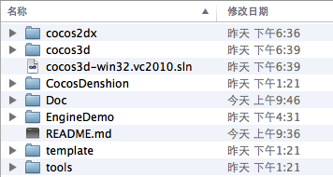

# Create cocos3d-x project

Open a terminal and navigate to cocos3d-x\tools\project-creator directory

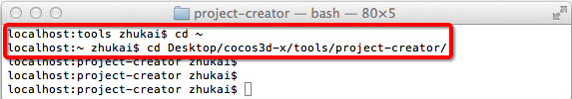

Input "Python ./create_project.py -project fishjoy -package com.chukong.fishJoy"

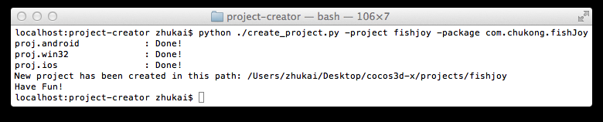

Finally, the newly created project will be located in cocos3d-x\projects.

# Compile Android project



## Configuration environment variable

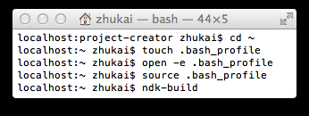1. Open a terminal

2. cd ~

3. touch .bash_profile

4. open -e .bash_profile

In this case change .bash_profile as below：

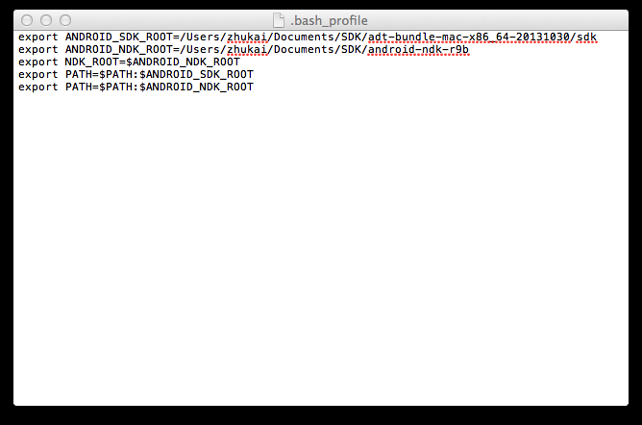

5. save and exit .bash_profile

6. source .bash_profile。

## Compile lib file

1. Open a terminal, navigate to cocos3d-x\projects\fishjoy\proj.android directory，and run build_native.sh：



The output as follows:

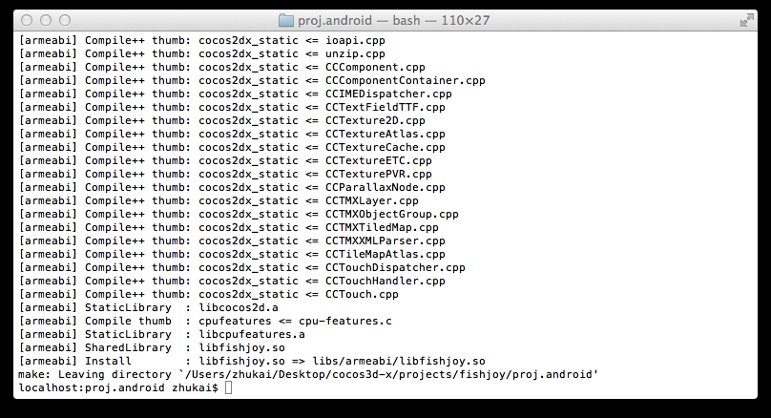

## Generate apk file

Run eclipse (/ Users/zhukai/Documents/SDK/adt-bundle-mac-x86_64-20131030/eclipse), right-click on a blank space in the Package Explorer, select import

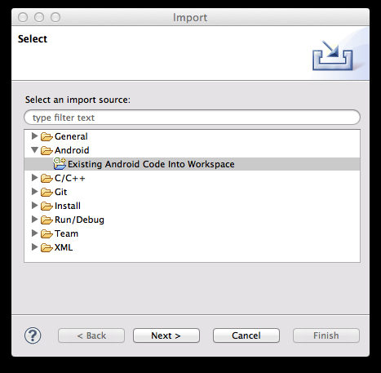

Select “Existing Android Code into Workspace” and then click the Browser button to import cocos2d-x lib for android projects

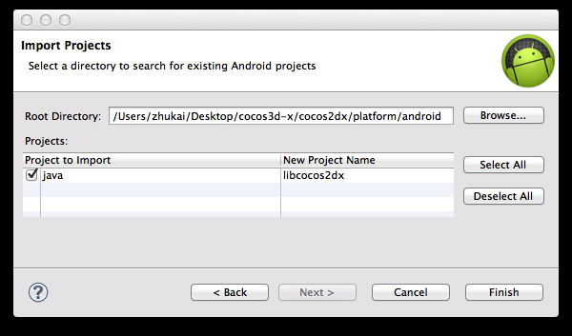

Repeat the above process, import your android project

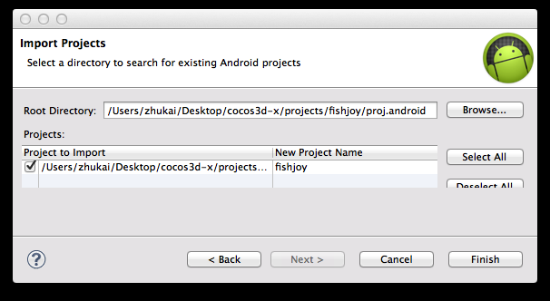

Click the Finish button to complete the import process and now the Package Explorer window will appear both projects

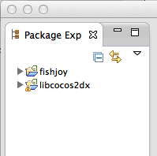

Right click fishjoy project -> Run as -> Android Application。

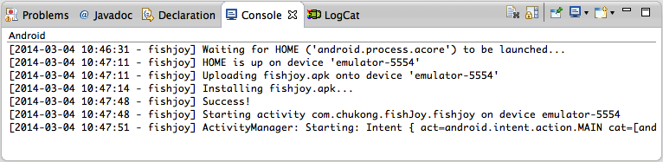

## Run

Select menu “Window->Andorid Virtual Device Manage” to create a avm( check “Use Host GPU”)

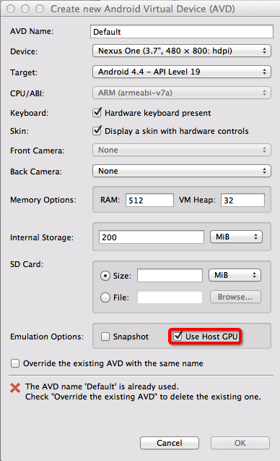

Finally, start the avm

