|  |
| --- |
| Chukong Technologies |
| Cocos3D Getting Started |
| PC-Android |

|  |
| --- |
| Cocos3D Team |

Contens

1 Preparations 0

2 Create cocos3d-x project 1

3 Compile Android project 1

3.1 Configuration environment variable 1

3.2 Compile lib file 1

3.3 Generate apk file 2

3.4 Run 4

# Preparation

* Software：

1. Windows (In this case, we use Windows7 64 bit)
2. Jre (In this case, we use Jre -7u51-windows-x64)

Download: <http://www.java.com/en/download/manual.jsp>

1. Python (In this case, we use python2.7.5 and install at C:\)

Download：<http://www.python.org/download/releases/2.7.5/>

1. Cygwin (In this case, we use Cygwin for 64-bit versions of Windows and install at D:\)

Download：<http://cygwin.com/install.html>

1. adt-bundle (In this case, we use adt-bundle-windows-x86_64-20131030 and unzip it at D:\)

Download：[http://developer.android.com/sdk/index.html#download](http://developer.android.com/sdk/index.html" \l "download)

1. NDK (In this case, we use android-ndk-r9b-windows-x86_64 and unzip it at D:\)

Download：<https://developer.android.com/tools/sdk/ndk/index.html>

* install Git (In this case we use git version 1.7.10-preview20120409)

Download: <http://git-scm.com/download/win>

Note：this step we suggest you choice third option shown below

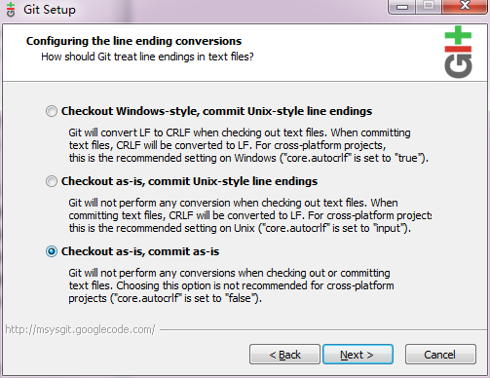

* Get cocos3d-x source from GitHub：<https://github.com/cocos2d/cocos3d-x> (in this case, we put the source into E:\)

# Create cocos3d-x project

Run Cygwin as Administrator and navigate to cocos3d-x\tools\project-creator directory

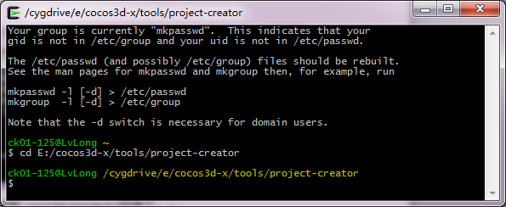

Input "Python ./create_project.py -project fishjoy -package com.chukong.fishJoy"



Finally, the newly created project will be located in cocos3d-x\projects

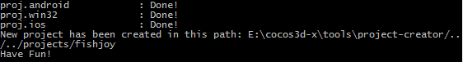

# Compile Android project



## Configuration environment variable

In this case, my environment variable as below:

ANDROID_SDK  D:\adt-bundle-windows\sdk

NDK_ROOT D:\android-ndk-r9b

Add D:\cygwin\bin to Path tail。

Add C:\ Python27 to Path tail

## Compile lib file

1. Run Cygwin as Administrator，navigate to cocos3d-x\projects\fishjoy\proj.android directory，and run build_native.sh



The output as follows:

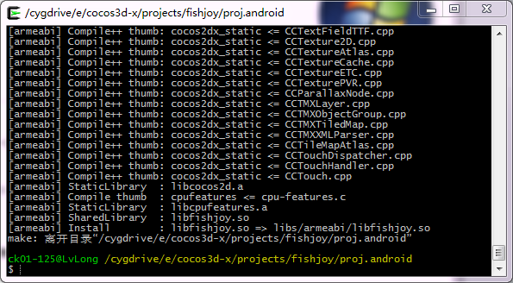

## Generate apk file

Run eclipse as Administrator，right-click on a blank space in the Package Explorer, select import

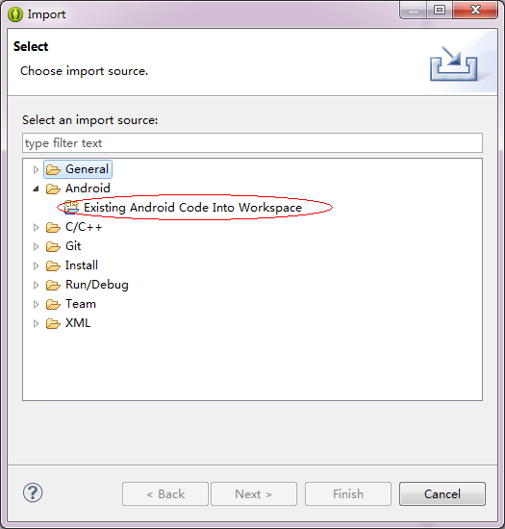

Select “Existing Android Code into Workspace” and then click the Browser button to import cocos2d-x lib for android projects

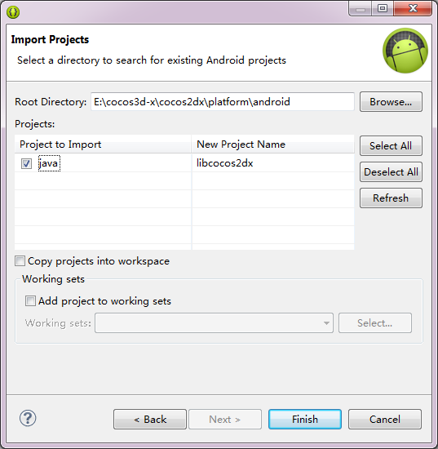

Repeat the above process, import your android project

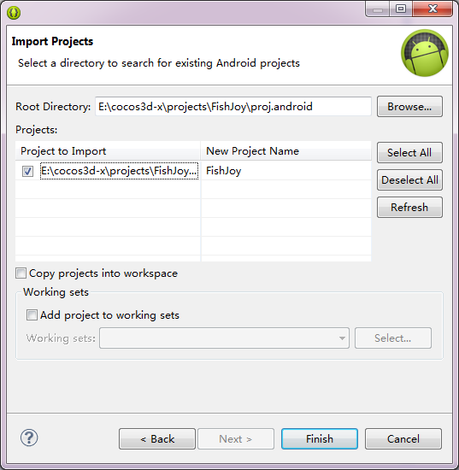

Click the Finish button to complete the import process and now the Package Explorer window will appear both projects

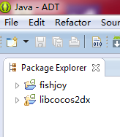

## Run

Right click fishjoy project -> Run as -> Android Application.

Note: at this step you may have permission problem as below:

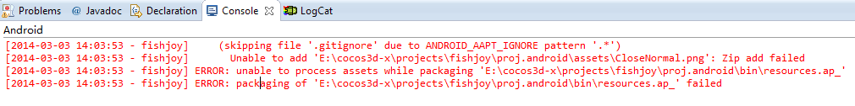

Double click the follow script



Now, right click proj.android folder select “管理员取得所有权限”:

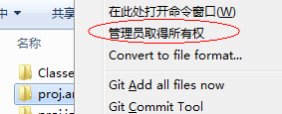

Select menu “Window->Andorid Virtual Device Manage” to create a avm( check “Use Host GPU”)

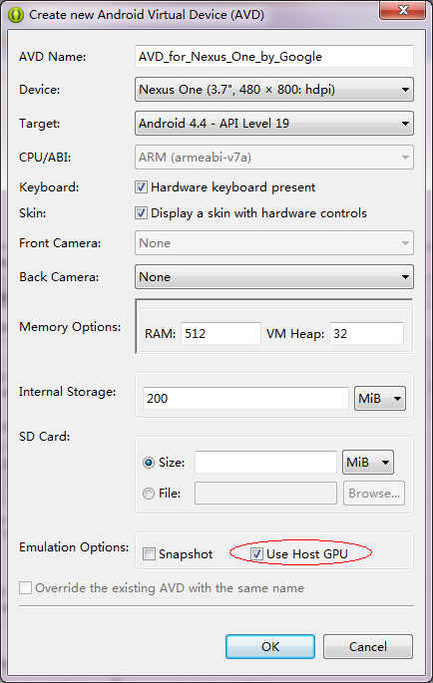

Finally, start the avm

