|  |
| --- |
| Chukong Technologies |
| Cocos3D Getting Started |
| PC-Win32 |

|  |
| --- |
| Cocos3D Team |

Contents

1 Preparation 0

2 Create cocos3d-x project 0

3 Compile Win32 project 1

# Preparation

* Software：

1. Windows (In this case we use Windows7 64 bit).
2. Microsoft Visual Studio 2010.
3. Python (In this case we use python2.7.5 and locate to C:\)

Download: <http://www.python.org/download/releases/2.7.5/>.

1. Cygwin (In this case we use Cygwin for 64-bit versions of Windows and locate E:\)

Download: <http://cygwin.com/install.html>

* install Git (In this case we use git version 1.7.10-preview20120409)

Download: <http://git-scm.com/download/win>

Note：this step we suggest you choice third option shown below

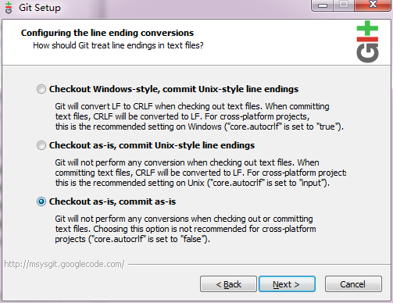

* Get cocos3d-x source from GitHub：<https://github.com/cocos2d/cocos3d-x> (in this case, we put the source into E:\).

# Create cocos3d-x project

Run Cygwin as Administrator and navigate to cocos3d-x\tools\project-creator directory

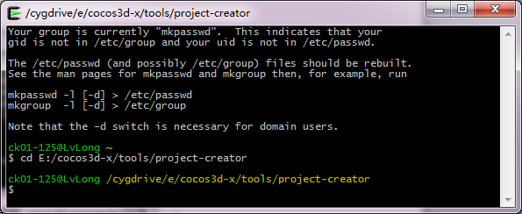

Input "Python ./create_project.py -project fishjoy -package com.chukong.fishJoy"



Finally, the newly created project will be located in cocos3d-x\projects

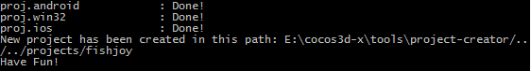

# Compile Win32 project

Navigate to “cocos3d-x\projects\fishjoy\proj.win32”, open fishjoy.sln, compile and run the fishjoy peoject

