1. Download Git from <https://git-scm.com/download/win>
2. Install Git

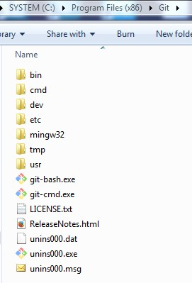

1. Run git-bash.exe

C:\Users\IBM_ADMIN\AppData\Roaming\Tencent\Users\1095570977\QQ\WinTemp\RichOle\Y3Y__ZNMPK@UV1~YLSYBG7N.jpg

1. Change directory to disk C:

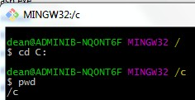

1. Clone remote repository from GitHub <https://github.com/DeanJi/WASAdminConfig>

By default, the local repository WASAdminConfig will be created under current directory C:\

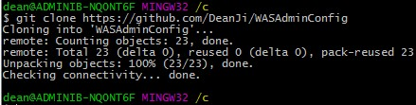

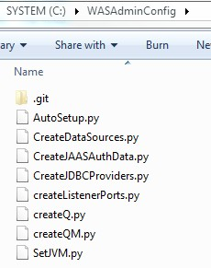

1. Change Directory to local repository folder C:\WASAdminConfig

C:\Users\IBM_ADMIN\AppData\Roaming\Tencent\Users\1095570977\QQ\WinTemp\RichOle\M@04`Y}IXC_$8TLR}4]{_@S.jpg

1. Create test file testCommitPush.txt under local repository folder

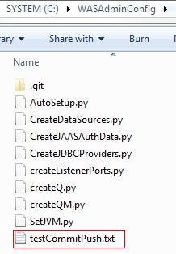

1. Add testCommitPush.txt to local repository

C:\Users\IBM_ADMIN\AppData\Roaming\Tencent\Users\1095570977\QQ\WinTemp\RichOle\YW[ZW~4NCI]9FR40Y`3O3(9.jpg

1. Commit testCommitPush.txt to local repository

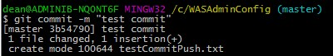

1. Push testCommitPush.txt to remote repository

C:\Users\IBM_ADMIN\AppData\Roaming\Tencent\Users\1095570977\QQ\WinTemp\RichOle\TVBJ8WWO2[_I~`PVOWWP6JQ.jpg

1. Enter GitHub Username

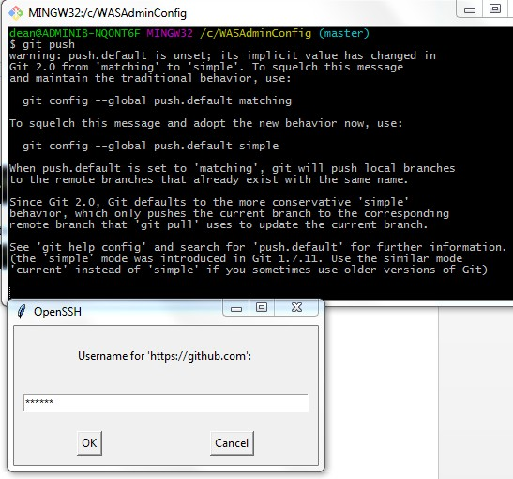

1. Enter GitHub Password

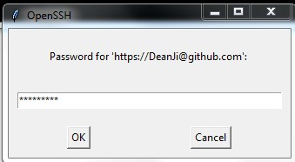

1. Push testCommitPush.txt successfully to remote repository

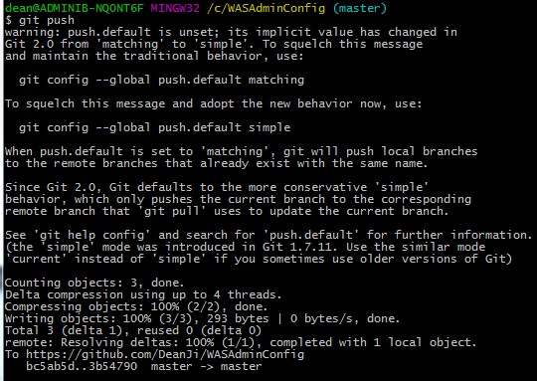

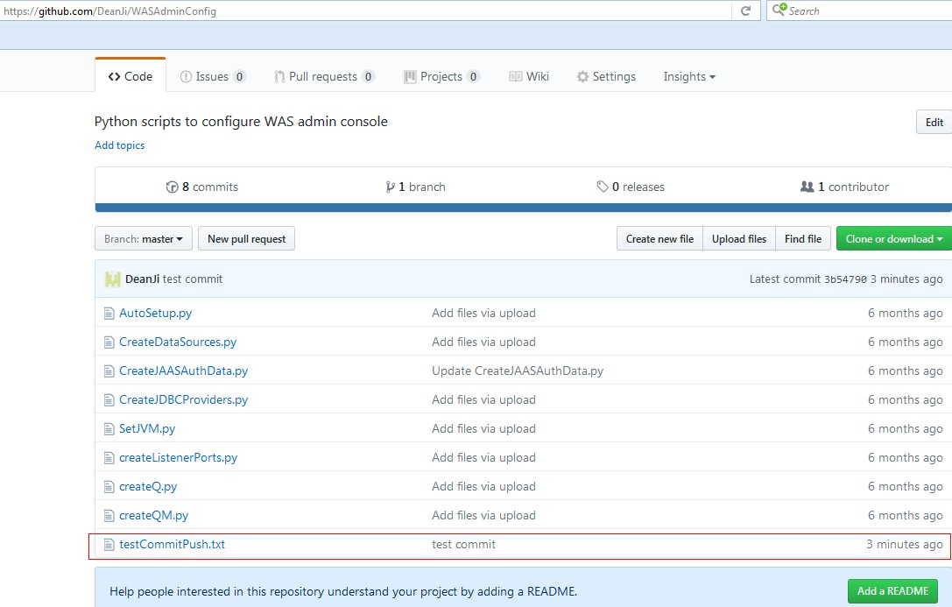

1. Configure SSH so no need to input password when push file to remote repository
2. Change directory to Git home directory(PROGRA~2 is the short term of Program Files (x86))

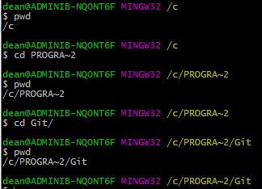

1. Run ssh-keygen -t rsa -b 4096 -C [j\_j\_d\_1987@126.com](mailto:j_j_d_1987@126.com)

C:\Users\IBM_ADMIN\AppData\Roaming\Tencent\Users\1095570977\QQ\WinTemp\RichOle\2DGD@14ZDY4H8D@$[`(@HE2.jpg

1. Press Enter

C:\Users\IBM_ADMIN\AppData\Roaming\Tencent\Users\1095570977\QQ\WinTemp\RichOle\6LABGBOC@(OP@`SR9~RDQ02.jpg

1. Press Enter

C:\Users\IBM_ADMIN\AppData\Roaming\Tencent\Users\1095570977\QQ\WinTemp\RichOle\JAXWGI}7~~{HRTB2(_F1SOX.jpg

1. SSH key generated successfully

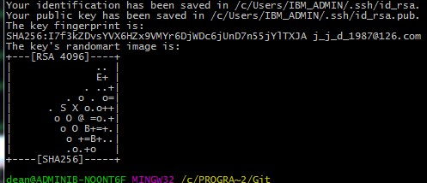

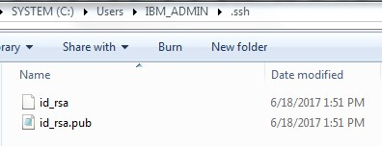

1. Copy the content of id\_rsa.pub
2. Login to GitHub 🡪 settings 🡪 SSH and GPG keys

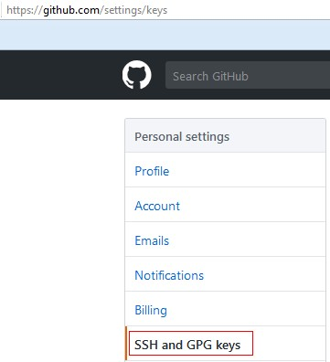

1. New SSH key

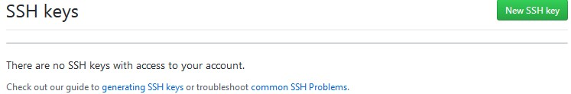

1. Input Title field, paste the content of id\_rsa.pub in Key field, Add SSH key

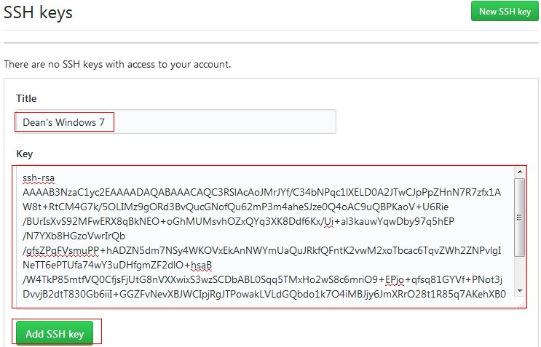

1. Confirm GitHub account password

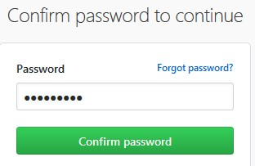

1. Create SSH key successfully in GitHub

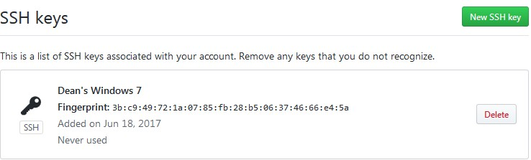

1. Test SSH connection via running command “ssh –T git@github.com”

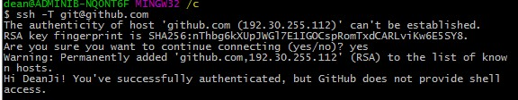

1. know\_hosts file created

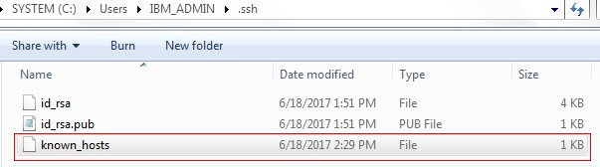

1. Now try to push new file to GitHub again
2. Create test file testSSHPush.txt under local repository folder

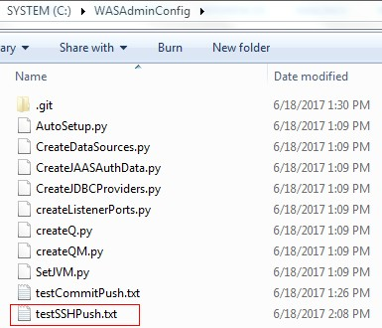

1. Change directory to local repository folder

C:\Users\IBM_ADMIN\AppData\Roaming\Tencent\Users\1095570977\QQ\WinTemp\RichOle\G_VP6A0@8`RP[SKHX{YWP2W.jpg

1. Add testSSHPush.txt to local repository

C:\Users\IBM_ADMIN\AppData\Roaming\Tencent\Users\1095570977\QQ\WinTemp\RichOle\7T34E()AK1{Z`4K18KT3MWJ.jpg

1. Commit testSSHPush.txt to local repository

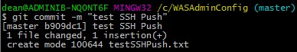

1. Push testSSHPush.txt to remote repository

C:\Users\IBM_ADMIN\AppData\Roaming\Tencent\Users\1095570977\QQ\WinTemp\RichOle\TVBJ8WWO2[_I~`PVOWWP6JQ.jpg

1. Still need to input the password, will check later