1. Login Jenkins 🡪 Manage Jenkins

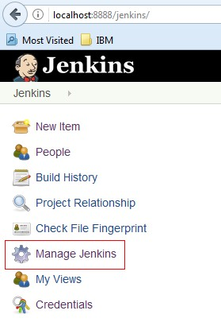

1. Configure System



1. Home directory

C:\Users\IBM_ADMIN\AppData\Roaming\Tencent\Users\1095570977\QQ\WinTemp\RichOle\VG1[Y7C{270A3SCRLRLNM[O.jpg

1. Maven project configuration

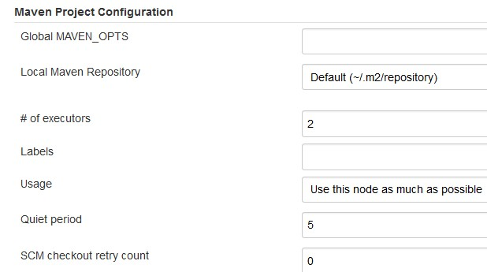

1. Jenkins Location

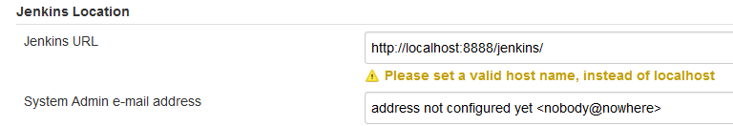

1. Weblogic Deployment Plugin

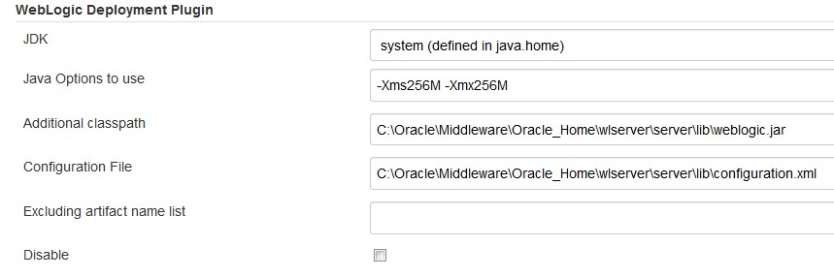



1. Global Tool Configuration

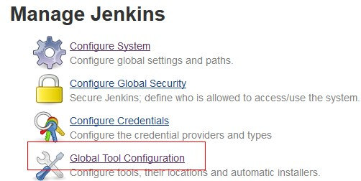

1. Maven Configuration

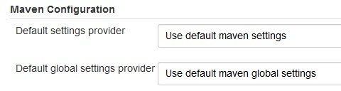

1. JDK

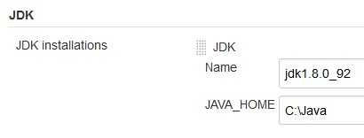

1. Git

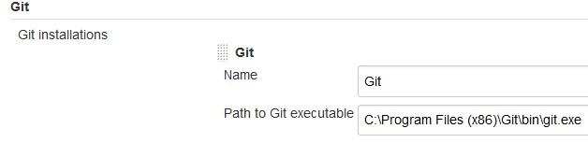

1. Maven

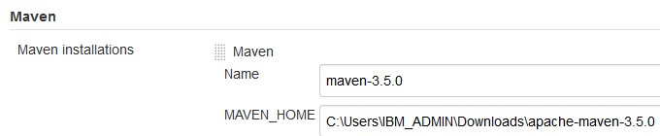

1. Create a freestyle project TEST
2. SCM

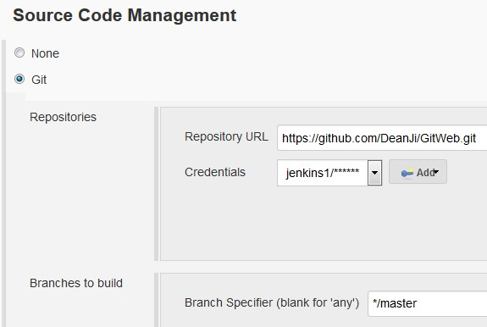

1. Build

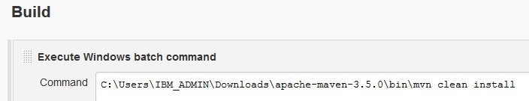

1. Post-build action

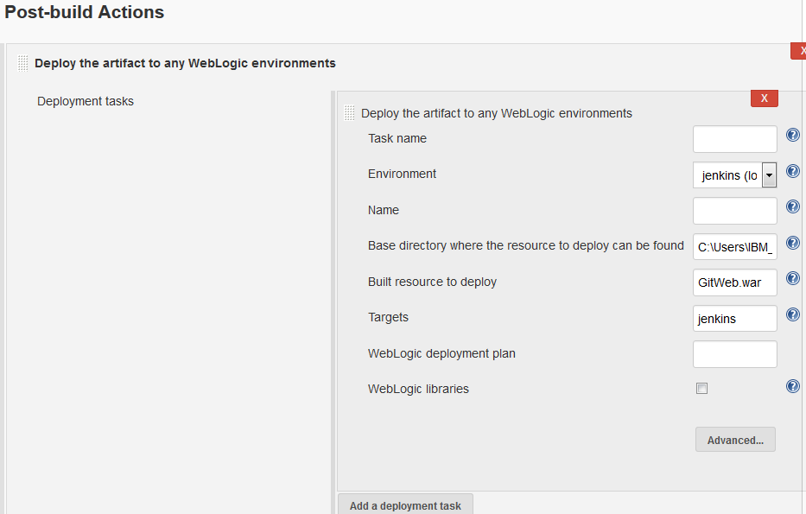

Base directory where the resource to deploy can be found: C:\Users\IBM\_ADMIN\.jenkins\workspace\TEST\target

1. Update index.jsp and push to github

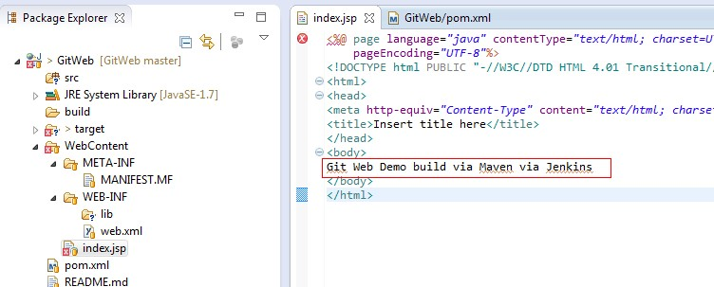

1. Build Now

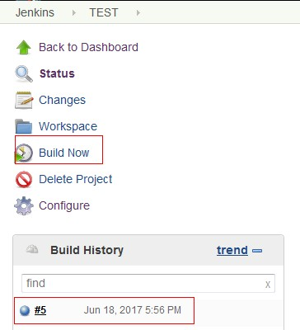

1. GitWeb.war is deployed to weblogic managed server Jenkins

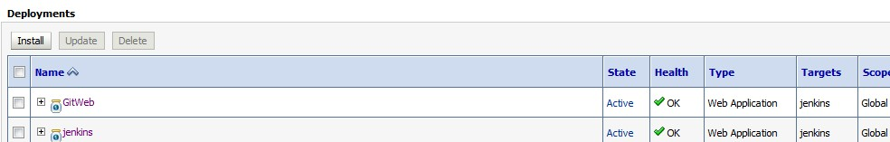

1. Can see the updated content of index.jsp

