**Model diagram**

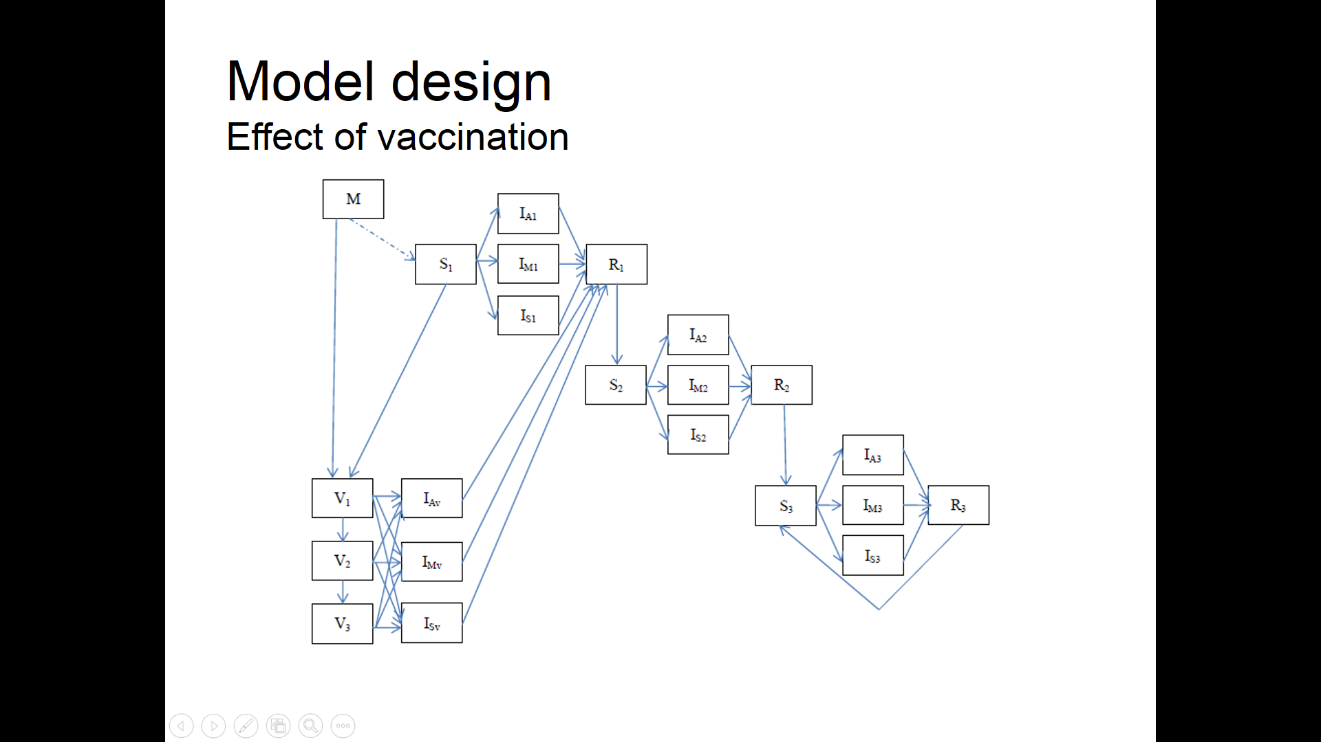

|  |  |  |  |  |  |  |  |  |  |  |  |  |  |  |  |  |  |  |  |  |  |  |  |  |  |  |  |  |  |  |  |  |  |  |  |  |  |  |  |  |  |  |  |  |  |  |  |  |  |  |  |  |  |  |  |  |  |  |  |  |  |  |  |  |  |  |  |  |  |  |  |  |  |  |  |  |  |  |  |  |  |  |  |  |  |  |  |  |  |  |  |  |  |  |  |  |  |  |  |  |  |  |  |  |  |  |  |
| --- | --- | --- | --- | --- | --- | --- | --- | --- | --- | --- | --- | --- | --- | --- | --- | --- | --- | --- | --- | --- | --- | --- | --- | --- | --- | --- | --- | --- | --- | --- | --- | --- | --- | --- | --- | --- | --- | --- | --- | --- | --- | --- | --- | --- | --- | --- | --- | --- | --- | --- | --- | --- | --- | --- | --- | --- | --- | --- | --- | --- | --- | --- | --- | --- | --- | --- | --- | --- | --- | --- | --- | --- | --- | --- | --- | --- | --- | --- | --- | --- | --- | --- | --- | --- | --- | --- | --- | --- | --- | --- | --- | --- | --- | --- | --- | --- | --- | --- | --- | --- | --- | --- | --- | --- | --- | --- | --- |
| |  |  |  |  |  |  | | --- | --- | --- | --- | --- | --- | | Source | Values | | | Symbol | Parameter | | [23,32] | RVGE | | |  | Probability of severity given infection | | severe | mild | asymp. | | 0.133 | 0.34 | 0.53 |  | Primary infection | | 0.03 | 0.22 | 0.75 |  | Secondary infection | |  | 0 | 0.2 | 0.8 |  | Subsequent infection | | [30] |  | | | 1/*γ* | Duration of infection (**days**) | | 7 | | |  | First infection | | 3.5 | | |  | Second/Asymptomatic infection | | [23] | RVGE | | |  | Relative infectiousness | | severe | mild | asymp. | |  | 1.0 | 1.0 | 0.1 |  | First infection  Second and Subsequent infection | | 0.8 | 0.5 | 0.1 | | [32] |  | | | *σ* | Relative susceptibility following: | |  | 0.62 | | |  | Primary infection | | 0.37 | | |  | Second and Subsequent infection | | [23] |  | | | 1/*ω* | Duration of immunity (**months**) | |  | | | |  | 3 | | |  | From maternal antibodies | | 18 | | |  | From first infection | | 24 | | |  | From subsequent infections | |

**Missing parameters**

* Susceptibility rate for ages $β_{j}$: 0-1, 1-2, 2-5, 5-15, >15 and seasonal offset $φ$

Vaccine is not likely to wane. (No arrow between V to S0)

<http://pediatrics.aappublications.org/content/early/2016/09/21/peds.2016-1173>

<https://ac.els-cdn.com/S0264410X15003047/1-s2.0-S0264410X15003047-main.pdf?_tid=29c01506-e694-11e7-9266-00000aab0f01&acdnat=1513891149_c0dceb0ff32da33e21c2b843345f762c>

**Age groups**

* **The population is stratified into the following 14 age groups: 0–2, 2–4, 4–6, 6–12 months, 1–2, 2–3, 3–4, 4–5, 5–15, 15–20, 20–30, 30–50, 50–65, >65 years**
* To maintain fix population and fixed age groups:

*di* - is the aging rate

ageUi- ageLi = age group duration

*N0j* – represents the proportion of age group j in the population.

Death rate in Japan ( vector divided by 1000)

$$\{μ_{0},μ_{1},μ_{2},μ_{3},μ_{4},μ_{5},μ_{6},μ_{7},μ_{8},μ_{9},μ_{10},μ_{11},μ_{12},μ_{13}\}=\{3,3,3,3,0.5,0.25,0.251,0.251,0.1,0.1,0.381835,0.8125,3.558,22.2\}/1000$$

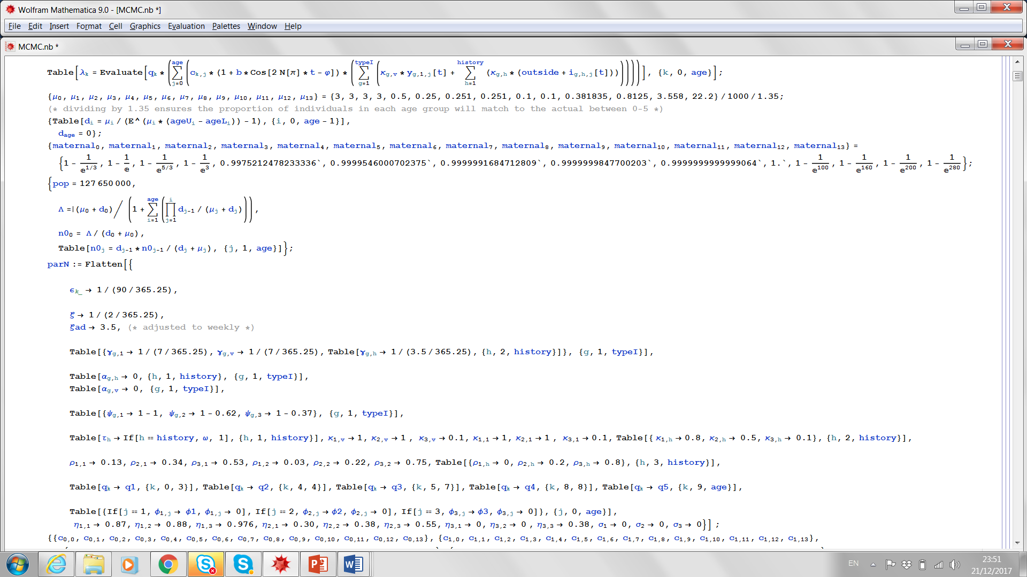 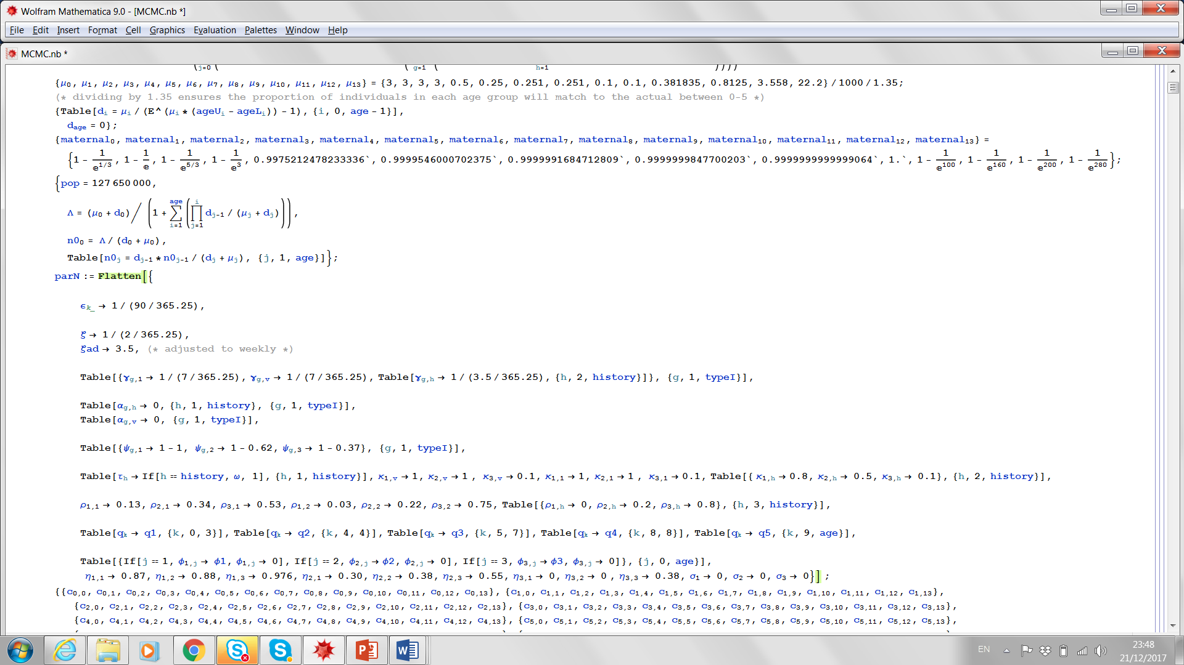

1. **Data for fit**

Weekly

Variance of the normal distribution

Years – for Fit 10

Graphs