CEE 362G Project 1

Yimin Liu, Wentao Zhang

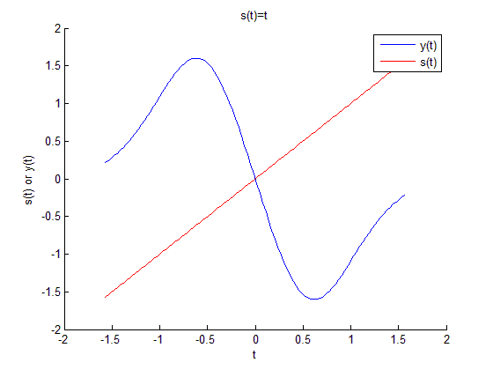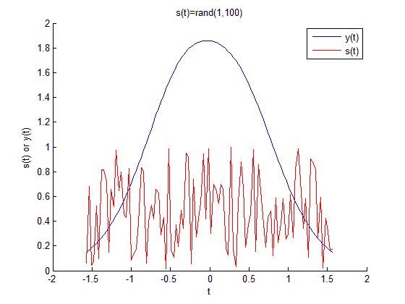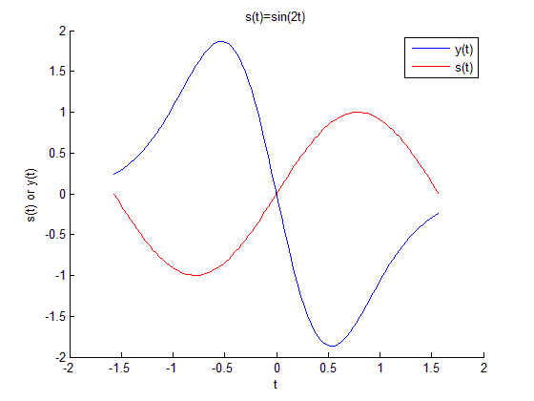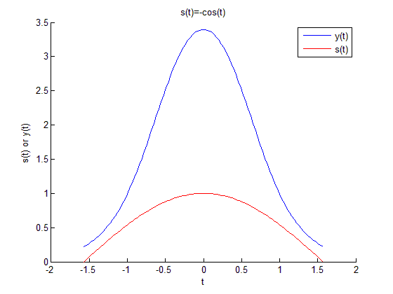

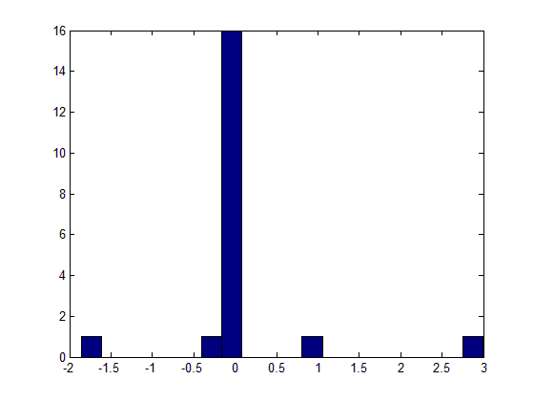

Figure 1 Distribution of the Spectrum (N=20)

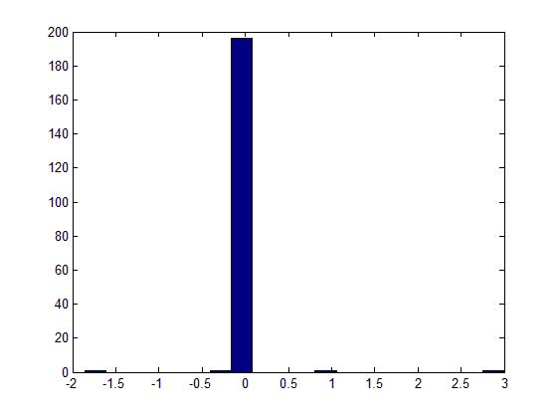

Figure 2 Distribution of the Spectrum (N=200)

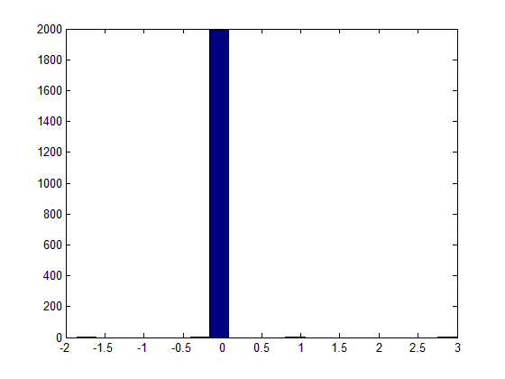

Figure 3 Distribution of the Spectrum (N=2000)

From the distribution of the spectrum of H, we can see that as N increases, eigenvalues are centralized around 0. This indicates that the condition number of H is quite large so H is ill-conditioned. In this case, a small perturbation to y can cause large impacts on s.

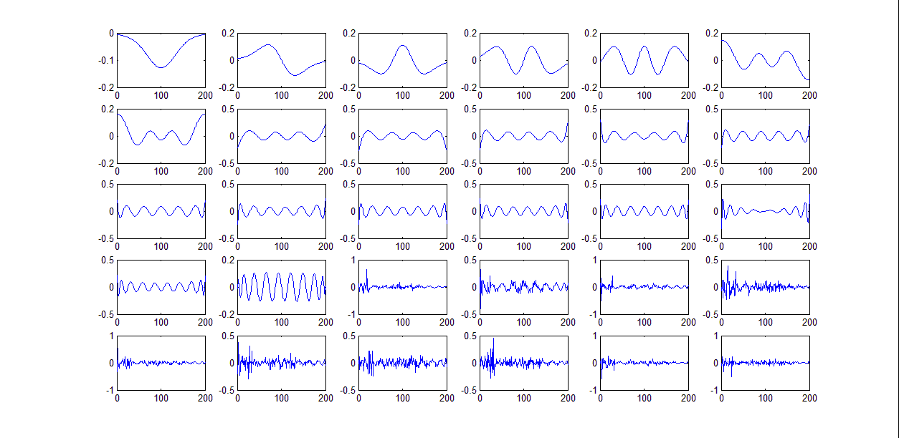

Figure Column Vectors of Matrix V (the first 20 are ‘most important’)

In this case, MATLAB gives rank(H)=20. We can see that the first 20 vectors in V present different periodic trends. These 20 vectors can be considered as the ‘most important’ vectors that span the rowspace of H. Other vectors are the linear combinations of these 20 vectors.

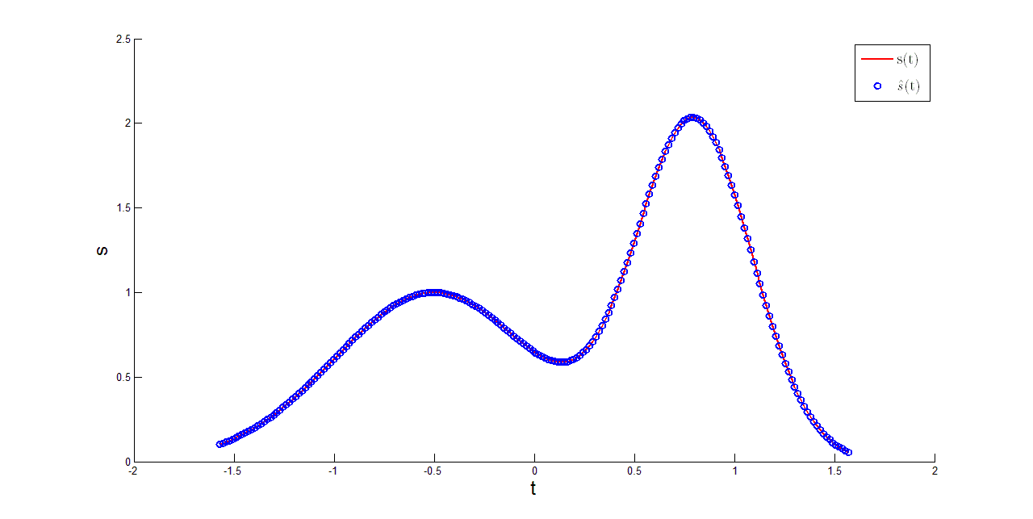

Figure Comparison between the True s and the s from Pseudo-inverse (without noise)

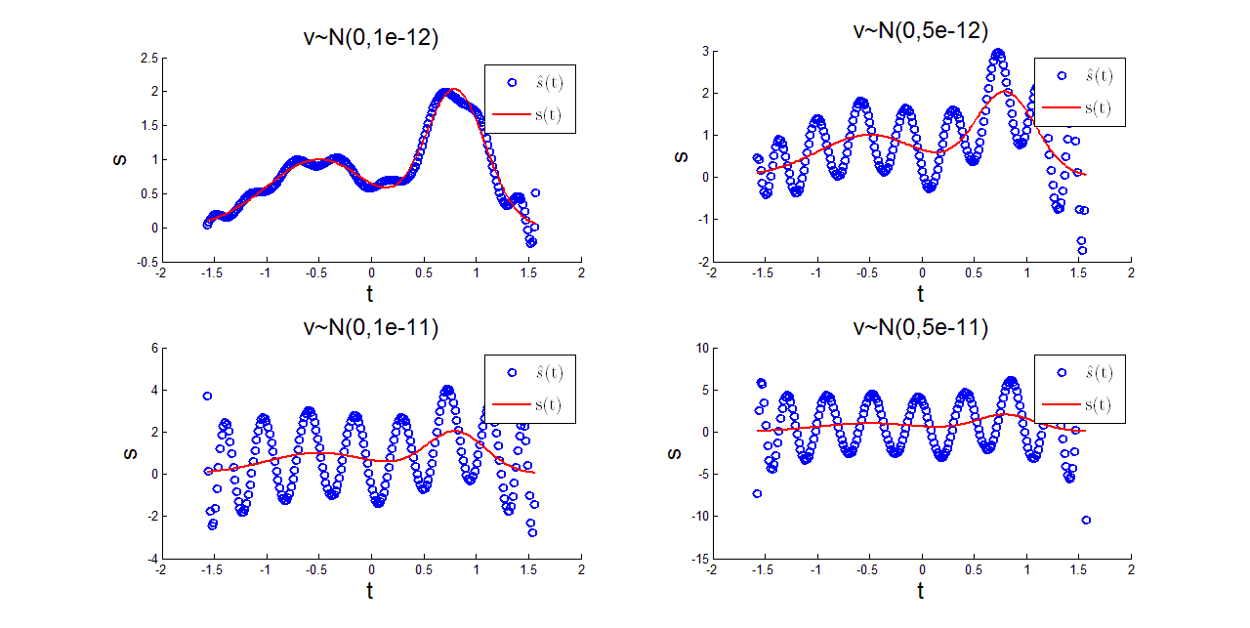

Figure Comparison between the True s and the s from Pseudo-inverse (with noise)