Remote Monitoring Surveillance System

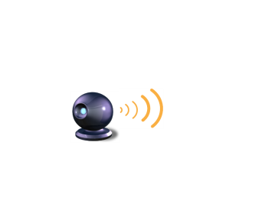 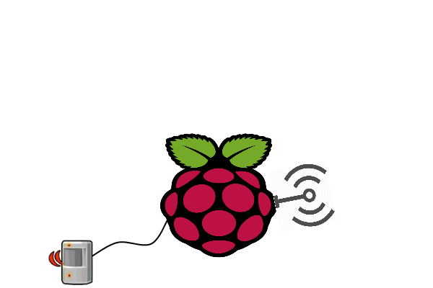 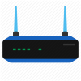

**System**

**Server**

**Motion Detector**

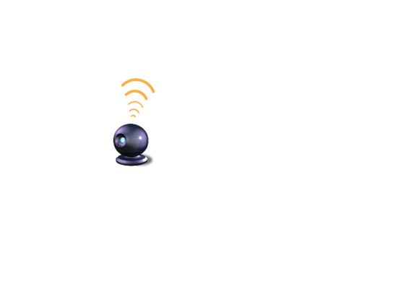 

**Cams**

(RTSP)

**Screen2** (3pgs)*From login- Home Screen+Camera screens*Usergets view of two cameras and can navigate to each one by selection.

The user can control camera movement and record videos to upload to his/her dropbox.

Once logged in, the user can receive active notifications from the motion detection.



**Application**

**Screen3** (1pg)*Settings*The settings page will contain the logout, general settings page (delete/edit account etc )

**Client**

**Screen1** (3pgs)*Login + Register*Usercan login with his/her details if they are registered (redirected to login page)

They can register with details including dropbox if not logged in. (redirected to register page)

